NEWS OF EUROPEAN PANCREATOLOGY
(by materials of 49th Meeting of European Pancreatic Club)
¹N. B. Gubergrits, ¹N. V. Byelyayeva, ¹G. M. Lukashevich, ¹A. Ye. Klochkov,
¹P. G. Fomenko, ²O. V. Rotar
¹Donetsk National Medical University, Ukraine
²Bukovina State Medical University, Chernivtsi, Ukraine

Key words: European Pancreatic Club, Ukrainian Pancreatic Club, diagnostics and treatment of chronic pancreatitis, pancreatic insufficiency, Creon

On June 28th — July 1 2017 in Budapest (Hungary) the 49th meeting of the European Pancreatic Club took place. About 500 oral and poster reports were presented there [3].
Let us start from the advances of the Ukrainian Pancreatic Club. Our Club is still the most numerous in Europe. At the meeting in Budapest, we presented over 40 papers in the form of poster presentations (more works were sent by pancreatologists from Hungary, Germany, Great Britain). The most important is that the annual meeting of the European Pancreatic Club will be held in Kiev — the Congress will take place in June 2022. The elections were held fairly hard (not all of us believe), but voted for Ukraine 50 Ukrainians and Hungarians, Poles, Italians, Swedes and a few Russians. As a result, 85% of those attending the General Assembly of the European Club voted for Ukraine. Before Congress there are 5 years, but this term will give us time to prepare well. We are full of optimism!
Now briefly describe the results of some studies that attracting our attention. Let’s start with pancreatitis etiology.
E. Tjora et al. (Norway) 932 analyzed the medical history of patients with chronic pancreatitis (CP) from the database Nordic-Baltic Pancreatic Club. They examined history (abuse) alcohol, smoking, nutritional status in terms of body mass index (BMI), the state of exocrine function of the pancreas (pancreatic) as a result of fecal elastase test, the incidence of complications CP (calcification, recurrence of pancreatic attacks), as well as the frequency of combination of alcohol abuse and smoking. It has been found that smokers and alcohol abusers have a worse nutritional status (Figure 1). In current smokers (heavy smokers) and smokers in the past often revealed calcification of the prostate tissue (Fig. 2). In alcohol abusers more frequent relapses of pancreatic attacks (Figure 2). Active smokers had lower fecal elastase test results (Figure 3). Alcohol abusers had a higher pack-years indicator (Figure 4). Consequently, not only alcohol abuse, but also smoking contributes to the development and progression of CP, the deterioration of the exocrine function of the pancreas. This is important in the treatment, as well as in primary and secondary prevention of CP.
Research A. V. Okhlobystina with co-workers. (Russia) is devoted to the role of biliary sludge in the development of CP. Analyzed 6000 case histories of academic clinic patients and sick Highlight E having an E and biliary sludge, and CP. When conducting endosonography n ormalny diameter virsungianova duct defined only in 36% of patients; periampulent diverticulum — in 13%; from e to the nipple Vater — 38%, papillary fibrosis — 13% of patients. The authors analyzed the frequency of changes in the prostate and virsungian ducts, the fated nipple, depending on the type of biliary sludge determined by sonography. It turned out that CP was significantly more likely to develop with biliary sludge by type zamazkoobraznoy g e lchi (33.3% in the presence of this type of sludge), at least — in the presence of a non-homogeneous w e lchi with clots (7.7%) and less e esch- with a sludge in the form of hypoechoic particles (1.7%). In kupirova SRI pain in patients with biliary sludge and CP was effective gimekromon 400 mg 3 times a day.
Important information regarding the formation of CP after acute acute pancreatitis was obtained by T. G. Dyuzheva with co-workers. (Russia). The authors performed a percutaneous elastometry RV (Acuson S 2000, Siemens) 69 patients in different periods after acute necrotizing pancreatitis. The authors set out to not only track the state of the pancreas after the acute pancreatitis, but also to assess the possibility of surgical interventions for CP when indicated (for a denser tissue of the pancreas perform operations easier technically and better the prognosis of such interventions). The results are shown in Table 1. In accordance with the results obtained during the first year after sealing pancreatic necrosis occurs predominantly pancreas head, at a later date and other sealed sections RV, especially in the presence of ductal hypertension in the main pancreatic duct.
Table 1
Elastometry of the pancreas, wave velocity (m/s)
(by T. R. Dyuzhevaya et al., 2017 [3])
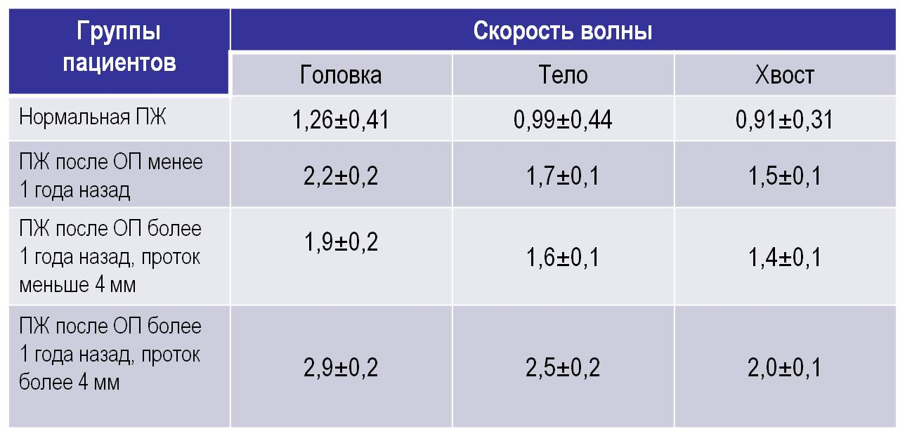
A. Parniczky et al. (Hungary), 121 patients with pancreatitis who developed before the age of 18 were examined in a multicenter APPLE study of pancreatitis in children.The etiology of the disease is presented in Figure 5. Genetic unke m utatsii predisposing to the development of pancreatitis, identified in 63% of cases with idiopathic pancreatitis and in 34% of cases with non-idiopathic pancreatitis. Table 2 shows the frequency of detected mutations in the examined patients. It is interesting that most often determined CTRC mutation (gene chymotrypsinogen). It is likely that genetic screening should pay close attention to the presence of risk factors for pancreatitis in children with this mutation.
Table 2
The frequency of genetic mutations in children with pancreatitis
(APPLE study) (by A. Parniczky et al. , 2017 [3])
 | The frequency of mutation carriers among all examined | The frequency of mutations among carriers of mutations
PRSS1 | 2.5% | 3.8%
CTRC | 37.3% | 57.8%
SPINK1 | 9.9% | 15.4%
CPA1 | 2.5% | 3.8%
CFTR | 12.4% | 19.2%

Zs. Vojnisek et al. (Hungary) investigated the frequency and causes of pancreatitis in children with inflammatory bowel disease (IBD). The study included 751 patients (231 — with ulcerative colitis, 465 — with Crohn's disease, 55 — with neutochn e nnym IBD). Pancreatitis is diagnosed in 12 patients (1.6%) patients, wherein the frequency f m pancreatitis was similar in ulcerative colitis and Crohn's disease. In 84% of cases of pancreatitis has evolved as the extraintestinal manifestation of IBD, the frequency with pancreatitis had 8% drug pathogenesis associated with at e IOM 5 am and nosalitsilatov, corticosteroids, 6-mercaptopurine or metronidazole. In 8% of cases the cause of pancreatitis remained unclear.
A number of works on the nutrient deficiency and micronutrients with exocrine pancreatic insufficiency of the prostate was presented at the congress. One such study is the study by S. Beer et al. (Germany), devoted to the study of e Goes levels of taurine in the blood. The authors examined 10 patients with CP and EPI receiving substitution enzyme therapy (APT), 8 patients with CP and EPI, but not receiving AFT and 10 patients without pathology of the prostate. An unreliable decrease in the blood taurine level was obtained in patients with CP and EPI without ZFT in comparison with other groups (Fig. 6). It is important that the index of taurine directly correlated with the results of the fecal elastase test (Figure 7). Consequently, with an increase in the number of patients in the study, it is possible to expect a significant decrease in the level of taurine in the blood under EPI, especially in the absence of APT. The study of the index of taurine is of particular interest, Because it binds to bile acids in bile, it facilitates the emulsification of fats. T. e., with a deficiency of taurine, hydrolysis of fats is disrupted, which leads to an aggravation of their maldigestion with EPI.
We were interested in the study of M. Kovacheva-Slavova et al. (Bulgaria), who and apolipoproteins zuchali AІ, AІІ, B, SІІІ as markers of cardiovascular risk in pancreatic pathology. The study included 70 patients with CP, 23 — after acute pancreatitis, 14 — with cancer of the pancreas, 14 patients underwent resection of the prostate. 46.3% of the patients had a high cardiovascular risk, which proved to be particularly high in men with prostatic cancer. 45.5% of all patients had reduced levels of apo A-I, 32,2% — increased rates of apo-B. Dyslipidemia with increased cholesterol and low-density lipoprotein and / or triglycerides was diagnosed in 26.5% of patients. In our opinion, it would be interesting to conduct a correlation analysis of the indices of apolipoproteins with nutritional status and fecal elastase test data, high cardiovascular risk in the pathology of the prostate is associated with EPI (see below).
Results of a meta-analysis on the effect of statins on the risk of pancreatic adenocarcinoma reported L. Archibugi et al. (Italy). Meta-analysis, which included predominantly studies type case — control, showed a protective effect of statins decrease prostate cancer risk (odds ratio 0.82). Of course, randomized trials are needed to more reliably approval.The mechanism of the protective effect of statins, according to the authors of the meta-analysis is that they are immuno nomodu oscillating and anti-inflammatory properties.
A. Lopez-Serrano et al. (Spain) carried dual energy X-ray absorptiometry CP patients and compared ee of the level of vitamin D in the blood, BMI. Identified relationship between fecal elastase test results, BMI, levels of vitamin D in the blood with the presence and degree of Ost Porozov lumbar vertebrae and femur. The authors believe that the decrease in BMI makes you think about the high risk of Ost Porozov and therefore prov odit assessment of bone mineral density.
D. Adams (USA) presented the results of a retrospective study on the long-term survival of patients with CP after total pancreatectomy with autologous islets of Langerhans (TPAO).
Advantages of TPAO:
- eliminates pain;
- allows to avoid chronic neuropathic pain syndromes;
- does not require immunosuppression;
- lack of organic rejection of islet tissue;
- allows to avoid destructive processes with external and pancreas endocrine insufficiency;
- eliminates inflammatory mediators produced by the pancreas.
The study included 160 e us CP patients undergoing TPAO. Long-term survival of these patients was compared with the life expectancy of patients with CP who were treated conventionally (drug therapy after failure → → endoscopic treatment after failure of surgery (resected or draining operation)). The observation period averaged 4.8 years.Mortality within 90 days after surgery was 8.1%. The causes of death are shown in Figure 8 unke and life expectancy of patients after TPAO — Fig. 9.
Conclusion, made by the authors of the study: TPAO has a high early postoperative lethality, but a greater long-term survival in comparison with the traditional approach to treatment of CP.
AT. Egorov (Russia) presented the experience of the treatment of 75 patients with duodenal dystrophy for the period 2004 — 2017. (the terms "furrow pancreatitis", "paroduodenal pancreatitis" are also used) (Fig. 10). 66 patients underwent pancreatic resection pilorosohranyayuschie with satisfactory immediate and gave e nnym results.
R. Kadaj-Lipka et al. (Poland) conducted an interesting prospective non-randomized, single-center study to clarify the causes of diarrhea in patients with diabetes. 231 patients were examined; a fecal elastase test and a hydrogen breath test with lactulose were performed, and blood lipase activity was monitored. The main group consisted of patients with abdominal symptoms (mainly with diarrhea) control group — patients without these symptoms. Reduction of fecal elastase among all patients identified in 14% of cases. Significantly more often diagnosed in the primary group of bacterial overgrowth in the small intestine syndrome (ARIS) (Fig. 11). Thus, the main cause of intestinal symptoms in diabetes is SIBR.
L. M. Poce et al. (Spain) examined 54 patients who underwent partial or total gastrectomy. They performed in odorodny breath test with glucose and triglyceride breath test. At 68, 5% of patients diagnosed with ARIS, at 20.4% — EPI, at 11.1% — a combination of ARIS and pancreatic insufficiency. Thus, in the treatment of patients after gastrectomy or gastrectomy, the high frequency of SIBR and VNPW should be considered.
Byung Kyu Park et al. (South Korea) reported the results of an important and scientifically, and in practical terms, the research on increasing CA 19-9 with benign district'snon-pancreatic diseases. 6899 cases analyzed CA19-9 increase 2 times or more. After exclusion of malignant diseases and pancreatobiliary The study included 195 patients.Reasons for increasing CA19-9 clarified in 77% of cases (Fig. 12). Of the 45 patients with a rise E IOM CA19-9 unknown etiology in 35 patients when viewed in a normalized figure for two years, 10 patients remained elevated. Nosological units expected to accompany Esja increased CA19-9, are listed below (the list in each group specified by the higher frequency vstrechaemos minute increase to low CA19-9).
Liver diseases:
- alcoholic hepatitis / cirrhosis;
- drug-induced hepatitis;
- acute hepatitis;
- chronic hepatitis B;
- autoimmune hepatitis;
- hepatic cyst.
Lungs diseases:
- bronchiectasis;
- diffuse interstitial damage;
- tuberculosis;
- lung abscess;
- pneumonia.
Gynecologic pathology:
- cystic teratoma;
- endometriosis.
Endocrine diseases:
- uncontrolled diabetes;
- hypothyroidism.
G. Zsory et al. (Hungary) studied the efficacy of metformin in non-alcoholic fatty liver and prostate disease in patients with newly diagnosed diabetes mellitus. The study included 19 patients. CT was performed to estimate SSB Hounsfield scale liver and pancreas density before and after treatment (m etformin in conventional doses of 4 months).Under the influence of treatment, the initially reduced density of the liver significantly increased. The density of the prostate has not undergone significant changes under the influence of metformin. T. e., the search for funds for the treatment of non-alcoholic fatty heart disease continues.
D. de la Iglesia-Garsia et al. (Spain, Great Britain, China) performed a meta-analysis and conducted a systematic review of the problem of the development of urinary acid after acute acute pancreatitis. The results of 27 prospective studies that included 14407 adult patients were analyzed. It was found that EPI develops in one of the three patients with acute pancreatitis. The risk of HPV is higher after pancreatic necrosis and necrectomy. In patients undergoing acute pancreatitis, the risk of EPI 2 times higher than after the e l mild acute pancreatitis.
Results of a multicenter European study "Systemic inflammation and its impact on quality of life of patients with CP," reported S. Robinson (United Kingdom). 220 patients were examined CPs who studied the relationship of blood proinflammatory cytokines with different manifestations of the disease and quality of life. It turned out that the sex, age, presence of diabetes did not affect the quality of life of patients. The decrease in BMI was associated with a significant deterioration in the overall health indicator. Alcoholic etiology correlated with an increased sense of guilt. High rates of interleukin-6 blood were associated with more intense pain; decrease in the level of interleukin-8 — with a decrease in physical and social functioning, cognitive impairment; increased interleukin-16 — with a higher incidence of nausea and vomiting, decreased appetite. In addition, the quality of life was reduced by smoking.
VM. Kopchak et al. (Ukraine) have analyzed the results of 545 radical surgery in patients with adenocarcinoma of the pancreas, in 121 of which an extended resection of the prostate. Pancreatoduodenal resection was performed in 402 observations, the distal resection — in 127 patients, total pancreatectomy — 16 patients. Postoperative complications of standard resection was 17.9%, with an extended — 19.8% (p> 0.05), mortality — 2.1% and 3.3% (p> 0.05), the five-year survival rate — 15 % and 13% (p <0.05). The authors conclude that the conduct extended operations on the pancreas does not increase the incidence of early complications, but was accompanied by the worst results.
IV. Khomyak, et al. (Ukraine) studied the value of biological markers of inflammation for early diagnosis of necrotic tissue infection in 70 patients with acute necrotic pancreatitis. Patients in the blood plasma is determined by presepsin, procalcitonin, C-reactive protein and interleukin-6, conducted bacteriological tests and contrast-enhanced CT scans. The positive results of bacteriological tests were obtained in 43 patients. Presepsin and procalcitonin levels were 3-4 times higher in patients with septic complications than in patients with sterile pancreatic necrosis. Increasing of presepsin above 632 pg/ml enables high sensitivity and specificity to confirm the presence of both local and systemic infection; exceeds the diagnostic capabilities and procalcitonin. High levels of interleukin-6 and and C-reactive protein were characteristic for the syndrome of a systemic inflammatory response of both infectious and non-infectious origin.
During the meeting of the European Pancreatic Club, Symposium was held by Abbott company, dedicated to modern advances in treatment of EPI. At the symposium the lecture was delivered by Prof. J.-E. Dominguez-Munoz (Spain). First of all, he drew the attention of physicians to the clinical consequences of EPI. Nutritional insufficiency, characteristic for EPI, is manifested by a low level of proteins, essential amino acids, fatty acids, microelements, antioxidants and fat-soluble vitamins in the blood, as well as low levels of high density lipoproteins, apolipoprotein AI and lipoprotein A. This leads to a high risk of complications associated with nutritional insufficiency. So, we are talking about a high risk of cardiovascular diseases, osteoporosis and pathological fractures, sarcopenia, propensity to infections. In CP with EPI develop more intense pain, more frequent hospitalization is needed. In cancer of the prostate gland there is a poor tolerance of chemotherapy. EPI leads to a decrease in the quality of life. As a result, CP as such, and EPI lead to an increase in mortality of patients (Fig. 13).
Diagnosis of EPI in clinical practice should begin with an assessment of the symptoms of digestive disorders, then it is necessary to analyze the indicators of nutritional status and, finally, to conduct a fecal elastase test. To assess the nutritional status, anthropometric methods (body weight, BMI) are used, a general blood test is performed (hemoglobin index, lymphocyte count), as well as biochemical studies (plasma proteins — albumin, prealbumin, retinol-binding protein, transferrin, fat-soluble vitamins, magnesium, zinc, etc.). The more nutritional parameters are disrupted, the higher the probability of HPNW [6].
The problem of clinical evaluation of the results of the fecal elastase test consists in their sufficient sensitivity at low specificity, especially in light EPI (Fig. 14).
The optimal treatment of HPV is a combination of normal healthy food and ZPT in adequate doses.
Requirements for enzyme preparations:
- adequate dispersion and mixing with nutrients;
- resistance to inactivation by acid;
- coordinated gastric emptying with nutrients;
- normal pH of the duodenum;
- the proper dissolution time of the enteric coating;
- the appropriate dose of enzymes.
It is important that the CFT correspond to the dynamics of pancreatic secretion in physiological conditions. The smaller the size of the enzyme preparation microspheres, the earlier it is evacuated from the stomach together with the chyme, and the better it corresponds to physiological conditions (Fig. 15). That is why the efficiency of a minimocrope of 1.0-1.2 mm (Creon) is 25% higher than microspheres or microtablets measuring 1.8-2.0 mm.
The last day of the congress was devoted to the analysis of the Unified European recommendations on the diagnosis and treatment of CP [8]. Given the large volume of recommendations, we will outline only the main positions concerning the conservative treatment of CP, which was presented by prof. J.-E. Dominguez-Munoz (Spain) (Table 3). Fully recommendations in English and Russian are available on the website of the Ukrainian Pancreatic Club www.pancreatology.com.ua.
Table 3
The main provisions of the Unified European recommendations for the diagnosis and treatment of CP related to conservative treatment [8]
Question | Statement
Enzyme replacement therapy
What are the indications for the appointment of substitution therapy with enzyme preparations in CP? | Replacement therapy enzyme preparations is indicated in patients with CP EPI and the presence of clinical symptoms or laboratory evidence of malabsorption. For signs of malabsorption is recommended that appropriate evaluation of malabsorption.  GRADE 1A, high consistency.
Which enzyme preparations are preferred? | Microspheres in enteric-coated or minimicrospheressize <2 mm are the drugs of choice EPI. Mic o-or minitablets size of 2.2-2.5 mm can also be effective, although scientific evidence to that effect when CP is much smaller, and they are limited.Comparative clinical studies of various enzyme preparations are not available.  GRADE 1B, high consistency.
How should I take PZ enzyme preparations? | Oral preparations of pancreatic enzymes should be evenly distributed throughout the day between all major and intermediate meals. GRADE 1A, high consistency.
What is the optimal dose of enzyme preparations for EPI against the background of CP? | The minimum recommended dose of lipase is 40000-50000 PhU (pharmacological units) with basic meals and half - with intermediate meals.  GRADE 1A, high consistency.
How to evaluate the effectiveness of substitution therapy enzyme preparations? | On the efficiency of replacement therapy with enzyme preparations can be objectively judged to alleviate symptoms associated with maldigestion (e.g., steatorrhea, weight loss, bloating) and normalization of the nutritional status of patients. In patients who have not responded to treatment, it may be useful to use functional studies of the prostate (determination of the fat absorption factor or 13C-MTG-BT) in parallel with the use of enzyme preparations.  GRADE 1B, high consistency.
How to proceed  in case of unsatisfactory clinical response? | In case of unsatisfactory clinical response, you should increase the dose of enzymes (double or triple) or add a proton pump inhibitor to therapy. If these therapeutic strategies are unsuccessful, you should look for another cause maldigestion.  GRADE 2B, high consistency.
Is it worth adding PPI to pancreatic enzyme preparations in the treatment of HPN with CP? | Addition of the IPP to oral pancreatic enzyme may be useful in insufficient clinical response to enzyme replacement therapy bubbled n drugs.  GRADE 1B, high consistency.
Pain relief
Does the pain in CP suffer from smoking and alcohol withdrawal? | Refusal from consumption of alcohol and, possibly, from smoking reduce pain at CP.  GRADE 1B, the average consistency.
Does the administration of pancreatic enzyme preparations affect the pain syndrome in CP? | The appointment of drugs of the enzymes of the prostate for the treatment of pain in patients with CP use  should not be.  GRADE 1B, the average consistency.
Treatment with antioxidants does it have an effect on CP pain? | Antioxidants  not recommended for the treatment of pain in CP.  GRADE 1B, the average consistency.
What analgesics are recommended for relief of pain in CP? | Standard clinical guidelines for medical pain therapy in CP comply with the principles "Stepwise" approach of the World Health Organization (WHO).GRADE 1B, high consistency.
Malnutrition
What recommendations can be given to patients with CP with regard to dietary intake and consumption of proteins, fats and carbohydrates? | Patients who do not have malnutrition and are well fed, should be encouraged to follow a healthy diet. In patients with impaired nutritional status, a correction of VNPW is necessary. Improving the nutritionalstatus can be achieved by assessing the nutritionalstatus and individual counseling on nutrition from an experienced nutritionist.  GRADE 1B, high consistency.
Showing whether in CP, oral nutritional supplements, whether or not containing medium chain triglycerides? | Most patients with CP oral dietary supplements are not required. For those who has malnutrition, and who can not compensate for their nutritional needs, even though the power correction, oral supplements may be helpful.
When the CP is shown  to introduce in the diet drugs / supplements with trace elements? | Give specific recommendations for additional administration of vitamin A, E and K can not be, because the research on this subject is extremely small. Recommended clinical examination, the appointment of adequate replacement therapy enzyme preparations and food correction.  GRADE 1B, high consistency.  Vitamin D deficiency can be treated with oral medications or one intramuscular injection.  GRADE 2C, high consistency.
When in CP shown prescribe parenteral nutrition andhow it should be carried out? | Parenteral nutrition is indicated in patients with delayed evacuation of chyme from the stomach, developed on the background of duodenal stenosis, patients with complex diseases with formation of fistulas in patients with severe malnutrition areapparent before surgery on the pancreas, if enteralnutrition is impossible.  GRADE 1C, high consistency.
As shown in CP enteral food and how it should be carried out? | If enteral nutrition to the patient is required for more than 30 days, it is advisable to consider holdingeyunostomii for insertion of a probe for probe feeding. Patients with EPI possible to use mixtures for enteral nutrition and a peptide-basedmedium chain triglycerides.  GRADE 2C, high consistency.  According to the testimony, together with enteralnutrition spend replacement therapy enzymatic prepand Tami.  GRADE 2C, high consistency.  Enteral nutrition is indicated in patients withmalnutrition are that  It does not help oral nutritional support.  GRADE 2C, high consistency.  Enteral nutrition to patients with pain, delayed gastric emptying, nauseating persistent vomiting or recommended through a nasojejunal probe.  GRADE 2C, high consistency.
What approach is recommended for the prevention and treatment of osteoporosis? | Basic preventive measures (proper diet, especially the consumption of the necessary amount of calcium and of vitamin D, regular dosage load and quitting smoking / alcohol) should be recommended to all patients with CP (1C class). Patients with osteopeniashould follow the basic preventive measures, and every two years to perform dual-energy x-rayabsorptiometry (1C class). Patients with osteoporosis (or vertebral fractures) should receive the appropriate drugs be screened for other causes of osteoporosis and / or a referral to a specialist in bone disease as well as to perform basic preventive measures.  GRADE 1C, high consistency.
Diabetes
What is the optimal medication for type 3c diabetes? | Treatment should include efforts to encourage patients to change their lifestyle, which can improve glycemic control and minimize the risk of hypoglycemia.Patients with severe malnutrition are usually used as first-line therapy with insulin is selected in view of the desired anabolic effects of insulin in this particular subset of patients.  GRADE 1C, high consistency.  If hyperglycemia light and at the same time it is diagnosed or suspected related insulin resistance, the drug of choice in the absence of contraindications can be metformin.  GRADE 1C, high consistency.  Of primary importance is ensuring his patient adequate and appropriate state vicariously second enzyme therapy.  GRADE 1C, high consistency.

The modern algorithm of ZFT is shown in Fig. 16.
The meeting of the European Club of Pancreatologists was interesting, informative and well organized. She brought us luck. We will try to hold the Congress in Kiev at the same level.

References:
- Dominguez-Munoz J.-E. Pancreatic enzyme therapy for pancreatic exocrine insufficiency/ J.-E. Dominguez-Munoz // Gastroenterol. Hepatol. — 2011. — Vol. 7, No 6. — P. 401–403.
- Efficacy of pancreatic enzyme replacement therapy in chronic pancreatitis : systematic review and meta-analysis / D. de la Iglesia-Garcia, W. Huang, P. Szatmary [et al.] // Gut. ― 2017. ― Vol. 66. ― P. 1474–1486.
- 49th European Pancreatic Club (EPC) meeting // Pancreatology. — 2017. — Vol. 17, No 3S. — P. S1–S142 ; http://www.pancreatology.net/issue/S1424-3903(17)X0005-7.
- Kuhnelt P. Effect of pellet size of a pancreas enzyme preparation on duodenal lipolytic activity / P. Kuhnelt, S. Mundlos, G. Adler // Z. Gastroenterol. —1991. — Vol. 29, No 9. — P. 417–421.
- Pancreatic exocrine insufficiency: comparing fecal elastase 1 with 72-h stool for fecal fat estimation / S. D. Chowdhury, R. T. Kurien, A. Ramachandran [et al.] // Indian J. Gastroenterol. — 2016. — Vol. 35, No 6. — P. 441–444.
- Serum nutritional markers for prediction of pancreatic exocrine insufficiency in chronic pancreatitis / B. Lindkvist, J.-E. Dominguez-Munoz, M. Luaces-Regueira [et al.] // Pancreatology. — 2012. — Vol. 12, No 4. — P. 305–310.
- Temporal relationships of cholecystokinin release, pancreatobiliary secretion, and gastric emptying of a mixed meal / M. Fried, E. A. Mayer, J. B. Jansen [et al.] // Gastroenterology. — 1988. — Vol. 95. No 5. — P. 1344–1350.
- United European Gastroenterology evidence-based guidelines for the diagnosis and therapy of chronic pancreatitis (HaPanEU) / J. M. Lohr, E. Dominguez-Munoz, J. Rosendahl [et al.] // UEG Journal. — 2017. — Vol. 5, No 2. — P. 1–47.
Подписи к рисункам
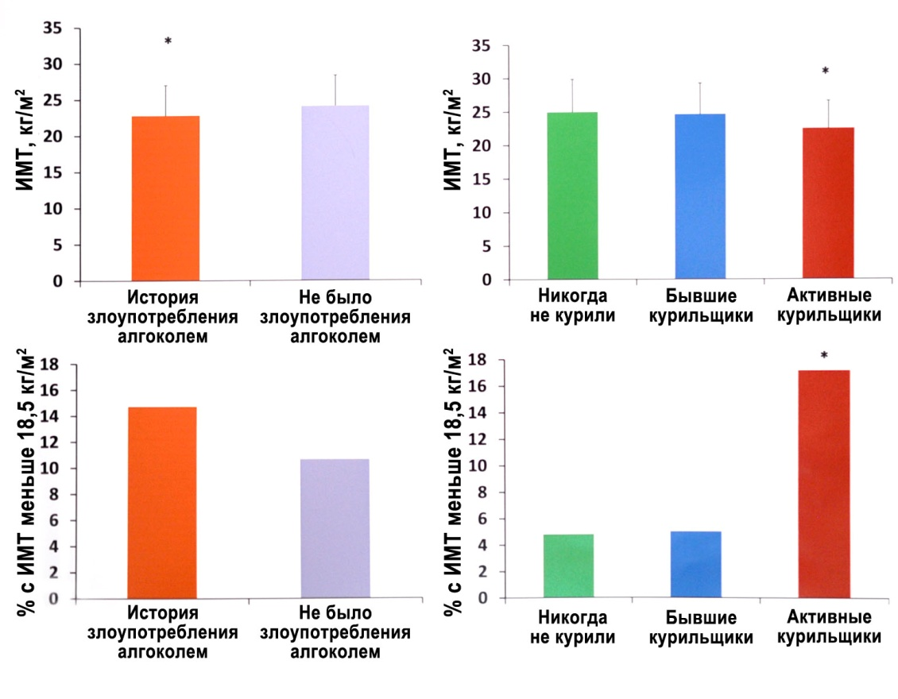
Fig. 1. Nutritive status of patients with CP depending on BMI and status of alcohol consumption and smoking (по E. Tjora et al., 2017 [3]).
* ― index has significant difference (р<0,05) as compared to other groups.
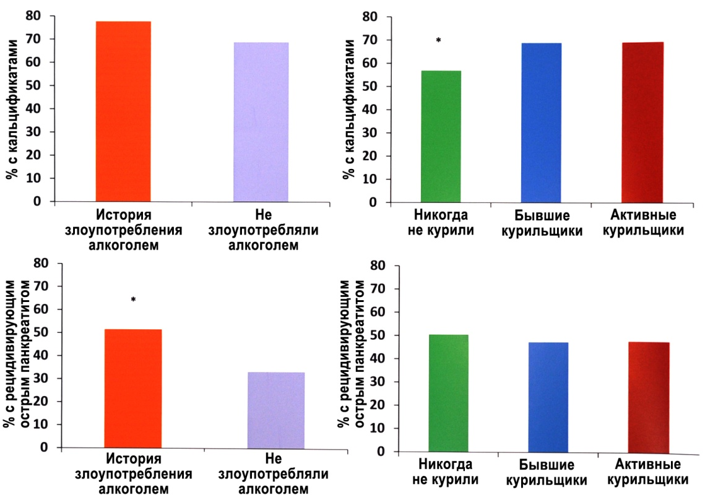
Fig. 2. Rate of pancreas calcification and pancreatic attacks in patients with CP depending on status of alcohol consumption and smoking (по E. Tjora et al., 2017 [3]).
* ― index has significant difference (р<0,05) as compared to other groups.
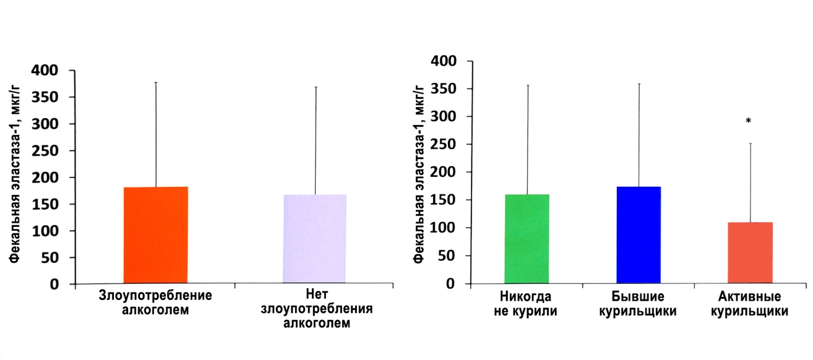
Fig. 3. Results of fecal elastase test in patients with CP depending on status of alcohol consumption and smoking (по E. Tjora et al., 2017 [3]).
* ― index has significant difference (р<0,05) as compared to other groups.
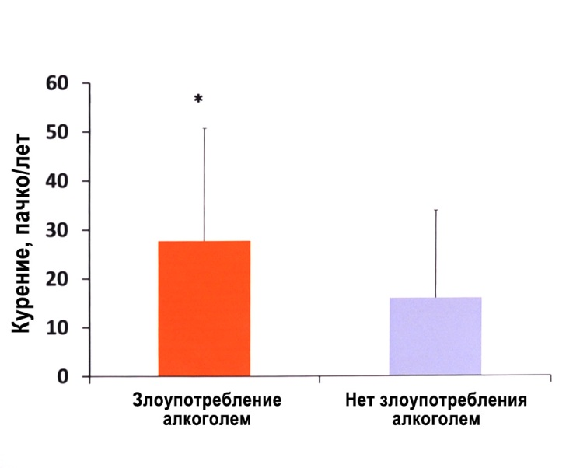
Fig. 4. Index of pack-years in patients with CP depending on status of alcohol consumption (по E. Tjora et al., 2017 [3]).
* ― index has significant difference (р<0,05) as compared to other groups.
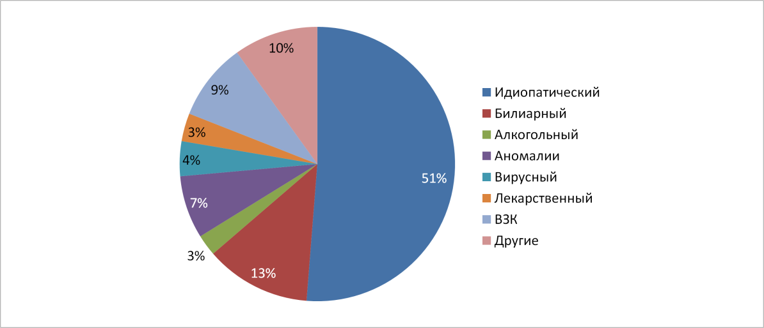
Fig. 5. Reasons of pancreatitis development in children (APPLE research) (by A. Parniczky et al., 2017 [3]).
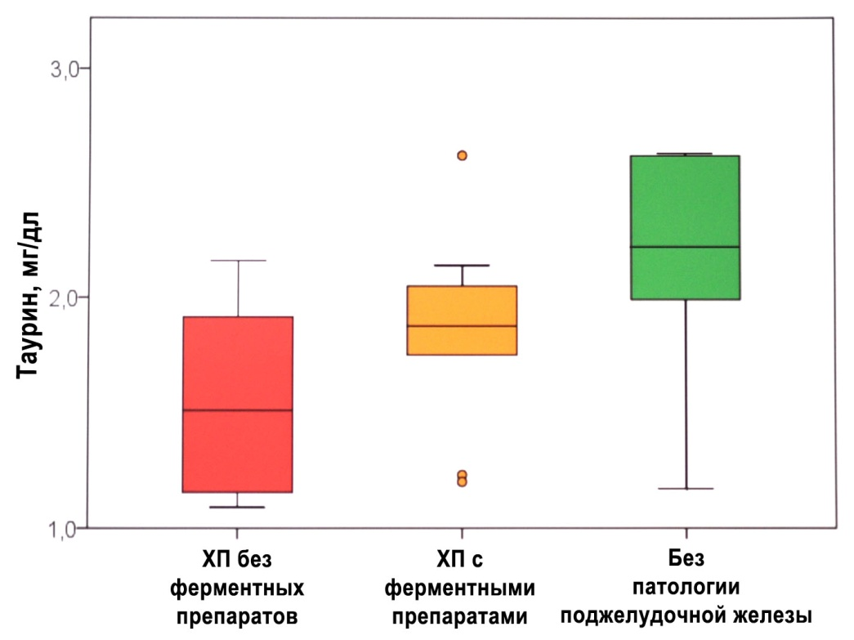
Fig. 6. Taurine blood level in the patients examined (by S. Beer et al., 2017 [3]).
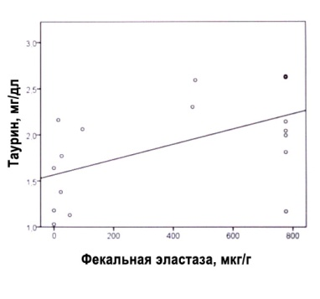
Fig. 7. Correlation between taurine blood level and results of fecal elastase test in patients with CP (by S. Beer et al., 2017 [3]).
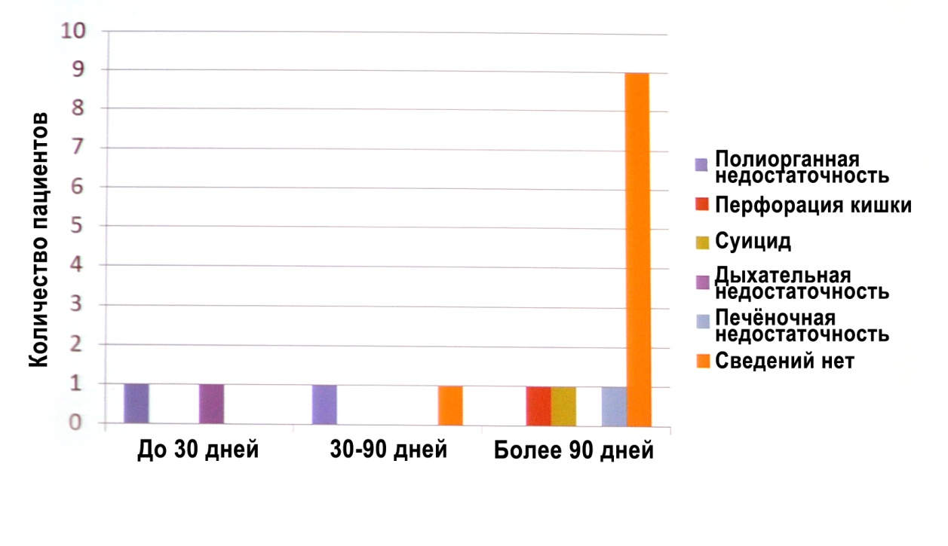
Fig. 8. Causes of mortality of patients with CP in different terms after TPAO (by D. Adams, 2017 [3]).
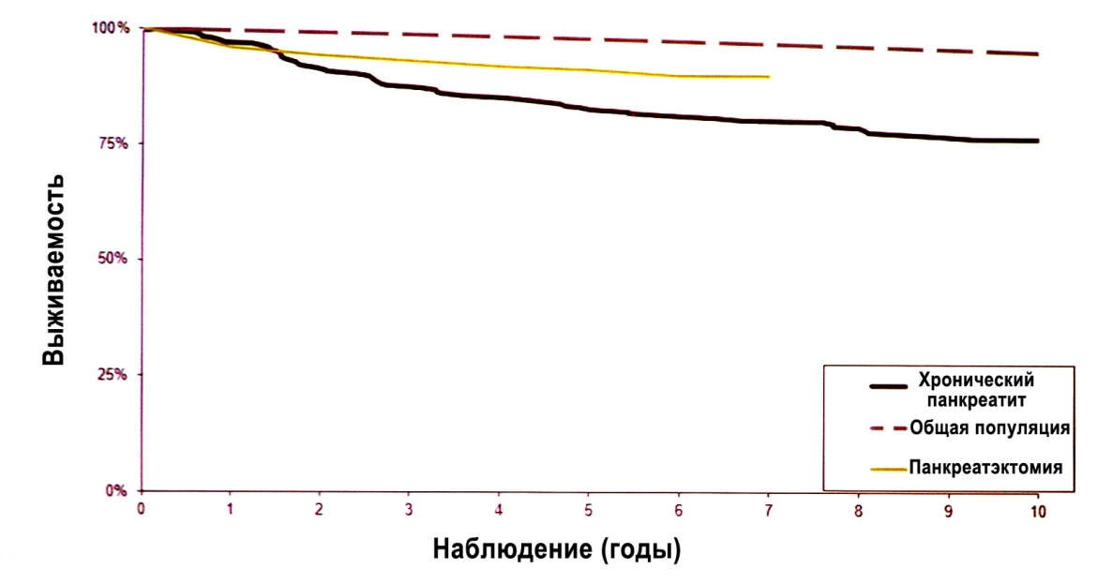
Fig. 9. Comparison of survival rate after TPAO (160 patients) with survival rate upon traditional approach for the treatment of CP in South Carolina, USA (by D. Adams, 2017 [3]).
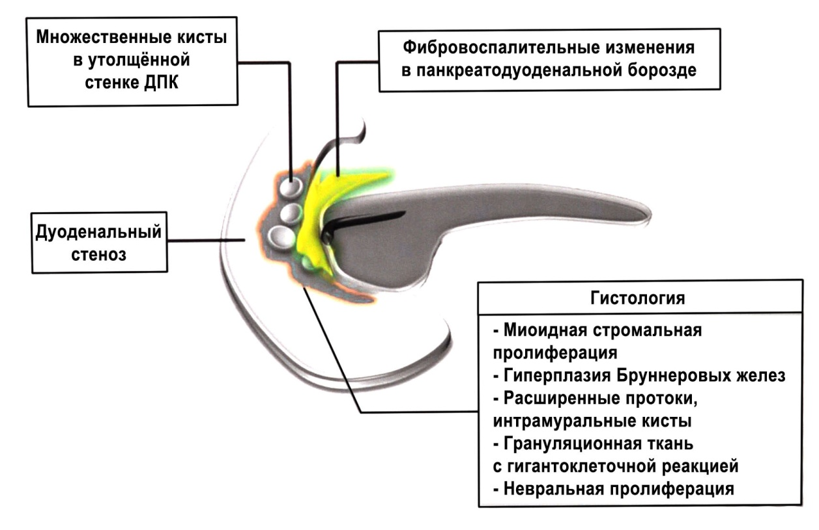
Fig. 10. Changes typical for groove pancreatitis.
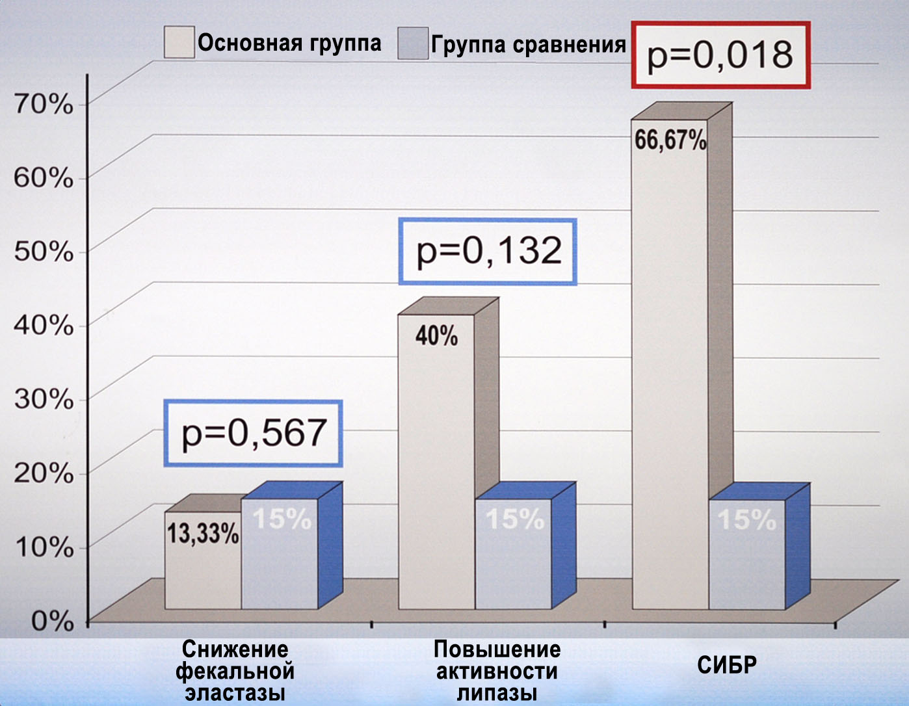
Fig. 11. Rate of decreasing fecal elatase-1 indices, increasing activity of blood serum lipase and BOS in patients with diabetes (by R. Kadaj-Lipka et al., 2017 [3]).
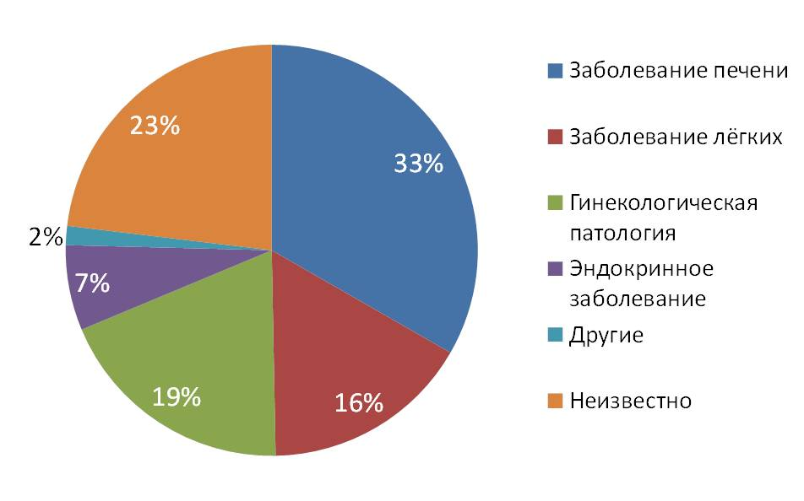
Fig. 12. Reasons of increasing СА 19-9 upon benign non-pancreatic diseases (by Byung Kyu Park et al., 2017 [3]).
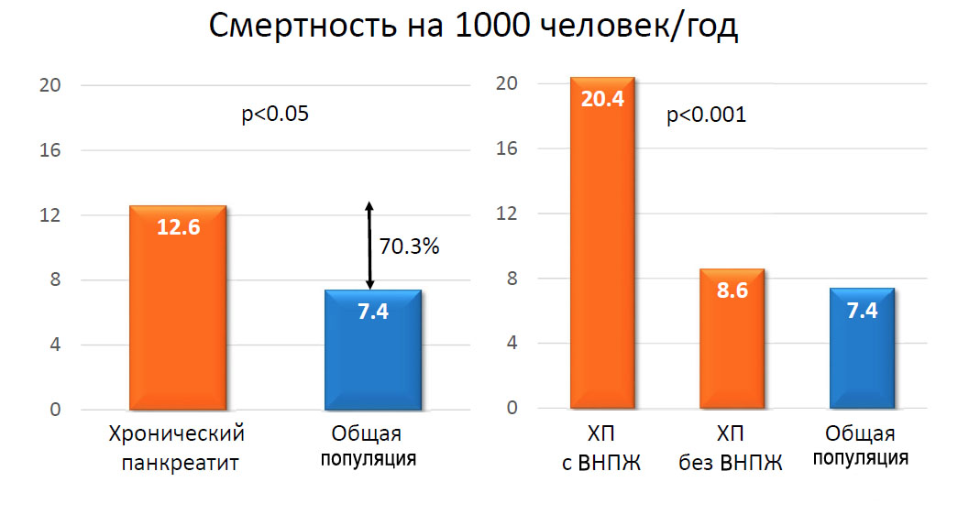

Fig. 13. Mortality in general population, upon Cp and EPI (by D. de la Iglesia-Garsia et al., 2017 [2]).

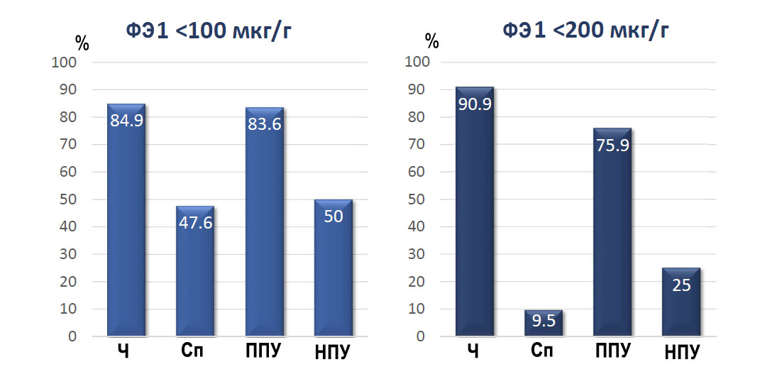
Fig. 14. Informative value of fecal elastase test (quantitative fat detection in feces during 72 hours as a standard) (by S. D. Chowdhury et al., 2016 [5]).
ФЭ — fecal elastase, Ч — sensitivity, Сп — specificity, ППУ — positive predictive level, НПУ — negative predictive level.
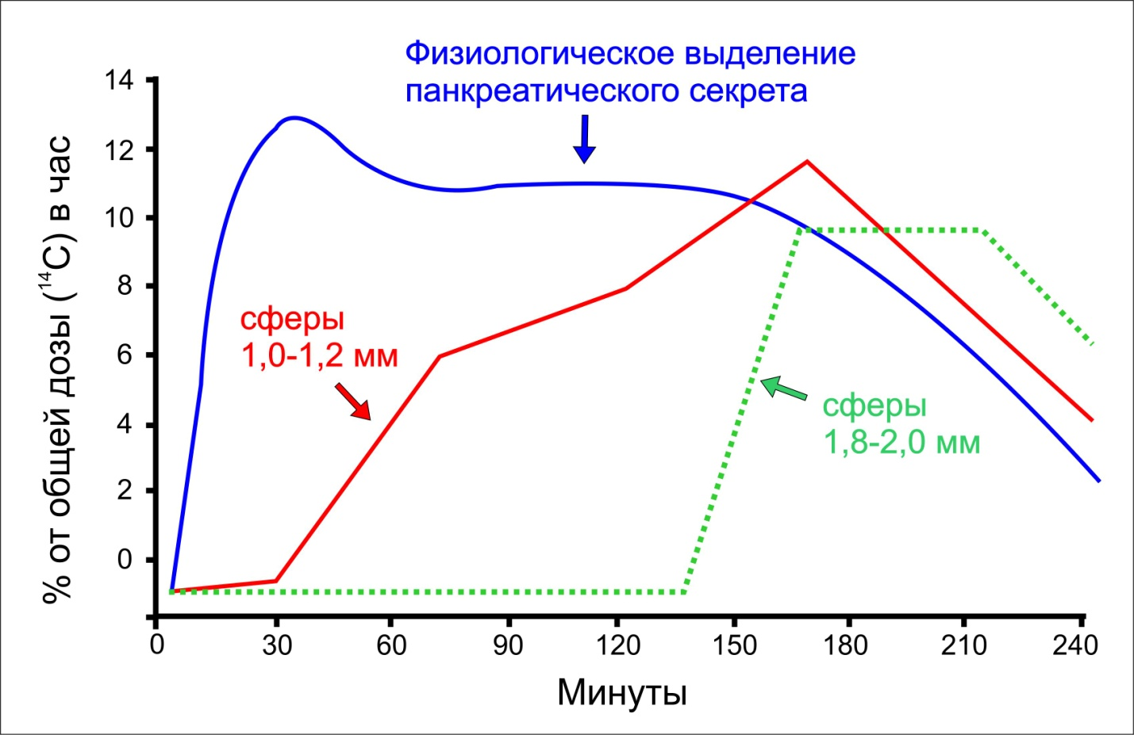

Fig. 15. Evacuation of spheres of enzyme preparations of different size from stomach and their correspondence to physiological dynamics of pancreatic secretion (triglyceride breath test) (by M. Fried et al., 1988 [7] and P. Kuhnelt et al., 1991 [4]).

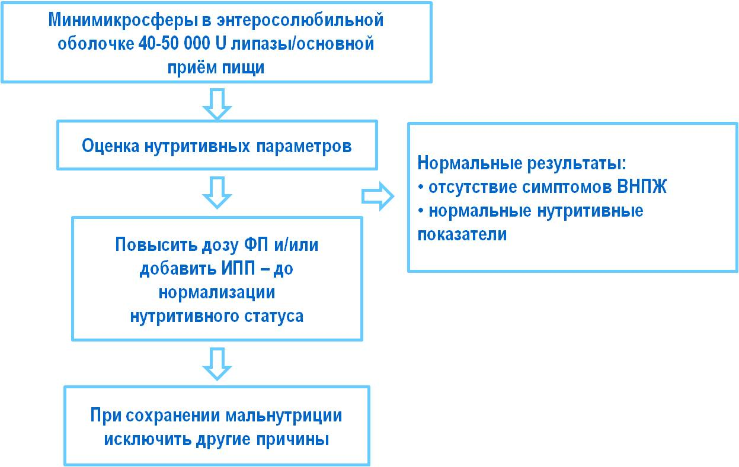

Fig. 16. ERT algorithm (by J.-E. Dominguez-Munoz, 2011 [1] with changes and additions by N. B. Gubergrits).

NEWS OF EUROPEAN PANCREATOLOGY
(by materials of 49th Meeting of European Pancreatic Club)
¹N. B. Gubergrits, ¹N. V. Byelyayeva, ¹G. M. Lukashevich, ¹A. Ye. Klochkov,
¹P. G. Fomenko, ²O. V. Rotar
¹Donetsk National Medical University, Ukraine
²Bukovina State Medical University, Chernivtsi, Ukraine

Key words: European Pancreatic Club, Ukrainian Pancreatic Club, diagnostics and treatment of chronic pancreatitis, pancreatic insufficiency, Creon

Article represents the results of main scientific researches in pancreatology conducted in 2016–2017. There are stated achievements of leading pancreatologists of Europe regarding study of etiology, pathogenesis, diagnostics and treatment of pancreatitis and tumors of the pancreas.

