**Distribution of genotypes of Helicobacter pylori in Uzbekistan**

M. M. Karimov, J. A. Ismailova, G. N. Sobirova, D. A. Dalimova, S. T. Rustamova

Republican Specialized Scientific Practical Medical Center of Therapy and Medical Rehabilitation, Tashkent, Uzbekistan

**Key words:** HP-infection, gastric cancer, genomic DNA, genes Cag A, Vac A, Ice A, Fisher test

Modern medicine, including gastroenterology, is developed all over the world through the adoption of consensus and agreements in various branches of medicine. With respect to diseases associated with Helicobacter pylori (HP), this document is Maastricht where clearly indicated HP diagnostic principles, indications and principles eradication therapy [[1](https://translate.googleusercontent.com/translate_f#_Ref484006143), [4](https://translate.googleusercontent.com/translate_f#_Ref484006147)]. But these reports should not be taken as dogma, because medicine is constantly evolving, new facts and, most importantly, each region has its own characteristics according to the frequency of the spread of HP infection, its pathogenic characteristics and resistance to antibiotics [[1](https://translate.googleusercontent.com/translate_f#_Ref484006154)]. Meanwhile, Uzbekistan, along with other countries in the region, one of the countries with high levels of infection with HP population, reaching in some regions 60-80% and correlated with high rates of stomach cancer [[5](https://translate.googleusercontent.com/translate_f#_Ref484006158)].

Currently, it noted that despite the high HP infection in many countries, not all arise associated with this infection diseases such as gastritis, gastric ulcer and duodenal ulcers, gastric cancer [[3](https://translate.googleusercontent.com/translate_f#_Ref484006162)]. Most likely, the development of these diseases is associated with the presence of genes of virulence in the bacterium. That is, it is necessary to severely separate those genotypes of bacteria that cause the development of stomach diseases and identify non-dangerous and less dangerous genotypes. Complete eradication of HP in a region where the infection is more than 80% is almost impossible, the likelihood of recurrence of infection is too high. Therefore, one of the ways to prevent the development of stomach diseases, and especially stomach cancer, we see in the definition of virulence HP, Living in the stomach of patients.

**The aim of our research** was to determine the virulence of HP in patients with gastrointestinal diseases in Uzbekistan.

**Material and methods of investigation.** 100 samples of a biopsy of patients who received inpatient treatment in the department of gastroenterology of JSC "Republican Specialized Scientific and Practical Medical Center for Therapy and Medical Rehabilitation" were examined. Of these 4 patients were erosive bulbita 16 — ulcerative colitis, 14 — In chronic gastritis, 30 — gastric ulcer and duodenal ulcer (DU) and 36 — with gastric cancer, which were divided into 5 groups according nosologies. From each biopsy specimen, genomic DNA was isolated using Diatom ™ DNA Prep 200 reagent kits (manufactured by OOO Isogen Laboratory). Isolation of DNA was carried out according to a standard protocol for DNA extraction kit reagents Diatom ™ DNA Prep 200 with a modification step to lyse 16 hours at 37 C. The supernatant is subjected directly to DNA genotyping by PCR amplification. PCR analysis was carried out using a set of reagents for PCR amplification of GenePak ™ PCR Core DNA (manufactured by OOO Isogen Laboratory). PCR amplification was performed using a modified protocol. The DNA samples were sampled for the CagA, VacA and IceA genes using the specific oligonucleotide primers shown in Table 1. The PCR amplification products were visualized in a 2% agarose gel for 1.5-2 hours at a voltage of 120 V; Stained with ethidium bromide, visualized in UV light and photographed in the gel documentation system.

Table 1

|  |  |  |  |
| --- | --- | --- | --- |
| Gene | Primer | The primer sequence (5'right-arrow3') | Size (bp) and location |
| Сag A | CAGAF  CAGAR | GATAACAGGCAAGCTTTTGAGG  CTGCAAAAGATTGTTTGGCAGA | 349 (1228-1576) |
| Gene | Primer | The primer sequence (5'right-arrow3') | Size (bp) and location |
| Сag A | CAGAF  CAGAR | GATAACAGGCAAGCTTTTGAGG  CTGCAAAAGATTGTTTGGCAGA | 349 (1228-1576) |

**Results of the research.** We have genotyped 100 biopsy specimens for the virulence genes CagA, VacA, IceA, 57 of them were isolated in the Khorezm region and the Republic of Karakalpakstan, 43 samples from patients from the city of Tashkent and the Tashkent region. A method for direct genotyping of HP from a biopsy material has been developed, and its effectiveness for 100 biopsy specimens is shown.

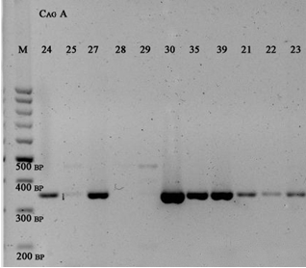

Fig. 1. Virulence gene CagA.

As shown by the results of genotyping (Table 2), in 85 (85%) of 100 samples a CagA gene was detected. Virtually in all samples — 99 (99%) the VacA s gene was verified.

Table 2

Distribution of genotypes of CagA, VacA and IceA H.Pylolri in the total sample

|  |  |  |  |  |
| --- | --- | --- | --- | --- |
| **CagA** | **About Tritz (-)** | **Olozh P (+)** |  |  |
|  | 15 | 85 |  |  |
|  | 15% | 85% |  |  |
| **VacA s** | **S1** | **S2** | **S1,2** | **S-** |
|  | 68 | 14 | 17th | 1 |
|  | 68% | 14% | 17% | 1% |
| **VacA m** | **M1** | **M2** | **M1,2** | **M-** |
|  | 24 | 58 | 14 | 4 |
|  | 24% | 58% | 14% | 4% |
| **IceA** | **A1** | **A2** | **A1,2** | **A-** |
|  | 22 | 9 | 60 | 9 |
|  | 22% | 9% | 60% | 9% |

Each of the 5 surveyed groups reflects the increasing severity of the gastrointestinal tract, the hardest of which is gastric cancer. There are data in the literature that speak of the association of the CagA gene with various gastroduodenal pathologies.

The conducted studies showed that the CagA gene had the following distribution: in the group of patients with erosive bulbite (n = 4) it was found in all the samples, in the group of patients with ulcerative colitis (n = 16) it was determined in 11 samples, in the group of patients with gastritis (n = 14) in 13 samples. In groups suffering from ulcer (stomach and duodenum) (n = 30) and stomach cancer (n = 36), the CagA + genotype was verified in 28 and 29 samples respectively (Figure 2).

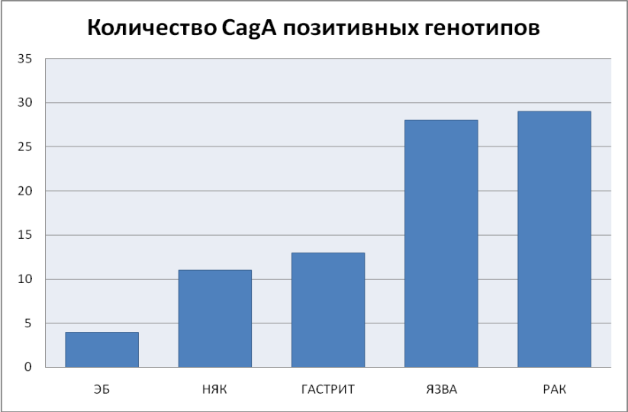

Fig. 2. Distribution of the CagA genotype in the general sample by groups with different diseases.

It was not possible to calculate the reliability of the distribution of so many different samples for each individual pathology, this is due to the fact that in the general sample there is no control group of healthy people, or not infected, but suffering from a certain gastroduodenal disorder. However, the Fisher test allowed to calculate the reliability for the total sample. As a null hypothesis, the probable association of CagA positive genotypes with gastroduodenal pathologies (for five in this work) was considered. The value of p turned out to be quite high — p = 0.206, provided that p≥0.05, we have 85% confidence. The result of the χ2 test is χ2 = 6.67 (degrees of freedom 4), according to the quantile table, we calculate the probability, which is equal to 0.154, which confirms the reliable distribution in this study.

**Conclusions:**

1. Positives first CagA strain found 70% of patients from Gastroduodenal pathology, often The Patients of cities Tashkent.
2. Negative CagA strain Met The Patients Khorezm Field of 2 times more often by Comparison of from Patients of Tashkent.
3. Our study Demonstrated Availability Close Genotypes Microorganism HP The Patients from Erosive bulbita, chronic Gastritis and Ulcerative Disease Stomach and Duodenum intestine.
4. Results It is necessary consider At Appointment Antihelikobakterna therapy.

**References:**

1. Лазебник Л. Б. VIII съезд научного общества гастроэнтерологов России. Стандарты «Диагностика и терапия кислотозависимых заболеваний, в том числе ассоциированных с Helicobacter pylori» / Л. Б. Лазебник, Ю. В. Васильев // Экспериментальная гастроэнтерология. — 2008. — №3. — С. 130–134.
2. Current concepts in the management of Helicobacter pylori infection: the Maastricht III Consensus Report / P. Malfertheiner, F. Megraud, С. O’Morain [et al.] // Gut. — 2007. — Vol. 56, No 6. — P. 772–781.
3. Graham D. Y. New concepts of resistance in the treatment of Helicobacter pylori infections / D. Y. Graham, A. Shiotani // Nat. Clin. Pract. Gastroenterol. Hepatol. — 2008. — Vol. 5. — P. 321–331.
4. Management of Helicobacter pylori infection — the Maastricht IV/ Florence Consensus Report / P. Malfertheiner, F. Megraud, С. O’Morain [et al.] // Gut. — 2012. — Vol. 61, No 5. — P. 772–781.
5. The prevalence of the cagA and vacA genotypes of H. pylori from patients with upper gastrointestinal diseases in Uzbekistan / A. Abdurakhimov, D. Dalimova, S. Turdikulova, R. Mukhamedov // European Journal of Human Genetics. — 2014. / J03.13/

**Distribution of genotypes of Helicobacter pylori in Uzbekistan**

M. M. Karimov, J. A. Ismailova, G. N. Sobirova, D. A. Dalimova, S. T. Rustamova

Republican Specialized Scientific Practical Medical Center of Therapy and Medical Rehabilitation, Tashkent, Uzbekistan

**Key words:** HP-infection, gastric cancer, genomic DNA, genes Cag A, Vac A, Ice A, Fisher test

It is stated now that, in spite of the high level of Helicobacter pylori (HP) infection in many countries, such associated diseases as gastritis, gastric and duodenal ulcer, gastric cancer, do not occur everywhere. Total eradication of HP in the region, where the level of infection is above 80%, is almost not available, as the risk of relapse is too high, so one of the ways to prevent the development of gastric diseases, especially gastric cancer, is the determining HP virulence in stomach of patients. The aim is to study HP virulence in patients with gastrointestinal diseases in Uzbekistan.