Comprehensive diagnostics of biliary hypertension
in patients with chronic pancreatitis
V. I. Pylypchuk, S. M. Hedzyk, O. L. Dyriv
Ivano-Frankivsk National Medical University, Ukraine
Key words: chronic pancreatitis, biliary hypertension, biliary pressure
Chronic pancreatitis (CP) is a progressing illness that is accompanied by recurrent acute exacerbation of chronic inflammation, development of sclerosis and fibrosis, which lead to replacement of secretory tissue of the gland by the connective tissue and depression of the external secretory function of the pancreas [4].
Frequent complications of CP include stenosis of the common bile duct (CBD) and duodenal stenosis caused by pancreatic fibrosis and inflammation in the head of the pancreas [19]. According to V. Ratchyk et al. [10], in cases of CP, duodenum obstruction complicates the course of the disease in 16.3% of patients, prepapillary stenosis of the CBD occurs in every third patient, and compression of the mesenteric portal system with ascites – in 11.6% of patients. A significant role in the development of obstructive jaundice in cases of CP is played by compression of the distal part of CBD by fibrotically changed pancreatic lingula [8]. Dobrov et al. [5] found obstruction of CBD in 56.3% of patients with CP, jaundice – in 22.2%, and jaundice combined with cholangitis – in 6% of patients. According to the resolution of the Plenary Session of the Board of the Hepato-Pancreato-Biliary Association of Russia and the CIS [11], “…biliary hypertension occurs in 30-50% of patients with CP. It is often asymptomatic, accompanied by temporary increase of bilirubin and alkaline phosphatase level. Before performing a surgery on such patients, one should have the information about the length of the stricture of the distal part of the common bile duct. For this purpose, it is necessary to perform endoscopic retrograde cholangiopancreatography (ERCP) (if necessary, direct enhancement of bile ducts should be accompanied by biliary decompression) or magnetic resonance cholangiography.
At present, there is no clear consensus concerning the optimum diagnostic techniques and their use in cases of CP [14]. The algorithm for diagnosing CP with biliary hypertension (BH) consists of a number of tests, both noninvasive and less invasive ones, including physical examination, laboratory data, assessment of the functioning and structure of the pancreas and liver, genetic and immunological testing. The instrumental diagnostic techniques used include ultrasonography (USG), ERCP, computed tomography (CT), endoscopic USG (endoUSG), magnetic-resonance tomography (MRT), and magnetic-resonance retrograde cholangiopancreatography (MRCP).
Sonography sensitivity in verification of CP form at later stages reaches, according to different authors, 80.6% to 87.6%, and its specificity – 81.1% [1, 3]. The accuracy of USG in identification of the level and reasons of bile duct obstruction ranges from 29% to 95% [2]. Duct dilatation is an indirect indicator of its obstruction. Sensitivity of USG reaches 99%, and its accuracy is quite high (78-98%) when it comes to finding duct dilatations. CBD diameter that exceeds 7 mm indicates to its obstruction. However, regular size of bile ducts does not exclude the possibility of their obstruction, for in a number of cases obstruction may be not accompanied by dilatation of bile ducts [2].
EndoUSG is a high-sensitivity CP diagnostics technique [14]. This method is deprived of the drawbacks of transabdominal USG (it does not depend on the body build or flatulence), allows for examination of all sections of the pancreas, pancreatic duct, CBD, and their pathological changes due to location of the ultrasonic sensor directly near the organ – in the stomach lumen or duodenal lumen [21]. EndoUSG allows for diagnosing parenchymal changes in the pancreas even before visible changes of the duct system take place [13, 17, 20]. However, other authors believe that the role of this method in early CP diagnostics is controversial [18].
Sensitivity of ERCP in CP diagnostics is about 75%, and its specificity reaches almost 100% [21]. The drawbacks of ERCP include invasiveness, high cost, possible intraoperative complications, dependence on doctor's expertise (successful cannulation is achieved only in 70-91% of cases) [21]. Mortality rate after ERCP is 0.2%, and complications occur in 1-7% of cases [12, 15, 21].
CT is the most widespread method of diagnosing inflammatory and neoplastic diseases of the pancreas. CT is an informative method in examining duct system of the pancreas; it detects duct defects, their obstruction, dilatation of the main pancreatic duct and CBD [12, 21]. CT sensitivity in CP diagnostics is 90.5%-96.5%, its specificity is 92.4% depending on the seriousness of the disease [1, 3]. CT offers a broader range of portal hypertension characteristics, and in diagnosing BH associated with CP it is more precise than USG, and its results coincide with intraoperative examinations [7]. The accuracy of CT in detection of bile duct obstruction reaches 88-92% [2].
MRCP is of great diagnostic value. The sensitivity of MRCP with secretin stimulation is 89%, and for exclusion of CP diagnosis – 98% [16, 21]. MRCP provides high accuracy in assessment of the biliary tree architecture, confirms or rules out the presence of stones and duct strictures, determines connections of pancreatic cysts with Wirsung’s duct. Combination of MRT and MRCP in patients with obstructed CP and tubular stenosis of CBD increases the value of diagnostics (sensitivity – 96.3%, specificity – 98%) [1, 3, 21]. The advantages of MRCP include noninvasiveness, non-use of contrast media, a holistic and high-contrast image of the biliary tree and pancreatic ducts, physiological assessment of the condition of bile passages and pancreatic ducts, absence of radiation exposure, and insignificant influence on the operator [6, 9]. Sensitivity of the method in terms of detecting dilatation and strictures of bile ducts reaches 97-100%, and its specificity – 74 % [2].
Objective of the paper: To determine the role and place of different techniques in diagnosing BH that accompanies CP, and in selection of surgical tactics.
Materials and methods of research. In 2009-2015, 127 patients with complicated forms of chronic pancreatitis have underwent surgical treatment at the department of general surgery of the Ivano-Frankivsk Regional Clinical Hospital. Chronic pancreatitis was accompanied by biliary hypertension in 39 (30.7%) patients. In 14 (11.1%) patients, biliary hypertension was combined with chronic duodenal obstruction (CDO), and in four (3.1%) patients a combination of BH+CDO and local venous hypertension (VH) of the vessels in pancreatobiliary area was found. The analyzed group included 36 (92.3%) men and three (7.7%) women aged 21 to 60.
To diagnose BH, the following approaches were used: laboratory tests (level of general and direct bilirubin and alkaline phosphatase), USG, ERCP, CT, MRCP, intraoperative measurement of the diameter of bile ducts (IOMDBD), and intraoperative measurement of biliary pressure (IOMBP).
To assess and compare the capabilities of diagnostic techniques we used such generally accepted criteria as specificity and sensitivity that allow for evaluation of diagnostic effectiveness of the method.
Results and their discussion.
In the course of laboratory testing of patients with CP accompanied by BH, hyperbilirubinemia connected with mechanical factor was found only in 26 (66.6%) patients. Diagnostic value of alkaline phosphatase level as a marker of cholestatic conditions was even lower in our research. Hyperphosphatasemia was found only in 18 (46.1%) patients.
USG was applied to all patients with BH. USG allowed for detection of dilatation of bile passages, determination of the degree of their dilatation, and statement of the existence of a mechanical obstacle both in patients with jaundice and without it. However, USG does not always enable to determine the reason of obstructive jaundice. Dilatation of the suprapancreatic part of CBD by more than 0.7 cm was considered to be a specific ultrasonic characteristic of BH accompanying CP.
Enlarged and hyperdense pancreas head (from 3.5 cm to 5.3 cm) was detected by USG in all 39 patients with CP accompanied by CH. However, CBD dilatation (from 0.7 cm to 1.7 cm) was diagnosed only in 25 (64.1%) patients. In four (10.2%) patients, CBD dilatation was accompanied by intrapancreatic cysts of the pancreas head, and in another 2 (5.1%) patients – by parapancreatic cysts in the areas of pancreas head. One patient had an intrapancreatic cyst, but CBD was not dilated on USG image. A stent that was installed in CBD lumina to manage obstructive jaundice was verified on USG image in 4 (10.2%) patients. IOMDBD detected bile duct dilatation (0.7 cm and more) in 29 (74.3%) patients. Discrepancy between the dimensions of bile ducts on USG image and at direct measurement occurred in four (19.2%) patients.
CT was performed on 27 (69.2%) patients with BH. Pathological changes of pancreas in cases of CP with BH are shown on CT image by changes in organ configuration, fuzziness of its contours, enlargement of pancreas head, dilatation of bile ducts, and cysts in the pancreas. Enlargement and hyperdensity of pancreas head was found on CT images of all patients. Cysts in pancreas head were diagnosed in three patients. Suprapancreatic CBD dilatation occurred in 22 (81.2%) cases.
ERCP was done using duodenoscopes Tjf-E and Tjf-V70 Olympus under control of X-ray apparatus with Simens BV 300 image converter. This method was used in 11 (28.2%) patients. In four (10.2%) patients, ERCP was impossible because of an express deformation of the duodenum, diverticulum or stenosis of major duodenal papilla. In the course of research, we paid attention to bile effusion through duodenal papilla, for it allowed us to detect abnormalities of bile outflow through biliary tract. Normally, the bile from the major duodenal papilla discharges portionwise, with a certain interval, it is translucent and moderately viscous. In case of pathological conditions, particularly cholangitis, the bile that was secreted by the major duodenal papilla into the duodenum lumen was cloudy and with pus impurities. If there are mechanical obstacles for bile outflow, it either does not get into duodenum lumen at all, or gets there in big portions with impurities. To evaluate the cholangiogram we used the following criteria: diameter of CBD and hepatic duct; detection of dilated segmental hepatic ducts; stenosis of terminal CBD segment, its length; reflux of contrast substance into the pancreatic duct; the time necessary to remove contrast substance. Pathognomonic signs of BH accompanying CP during ERCP included deformation and stenosis of the major duodenal papilla, tubular stenosis of intrapancreatic CBD segment and its suprastenotic dilation, lack of free passage of contrast substance into duodenum at the beginning of the examination, delay in contrast substance removal (more than 45 minutes). Stenosis of terminal CBD segment was characterized by clear and even contours and gradual (funnel-shaped) diminution of lumen, which constitute the main features distinguishing it from cancer of pancreas head.
Manifest tubular stenosis was detected in the course of ERCP in 10 (90.9%) patients. In four patients, these examinations ended up by endobiliary stenting of the CBD. In addition, choledocholithiasis was detected in one patient, so he underwent papillosphincterotomy and concrement extraction.
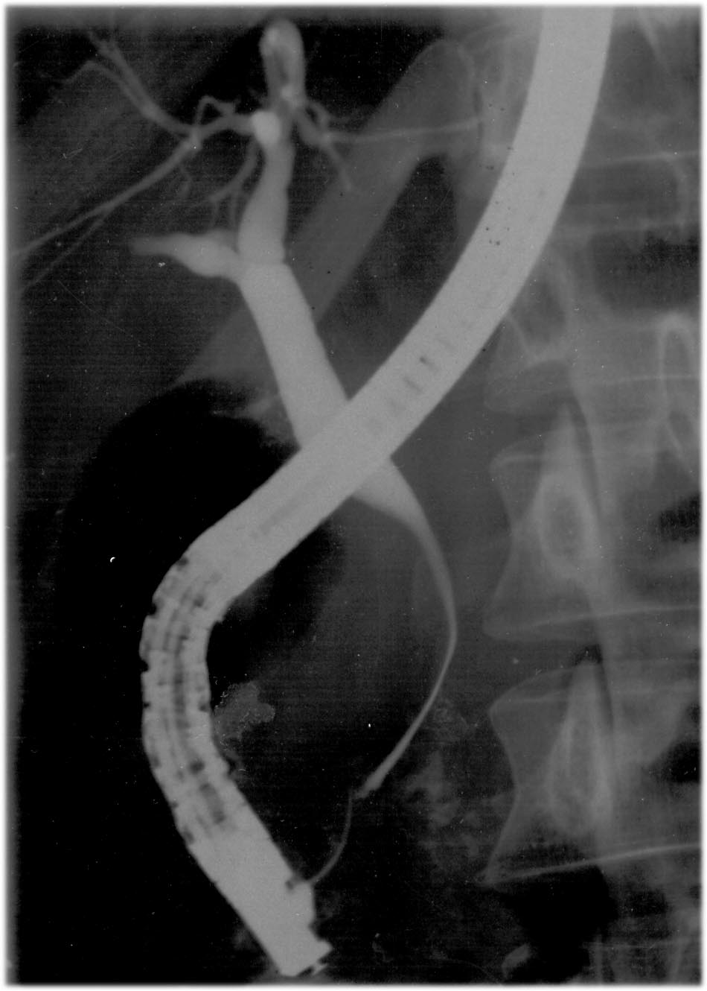
Fig. 1. ERCP. Tubular stenosis and suprastenotic dilation of CBD.
Lately, we have introduced MRCP for examination of the condition of the pancreas and bile ducts into our clinical practice. Thereat, we evaluated the size of pancreas, diameter of bile ducts, their patency and anatomy variants, and pathological processes in the pancreas and CBD. Examination was done using the magnetic resonance tomograph «Simens Magnetom Avanto» with magnetic field strength of 1.5 T. The patients underwent the examination in fasting state. Special programs were applied. MRCP was applied to four patients with CP accompanied by BH. Manifest tubular stenosis of intrapancreatic CBD segment was detected in all four patients. On MRCP, CBD obstruction had cone-like shape. Visualization of the altered part could be traced all along the pancreas head. Suprastenotic dilation of CBD was found in all cases. MRCP detected dilatation of bile ducts in one patient, in whom dilatation was not diagnosed using other methods. Unlike ERCP, MRCP allows for visualization of bile ducts above and below the obstruction level, as well as offers a real picture of bile duct condition in comparison of ERCP, where injection of contrast substance artificially dilates the ducts further. In all cases, MRCP enabled us to accurately determine the level and length of strictures and their cause, which had important practical implications for the selection of surgical approach.
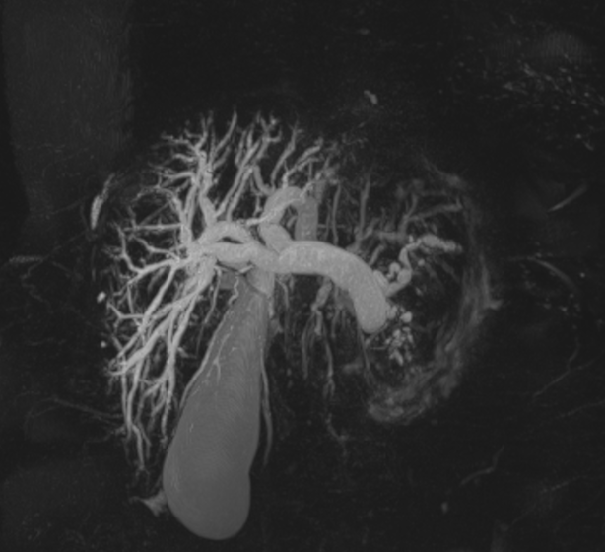
Fig. 2. MRCP. Tubular stenosis and suprastenotic dilation of CBD.
To evaluate the appropriateness of resection duodenum-preserving operations on pancreas head in cases of CP (Frey’s procedure, Beger’s procedure and its Berne modification) in regard to relieving bile ducts, detection of nonmanifest BH and its intraoperative correction, the method of biliary pressure monitoring in the course of the operation was used in 7 patients. CBD pressure was measured and registered throughout the whole period of surgical intervention on pancreas head. Residual pressure in CBD is normally 50-150 mm w.g. The pressure exceeding 160 mm w.g. indicated to BH.
At the beginning of the operation, residual pressure in CBD exceeded normal ranges (from 260 to 320 mm w.g.) in all 7 patients. After the fibrously-changed tissues of pancreas head were removed, BH persisted in 6 patients. In them, Frey’s procedure was supplemented by application of Roux-en-Y anastomosis. Intervention on bile ducts was not performed in one patient after BH indicators dropped to normal ranges.
Diagnostic value of instrumental methods of detecting BH accompanying CP is presented on the diagram.

Fig. 3. Sensitivity of instrumental methods in diagnostics of BH accompanying CP.
The research we conducted allowed us to generalize diagnostic criteria of BH when using different methods of patient examination for signs of CP.
Table 1
Diagnostic criteria of biliary hypertension accompanying chronic pancreatitis
Diagnostic technique | Diagnostic criteria
Complaints | jaundice
Anamnesis | jaundice, surgery on bile ducts
Laboratory data | conjugated hyperbilirubinemia, increase of the level of alkaline phosphatase
USG | dilation of bile ducts, intrapancreatic cyst, parapancreatic cysts
CT | dilation of bile ducts, intrapancreatic cyst, parapancreatic cysts
ERCP | tubular stenosis of bile ducts, its length, suprastenotic dilation, duration of contrast passage
MRCP | tubular stenosis of the choledoch, its length, suprastenotic dilation
IOMDBD | choledoch dilatation over 7 mm
IOMBP | biliary pressure exceeding 150 mm w.g.
Based on the conducted research we elaborated a diagnostic algorithm for detection of BH accompanying CP.
CP
ERCP
MRCP
Laboratory data
д
USG
CT
Complaints
I.
Anamnesis

II.

SURGERY
III.
IOMDBD + IOMBP

Surgery on pancreas without a biliodigestive anastomosis

Surgery on pancreas + biliodigestive anastomosis
IV.

Fig. 4. Diagnostic algorithm for detection of BH accompanying CP.
Conclusions:
- Comprehensive application of laboratory and instrumental examination techniques (including intraoperative ones) allows for detection of nonmanifest biliary hypertension accompanying chronic pancreatitis and selection of an appropriate surgical approach.
- Most sensitive methods of diagnosing biliary hypertension accompanying chronic pancreatitis are ERCP, MRCP and intraoperative measurement of biliary pressure.

References
- Войновский А. Е. Дифференцированная хирургическая тактика при хроническом панкреатите / А. Е. Войновский. — Автореф. дис. … доктора мед. наук. — Москва, 2008. — 43 с.
- Гарматина О. Ю. Современные методы неинвазивной визуализации желчевыводящих путей / О. Ю. Гарматина // Клінічна та експериментальна патологія. — 2014. — Т. 13, № 2. — С. 199–204.
- Проблема хронического панкреатита с позиций терапевта и хирурга / В. Б. Гриневич, Н. А. Майстренко, А. С. Прядко [та ін.] // Медицинский академический журнал. — 2012. — Т. 12, № 2.— С. 35–55.
- Губергриц Н. Б. Панкреатическая боль. Как помочь больному / Н. Б. Губергриц. — М. : Медпрактика, 2005. — 175 с.
- Желчная гипертензия у больных хроническим панкреатитом / С. Д. Добров, А. С. Полякевич, Е. М. Благитко, Г. Н. Толстых //Анналы хирургической гепатологии. — 2012. — № 4. — С. 35.
- Роль МРТ в выборе тактики ведения пациентов с механической желтухой / М. Е. Зеленцов, Я. Л. Манакова, Г. Н. Толстых, А. П. Дергилев // Бюллетень сибирской медицины. —2012. — № 5. — С. 124–125.
- Клименко А. В. Сравнительный анализ диагностических возможностей ультразвукового исследования и компьютерной томографии у больных хроническим панкреатитом, которым требуется хирургическое лечение / А. В. Клименко //Актуальні питання фармацевтичної і медичної науки та практики. — 2013. — № 1. — С. 103–105.
- Хирургическая анатомия поджелудочной железы / В. М. Копчак, А. Ю. Усенко, К. В. Копчак, А. И. Зелинский. — К. : Издательский дом «Аскания», 2011. — 141 с.
- Сравнение МРХПГ и ЭРХПГ в диагностике механической желтухи / Ж. Н. Кыжыров, Ю. И. Малахова, В. Е. Саютин, А. М. Кужукеев // Вестник КАЗНМУ. — 2015. — № 1. — С. 241–247.
- Ратчик В. М. Хирургическая коррекция осложненных форм хронического панкреатита / В. М. Ратчик, Ю. А. Гайдар // Сучасна хірургія та колопроктологія. — 2012. — № 4. — С. 53–57.
- Резолюция Пленума Правления Ассоциации хирургов-гепатологов России и стран СНГ (Ижевск 19–20 апреля 2012 г.) «Хронический панкреатит» // Анналы хирургической гепатологии. — 2012. — Т. 17, № 3. — С. 118–119.
- Advanced imaging of chronic pancreatitis / N. E. Chouieri, N. C. Balci, S. Alkaade, F. R. Burton // Curr. Gastroenterol. Rep. — 2010. — Vol. 12, No 2. — P. 114–120.
- Hayes J. M. Pancreatic stone and treatment using ERCP and ESWL procedures : a case study and review / J. M. Hayes, S. L. Ding // N. Zealand Med. J. — 2012. — Vol. 125, No 1361. — Р. 89–97.
- The diagnosis of chronic pancreatitis : a systematic review / M. Johnstone, R. Jackson, T. Hanna [et al.] // Pancreatoogy. — 2014. — Vol. 14, No S3. — P. S41.
- Lerch M. M. Advances in the etiology of chronic pancreatitis / M. M. Lerch, J. Mayerle, A. A. Aghdassi // Dig. Dis. — 2010. — Vol. 28, 2. — Р. 324–329.
- Ma Z. H. Magnetic resonance cholangiopancreatography for the detection of pancreatic duct stones in patients with chronic pancreatitis / Z. H. Ma, Q. Y. Ma, H. C. Sha // World J. Gastroenterol. — 2009. — Vol. 15, No 20. — Р. 2543–2546.
- Morris-Stiff G. Endoscopic ultrasound reliably identifies chronic pancreatitis when other imaging modalities have been non-diagnostic / G. Morris-Stiff, P. Webster, B. Frost // JOP. — 2009. — Vol. 10, No 3. — Р. 280–283.
- Sahai A. V. How to diagnose and follow early stage disease : the role of endoscopic ultrasound (EUS) / A. V. Sahai // In : Acute and chronic pancreatitis: new concepts and evidence-based approaches / Eds. : P. A. Testoni, A. Mariani, P. G. Arcidiacono. — Turin : Edizioni Minerva Medica, 2013. — P. 91–96.
- di Sebastiano P. Pathophysiology of chronic damage / P. di Sebastiano, F. F. di Mola // In : Acute and chronic pancreatitis: new concepts and evidence-based approaches / Eds. : P. A. Testoni, A. Mariani, P. G. Arcidiacono. — Turin : Edizioni Minerva Medica, 2013. — P. 63–69.
- Stevens T. Update on the role of endoscopic ultrasound in chronic pancreatitis / T. Stevens // Curr. Gastroenterol. Rep. — 2011. — Vol. 13, No 2. — Р. 117–122.
- Imaging in chronic disease: what is the best / L. Zantedeschi, G. Avesani, R. Negrelli, R. Manferdi // In : Acute and chronic pancreatitis: new concepts and evidence-based approaches / Eds. : P. A. Testoni, A. Mariani, P. G. Arcidiacono. — Turin : Edizioni Minerva Medica, 2013. — P. 83–90.

Comprehensive diagnostics of biliary hypertension
in patients with chronic pancreatitis
V. I. Pylypchuk, S. M. Hedzyk, O. L. Dyriv
Ivano-Frankivsk National Medical University, Ukraine
Key words: chronic pancreatitis, biliary hypertension, biliary pressure
The article analyzes the sensitivity of different instrumental techniques of diagnosing biliary hypertension accompanying chronic pancreatitis. The most informative methods are ERCP, MRCP and intraoperative measurement of biliary pressure. For the first time, diagnostic criteria of each technique regarding biliary hypertension have been summarized, and a diagnostic algorithm for detection of biliary hypertension accompying chronic pancreatitis has been elaborated. Comprehensive application of laboratory and instrumental examination techniques allows for detection of nonmanifest biliary hypertension accompanying chronic pancreatitis and selection of an appropriate surgical approach.

