“Fatal chain”: from acute pancreatitis to pancreatic cancer

N. B. Gubergrits, G. M. Lukashevich, P. G. Fomenko, N. V. Byelyayeva

Donetsk National Medical University n. a. M. Gorky

Key words: pancreatic diseases, stages of progression, risk factors, pathogenesis, treatment

For the doctor, the best thing is to take care of the ability to foresee... The task of treatment will be best accomplished if he foresees the future out of real suffering.

Gippokrat [3]

What is a "fatal chain"? Recall that by the term Academician E. M. Tareev meant "cirrhosis, and the whole complex of its development: acute hepatitis, chronic hepatitis, cirrhosis and liver cancer," [4].

But is this term applicable in pancreatology? At the present stage of the development of pancreatology, we can confidently state: "Yes, in the pancreatology the" fatal chain "also unfolds: from acute pancreatitis (AP) to its relapses and chronic pancreatitis (CP), progression of CP with development of pancreatic cirrhosis and adenocarcinoma ". It should be noted that cirrhosis of the prostate is a pathomorphological term and is not a nosological unit. However, is not that a bold statement about the "fatal chain" in pancreatology? If it is true, is it possible and how to stop this fateful course of events? Let's not be unfounded and justify the title of the article.

Let's start with acute pancreatitis. The annual incidence of AP ranged from 13 to 45 cases per 100 000 [84]. Patients treated in US hospitals in 2009, AP was the most frequent primary diagnosis among diseases of the gastrointestinal tract and liver [15]. The number of statements to the OD as the primary diagnosis was 30% higher than in 2000. The AP was the second most common cause of hospitalization, making the greatest contribution to the overall costs and being the fifth most common cause of death in the hospital [49].

The main risk factors for OI development are cholelithiasis (CHD) and alcohol abuse. However, within 20-30 years in patients with asymptomatic cholelithiasis biliary pancreatitis risk of not higher than 2% of [53], and for the alcoholic pancreatitis, this figure does not exceed 2-3% when expressed abuse [50]. Probably, other factors, possibly genetic ones, play a certain role. Medications are additional reason AP [31].

Smoking can increase the risk of AP [21, 71, 83]. There is no relationship between smoking and biliary pancreatitis, but the risk of non-biliary AP is more than 2 times higher (relative risk of 2.29, 95% CI 1.60-3.22) in those who currently smoke from 20 or more pack- Years in comparison with non-smokers.It is noteworthy that in malicious smokers with consumption of 400 or more grams of alcohol per month, the risk of AP increases more than 4 times (4-12, 1.98-8.60). The duration of smoking increases the risk more than the intensity. It is important to quit smoking, but only after 2 decades, the risk of AP will be the same as in non-smokers [21]. Based on these findings, [21] it could be argued that smoking is an independent risk factor for AP, but other factors and missing alcohol consumption data are limited studies [49].

However, in a later retrospective study, S. Munigala et al. (2015), which included 484,424 smokers and non-smokers, received more clear results. Patients were observed before the development of AP or before the end of the study (those who did not develop the AP). The study, which lasted from 2000 to November 2007 [41], has shown that smoking is an independent risk factor for AP and AP increases the risk of alcohol-related. Independently and in combination with alcohol, smoking increases the risk of AP, reduces the average age of onset of AP and increases the risk of relapse.

O. Sadr-Azodi et al. (2012) also showed that smoking is an independent risk factor for AP and HP, and smoking cessation reduces the risk of these diseases (Figure 1).

The four large retrospective studies have shown that type 2 diabetes increases the risk of AP in 1,86-2,89 times [44, 45, 67, 77]. Compared with nondiabetic patients, the risk was particularly high in young patients with diabetes (incidence rate 5.26 in persons younger than 45 years (95% CI 4.31-6.42), 2.44 in persons over 45 years of age (2.23- 2.66)) [44]. Possible to reduce the risk of using antidiabetic drugs [77].

It discusses the ability of therapy based on incretin cause AP [23, 58].

It is not known whether pancreas divisum is important in the development of AP. In the group of patients with AP and CP, the prevalence of pancreas divisum was similar among patients with and without idiopathic (7.5%) and alcoholic (7.0%) pancreatitis. This indicates that pancreas divisum by itself does not cause the disease [62]. Nevertheless, associations were observed between pancreas divisum and cystic fibrosis regulator (CFTR) mutations in 47%, the serine protease inhibitor Casal type 1 (SPINK 1) in 16%, indicating a cumulative effect. This conclusion is not definite, the association does not necessarily mean a causal relationship. Patients with pancreas divisum and mutations CFTRs should be directed to genetic counseling; and if necessary — to endoscopic or surgical treatment [28].

AP is the most common complication after endoscopic retrograde cholangiopancreatography (ERCP) (frequency of 3-5% in all patients, that this manipulation is conducted) [9].

Enteroscopy with one or two balloons can lead to hyperamylasemia and AP, probably because of repeated stretching of the small intestine or mesenteric ligaments. Hyperamylasemia rate is 17% for double balloon enteroscopy and with 16% — with a single tank, but significantly lower frequency AP and is not more than 1% [22, 54]. Large prospective studies are needed to establish the true frequency of the AP and to identify potentially avoidable risk factors after enteroscopy with one or two cylinders [49].

So, AP is the first link in the "fatal chain," and we must try to influence the aforementioned etiological factors in order to reduce the risk of its development. What is possible in this respect? To prevent pancreatitis after ERCP recommended preventive stenting sphincterotomy and [9]. Conclusions two meta-analyzes [18, 70] indicate that prophylactic pancreatic stent decreases the risk of pancreatitis after ERCP. Indomethacin inhibits the production of prostaglandins in vivo and is a potent inhibitor of serum phospholipase A ₂ at AP. More than three decades ago, it was shown that indomethacin administered before or soon after the episode AP caused a marked reduction in mortality rate in rats [46]. Later, it was demonstrated that the use of suppositories indomethacin decreased the frequency and intensity of pain attacks in patients with AP [47]. This beneficial effect of indomethacin was then forgotten to give recommendations rectal administration of 100 mg of diclofenac or indomethacin immediately before or after ERCP [9] on the basis of the findings of the three meta-analyzes [10, 26, 85]. In contrast, the prophylactic use of nitroglycerin, ceftazidime, somatostatin, gabexate, ulinastatina, glucocorticoids, antioxidants, heparin, interleukin 10, pentoxifylline, and semapimoda acetylhydrolase recombinant PAF is not suitable [9]. The results of meta-analyzes of a series of shows that rectal NSAIDs are superior pancreatic duct stents in preventing pancreatitis after ERCP [49, 74].

ERCP is just one of the many causes of AP. But the prevention of other etiological variants of AP is now reduced to "blurred" claims about the need to combat alcohol and smoking abuse.

We proceed to relapses of AP, which in many cases are essentially a manifestation of HP. PG Lankisch et al. (2009), within the framework of a multicenter study for 20 years, 532 patients who underwent OS were observed. During this period, a relapse of AP was developed in 88 (16.5%) patients. The relapse rate was 5.3; 1.5; 0,6 and 1,9 / 100 per year in patients with AP because of alcohol abuse, CLD, other identified causes and after idiopathic AP, respectively. CP developed only in alcoholics, regardless of the severity of AP and the duration of alcohol abuse and smoking. The overall incidence of HF was 13% in 10 years and 16% in 20 years. In the case of development of a second attack of AP for two years after the first episode of pancreatitis, the frequency of CP increased to 38%. Smoking significantly increased risk of progression from BP to HP in alcoholic pancreatitis (Fig. 2) [57].

Other data on the frequency of recurrence of AP and its transformation in CP are also published. F. Hao et al. (2016) retrospectively analyzed the health status of 159 children within 12 years after the OD. At least one relapse occurred in 45 (28.3%) patients, including 19 cases (12.0%) with 2 episodes of AP (not including the first AP). In 9 (5.7%) patients, HP developed. Relapses of AP often developed in the case of idiopathic pancreatitis. Predictors of recurrent AP were pancreatic necrosis, ascites, systemic complications (from other organs and systems) with the first AP. Development of more than two AP relapse predictor was HP, and with increasing number of relapses KP increased risk [29].

PK Garg et al. (2007), 75 patients with recurrent OD were observed. During follow-up CP was generated in 47% of patients ( Fig. 3) [37].

Their results on the frequency of functional failure of the pancreas after a previous AP, which already clearly indicates CP, at the meeting of the European Club of pancreatologists in 2013 in Zurich reported M. Vujasinovic et al. We examined 55 patients who underwent OS; The observation lasted 3 years. During this period, fecal elastase decreased in 23.6% of cases, mainly after alcoholic AP; Diabetes mellitus developed in 12.7% of cases (the etiology of pancreatitis did not matter). There was no correlation between the severity of AP and the likelihood of functional impairment of the prostate. It was concluded that it was necessary for observation of patients undergoing AP [33].

It should be noted that other authors, in contrast, are the weight relationship between OD and after development of functional pancreas insufficiency, t. E. CP (Fig. 4) [55]. The same authors formulated the hypothesis of the dynamics of external secretion of the pancreas in patients before, during and after AP (Figure 5).

What can be done to prevent recurrence of AP and its transformation in HP, i.e., to prevent the "unfolding" of the "fateful chain" at this stage? Study I. Nordback et al. (2009) [75] has shown that structured interviews with patients of specially trained nurses on the need to give up alcohol (the interval between conversations 6 months) significantly reduced the rate of recurrence of alcoholic pancreatitis two years. In patients with mild biliary AP, cholecystectomy should be performed before discharge. Patients with biliary necrotizing AP cholecystectomy should be delayed until the active inflammation subsided and the liquid accumulation elimination or stabilization to prevent infection [8]. Patients whose operation is not possible, the recurrence rate can be reduced significantly by using endoscopic sphincterotomy, which is performed in order to achieve a free passage of any stones are still present in the gall bladder [34].Of course, it is necessary to explain to patients the role of smoking in the development and recurrence of AP.

Before talking about the need to slow the progression of HP, we will try to answer the question: "Is CPP a precancerous disease?"

The relationship between HP and prostate cancer has been studied in many studies. The results obtained were contradictory. In some studies, this relationship was confirmed: patients with HP developed cancer of the prostate. In other observations chronology was reversed: the prostate cancer was detected earlier than he developed pancreatitis [63, 64].

In most "case-control" type studies have shown a high frequency prior pancreatitis in patients with prostate cancer [12, 39, 61, 65]. In 1993, the results of a multicentre retrospective sampling study of the association of HP with RV cancer were published. Six countries examined 1552 patients with HP with a duration of at least 2 years. 29 of them developed cancer of the prostate; The risk of its development was 16.5%, which is significantly higher than in the general population. In patients with a disease duration of up to 5 years, the corresponding risk was similar (14.4%). There was no difference in the incidence of prostate cancer in patients with alcoholic and non-alcoholic (mainly idiopathic) pancreatitis. In this study, the risk of developing prostate cancer within 10 years in patients with pancreatitis duration of 2 years or more was 2% and within 20 years  4% [66].

In France, the Center for the Study of Pancreatitis examined 567 patients. The duration of follow-up was 7.8 years. After 2.5 years of the study in 3 of included in the study developed pancreatic cancer (the risk was 13.7%) [79].

The results of these studies showed that, although the risk of developing RV cancer is significantly increased in patients with established CP, only some of them will ever develop cancer.

Taking into account the relationship between HP and RV cancer, we compare the main epidemiological data of these two diseases (Table 1). For the transformation of acinar or ductal epithelial cells already in a state of chronic inflammatory process, a certain "incubation" period is needed in cancer cells. On average, the period from the onset of HP to the development of prostate cancer is 10 to 20 years.

Table 1

Comparison of HP and RV cancer: epidemiological features
Index | Pancreatitis | Cancer of the pancreas
Occurrence in developed countries | 5 to 10 to 68 per 100 thousand population | Men — 5-10, women — 3-7 per 100 thousand population
Etiological variant | Alcohol: more common in men.Idiopathic: more often in women | The frequency in males 30 to 40% higher than that of women
Race | Black people have an increased risk | In dark-skinned people the risk is higher in the 40 to 50%
Onset of the disease (age) | 40 -49 years | 60 and more years
Proportion of patients under 50 years of age | 80 -90% | 5 -10%
Smoking | Co-factor | The risk increased by 2 times compared to non-smokers
Alcohol | Strong risk factor | No data available
Diabetes | In 50% of patients | In 10 -15% of patients
Genetic factors | Hereditary  Pancreatitis is associated with mutations of 7q35; Idiopathic pancreatitis is associated with mutations of SPINK 1 and CFTR; 20-55% of patients with tropical pancreatitis have a mutation SPINK 1 | BRCA 2 is a frequent genetic defect
The frequency of mutations K-ras gene | About 5 -10% | About 80%

Some of the risk factors for HP are also risk factors for prostate cancer, in particular smoking. At the same time alcohol is a powerful risk factor for pancreatitis, but not for cancer of the pancreas (see. Below). The incidence of diabetes increases with duration of CPs (risk of diabetes pancreatitis is about 45-50%). On the contrary, the risk of developing diabetes in patients with pancreatic cancer is 10%. Representatives of the Negroid race are more prone to both diseases (both to pancreatitis, and to pancreatic cancer) than to Caucasoid. The reason for this is not established, but perhaps the role of racial differences in the ability to metabolize the toxic substances contained in tobacco smoke play a role.

What are the variants of HP especially predispose to prostate cancer? First of all, it is hereditary pancreatitis. It proceeds for a long time, by the age of 70, the risk of developing RV cancer in patients with this disease reaches 40%. The average age at which prostate cancer develops is 55-60 years. Similar data were obtained in two other major international studies [32, 42].

A very high risk of developing Pancreatic Cancer in this variant of pancreatitis is probably associated with its longer duration in comparison with other (more frequent) variants of CP.

In India, a study was conducted involving 266 patients with tropical pancreatitis. In 22 (8,3%) of them developed pancreatic cancer with a duration of the disease for more than 8 years. The average age at which pancreatic cancer developed was 47.5 years. This is 15 years earlier than in patients with pancreatic cancer without previous tropical pancreatitis in the same region. In the analysis of tumor localization it was found that only a small part of them has been localized in the pancreatic head, and the majority of the body and the tail [13].

Patients with cystic fibrosis increased incidence of cancers of digestive organs, r. H. RV (compared with the general population risk is increased 5 to 10 times). This is due to the extensive destruction of the organ tissue, which is found in almost all patients with cystic fibrosis. The average age at which prostate cancer develops in this disease is 37 years, almost 30 years earlier than the development of pancreatic cancer without prior cystic fibrosis. Most patients with cystic fibrosis do not survive to 40 years. However, increasing their life expectancy the incidence of prostate cancer and other tumors of the digestive tract is increased [17, 78].

In a study by N. Malats et al. (2001) [24] examined one type of gene mutations CFTR ⎯ F508. When this mutation in patients developing an easy option of cystic fibrosis, manifested by recurrent attacks of HP. During the study it was found that F508 mutation frequency in patients with prostate cancer was 2.4%, which is similar to the frequency in the general population [24]. In another study, opposite results were obtained. CFTR gene mutation was identified in 14 (8.4% of) of 166 patients with prostate cancer at the age of 60 years, compared with 217 (4.1%) of 5349 patients without prostate cancer it prior disease [25].

The risk of pancreatic cancer increased biliary and HP, though less than in succession, tropical pancreatitis and cystic fibrosis. Thus, the risk of pancreatic cancer increases by 5 years or more after cholecystectomy, which is associated with an increase in cholecystokinin levels in the blood. In turn, stimulates cholecystokinin prostate tumorigenesis [36, 72].

A meta-analysis of all known studies from 1966 to 2000. It showed that overall alcohol does not increase the risk of pancreatic cancer, but only causes the CP (communication with cancer indirect). In a subgroup of non-smokers intake of alcohol (especially beer) increased the risk of pancreatic cancer in 3 times (RR — 3.15). In contrast, wine consumption was not significantly increased the risk of pancreatic cancer. Beer — a source of nitrosamine whereas wine, particularly red, has antioxidant properties, and may reduce the risk of cancer by preventing free radical damage [6]. In a later study PanScan also found no relationship between alcohol intake and the development of pancreatic cancer, but in the use of more than 60 g of ethanol per day the risk increased to 1.38, and in men who consumed spirits up — 2.23[7].

As for smoking, the study PanC4 shown that the risk of pancreatic cancer in smokers — 2.20, in heavy smokers (more than 35 cigarettes a day) — 3.39, in ex-smokers — 1.17 [82].

Association of autoimmune pancreatitis with pancreatic cancer is not described. We managed to find in the available literature only clinical observation cystadenocarcinoma of the pancreas in women 74 years of age, suffering from CP, which is regarded as an extraintestinal manifestation of Crohn's disease [38].

Can patients with HP, another factor that increases the risk of developing pancreatic cancer, performing mutation K-ras gene? According to the literature, the overall incidence of this mutation in patients with CP of approximately 13%, and in patients with prostate cancer — 80-90% (significantly more than with any other forms of cancer) [35].

Mutations of K-ras gene have been studied in many studies. However, contradictory results were obtained. According to one of the earlier studies reported no prostate cancer, 20 patients with the mutation K-ras gene after observing them for 78 months [52]. In another study, 112 patients were observed with CP for 3.5 years. Prostate cancer developed in 4 out of 44 patients having mutation K-ras gene, and in 9 of 68 patients who did not have this defect [68]. The combination of K-ras mutation gene and other molecular risk factors increases the likelihood of developing pancreatic cancer in patients with CP [73]. Therefore, it is appropriate to consider patients with CP and mutant K-ras gene subgroup, which increased the risk of developing pancreatic cancer.

Some specific types of tumors appear precancerous changes that precede malignancy: in target organs of certain histological changes always follow the path to malignancy. In the prostate such precancerous changes termed «PanIN» (pancreatic intraepithelial neoplasia), there is convincing evidence of increased risk of a subsequent malignancy. There are several types PanIN: from PanIN-I (intraepithelial ductal hyperplasia) to PanIN-III (dysplasia or carcinoma). Patients with pancreatic cancer usually determined PanIN-III. Upon detection of these cells in the pancreas material at needle biopsy in patients with familial pancreatic cancer history may conduct timely treatment. This strategy can also be used in patients with CP who have found premalignant changes in the pancreatic parenchyma [14, 80].

Although many studies of patients with CP have focused on the risk of developing pancreatic cancer, the risk of cancer at other sites was also significantly increased. In Italy, we observed 715 patients with HP for 10 years. In 61 of them developed cancer, but only 14 patients — cancer of the pancreas. For 20 -25 years after the debut of pancreatitis in more than 20% of patients develop a malignant neoplasm [43]. Another study showed that within 20 years more than half of CP patients died (mortality rate among them was 3.6 times higher than in the general population). Frequent risk factor for death in these patients is smoking, especially when the etiology of alcoholic pancreatitis. The development of cancer of the pancreas and other organs in these patients was the most frequent cause of death. Most deaths from cancer was also associated with smoking factor [69]. Similar results were obtained in Japan on patients with HP: cancer was the cause of 50% of death [59]. In all these studies emphasize that smoking patients more common cancers at other sites than pancreatic cancer.

So, we made sure that HP — a precancerous condition. Therefore, we need to approach the treatment of this disease is also from this point of view. We now move on to the next link "fatal chain" — the progression of CP from the initial stages with minimal fibrosis of the pancreas to its calcification and cirrhosis (Figure 6.). Can we terminate an unwanted course of events at that stage?

Proved that KP progression calcification RV increases with continued alcohol and reduced failure from alcohol, especially by increasing the duration of CP (Fig. 7). Upon termination of alcohol intake in patients with CP products bicarbonate, lipase and chymotrypsin is significantly higher than in those patients who continue to abuse alcohol (Fig. 8). However, smoking has great importance for the further course of the pathology of the prostate (Fig. 9). The experiment proved that ethanol and smoking stimulate pancreatic stellate cells [5]. Thus, we are back to the recommendations of the discontinuation of alcohol and smoking. Can we have more specific effects in relation to inhibition of fibrosis of the pancreas? Currently known number of drugs that can have such effects (Table. 2). However, the effect of these agents was studied mainly in the experiment. Their use in clinical practice to inhibit fibrosis of the pancreas — the near future.

Table 2

Drugs that can inhibit pancreatic fibrosis

(by M. Apte et al., 2015 [11])
Antioxidants | Vitamin E, N-acetylcysteine, oksipurinola, L-cysteine, ellagic acid, Salvianolic acid
inhibitors of cytokines | TGF-β: an antibody to TGF-β, halofuginone, Saiko-keishi-to  TNF-α: antibodies to TNF-α, soluble receptors for TNF-α  Pentoxifylline
anti-inflammatory agents | Protease inhibitors ( camostat mesylate), IS-741
Modulation of cell signaling | Inhibitors of mitogen-activated protein kinase, phosphatidylinositol 3-kinase, protein kinase C, troglitazone (ligand receptor, peroxisome activated proliferators-γ)
inhibitors of angiotensin | Captopril (angiotensin converting enzyme), losartan (angiotensin II receptor antagonist)
vitamin A | Retinol, retinoic acid

And today, the practitioner can normalize the nutritional status of patients with CP and pancreatic insufficiency, in order to improve the condition of patients and prolong their lives. So, BS Sandhu et al. (2007) have shown that the lower the nutritive indicators (studied the integral index — MyNutritionIndex), the higher the rate of recurrence of pain and frequency of hospitalizations — Fig. 10 [76]. Of course, this is a reflection of the progression of CP as a cause of abdominal pain. In addition, correction of nutritional status — is not only an important area of therapy in eliminating nutrient deficiency, but also in the prevention of relapse and progression of CP.

For many years the "gold standard" of enzyme therapy in the world is Creon. This is due to the fact that the drug meets the requirements for an ideal enzyme preparations: the high activity of enzymes, especially lipase; minimikrosfericheskaya release form with a diameter of 1.2-1.3 mm minimicrospheres and large (280-500) in the capsule amounts to provide the maximum possible at the present stage, the contact area with the chyme (18 times more than the tablet, and 2 times higher than mikrotabletirovannyh drugs) and smooth evacuation from the stomach with it; robust acid resistant shell that dissolves quickly in the duodenal lumen; physiological effect of pancreatic enzymes, the equivalent effect of its own pancreatic enzymes [51].

It has been shown that even a slight increase in particle size up to 1.8-2.0 mm were almost fourfold deceleration starting time of digestion enzymes and reducing efficiency, and as a result, and to improve the nutritional status of correction by 25% [51].

Creon (lifetime) Substitution therapy in an adequate dose contributes to significant reduction in mortality and increased life expectancy of patients with HP. So, N. Vallejo-Senra et al. (2015) under the supervision of 480 patients for 5 years have shown that in patients receiving Creon, mortality was 6,1% (12,3 ‰ per year) against 17,4% (34,3 ‰ per year) in patients without replacement enzyme therapy (p <0,05). The average age of death in patients who were not receiving Creon, was 57 years, and patients treated with adequate doses of Creon — '63 (p <0,05) [56]. Thus, Creon prolongs the life of patients with CP by an average of 6 years!

The same authors later in a retrospective study (covering the period of observation of 15 years), which included 445 patients showed that the replacement enzyme therapy in adequate doses significantly reduces the risk of cardiovascular events, in Vol. H. Critical (myocardial infarction, hypertensive crisis), due to correction lipid profile [19].

Consequently, Creon replacement therapy at a dose of 40-50 thousand U FIP on the main meal, and 20-25 thousand U FIP on an interim meal -.. A necessary condition for extending the life of patients with CP, and perhaps weakening of the links "a fatal chain".

It is proved that a proper and timely treatment of CP, preventing its progression makes it possible to reduce the risk of pancreatic cancer [1, 2]. In a retrospective single-center observational study, which included 147 patients operated on for HP (performed pancreatic resection, pancreatectomy), it is shown that the life expectancy of patients after surgery was significantly longer subject to the appointment of adequate replacement therapy (minimikrosferichesky drug at a dose of 50,000 U FIP on the main meal and 25 000 units of FIP at a snack) as compared to the life expectancy of patients who did not receive postoperative enzyme preparations. And, 6 years after surgery, the cumulative survival of patients treated with the enzyme preparations was almost twice that of the survival of patients who did not receive replacement therapy. It is important that in any case the prostate cancer did not develop [48] (Fig. 11).

The NV Korochansky study et al. the first group (n = 54) consisted of patients from complicated CPs who had undergone surgical treatment (low-invasive, resecting or drainage), the second — Patients with prostate cancer (n =: (2008) 2 group received 74 patients participated, of which were formed 20). Preoperative and postoperative rehabilitation is to appoint a sparing diet, antisecretory therapy, enzyme preparations, analgesics. For correction of exocrine pancreatic insufficiency patients received Creon which patients received long. All patients with complications after surgical treatment of CP were on dispensary observation for a period of 5 to 8 years. The collection of organ surgical procedures, comprehensive pre- and post-operative rehabilitation and active surveillance has prevented cancer transformation in the observed patients. During the whole period of observation after various types of surgery did not reveal a single case of cancer transformation. However, 40% of patients with prostate cancer history occurred uncomplicated KP. Thus, secondary prevention of prostate cancer screening is the observation of patients with precancerous states (KP) and ductal epithelial precancerous changes (dysplasia, metaplasia) by morphometry of the prostate and the complex of enzyme and a long fermentokorrigiruyuschey therapy.

In a study of patients who did not receive replacement therapy in adequate doses, after surgical treatment of pancreatitis, it was found that 14 of 484 patients operated on subsequently developed pancreatic cancer during the 7.7 years [81]. 4 patients developed pancreatic cancer within 1 year after surgery. This suggests that pancreatic cancer may develop pancreatitis before or in parallel to it.

And finally, the last link "fatal chain" — adenocarcinoma of the pancreas. Does the therapist, family doctor, gastroenterologist possibility to prolong life even in a fatal situation? It turns out, yes.

Let us turn to the study of prof. JE Dominguez-Munoz et al. (2013). They were examined 66 patients with inoperable pancreatic cancer. Patients using triglyceride breath test diagnosed with exocrine insufficiency of the pancreas, which is one of the reasons for weight loss in these patients (along with the activation of a cascade of acute-phase reaction, resulting in a decrease in the volume of muscle and fat, increasing energy consumption, reduction of volume of food because of anorexia; nausea and vomiting). At the same time, we know that cachexia negative impact on patient survival, and even significantly increases the likelihood of metastasis [16]. Prof. JE Dominguez-Munoz et al. Patients were divided into two groups, the first of which Creon administered in the above dosages in combination with palliative chemotherapy, and patients of the second group of enzyme replacement therapy are not obtained. In the first group, life expectancy averaged 301 days, while the second — 89 days (p 0.05) (. Figure 12) [30].

Thus, at the present stage of development of medicine and, in particular, pancreatology correctly using our available in the arsenal of drugs, we are able to break or at least to weaken almost all parts of the "fateful chain" from the AP to his relapse and HP, HP progression with the development of cirrhosis, and adenocarcinoma of the pancreas.

It concludes with a statement of the outstanding physician M. Ya. Mudrova: "Take your hands on the health of people, protect them from diseases... threatening, have honestly and for the doctor calmly, because it is easier to protect from diseases than to treat them. And in this is his first duty "[3].

Figure captions

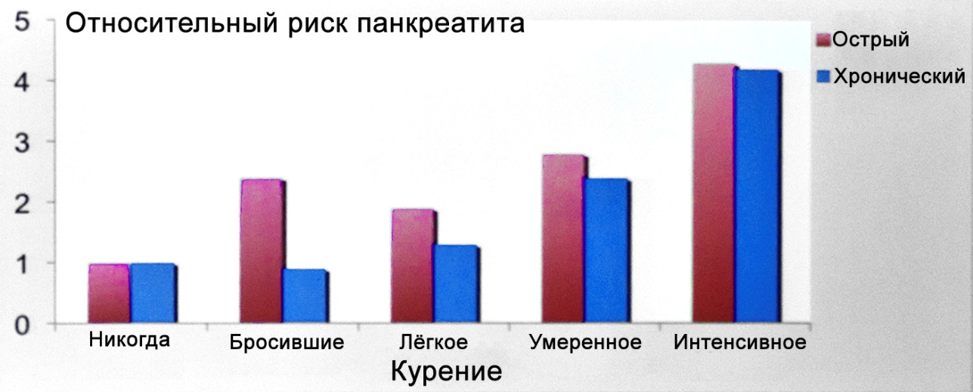

Fig. 1. The relative risk AP and CP, depending on the smoking (for O. Sadr-Azodi et al., 2012 [21]).

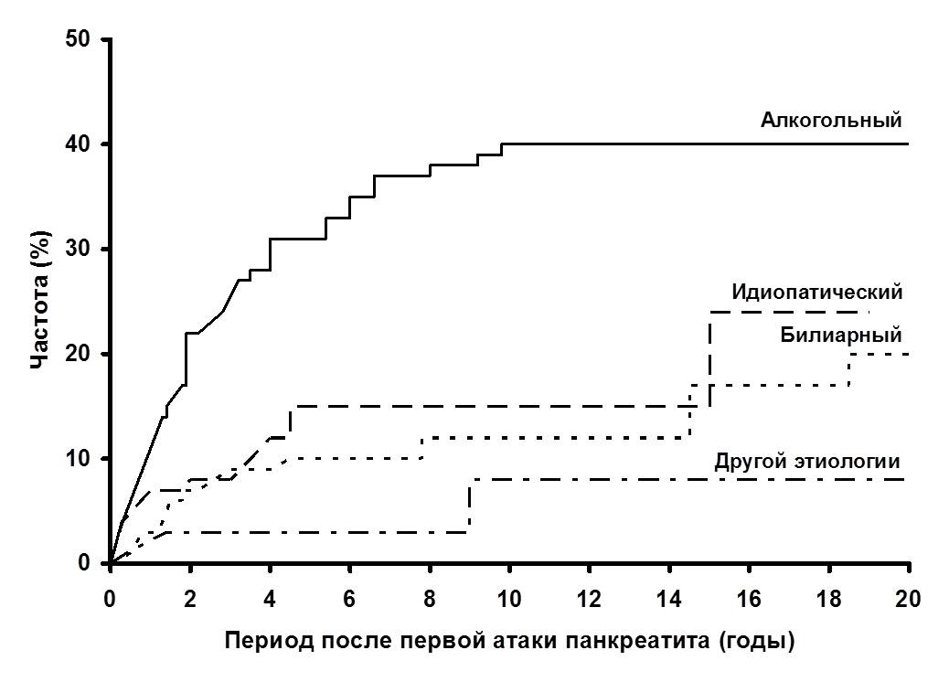

Fig. 2. The recurrence rate after the first episode in OD depending on its etiology (for PG Lankisch et al., 2009 [57]).

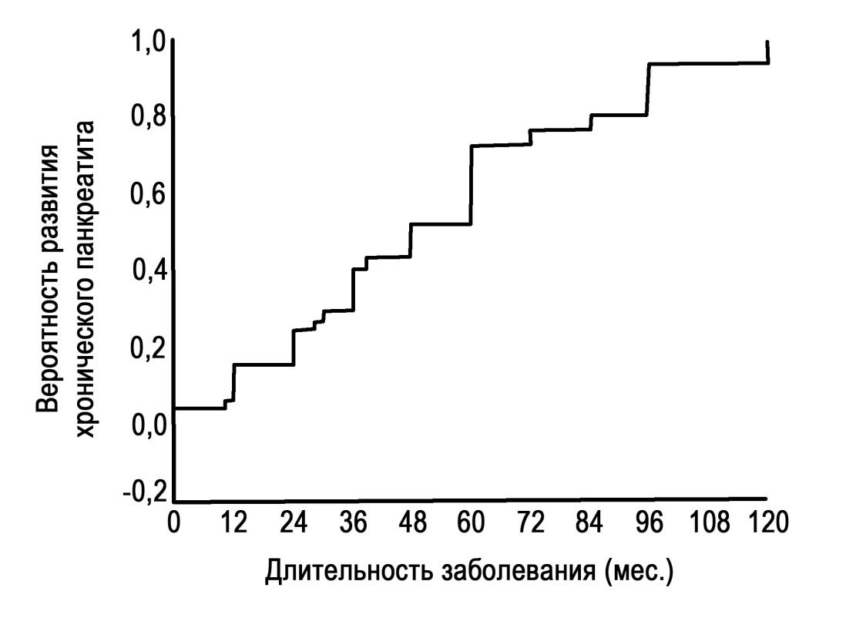

Fig. 3. The probability of the development of HP in patients with recurrent OD (at PK Garg et al., 2007 [37]).

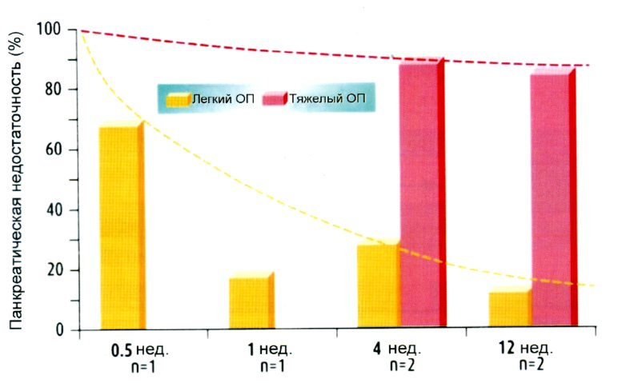

Fig. 4. Frequency of reduction of exocrine pancreatic function during the convalescence after OD OD depending on the severity (according to Ad AM Masclee et al., 2005 [55]).

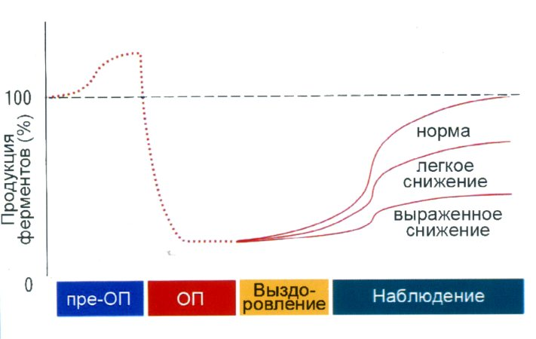

Fig. 5. Concept status of exocrine pancreatic function immediately before OD, in the initial phase of disease, convalescence and subsequent prolonged observation (according to Ad AM Masclee et al., 2005 [55]).

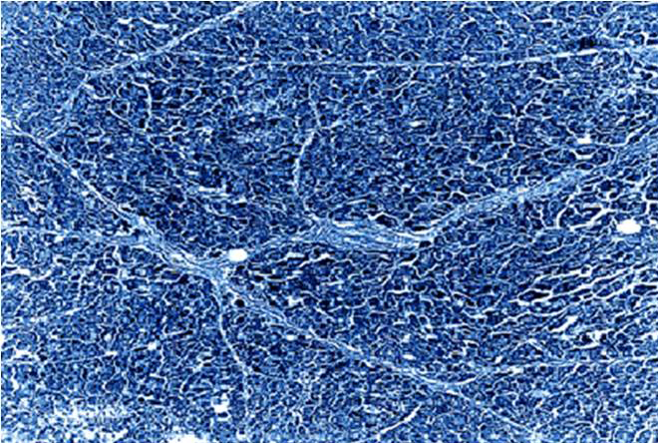

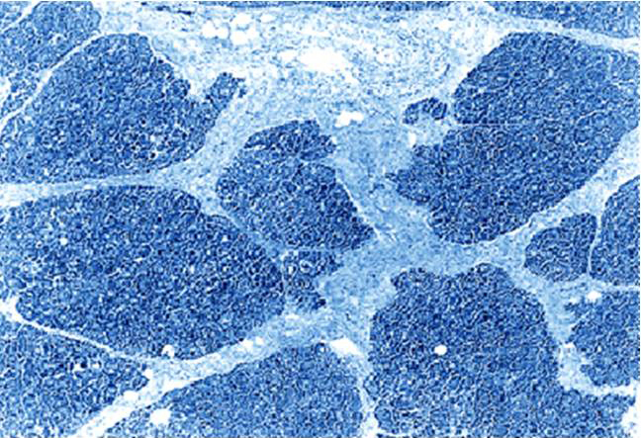

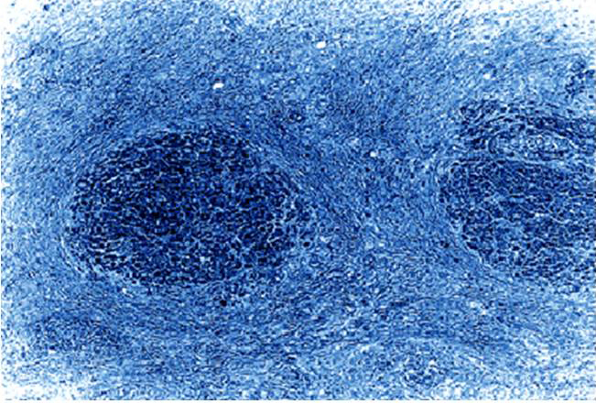

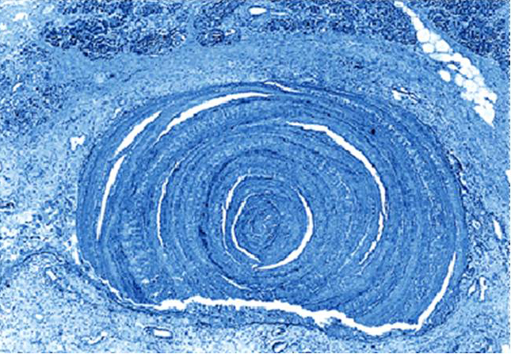

Fig. 6. The progression of fibrosis of the pancreas in CP thin layer of connective tissue between the slices (a) to cirrhosis RV (b) with atrophic parenchymal portions, which are isolated from each other strong connective tissue layers (c) and substituting parenchyma concentric layers of connective tissue (g) (by K. Suda, 2007 [60]). Hematoxylin-eosin, SW. × 40.

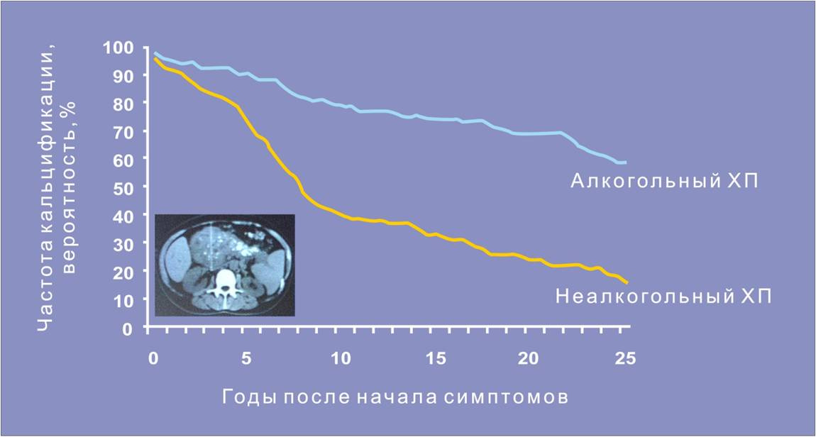

Fig. 7. Reducing the risk of calcification of RV failure alcohol with increasing duration of CPs (for P. Layer et al., 1994 [27]).

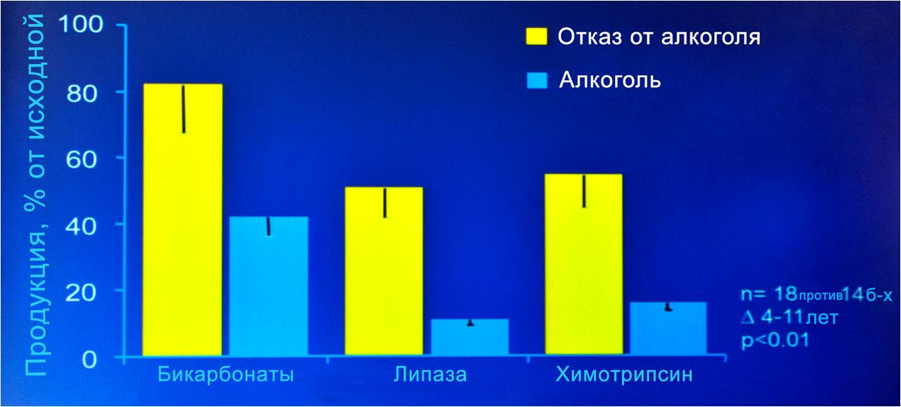

Fig. 8. Products bicarbonates and pancreatic enzymes in patients with CP, continue and cease reception of alcohol (by L. Gullo et al., 1988 [40]).

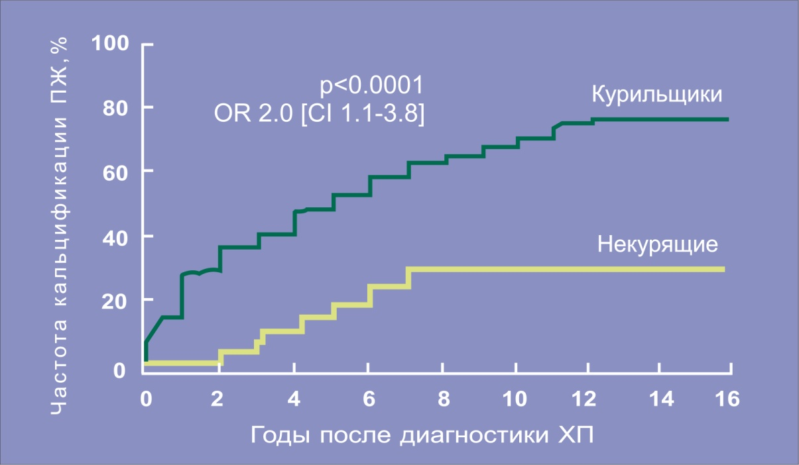

Fig. 9. The risk of prostate calcification in patients with CP according to smoking (for P. Maisonneuve et al., 2005 [20]).

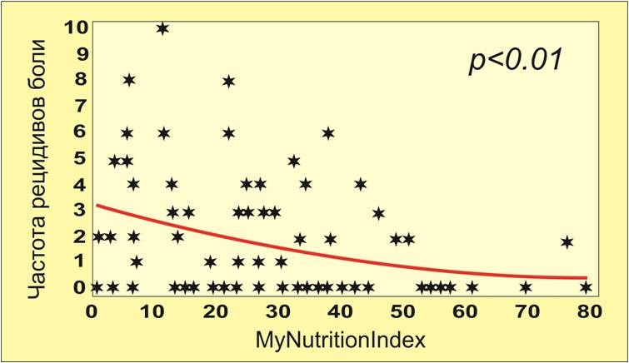

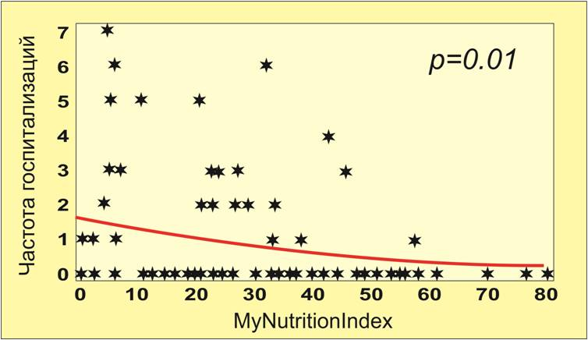

Fig. 10. The relationship between the integral index of nutritional status and the incidence of recurrence of pain in CP (a), the frequency of hospitalizations of patients (b) (n of BS Sandhu et al., 2007 [76]).

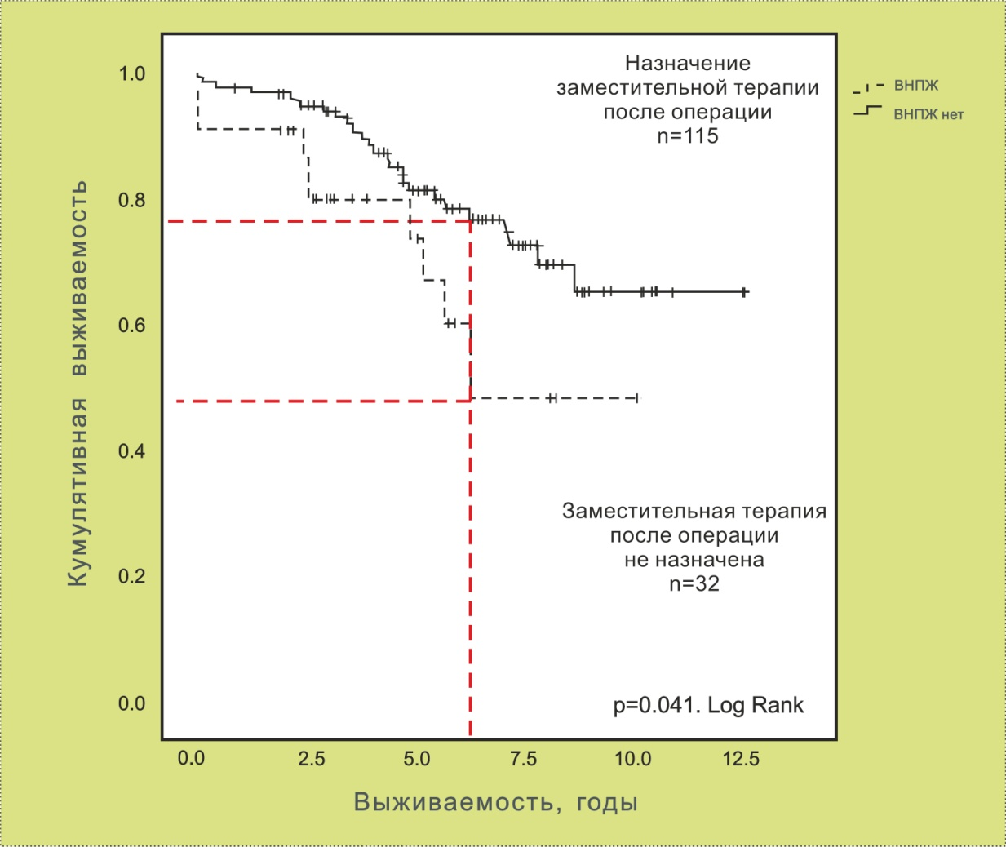

Fig. 11. Life expectancy CP patients after surgical interventions depending on the purpose of enzyme therapy (by M. Winny et al., 2014 [48]).

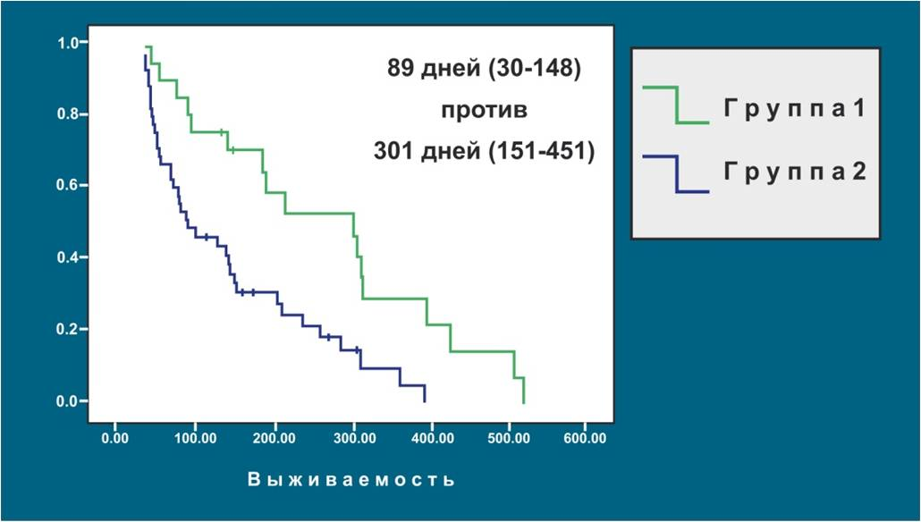

Fig. 12. A retrospective analysis — treating pancreatic insufficiency effect on survival of patients with unresectable pancreatic cancer (in JE Dominguez-Munoz et al (2013) [. 30]).

Group 1 — treatment of pancreatic insufficiency (50,000 Ph.U at main meals and at 25,000 Ph.U undershot) + palliative chemotherapy;

Group 2 — palliative chemotherapy.

References
- Корочанская Н. В. Хирургическая и медикаментозная профилактика раковой трансформации осложненного хронического панкреатита / Н. В. Корочанская, М. Л. Рогаль, И. Ю. Гришина // Гастро News. ― 2008. ― № 5. ― С. 46−50.
- Корочанская Н. В. Хирургическая и медикаментозная профилактика раковой трансформации хронического панкреатита / Н. В. Корочанская, М. Л. Рогаль, И. Ю. Гришина. ― М. : 4ТЕ АРТ, 2008. ― 56 с.
- Мудрые мысли о медицине и врачевании: изречения, афоризмы, цитаты / автор композиции Я. С. Циммерман. — 4-е изд., доп. — М. : ГЭОТАР-Медиа, 2015. — 256 с.
- Практическая гепатология / под ред. акад. РАМН Н. А. Мухина // Материалы «Школы гепатолога», проводимой на базе клиники нефрологии, внутренних и профессиональных заболеваний им. Е. М. Тареева ММА им. И. М. Сеченова. — М., 2004. — 294 с.
- Alcohol and cigarette smoke components activate human pancreatic stellate cells: implications for the progression of chronic pancreatitis / A. T. Lee, Z. Xu, S. P. Pothula [et al.] // Alcohol. Clin. Exp. Res. — 2015. — Vol. 39, No 11. — P. 2123–2133.
- Alcohol consumption and site-specific cancer risk : a comprehensive dose-response meta-analysis / V. Bagnardi, M. Rota, E. Botteri [et al.] / Br. J. Cancer. —2015. — Vol. 112, No 3. — P. 580–593.
- Alcohol intake and pancreatic cancer : a pooled analysis from the pancreatic cancer cohort consortium (PanScan) / D. S. Michaud, L. Jiao [et al.] // Cancer Causes Control. — 2010. — Vol. 21, No 8. — P. 1213–1225.
- And the American College of Gastroenterology. American College of Gastroenterology guideline : management of acute pancreatitis / S. Tenner, J. Baillie, J. DeWitt, S. S. Vege // Am. J. Gastroenterol. — 2013. — Vol. 108. — P. 1400–1416.
- And the European Society of Gastrointestinal Endoscopy. European Society of Gastrointestinal Endoscopy (ESGE) Guideline: prophylaxis of post-ERCP pancreatitis / J. M. Dumonceau, A. Andriulli, J. Deviere [et al.] // Endoscopy. — 2010. — Vol. 42. — P. 503–515.
- And the U.S. Cooperative for Outcomes Research in Endoscopy (USCORE). A randomized trial of rectal indomethacin to prevent post-ERCP pancreatitis / B. J. Elmunzer, J. M. Scheiman, G. A. Lehman [et al.] // N. Engl. J. Med. — 2012. — Vol. 366. — P. 1414–1422.
- Apte M. Pancreatic stellate cell: physiologic role, role in fibrosis and cancer / M. Apte, R. C. Pirola, J. S. Wilson // Curr. Opin. Gastroenterol. — 2015. — Vol. 31, No 5. — P. 416–423.
- Aspects of medical history and exocrine carcinoma of the pancreas: a population-based case-control study in the Netherlands / H. B. Bueno de Mesquita, P. Maisonneure, C. J. Moerman, A. M. Walker // Int. О. Cancer. ― 1992. ― Vol. 52. ― P. 17−23.
- Augustine P. Is tropical pancreatitis premalignant? / P. Augustine, H. Ramesh // Am. J. Gastroenterol. ― 1992. ― Vol. 87. ― P. 1005−1008.
- Brentnall T. A. Management strategies for patients with hereditary pancreatic cancer / T. A. Brentnall // Curr. Treat. Options Oncol. ― 2005. ― Vol. 6. ― P. 437−445.
- Burden of gastrointestinal disease in the United States : 2012 update / A. F. Peery, E. S. Dellon, J. Lund [et al.] // Gastroenterology. — 2012. — Vol. 143. — P. 1179–1187, e1–3.
- Cachexia in patients with chronic pancreatitis and pancreatic cancer: impact on survival and outcome / J. Bachmann, M. W. Buchler, H. Friess, M. E. Martignoni // Nutr. Cancer. — 2013. — Vol. 65, No 6. — P. 827–833.
- Cancer risk in nontransplanted and transplanted cystic fibrosis: a 10-year study / P. Maisonneuve, S. C. FitzSimmons, J. P. Neglia [et al.] // J. Natl. Cancer Inst. ― 2003. ― Vol. 95. ― P. 381−387.
- Can early precut implementation reduce endoscopic retrograde cholangiopancreatography-related complication risk? Meta-analysis of randomized controlled trials / V. Cennamo, L. Fuccio, R. M. Zagari [et al.] // Endoscopy. — 2010. — Vol. 42. — P. 381–388.
- Cardiovascular risk (CVR) associated with pancreatic exocrine insufficiency (PEI) in patients with chronic pancreatitis / N. Vallejo-Senra, De la Inglesia-Garsia, A. Lopez-Lopez [et al.] // Pancreatology. — 2016. — Vol. 16, No 3S1. — P. S80.
- Cigarette smoking accelerates progression of alcoholic chronic pancreatitis / P. Maisonneuve, A. B. Lowenfels, B. Mullhaupt [et al.] // Gut. ― 2005. ― Vol. 54, No 4. ― P. 510–514.
- Cigarette smoking, smoking cessation and acute pancreatitis : a prospective population-based study / O. Sadr-Azodi, A. Andren-Sandberg, N. Orsini, A. Wolk // Gut. — 2012. — Vol. 61. — P. 262–267.
- Complications of single-balloon enteroscopy : a prospective evaluation of 166 procedures / H. Aktas, L. de Ridder, J. Haringsma [et al.] // Endoscopy. — 2010. — Vol. 42. — P. 365–368.
- A critical analysis of the clinical use of incretin-based therapies: are the GLP-1 therapies safe? / P. C. Butler, M. Elashoff, R. Elashoff, E. A. Gale // Diabetes Care. — 2013. — Vol. 36. — P. 2118–2125.
- Cystic fibrosis transmembrane regulator (CFTR) DeltaF508 mutation and ST allele in patients with chronic pancreatitis and exocrine pancreatic cancer. PANKRAS II Study Group / N. Malats, T. Casals, M. Porta [et al.] // Gut. ― 2001. ― Vol. 48. ― P. 70−74.
- Cystic fibrosis transmembrane regulator gene carrier status is a risk factor for young onset pancreatic adenocarcinoma / R. McWilliams, W. E. Highsmith, K. G. Rabe [et al.] // Gut. ― 2005. ― Vol. 54. ― P. 1661−1662.
- Dai H. F. Role of nonsteroidal anti-inflammatory drugs in the prevention of post-ERCP pancreatitis : a meta-analysis / H. F. Dai, X. W. Wang, K. Zhao // Hepatobiliary Pancreat. Dis. Int. — 2009. — Vol. 8. — P. 11–16.
- The different courses of early- and late-onset idiopathic and alcoholic chronic pancreatitis / P. Layer, H. Yamamoto, L. Kalthoff [et al.] // Gastroenterology. ― 1994. ― Vol. 107, No 5. ― P. 1481–1487.
- DiMagno M. J. Pancreas divisum does not cause pancreatitis, but associates with CFTR mutations / M. J. DiMagno, E. P. Dimagno // Am. J. Gastroenterol. — 2012. — Vol. 107. — P. 318–320.
- Disease progression of acute pancreatitis in pediatric patients / F. Hao, H. Guo, Q. Luo, C. Guo // J. Surg. Res. — 2016. — Vol. 202, No 2. — P. 422–427.
- Dominguez-Munoz J. E. Survival of patients with unresectable pancreatic cancer: impact of the treatment of pancreatic exocrine insufficiency and malnutrition / J. E. Dominguez-Munoz, L. Nieto, J. Iglesias-Garcia // Pancreatology. — 2013. — Vol. 13, Issue 4. — P. e5.
- Drug-induced pancreatitis // C. Nitsche, S. Maertin, J. Scheiber [et al.] // Curr. Gastroenterol. Rep. — 2012. — Vol. 14. — P. 131–138.
- European Registry of Hereditary Pancreatitis and Pancreatic Cancer (EUROPAC). Clinical and genetic characteristics of hereditary pancreatitis in Europe / N. Howes, M. M. Lerch, W. Greenhalf [et al.] // Clin. Gastroenterol. Hepatol. ― 2004. ― Vol. 2. ― P. 52−61.
- Exocrine and endocrine pancreatic insufficiency after acute pancreatitis / M. Vujasinovic, B. Tepes, J. Makuc [et al.] // Pancreatology. — 2013. — Vol. 13, No 3S. — P. S65.
- For the Dutch Pancreatitis Study Group. Timing of cholecystectomy after mild biliary pancreatitis / O. J. Bakker, H. C. van Santvoort, J. C. Hagenaars [et al.] // Brit. J. Surg. — 2011. — Vol. 98. — P. 1446–1454.
- Frequency of K-ras mutations in pancreatic intraductal neoplasias associated with pancreatic ductal adenocarcinoma and chronic pancreatitis : a meta-analysis / M. Lohr, G. Kloppel, P. Maisonneuve [et al.] // Neoplasia. ― 2005. ― Vol. 7. ― P. 17−23.
- Gallstones, cholecystectomy and risk of cancers of the liver, biliary tract and pancreas / W. H. Chow, C. Johansen, G. Gridley [et al.] // Br. J. Cancer. —1999. —Vol. 79, No 3–4. — P. 640–644.
- Garg P. K. Is biliary microlithiasis a significant cause of idiopathic recurrent acute pancreatitis? A long-term follow-up study / P. K. Garg, P. K. Tandon, K. Madan // Clin. Gastroenterol. Hepatol. — 2007. — Vol. 5, No 1. — P. 75–79.
- Gotian A. Pancreatitis associated with Crohn's disease: a premalignant state for cystadenocarcinoma of pancreas? / A. Gotian, S. Katz // Am. J. Gastroenterol. — 1999. — Vol. 94, No 8. — P. 2301–2302.
- Gradirian P. Tobacco, alcohol, and coffee and саncer of the pancreas. A population-based, case-control study in Quebec, Canada / P. Gradirian, A. Simard, J. Baillargeon // Cancer. ― 1991. ― Vol. 67. ― P. 2664−2670.
- Gullo L. Effect of cessation of alcohol use on the course of pancreatic dysfunction in alcoholic pancreatitis / L. Gullo, L. Barbara, G. Labo // Gastroenterology. ― 1988. ― Vol. 95, No 4. ― P. 1063–1068.
- Heavy smoking is associated with lower age at first episode of acute pancreatitis and a higher risk of recurrence / S. Munigala, D. L. Conwell, A. Gelrud, B. Agarwal // Pancreas. — 2015. — Vol. 44, No 6. — P. 876–881.
- Hereditary pancreatitis and the risk of pancreatic cancer. International Hereditary Pancreatitis Study Group / A. B. Lowenfels, P. Maisonneuve, E. P. DiMango [et al.] // J. Natl. Cancer Inst. ― 1997. ― Vol. 89. ― P. 442−446.
- Incidence of cancer in the course of chronic pancreatitis / G. Talamini, M. Falconi, C. Bassi [et al.] // Am. J. Gastroenterol. ― 1999. ― Vol. 94. ― P. 1253−1260.
- Increased risk of acute pancreatitis and biliary disease observed in patients with type 2 diabetes : a retrospective cohort study / R. A. Noel, D. K. Braun, R. E. Patterson, G. L. Bloomgren // Diabetes Care. — 2009. — Vol. 32. — P. 834–838.
- Increased risk of acute pancreatitis in patients with type 2 diabetes : an observational study using a Japanese hospital database / H. Urushihara, M. Taketsuna, Y. Liu [et al.] // PLoS One. — 2012. — Vol. 7. — P. e53224.
- Indomethacin treatment of acute experimental pancreatitis in the rat / P. G. Lankisch, H. Koop, K. Winckler [et al.] // Scand. J. Gastroenterol. — 1978. — Vol. 13. — P. 629–633.
- Indomethacin treatment of acute pancreatitis. A controlled double-blind trial / N. Ebbehoj, J. Friis, L. B. Svendsen [et al.] // Scand. J. Gastroenterol. — 1985. — Vol. 20. — P. 798–800.
- Insulin dependence and pancreatic enzyme replacement therapy are independent prognostic factors for long-term survival after operation for chronic pancreatitis / M. Winny, V. Paroglou, H. Bektas [et al.] // Surgery. — 2014. — Vol. 155, No 2. — P. 271–279.
- Lankisch P. G. Acute pancreatitis / P. G. Lankisch, M. Apte, P. A. Banks // The Lancet. — 2015. — Vol. 386, No 9988. — P. 85–96.
- Lankisch P. G. What is the risk of alcoholic pancreatitis in heavy drinkers? / P. G. Lankisch, A. B. Lowenfels, P. Maisonneuve // Pancreas. — 2002. — Vol. 25. — P. 411–412.
- Lohr J. M. Synopsis of recent guidelines on pancreatic exocrine insufficiency / J. M. Lohr, M. R. Oliver, L. Frulloni // United Eur. Gastroenterol. J. — 2013. — Vol. 1, No 2. — Р. 79–83.
- Long-term follow-up of patients with chronic pancreatitis and K-ras gene mutation detected in pancreatic juice / N. Furuya, S. Kawa, T. Akamatsu, K. Furihata // Gastroenterology. ― 1997. ― Vol. 113. ― P. 593−598.
- Lowenfels A. B. What is the risk of biliary pancreatitis in patients with gallstones? / A. B. Lowenfels, P. G. Lankisch, P. Maisonneuve. — Gastroenterology. — 2000. — Vol. 119. — P. 879–880.
- Low incidence of hyperamylasemia after proximal double-balloon enteroscopy: has the insertion technique improved? / H. Aktas, P. B. Mensink, J. Haringsma, E. J. Kuipers // Endoscopy. — 2009. — Vol. 41. — P. 670–673.
- Masclee Ad A.M. Pancreatic exocrine insufficiency after acute pancreatitis / Ad A. M. Masclee, T. Symersky // Asian Pacific digestive disease week 2005. Proceedings of a Solvay satellite symposium. — 27 September 2005. — Seoul, Korea. — P. 9–12.
- Mortality in patients with chronic pancreatitis (CP) with and without exocrine pancreatic insufficiency (EPI) / N. Vallejo-Senra, J. Iglesias-Garcia, J. Larino-Noia [et al.] // Pancreatology. — 2015. — Vol. 15, Issue 3. — S12–S13.
- Natural history of acute pancreatitis: a long-term population-based study / P. G. Lankisch, N. Breuer, A. Bruns [et al.] // Am. J. Gastroenterol. — 2009. — Vol. 104, No 11. — P. 2797–2805.
- Nauck M. A. A critical analysis of the clinical use of incretin-based therapies: the benefits by far outweigh the potential risks / M. A. Nauck // Diabetes Care. — 2013. — Vol. 36. — P. 2126–2132.
- Otsuki M. Chronic pancreatitis in Japan: epidemiology, prognosis, diagnostic criteria, and future problems / M. Otsuki // J. Gastroenterol. ― 2003. ― Vol. 38. ― P. 315−326.
- Pancreas — pathological practice and research / Ed. K. Suda. — Basel [et al.] : Karger, 2007. — 318 p.
- Pancreas cancer and smoking, beverage consumption, and past medical history / T. M. Mack, M. C. Yu, R. Hanisch, B. E. Henderson // О. Natl. Cancer Inst. ― 1986. ― Vol. 76. ― P. 49−60.
- Pancreas divisum is not a cause of pancreatitis by itself but acts as a partner of genetic mutations / C. Bertin, A. L. Pelletier, M. P. Vullierme [et al.] // Am. J. Gastroenterol. — 2012. — Vol. 107. — P. 311–317.
- Pancreatic carcinoma developing in chronic pancreatitis: a report of four cases / O. Haas, G. Guillard, P. Rat [et al.] // Hepatogastroenterology. ― 1990. ― Vol. 37. ― P. 350–351.
- Pancreatic carcinoma in chronic pancreatitis with inflammatory tumor of the head of the pancreas / W. Schlosser, M. H. Schoenberg, E. Rhein [et al.] // Gastroenterol. ― 1996.― Vol. 34. ― P. 3–8.
- Pancreatitis and the risk of pancreatic cancer / E. Fernandez, C. La Vecchia, M. Porta [et al.] // Pancreas. ― 1995. ― Vol. 11. ― P. 185−189.
- Pancreatitis and the risk of pancreatic cancer. International Pancreatitis Study Group / A. B. Lowenfels, P. Maisonneuve, G. Cavallini [et al.] // N. Engl. О. Med. ― 1993. ― Vol. 328. ― P. 1433−1437.
- Patients with type 2 diabetes mellitus have higher risk for acute pancreatitis compared with those without diabetes / C. J. Girman, T. D. Kou, B. Cai [et al.] // Diabetes Obes. Metab. — 2010. — Vol. 12. — P. 766–771.
- Predictive factors for pancreatic cancer in patients with chronic pancreatitis in association with K-ras gene mutation / M. Arvanitakis, J. L. Van Laethem, J. Parma [et al.] // Endoscopy. ― 2004. ― Vol. 36. ― P. 535−542.
- Prognosis of chronic pancreatitis : an international multicenter study. International Pancreatitis Study Group / A. B. Lowenfels, P. Maisonneuve, G. Cavallini [et al.] // Am. J. Gastroenterol. ― 1994. ― Vol. 89. ― P. 1467−1471.
- Prophylactic pancreatic stent placement and post-ERCP pancreatitis : an updated meta-analysis / T. Mazaki, K. Mado, H. Masuda, M. Shiono // J. Gastroenterol. — 2013. — Vol. 49. — P. 343–355.
- A prospective cohort study of smoking in acute pancreatitis / B. Lindkvist, S. Appelros, J. Manjer [et al.] // Pancreatology. — 2008. — Vol. 8. — P. 63–70.
- A prospective study of pancreatic cancer in the elderly / A. Shibata, T. M. Mack, A. Paganini-Hill [et al.] // Int. J. Cancer. — 1994. — Vol. 58, No 1. — P. 46–49.
- Proteomic analysis of chronic pancreatitis and pancreatic adenocarcinoma / T. Crnogorac-Jurcevic, R. Gangeswaran, V. Bhakta [et al.] // Gastroenterology. ― 2005. ― Vol. 129. ― P. 1454−1463.
- Rectal nonsteroidal anti-inflammatory drugs are superior to pancreatic duct stents in preventing pancreatitis after endoscopic retrograde cholangiopancreatography : a network meta-analysis / A. Akbar, B. K. Abu Dayyeh, T. H. Baron [et al.] // Clin. Gastroenterol. Hepatol. — 2013. — Vol. 11. — P. 778–783.
- The recurrence of acute alcohol-associated pancreatitis can be reduced : a randomized controlled trial / I. Nordback, H. Pelli, R. Lappalainen-Lehto [et al.] // Scand. J. Gastroenterology. — 2009. — Vol. 136. — P. 848–855.
- Recurrent flares of pancreatitis predict development of exocrine insufficiency in chronic pancreatitis / B. S. Sandhu, W. A. Hackworth, S. Stevens [et al.] // Clin. Gastroenterol. Hepatol. — 2007. — Vol. 5, No 9. — P. 1085–1091.
- Risk of acute pancreatitis in type 2 diabetes and risk reduction on anti-diabetic drugs: a population-based cohort study in Taiwan / S. W. Lai, C. H. Muo, K. F. Liao [et al.] // Am. J. Gastroenterol. — 2011. — Vol. 106. — P. 1697–1704.
- The risk of cancer among patients with cystic fibrosis. Cystic Fibrosis and Cancer Study Group / J. P. Neglia, S. C. FitzSimmons, P. Maisonneuve [et al.] // N. Engl. J. Med. ― 1995. ― Vol. 332. ― P. 494−499.
- Risk of pancreatic adenocarcinoma in chronic pancreatitis / D. Malka, P. Hammel, А. Maire [et al.] // Gut. ― 2002. ― Vol. 51. ― P. 849−852.
- Rulyak S. J. Inherited pancreatic cancer: improvements in our understanding of genetics and screening / S. J. Rulyak, T. A. Brentnall // Int. J. Biochem. Cell. Biol. ― 2004. ― Vol. 36. ― P. 1386−1392.
- Sakofaras G. H. Pancreatic cancer after surgery for chronic pancreatitis / G. H. Sakofaras, M. G. Sarr // Dig. Liver Dis. ― 2003. ― Vol. 35. ― P. 482−485.
- Smoking and body mass index and survival in pancreatic cancer patients / C. Pelucchi, C. Galeone, J. Polesel [et al.] // Pancreas. — 2014. — Vol. 43, No 1. — P. 47–52.
- Smoking and risk of acute and chronic pancreatitis among women and men : a population-based cohort study / J. S. Tolstrup, L. Kristiansen, U. Becker, M. Gronbaek // Arch. Intern. Med. — 2009. — Vol. 169. — P. 603–609.
- Yadav D. The epidemiology of pancreatitis and pancreatic cancer / D. Yadav, A. B. Lowenfels // Gastroenterology. — 2013. — Vol. 144. — P. 1252–1261.
- Zheng M. H. Rectal administration of NSAIDs in the prevention of post-ERCP pancreatitis : a complementary meta-analysis / M. H. Zheng, H. H. Xia, Y. P. Chen. — Gut. — 2008. — Vol. 57. — P. 1632–1633.

“Fatal chain”: from acute pancreatitis to pancreatic cancer
N. B. Gubergrits, G. M. Lukashevich, P. G. Fomenko, N. V. Byelyayeva
Donetsk National Medical University n. a. M. Gorky

Key words: pancreatic diseases, stages of progression, risk factors, pathogenesis, treatment

The article provides a review of literature on the "fatal chain" in pancreatology. This refers to the links starting from acute pancreatitis to its relapse, development of chronic pancreatitis, pancreatic fibrosis progression and increasing risk of pancreatic adenocarcinoma (similar to the "fatal chain" in hepatology: from acute to chronic hepatitis, cirrhosis and liver cancer). Logical links are confirmed by the literature data and results of the evidence-based research. Preventive and curative actions aimed to interrupt "fatal chain" are discussed.

