CT modern potential in acute pancreatitis visualization (part 3)
A. A. Filatau, A. A. Litvin
Gomel Regional Clinical Hospital, Gomel, Belarus
Baltic Federal University n. a. I. Kant, Kaliningrad, Russia

Key words: acute pancreatitis, complication, diagnostics, visualization, computed tomography
In the previous number of the magazine ah [12] we gave two messages I have the problem of CT imaging of acute pancreatitis, the main purpose of which was to review the literature's modern capabilities of computed tomography in the diagnosis and treatment of acute pancreatitis (AP). Currently very popular acquires other type of digital imaging of the pancreas in acute pancreatitis — Magnetic Resonance Imaging (MRI) [35]. The purpose of the communication (part 3) a review of contemporary literature on the effectiveness of MRI in the diagnosis and treatment of severe AP.
In general, the MRI in a number of diseases considered to be more accurate method of study than CT [18, 21 28, 34]. When AP use of MRI has a number of features in preparation for the study, and in the technique of execution.
Preparation of patients with severe AP MRI is often difficult due to intestinal paresis. [26] In addition, MRI rovedenie n lasts from 30 to 60 minutes, which is poorlytolerated by patients with severe forms and AP [11, 13]. P atsientam who are on mechanical ventilation, performing MRI in most cases it is impossible, because need a special"non-metallic" breathing apparatus [3, 6, 20].
The effect of nuclear magnetic resonance arises from the interaction between protons of biological tissues, a constant or alternating magnetic field, and the energy of radio-frequency pulses emitted by a coil placed near the investigated part of the body. Under the influence of radio-frequency pulses, the protons of hydrogen atoms temporarily shift to a higher energy level. The return of the protons to the equilibrium state is accompanied by the release of energy in the form of pulses of a certain (so-called resonant) frequency;This energy can be measured with a receiving coil [3]. The relaxation time T1 and T2 — is the time during which protons are returned to an equilibrium state. It is different in healthy and diseased tissues. T1 — the time during which the back 63% of the protons return to equilibrium. T2 — is a time in which 63% of the spins of protons are shifted in phase (dephase) by neighboring protons. The intensity of the signal and the contrast of the image depend on parameters such as the interval between the pulses being fed (repetition time, TR) and the time between the supplied pulse and the emitted signal (echo delay, TE). The T1-weighted image is formed with relatively short TR and TE. Contrast tissues depends mainly on -Time T1. A T2-weighted image is formed with longer TR and TE. Time T1 peripancreatic adipose tissue normally short, and therefore it is so intense signal et on T1-weighted images. Fabrics containing a large amount of water, as observed edema peripancreatic tissue in interstitial acute pancreatitis have long T R and T E, so they are poorly visible on T1-weighted images and well — on T2-weighted images [3, 12].
Normal pancreas parenchyma (RV) shows high signal intensity on T1-weighted images and uniform amplification in later hepatic arterial phase [14, 22]. In marked contrast enhancement capillary uniform amplification of the signal from the gland on the first post-contrast images, the intensity significantly exceeds the signal level of the liver, gastrointestinal tract and adjacent peripankretichesk fat oh oh fiber [22].
Acute edematous pancreatitis. Since inflammation and swelling of the prostate at OD primarily revealed diffuse or locally e increase cancer disappears clarity pancreatic contours intensity gland signal T1 — pictures hypointense relative to the liver, while on T2 — images hyperintense [4, 37] (uc p. 1).
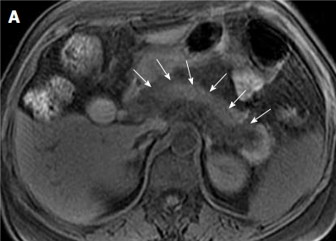 | 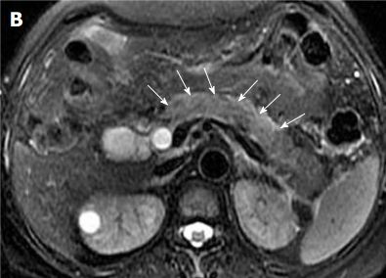
Fig. 1. 29-year-old s a man with acute edematous pancreatitis. T1-weighted imaging th e without contrast I (A) and T2-weighted sequence without opacification demonstrate that the head, body and tail part of the gland hypointense on the first picture and the second hyperintensity in comparison with liver — indicated by white arrows.

Pancreatic necrosis. Pancreatic Necrosis is essentially captive pathological MSE nonviable tissues O n can be local or diffuse superficial or deep. Itself necrosis on MRimages revealed similarly as for CT — zone violation or Strongly missing "staining" in relation to the unmodified parenchyma [37]. W hen this region hypointense on T1-scans must meet hyperintense regions on T2-weighted images. H Assigning intravenous stirovaniya counter and to distinguish from transient ischemia pancreatic necrosis true [14, 17].Characterized by a local necrosis on contrast-enhanced MR images as a hypointense area multicolored speckled ("sprinkled pepper") [17, 36] (p uc. 2). Big "NOT," RV area ("black pancreas") MRI with contrast is evidence in favor of diffuse pancreatic necrosis [17, 36, 37].

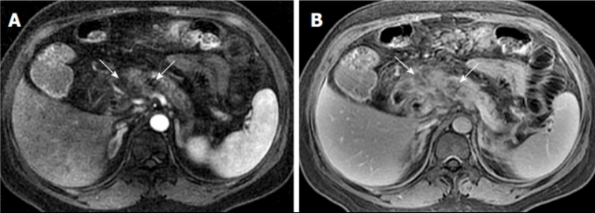
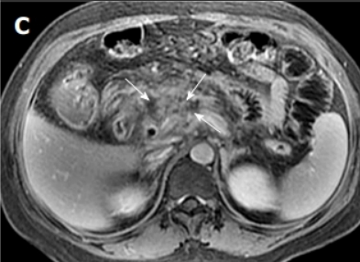 | Fig. 2. A 43-year-old patient with acute pancreatitis. Represented T1-weighted images with contrast in the arterial phase (A) and late venous phase (B, C), which identifies changes characteristic of focal necrosis in the pancreas head ("as dusted pepper") — white arrow

Criteria to assess the extent of necrosis with MRI similar to those described for CT (Table. 1) [19, 31, 36].

Table 1
MRI index of severity of acute pancreatitis [19]
Prognostic indicator | Characteristic | MRTIT,  Points
Pancreatic inflammation | Normal pancreas | 0
Pancreatic inflammation | Local or diffuse pancreatic enlargement | 1
Pancreatic inflammation | Intra-pancreatic changes with inflammatory changes in peripancreatic tissues | 2
Pancreatic inflammation | One fluid cluster | 3
Pancreatic inflammation | Two or more clusters or presence of gas in the pancreas or next to it | 4
Pancreatic necrosis | No necrosis | 0
Pancreatic necrosis | Up to 30% necrosis | 2
Pancreatic necrosis | 30-50% of necrosis | 4
Pancreatic necrosis | More than 50% necrosis | 6th
Amount balls 0-3 corresponds mild, 4-6 — moderate, 7-10 — corresponds to severe pancreatitis

According to the literature, the index MR severity of acute pancreatitis showed statistically significant correlation with the severity index of CT-AP, scale Ranson, C-reactive protein, the appearance of systemic complications and hospitalization duration outcome of the disease [31, 33].
Hemorrhagic complications of AP. In the evolution of hemoglobin to methemoglobin place hemorrhage MRI look like point, spotted ("salted") or filamentous zone hyperintensity on T1-weighted images [17, 18]. It is known that the symptoms persist hemorrhage MRI long time and have varying MR signs depending on the time of existence of the formation (methemoglobin giperintensiven on T1-weighted images, while on hemosiderin gipointensiven -Images T 2) [18, 37] (p uc. 3).
Changes in peripancreatic tissue. In normal pancreatic capsule can not be seen by CT or MRI, while in AP arises edema and thickening of the pancreatic capsule subkasulyarnyh formation fluid accumulations (that is best detected on T2-pictures) [4]. Meanwhile pancreatic capsule is not a significant barrier to the propagation of the inflammatory process in AP that leads to the ingress of pancreatic enzymes in peripancreatic tissue, and then to the development of edema and necrosis fat varying degrees [15,17].
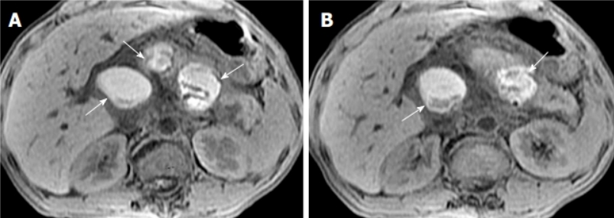
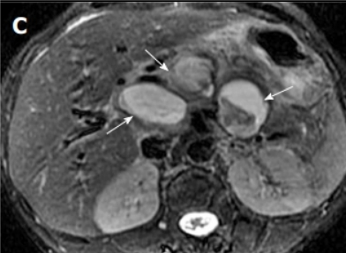 | Fig. 3. A 35-year-old patient with multiple cysts complicated by hemorrhage (acute pancreatitis in the nearest anamnesis). On T1-weighted images without contrasting (A, B) and T2-weighted image (C), white arrows indicate cystic formations with a non-uniform hyperecho signal, which speaks in favor of the blood contained in them

At the same time it is distinguished adipose tissue edema, and necrosis is extremely difficult on MRI in mind a similar visual picture of these states [37]. Further increase in edema, progression of necrosis with "melting" of peripancreatic tissues can lead to the formation of fluid clusters. According to T2-images, it is possible to accurately identify and describe the formation data, while according to the T1-sequence data, it is possible to clarify the content in their lumen of blood or postnecrotic sequestration [36]. Also according MRI clearly visualized involvement in pathological process perirenal and parakolicheskih spaces mesentery of the small intestine, omentum — with the development of the disease in these structures edema, forming pockets of fat necrosis or fluid accumulations [15 1 7] (figure 4.).
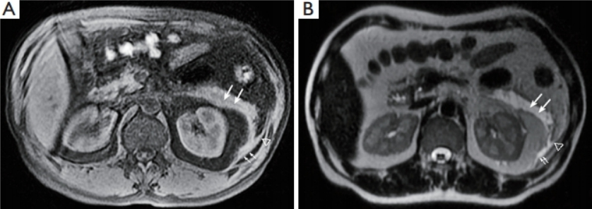
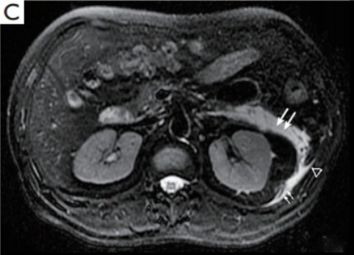 | Fig. 4. A 36-year-old patient with acute pancreatitis.Inflammation is defined in the left half of the mesentery root (long arrows), left posterior space (short arrows) and left paracolic space (triangle) as an isointeous signal on the T1-weighted image without contrasting (A) and hyperintensive zones on the T2-weighted image (B) Without fat suppression and using the technique of suppression of the signal from the adipose tissue (C)

MR-picture of complications of acute pancreatitis
Pseudocysts. Pseudocyst formed the majority of patients undergoing necrotizing pancreatitis, 4-6 weeks after it began. Localization are divided into parenchymal and extrapancreatic, the former often have a connection with the main pancreatic duct [16, 37]. According MRI they are round or oval formation fluid, surrounded by a wall and clearly defined homogeneous signal intensity like water [16].
Infection. And nfitsirovanie foci of necrosis in the parenchyma of the prostate and peripancreatic tissues leads to further swelling and infiltration in the area of inflammation that when contrast enhanced MR sequences results in the formation of images like "hornet's nest" — multi-cell mass with rounded foci "neprokrashivaemyh"swelling of tissues, surrounded by hyperintense ringed structures [37] (Fig. 5). It is important to note that it is extremely difficult to distinguish a simple and festering pseudocyst from MR-tomograms. So even the presence of gas bubbles detected at native CT study, MRI is difficult to determine [16].

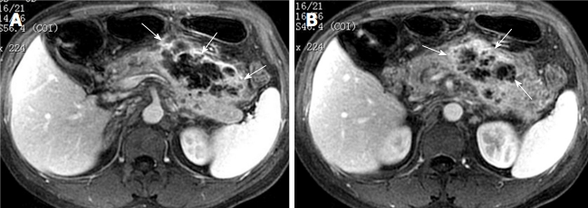
Fig. 5. A 39-year-old patient with acute pancreatitis and peripancreatic cellulitis. Contrast-enhanced T1-weighted images demonstrate multilocular structure with ringed hyperintensity inclusions and NOT, contents (for "wasp nest" type) — white arrow in A and B pictures.

Vascular complications. Extravasation active pankr e aticheskih enzymes may cause damage to the surrounding arteries and veins. Among the possible pathologic conditions by the vessels should be allocated: 1) vasculitis; 2) arterial hemorrhage or aneurysm formation — often involved splenic, and gastroduodenal artery pancreatoduodenal; 3) phlebothrombosis or vein occlusion; 4) pancreatogenic portal hypertension; 5) combination and conditions mentioned above. MR angiography is precisely conducted to identify the list of complications [17, 25].
Arterial damage is an effect devastated vessels ("black blood") on the T2-weighted images and NOT, vessels — during MR angiography contrast agent during the arterial phase. Rough and blackout wall of arteries and speaks in favor of vasculitis. In turn vasculitis when combined with partial arterial occlusion may result in heart attacks secondary internal organs (e.g. spleen) [17, 37].
Pseudoaneurysms are relatively rare and are on tsrochennym complications AP, but carry significant risk and threat to life is complicated when their rated current [25].MRI aneurysm cavity is rounded formation fluid, which communicates with the involved artery and is hyperechoic with contrast enhancement (zone without contrast in the lumen of the aneurysm can speak of parietal thrombi) [17, 25] (Fig. 6).

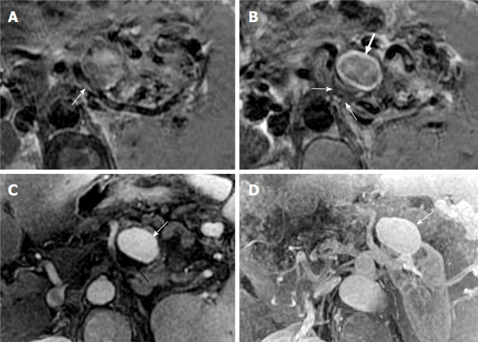
Fig. 6. A 36-year-old patient with a history of acute pancreatitis and an aneurysm of the splenic artery. On T2-weighted images without contrasting, the involved segment of the splenic artery is seen (arrow in picture A and smaller arrows in picture B) and the actual aneurysmal bag (the big arrow in picture B). Also aneurysm marked by arrows in enhanced image contrast in the arterial phase (C) and MR angiography with the contrast agent (D)

Splenic Vienna most frequently involved in n atologicheskie processes in AP in mind its proximity to th e RV. In this case, both thrombosis of this vein and occlusion can develop. MRI determined the effect zapustevshih veins at T2 sequence, and after staining the venous phase can be detected in corolla triprosvetny asymmetric defect filling [17].
Also as a result of venous thrombosis and occlusion in the background OD can develop portal hypertension, which leads to the development of lateral circulation to linvolving short gastric vein, gastro — gland veins along the greater curvature and the splenic vein closer to the gate. In this case, the MR images determined by the large amount of crimped veins with impaired "staining" and splenomegaly [8].
Benefits MRI in acute pancreatitis
1. Best visualization of soft tissue cells, exceeds the capacity of CT with contrast enhancement in the imaging ratio and solid components and postnecrotic sequesters within pancreatic fluid accumulations. MRI can be used early in the disease for the differential diagnosis of acute peripancreatic fluid accumulation and acute necrotizing cluster[5, 17, 36].
2. MRI and more effective for obtaining accurate pancreatonecrosis of characteristic lesions (predominance of liquid or tissue component contents, communication with the pancreatic duct) (Fig. 7).
3. MRI without amplification more accurate and trustworthy than CT with contrast in evaluations e severity and prognosis of acute pancreatitis [28, 31, 33].
4. The ability to accurately diagnosis of acute pancreatitis edematous th, which often do not have the first characteristic manifestations on CT [9, 10, 29].
5. POSSIBILITY application MR holangiopankreatikografii in its various embodiments, by means of which improved visualization pathology pancreatic duct and biliary tract [7 23 27, 32].
6. Lack of organic ionizing radiation.
7. Exposure to extreme resolution of the MRI without contrast gives possibility in patients who are contraindicated for the introduction of contrast agents: due to an allergy to iodinated contrast agents, renal failure, pregnancy [10, thirty, 36].
8. The MRI contrast agent gadolinium compounds has fewer side effects compared with radiopaque agents.

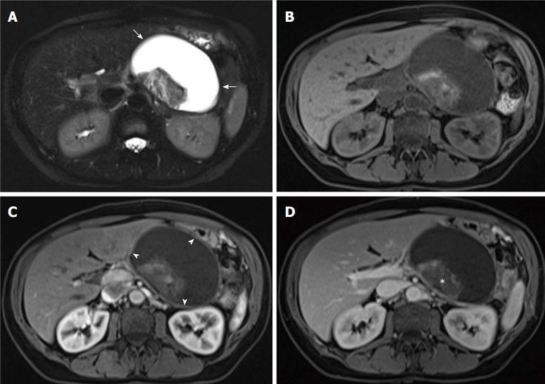
Fig. 7. A 45-year-old patient with delimited necrosis. On the turbo spin echo T2-weighted image (A) and on T2-weighted images before contrasting (B), in the arterial (C) and venous phases after contrasting, a large-scale liquid formation with formed walls is detected, containing solid inclusions (sequesters)

Disadvantages of MRI in acute pancreatitis
1. Failure to conduct a study of patients with presence of m in the body of materials and devices with magnetic properties: vascular clips, metal fasteners, metal and magnetic implants and more.
2. The duration of the procedure, which is important in critically ill patients requiring continuous monitoring.
3. The cost of the study — MRI is more expensive compared with th US and CT.

Conclusion
In general, as we have noted in previous publications [1, 2], the "gold standard" for evaluation of patients with severe AP is CT with bolus contrast enhancement. To date, this method satisfies practitioners and researchers in the accuracy of diagnosis, stratification and AP definition of further tactics of treatment of severe acute pancreatitis. Place of MRI in patients with severe OD seen in more precise diagnosis of necrotic changes in the pancreas and peripancreatic tissue, particularly in early disease. It MRI reveals the "gap" of the pancreatic duct at the beginning of the disease AP [24]. Diagnosis of AP with MRI and subsequent minimally invasive correction insolvency flow may prevent the development of severe forms of AP later. Furthermore, d iagnostichesky MRCP potential approaches the level of endoscopic retrograde holangiopankreatikografii, wherein is Jaś noninvasive examinations [9, 27].
According to most authors, a more widespread adoption of the various options MR studies in acute pancreatitis in all medical institutions equipped with MRI.
References:
- Филатов А. А. Современные возможности визуализации острого панкреатита (Сообщение 1) / А. А. Филатов, А. А. Литвин // Вестник клуба панкреатологов. — 2015. — №3 (28). — С. 17–24.
- Филатов А. А. Современные возможности КТ-визуализации острого панкреатита (сообщение 2) / А. А. Филатов, А. А. Литвин // Вестник клуба панкреатологов. — 2015. — №4 (29). — С. 30–38.
- Шилов Г. Н. Теория и практика основных методов лучевой диагностики: курс лекций / Г. Н. Шилов. — Минск : МГЭУ им. А.Д. Сахарова, 2008. — 72 с.
- Acute interstitial edematous pancreatitis: findings on non-enhanced MR imaging / X. M. Zhang, Z. S. Feng, Q. H. Zhao [et al.] // World J. Gastroenterol. — 2006. — Vol. 12. — P. 5859–5865.
- Another dimension in magnetic resonance cholangiopancreatography: comparison of 2- and 3-dimensional magnetic resonance cholangiopancreatography for the evaluation of intraductal papillary mucinous neoplasm of the pancreas / L. S. Yoon, O. A. Catalano, S. Fritz, [et al.] // J. Comput. Assist. Tomogr. — 2009. — Vol. 33. — P. 363–368.
- Breath-hold MR cholangiopancreatography with a long-echo-train fast spin-echo sequence and a surface coil in chronic pancreatitis / Y. Takehara, K. Ichijo, N. Tooyama, [et al.] // Radiology. — 1994. — Vol. 192. — P. 73–78.
- Chey WY. Secretin, 100 years later / W. Y. Chey, T. M. Chang // J. Gastroenterol. — 2003. — Vol. 38. — P. 1025–1035
- Diagnosis and treatment of pancreatogenic portal hypertension: analysis of 26 cases / C. X. Wang, R. Li, X. J. Cai [et al.] // Zhonghua Yixue Zazhi. —2008. — Vol. 88. — P. 395–397.
- Diagnosis of mild chronic pancreatitis (Cambridge classification): comparative study using secretin injection-magnetic resonance cholangiopancreatography and endoscopic retrograde pancreatography / J. K. Sai, M. Suyama, Y. Kubokawa, [et al.] // World J. Gastroenterol. — 2008. — Vol. 14. — P. 1218–1221.
- Effectiveness of MR imaging for diagnosing the mild forms of acute pancreatitis: comparison with MDCT / Y. K. Kim, S. W. Ko, C. S. Kim, S. B. Hwang // J. Magn. Reson. Imaging. — 2006. — Vol. 24(6) . — P. 1342–1349.
- Evaluation of motion correction effect and image quality with the periodically rotated overlapping parallel lines with enhanced reconstruction (PROPELLER) (BLADE) and parallel imaging acquisition technique in the upper abdomen / Y. Hirokawa, H. Isoda, Y. S. Maetani, [et al.] // J. Magn. Reson. Imaging. — 2008. — 28. — P. 957–962.
- Evaluation of optimized inversion-recovery fat-suppression techniques for T2-weighted abdominal MR imaging / T.C. Lauenstein, P. Sharma, T. Hughes [et al.] // J. Magn. Reson. Imaging. — 2008. — Vol. 27. — P. 1448–1454.
- Free-breathing 3D T1-weighted gradient-echo sequence with radial data sampling in abdominal MRI: preliminary observations / R. M. Azevedo, R. O. de Campos, M. Ramalho [et al.] // Am. J. Roentgenol. — 2011. — Vol. 197. — P. 650–657.
- Gadoliniumenhanced imaging of liver tumors and manifestations of hepatitis: pharmacodynamic and technical considerations / P. Sharma, H. D. Kitajima, B. Kalb, [et al.] // Top Magn. Reson. Imaging. — 2009. — Vol. 20. — P. 71–78.
- Imaging assessment of acute pancreatitis : a review / M. Scaglione, E. Casciani, A. Pinto [et al.] // Semin. Ultrasound CT MR. — 2008. — Vol. 29. — P. 322–340.
- Imaging diagnosis of cystic pancreatic lesions: pseudocyst versus nonpseudocyst / Y. H. Kim, S. Saini, D. Sahani [et al.] // Radiographics. –2005. — Vol. 25. — P. 671–685.
- Magnetic resonance imaging for local complications of acute pancreatitis : a pictorial review / B. Xiao, X. M. Zhang, W. Tang [et al.] // World J. Gastroenterol. — 2010. — Vol. 16, No 22. — P. 2735–2742.
- Magnetic resonance imaging in pancreatitis / N. C. Balci, B. K. Bieneman, M. Bilgin [et al.] // Top Magn. Reson. Imaging. — 2009. — Vol. 20. — P. 25–30.
- MR imaging of acute pancreatitis: correlation of abdominal wall edema with severity scores / R. Yang, Z. L. Jing, X. M. Zhang [et al.] // Eur. J. Radiol. — 2012. — Vol. 81. — P. 3041–3047.
- MR Imaging Techniques for Pancreas / T. Tirkes, C. O. Menias, K. Sandrasegaran // Radiol. Clin. N. Am. — 2012. — Vol. 50. — P. 379–393.
- New diagnostic criteria of acute pancreatitis / S. Kiriyama, T. Gabata, T. Takada [et al.] // J. Hepatobiliary Pancreat. Sci. — 2010. — Vol. 17, No 1. — P. 24–36.
- Nonenhanced magnetic resonance imaging of mild acute pancreatitis / Y. Amano, T. Oishi, M. Takahashi, T. Kumazaki // Abdom Imaging. — 2001. — Vol. 26. — P. 59–63.
- Pancreas divisum: evaluation with MR cholangiopancreatography / P. M. Bret, C. Reinhold, P. Taourel [et al.] // Radiology. — 1996. — Vol. 199. — P. 99–103.
- Pancreatic duct: MR cholangiopancreatography with a three-dimensional fast spin-echo technique / J. A. Soto, M. A. Barish, E. K. Yucel [et al.] // Radiology. — 1995. — Vol. 196. — 459–464.
- Peripancreatic vascular abnormalities complicating acute pancreatitis: contrastenhanced helical CT findings / K. J. Mortelé, P. J. Mergo, H. M. Taylor [et al.] // Eur. J. Radiol. — 2004. — Vol. 52. — P. 67–72.
- Pineapple juice labeled with gadolinium: a convenient oral contrast for magnetic resonance cholangiopancreatography / E. Coppens, T. Metens, C. Winant [et al.] // Eur. Radiol. — 2005. — Vol. 15. — P. 2122–2129.
- Quantification of pancreatic exocrine function with secretinenhanced magnetic resonance cholangiopancreatography: normal values and short-term effects of pancreatic duct drainage procedures in chronic pancreatitis. Initial results / M. A. Bali, A. Sztantics, T. Metens, [et al.] // Eur. Radiol. — 2005. — Vol. 15. — P. 2110–2121.
- Role of fat-suppressed t1-weighted magnetic resonance imaging in predicting severity and prognosis of acute pancreatitis: an intraindividual comparison with multidetector computed tomography / Y. K. Kim, C. S. Kim, Y. M. Han. // J. Comput. Assist. Tomogr. — 2009. — Vol. 33. — P. 651–656.
- Secretin-stimulated magnetic resonance cholangiopancreatography of patients with unclear disease in the pancreaticobiliary tract / J. C. Hellund, J. Skattum, T. Buanes, [et al.] // Acta Radiol. — 2007. — Vol. 48. — P. 135–141.
- Severe acute pancreatitis / V. S. Swaroop, S. T. Chari, J. E. Clain [et al.] // JAMA. — 2004. — Vol. 291, No 23. — P. 2865–2868.
- Staging of severity and prognosis of acute pancreatitis by computed tomography and magnetic resonance imaging — a comparative study / M. Arvanitakis, G. Koustiani, A. Gantzarou [et al.] // Dig. Liver Dis. — 2007. — Vol. 39. — P. 473–482.
- Suspected chronic pancreatitis with normal MRCP: findings on MRI in correlation with secretin MRCP / N.C. Balci, S. Alkaade, L. Magas, [et al.] // J. Magn. Reson. Imaging. — 2008. — Vol. 27. — P. 125–131.
- The role of nonenhanced magnetic resonance imaging in the early assessment of acute pancreatitis / D. Stimac, D. Miletić, M. Radić [et al.] // Am. J. Gastroenterol. — 2007. — Vol. 102. — P. 997–1004.
- Threedimensional fast-recovery fast spin-echo MRCP: comparison with two-dimensional single-shot fast spin-echo techniques / A. Sodickson, K. J. Mortele, M. A. Barish, [et al.] // Radiology. — 2006. — Vol. 238. — P. 549–559.
- Update on acute pancreatitis: ultrasound, computed tomography, and magnetic resonance imaging features / T. L. Bollen, H. C. van Santvoort, M. G. Besselink, [et al.] // Semin Ultrasound CT MR. — 2007. — Vol. 28, No 5. — P. 371–383.
- Visualization of the heterogeneous internal structure of so-called “pancreatic necrosis” by magnetic resonance imaging in acute necrotizing pancreatitis / M. Hirota, Y. Kimura, T. Ishiko [et al.] // Pancreas. — 2002. — Vol. 25, No 1. — P. 63–67.
- Xiao B. Magnetic resonance imaging for acute pancreatitis / B. Xiao, X. M. Zhang // World J. Radiol. — 2010. — Vol. 2, No 8. — P. 298–308.

CT modern potential in acute pancreatitis visualization (part 3)
A. A. Filatau, A. A. Litvin
Gomel Regional Clinical Hospital, Gomel, Belarus
Baltic Federal University n. a. I. Kant, Kaliningrad, Russia

Key words: acute pancreatitis, complication, diagnostics, visualization, computed tomography
Currently, magnetic resonance imaging (MRI) acquires a special popularity in visualization of the pancreas in acute pancreatitis. The article deals with the effectiveness of MRI in the diagnostics and treatment of severe acute pancreatitis. Advantages of MRI can be listed as following: better zoom of soft tissue structures and minimal pathological changes, absence of ionizing radiation, informative value of unenhanced investigation (including vessels), possibility of MRCP with all its advantages. For patients with severe acute pancreatitis the MRI importance is seen in a more precise diagnostics of necrotic changes in the pancreas and peripancreatic tissues, especially at the beginning of the disease.

