Treatment of a patient with relapsing hypertriglyceridemia-induced necrotizing pancreatitis: a case report
Y. M. Susak¹, O. A. Tkachenko², O. M. Lobanova²
¹National Medical University n. a. O. O. Bohomolets, Kyiv, Ukraine
²Kyiv City Clinical Emergency Hospital

Key words: acute pancreatitis, necrotizing infected pancreatitis, hypertriglyceridemia, surgical techniques, complications
Acute pancreatitis (CP) - common disease with unpredictable complications and high mortality [12]. One of the dangerous complications GP is acute necrotizing pancreatitis (HNP), which occurs in 15-25% of cases. Mortality in patients with infectious complications is 30%, which leads relevance of [6, 7]. Hypertriglyceridemia (GT) above 11.3 mmol / l - the third reason (from 3.8 to 10% of cases) after the GP of alcohol and gallstone disease [8, 10]. An integral part of treating this group of patients are efferent therapy [5, 8]. Up to 72% of patients with GP on the background of HT have corrected heavily diabetes 2 diabetes [3]. Recurrent GP described in the literature [9], but cases of recurrent attacks of severe GP patients with HT literature we found.
Clinical case
Patient B., 1977 Mr. arodzhennya, 9/22/07 team sent by ambulance to the Center of the liver bile duct surgery and pancreatic cancer (surgical ward number 2) th Kyiv CityClinical Emergency Hospital with a diagnosis of GP. At admission, complaints of intense pain in her epihastri, nausea, repeated vomiting, abdominal bloating or expressed, nevidhodzhennya emptying and gases. The attack came after receiving a large number of non-alcoholic energy drink.
Heart shorten en - 103 in 1 minute, blood pressure - 100/60 mm Hg. c., body temperature - 37,2 ° C.
Abdomen soft, tender in the epidemiological and mezohastralniy site where palpation determined infiltrate th size 20 × 15 cm. Symptoms of peritoneal irritation weakly positive. Auscultation - peristalsis does not listen.
Complete blood count: white blood cells 12.0 g / l, hemoglobin - 150 g / l.
Biochemical analysis of blood: "hiloz" glucose - 30.4 mg / dL.
X-ray of the abdomen: tonkokyshkovi single liquid level.
X-rays of the chest cavity, nyzhnochastkova bilateral pneumonia. Right pleural effusion.
Ultrasound: increase the size of the spread of pancreatic process retroperitoneal fat (the root of the mesentery of the small intestine, left subdiaphragmatic, left parakolyarnyy space).
Hipovolemichnoh shock therapy and correction of abdominal ischemia etc. ovodyly in the department of intensive care general (ICU W). Within 36 hours of admission apply the rule of "four catheters" by J. M. Susak [2] catheterized the left subclavian vein, the epidural space ₁₀ Th ₉ -Th for prolonged analgesia duringfibroezofagogastroduodenoscopy probe installed in the jejunum for enteral nutrition, diagnostic performed celiocentesis: received 700 ml of hemorrhagic content (α-amylase -440 g / (h · l). for drainage of abdominal allocated to 600 ± 200 ml brown liquid daily for 4 days, then drain r Leno. In ICU patients treated with the principles of early targeted infusion therapy (the first 12 hours - 100 ml / kg body weight, subsequently injected fluid depending on the level of central venous pressure). Due to stable HT patient 24.09.07hemosorption made to sorbent SCN (spherical karbonid) and HSHD (hemosorbent granular delihandyzuyuchyy).
Under the influence of conservative treatment (pain blockers, proton pump deeskalatsiyna antibiotics, insulin, enteral nutrition, anti-inflammatory therapy) infiltration decreased in size and 18.10.07 patients discharged to outpatient treatment.
The diagnosis of acute severe necrotizing pancreatitis is infected. Enzymatic peritonitis. Parapankreatychnyy infiltration. Right-sided pleural effusion. Bilateral nyzhnochastkova pneumonia. Type 2 diabetes, intermedius, decompensated.
After being discharged due to ill repeatedly GT was treated at the clinic, including plasmapheresis courses.
10/07/12 48 hours after the attack patient in serious condition with pain in the upper abdomen, bloating or abdominal pain, nausea, dry mouth detained in hospital ambulance crew.
X-rays of the chest cavity, pleural effusion on the left.
X-rays of the abdomen: several horizontal levels of the liquid.
Ultrasound: signs GP (pancreatic necrosis), fluid in the bag stuffing, a large amount of fluid in the abdominal cavity.
Complete blood count: white blood cells - 14.8 × 10 ⁹ / L, hemoglobin - 155 g / l, hematocrit - 42%; Ca ²⁺ - 0,66 mg / l; PaO ₂ - 40 mm Hg. c., FiO ₂ - 21, PaO ₂ / FiO ₂ - 190,48, pH - 7,28, α - amylase blood - 400 g / (h · l).
According to the modified scale Marshall - 7 points (severe organ dysfunction).
Patients with induction center hospitalized in ICU W, where applicable rule of "four catheters": central vein catheterization, epidural space probe set for connection Treytsa for enteral Har vigil, performed diagnostic celiocentesis: received 700 ml hemorrhagic fluid.
11/07/12: hemosorbtion (in sorbent Ovosorb). 7/17/12: reducing hemodynamic patient transferred to ICU RFP. 19.07.12 and 25.07.12 - pleural puncture.
Despite conservative therapy, the patient's condition deteriorated, were growing signs of sepsis. Spiral computed tomography of 26.07.12: Mr. Ostrom necrotizing pancreatitis complicated by peritonitis in the left epigastric region, and mesogaster pararenalniy area with signs of degradation. Splenohepatomehaliya. Pyelonephritis left kidney.Nyzhnochastkova left-sided pleuropneumonia (Fig. 1).
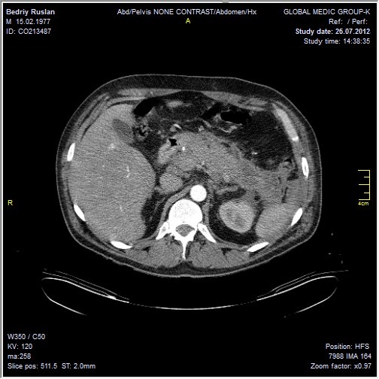
Fig. 1. Spiral computed tomography 26.07.12.

8/27/12 done operation - the removal of necrotic nekrsekvestrektomiyu retroperitoneal fat and retroperitoneal drainage subdiaphragmatic abscesses. 14.09.12 arozyvna bleeding occurred, which were treated conservatively. 10/10/12 - krizshkirne abscess drainage subdiaphragmatic space left under ultrasound. 20/10/12 discovered pancreatic fistulas, which were treated conservatively. 2/11/12 patient discharged to outpatient treatment.
A blood test on 22/12/16: leukocytes - 6.2 x 10 ⁹ / L, erythrocyte - 2% of band neutrophils - 6%, segmented - 46% monocytes - 6%, lymphocytes - 40%. Hemoglobin - 184 mg / dL, hematocrit - 45.4%, platelets - 205 × 10 ⁹ / L, erythrocyte sedimentation rate - 4 mm / h. Biochemical analysis of blood: "Hiloz" glucose - 17 mg / dL, total cholesterol -14.26 mg / dL, triglycerides - 21.92 mg / dL, high-density lipoprotein - are not defined, low-density lipoprotein - not determined, especially lipoproteins low density - 9 9 mmol / l.
12/29/16: pancreatic elastase in stool - 282 mg / g.
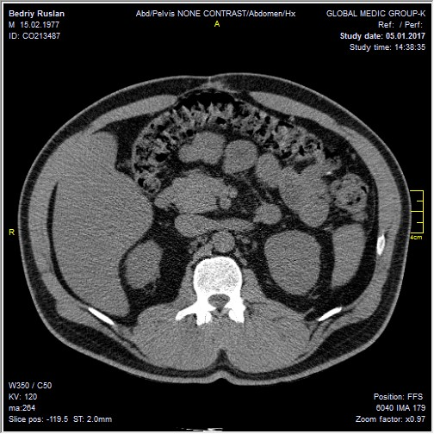
Fig. 2. Spiral CT 5/1/17.

Spiral CT on 01/05/17: signs hepatosplenomegaly, portal hypertension, steatohepatosis, chronic pancreatitis, hipovaskulyarne hearth diameter of 12.8 mm the head of the pancreas (Fig. 2).
Diagnosis: F ibroz pancreas. Giant postoperative hernia, fistula ligature, subcompensated medium severity insulin-dependent diabetes.
Assessment of quality of life of the patient, according to the questionnaire SF-36 [1]:
- PF (physical functioning) - 69.1 (from nachennya approaching 75 percentile standardized population values and indicates that physical activity (self climbing stairs) and execution of significant physical activity is not limited).
- RP (role-physical functioning, physical condition is caused by) - 60.9 (corresponds to 75 standardized population percentile values indicates what daily activities is not limited to the physical condition of the patient).
- BP (pain intensity) - 64.73 (75th percentile value exceeds the standardized population values, indicating that in the last month the pain did not affect the quality of life).
- GH (general health patient) - 46.61 (values between 25 and 50 standardized population percentile values are criteria for assessing the state of health at the moment).
- VT (vitality) - 70.41 (75th percentile value exceeds the standardized population values, indicating that the patient feels full of strength and energy).
- SF (social functioning) - 62.95, which is high and shows no restriction of social contacts, that level of communication does not suffer.
- RE (role-functioning caused by emotional state) - 60.19, which is high and indicates that the restriction in the performance of daily activities caused by emotional state of deterioration, no.
- MH (mental health) - 68.62 (large population-value, which indicates the absence of depression in a patient, disturbing experiences of mental distress).
Analysis of the results was carried out questionnaire SF-36 [1].
Discussion
Since 1885, when Speck was first reported on the relationship between hyperlipidemia and GP data published much on this issue. [11] It is believed that in serum triglycerides or chylomicrons are hydrolyzed lipase in the capillaries of the pancreas to release free fatty acids bind calcium ions ²⁺ trombuyut and damage the capillaries, leading to the development GP [11]. Patient in 2007 and 2012 suffered a severe necrotic form GP caused GT, although in both cases there was a reception of "energy" drinks without alcohol: in 2007 - uninfected forms of serious GP, and in 2012 - the infected necrotizing pancreatitis, which along with conservative treatment needed sekvestrnekrektomiyi with laparotomy access. In the immediate postoperative period having arozyvna bleeding, which treated conservatively and external pancreatic fistula. Along with the standard treatment of patients spent efferent therapy (hemosorption, plasmapheresis), insulin, heparin was administered. In remote pislyaoperatsyynyy period revealed a giant pislyaoperatsyynu hernia and fistula ligature. However, despite two bouts of pancreatitis necrosis / parapankreatytu and dangerous complications in the postoperative period,according to the questionnaire SF-36, close to the patient's condition satisfactory. If severe fibrosis in the pancreas patient received no enzymes and the content of pancreatic elastase in the stool equal to 282 mg / g. The clinical case demonstrates the dangers of repeated attacks necrotizing pancreatitis in patients with hyperlipidemia and need for efferent therapy for this disease. Patients with hyperlipidemia necessary to detect attacks of GP and conduct complex treatment aimed at normalizing triglycerides in the blood.

References:
- Популяционные показатели качества жизни по опроснику SF-36 (результаты многоцентрового исследования качества жизни «МИРАЖ») // Науч.-практ. ревматол. — 2008. — № 1.
- Сусак Я. М. Лікування хворих з гострим некротичним панкреатитом: правило «чотирьох катетерів» / Я. М. Сусак // Лучевая диагностика. Лучевая терапия. — 2016. — № 2. — С. 44–48.
- Fortson M. R. Clinical assessment of hyperlipidemic pancreatitis / M. R. Fortson, S. N. Freedman, P. D. Webster // Am. J. Gastroenterol. — 1995. — Vol. 90, No 12. — P. 21–34.
- Havel R. J. Approach to the patient with hyperlipidemia / R. J. Havel // Med. Clin. North. Am. — 1982. — Vol. 66. — P. 319–333.
- Insulin and heparin in treatment of hyper-triglyceridemia-induced pancreatitis / P. Jain, R. R. Rai, H. Udawat [et al.] // World J. Gastroenterol. — 2007. — Vol. 13. — P. 2642–2643.
- Kokosis G. Surgical management of necrotizing pancreatitis : an overview / G. Kokosis, A. Perez, T. N. Pappas // World J. Gastroenterol. — 2014. — Vol. 20, No 43. — P. 16106–16112.
- Organ failure and infection of pancreatic necrosis as determinants of mortality in patients with acute pancreatitis / M. S. Petrov, S. Shanblan, M. Chakraborty [et al.] // Gastroenterol. — 2010. — Vol. 139. — P. 813–820.
- Plasmapheresis in the management of acute severe hyperlipidemic pancreatitis : report of 5 cases / P. Kyriakidis, N. Karydakis, M. Neofytou [et al.] // Pancreatol. — 2005. — Vol. 5. — P. 201–204.
- Recurrent acute pancreatitis in a patient with type IIB hyperlipoproteinemia : a case report and review of the literature / B. C. Kim, M. J. Kim, W. C. Chang [et al.] // Korea J. — 2006. — Vol. 47, No 1. — P. 144–147.
- Systematic review of hypertriglyceridemia–induced acute pancreatitis: a more virulent etiology? / R. A. Carr, B. J. Rejowski, G. A. Cote [et al.] // Pancreatol. — 2016. — Vol. 16, No 4. — P. 469–476.
- Thannhauser S. Lipidoses: diseases of the intracellular lipid metabolism / S. Thannhauser. — 3rd ed. — New York : Grune & Stratton, 1958.
- Yadav D. The epidemiology of pancreatitis and pancreatic cancer / D. Yadav, A. B. Lowenfels // Gastroenterol. — 2013. — Vol. 144. — P. 1252–1261.

Treatment of a patient with relapsing hypertriglyceridemia-induced necrotizing pancreatitis: a case report
Y. M. Susak¹, O. A. Tkachenko², O. M. Lobanova²
¹National Medical University n. a. O. O. Bohomolets, Kyiv, Ukraine
²Kyiv City Clinical Emergency Hospital

Key words: acute pancreatitis, necrotizing infected pancreatitis, hypertriglyceridemia, surgical techniques, complications
This case report demonstrates a clinical treatment tactic of a 39 y.o. patient with acute necrotizing pancreatitis. The peculiarity of the disease course is its cause — hypertriglyceridemia associated with poorly managed type 2 diabetes. Within 5-year interval in 2007 and 2012 respectively, the patient suffered two attacks of severe necrotizing pancreatitis. In 2007 he had necrotizing noninfectious pancreatitis, and in 2012 — infectious necrotizing pancreatitis requiring open sequestrectomy. The patient underwent efferent therapy methods such as hemosorbtion and plasmapheresis in combination with standard treatment scheme. The post-operative period was marked by arrosive hemorrhage, subphrenic abscess, ligature fistulas and giant post-operative hernia. During all period of observation (2007 — 2017), the patient was suffering hypertriglyceridemia (blood test as of December 22, 2016 demonstrated high level of triglycerides — 21.92 mmol/L), which required the periodical plasmapheresis procedure. Despite two attacks of severe acute necrotizing pancreatitis, five years later the patient’s life quality according to SF-36 questionnaire is approaching normal.

