Chronic biliary pancreatitis
E. Y. Eremina, O. A. Strokova
Mordovian State University n. a. N. P. Ogarev, Saransk, Russia

Key words: pancreatitis, etiology, pathogenesis, biliary pathology, treatment of pancreatitis
Biliary pathology primarily variety biliary dysfunction, chronic cholecystitis and cholelithiasis (CL) are the most frequent cause of acute and chronic Biliary acute pancreatitis (BP) [8]. The prevalence of pathological conditions data is progressively increasing from year to year among all age categories of patients, especially in women [13]. The frequency of pancreatitis is different for different types of biliary pathology, according to different data, from 10 to 90%. Thus, with the incidence of cholelithiasis PD is 25-90%, and more [5]. Choledocholithiasis in 25-65% of cases leads to the development of BP. Frequent relapses of BP usually occur when small and very small stones (microliths) migrate. The most dangerous stones are less than 4 mm in size: they increase the risk of development of BP by four times.
The main mechanism for the development of BP is bilioduodenal hypertension, leading to the transfer of bile into the pancreatic duct and the activation of pancreatic enzymes in the pancreatic duct system (PZ). Biliary hypertension can be due to functional or organic causes. Functional refers to the sphincter of Oddi hypertension, especially when combined with hypertension of the duodenum (PDC); Hyperkinetic dysfunction of the gallbladder; A combined variant of biliary dysfunction, including hypokinetic dyskinesia of the gallbladder and spasm of the sphincter of Oddi; A violation of the synergism of the functioning of the sphincter apparatus of the choledochus and the main pancreatic duct; Various psychogenic and endocrine factors, accompanied by a change in the functioning of neurohumoral regulatory systems.
Organic causes of biliary hypertension are often represented by biliary sludge; Choledocholithiasis; Stenosing papillitis; Strictures and cysts of the distal choledochus; Compression of choledoch from outside with tumors, enlarged head of the prostate, spikes, enlarged lymph nodes or paraphatular diverticulum (especially with diverticulitis); Inconsistency of the large duodenal papilla due to papillo-sphincterotomy; Arterio-mesenteric obstruction; Lymphadenitis in the region of the Treitz ligament; Syndrome of the resulting loop after resection of the stomach; Helminthic invasion; Autoimmune or primary sclerosing (with defeat of choledocha) cholangitis; tumors of the bile duct or papillary [1, 6].
The prevalence of BP is high among patients who underwent cholecystectomy. Its development or progression in this category of patients is associated with traumatization of organs and tissues of the biliopancreatic zone, technical errors in surgical intervention, changes in anatomical and functional relationships of organs, development or progression of Oddi's sphincter dysfunction, choledocholithiasis and papillitis. Approximately one third of patients, even after successfully performed cholecystectomy, retain different degrees and duration of the clinic of pancreatitis, and at least a third of patients it progresses. Essential value in this belongs, along with biliary hypertension, to the biliary sludge. Biliary sludge and microliths, especially when combined with hypertension of the sphincter of Oddi, contribute to the development of stenosing papillitis, biliary pancreatic reflux and relapses of BP in the late postcholecystectomic period. BP relapses, directly or indirectly, can be associated with exacerbation of diseases of the gastroduodenal zone, especially those with hyperproduction of hydrochloric acid. Acidification duodenal contents contributes, on the one hand, stimulation of the secretory activity of the pancreas, and on the other, outflow disruption of pancreatic secretion and bile in the duodenum, which in turn leads to an exacerbation and progression of PD [16].
The development of exocrine insufficiency of the prostate in BP is associated with a decrease in the mass of the functioning exocrine parenchyma as a result of its atrophy or fibrosis, as well as a violation of the outflow of pancreatic secretion into the PDC. In addition, pancreatic insufficiency may occur because pancreatic enzymes are not activated or inactivated in the intestine, and in some cases this mechanism is leading in PD. So, for example, with LDS and postcholecystectomy dysfunction of the sphincter of Oddi, there is an asynchronism of admission to the PDC of bile and pancreatic juice. This contributes to inadequate activation of pancreatic lipase, its inactivation due to acidification of the DPC, a violation of fat emulsification and the formation of micelles. An additional factor aggravating the manifestations of exocrine insufficiency of the prostate is bacterial contamination of the small intestine.
According to our studies [2, 3, 4], clinical signs of impaired intestinal digestion with PD due to violation of not only the recessed, but also the membrane of the intestinal phase of digestion. They are characterized by a decrease in the activity of membrane-bound intestinal enzymes (sucrose, maltase, alkaline phosphatase, aminopeptidase, γ-amylase) and membrane-cytosolic dipeptidases in the mucosa of the small intestine, as well as changes in the regulatory properties of intestinal enzymes (see, for example, changes in alkaline phosphatase activity In the presence of a competitive inhibitor). The latter testified to the violation of enzyme adaptations of the intestine in conditions of natural polysubstrate digestion.
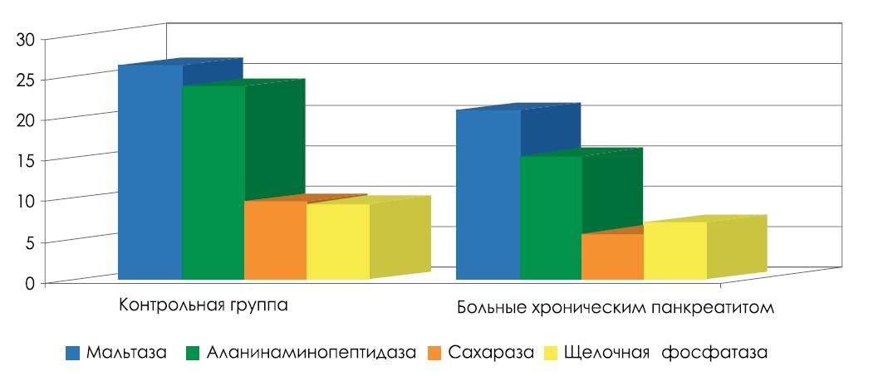
Fig. 1. Activity of some membrane-bound intestinal enzymes (μmol / min / g protein) in patients with chronic biliary pancreatitis.
Patients BP reduction was observed amylolytic activity in the digestive zone membrane, which occurs due to the intestinal membrane bound γ-amylase, and by reducing the amount of adsorbed fractions activity of pancreatic α-amylase [2, 3]. Disruption fermentsinteticheskih processes in the small intestine and exacerbate existing fermentopathia PD patients and contributes to lower protein content in the mucosa of the small intestine, which is responsible for the attenuation of mucosal resistance and disturbance of its regeneration [2, 3, 4].
The structural basis of the disturbance of the membrane stage of intestinal digestion in PD is the morphological changes in the mucous membrane of the small intestine according to the type of chronic ulnitis (in 66.7%) and the neurite with elements of atrophy (in 33.3%). Ultrastructural changes in intestinal villus epithelium (Fig. 2) show a thinning or disappearance of the glycocalyx, deformation, fragmentation vacuum intestinal microvilli and dystrophic changes of the enterocytes of intracellular structures [2]. The detected changes of the small intestine state in PD are progressive in nature and are compounded for prolonged disease course [4].
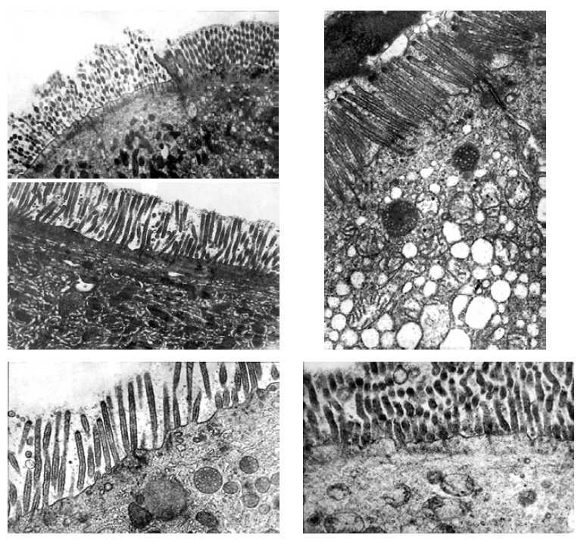
Fig. 2. Ultrastructure of the apical part of the epithelium of the intestinal villi in patients with chronic BP.
The peculiarity of the clinical symptomatology of BP is a combination of multiple manifestations of pancreatitis proper, biliary pathology and associated conditions (gastroduodenitis, duodenal gastric and duodenogastroesophageal reflux, exocrine insufficiency of the prostate, excessive bacterial growth in the intestine, irritable bowel syndrome, cholagic diarrhea, trophological, asthenovegetative disorders and Other). Traditionally, the BP clinic includes abdominal pain syndrome, symptoms of exocrine and endocrine insufficiency of the prostate, biliary hypertension and biliary insufficiency. Pain syndrome of varying severity and duration of the localization of epigastric pain, right or left hypochondrium and radiating it in the back is observed in 80-90% of patients [5]. Pain usually appears 0.5-1.5 hours after eating, in the evenings and at night. Their connection with overeating, consumption of acute, fatty, fried, smoked, very cold food is traced, especially when dietary errors are combined with alcohol. The pronounced pain syndrome develops when the concrement is infringed in the ampulla of the large duodenal papilla, accompanied by a violation of the outflow of pancreatic secretion and bile, and by the addition of signs of mechanical jaundice.
Mechanisms of pain abdominal syndrome in PD are diverse and subdivided into pancreatic and extra-pancreatic. Pancreatic mechanisms are associated with inflammatory edema of the prostate tissue, dilatation of its capsule, compression of nerve endings and vessels, obstruction of pancreatic ducts with protein precipitates, calcinates and fibrous tissue with increased intracavitary pressure in the ducts, pseudocyst formation and cysts (Fig. 3). For extra-pancreatic reasons, abdominal pain in PD includes compression of the common bile duct due to edema, fibrosis, cysts or pseudocysts of the head of the prostate; Cicatricial stenosis of the large duodenal papilla due to traumatization of its mucous membrane with bile calculi; Duodenal stenosis due to depression of the enlarged head of the prostate gland into the lumen of the PDC or pseudocysts; Duodenal hypertension; Concomitant diseases, as well as exocrine pancreatic insufficiency, leading to motor disorders of the digestive tract, disruption of enzymatic hydrolysis of food components, excessive gas formation as a result of microbial contamination of the duodenum and small intestine. Deficiency of pancreatic enzymes in PDC leads to an increase in the production of cholecystokinin-pancreosimin, which has a stimulating effect on the functional activity of the pancreas, which aggravates the course of pancreatitis and maintains a long-term preservation of the pain syndrome.
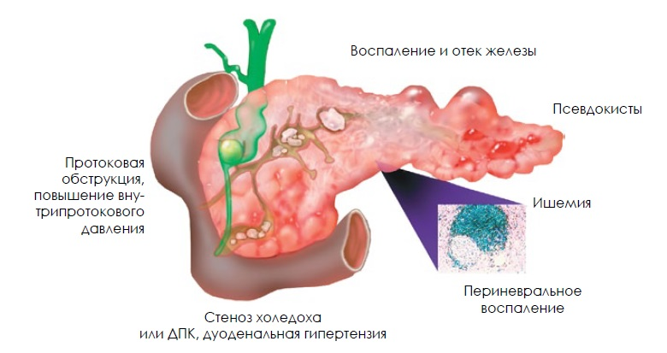
Fig. 3. Mechanisms abdominal pain syndrome in biliary pancreatitis [17].
The syndrome of endocrine disorders of the prostate, or "pancreatogenic" diabetes mellitus, is detected in about 1/3 of patients with BP with a duration of more than 10 years. The peculiarities of its course include a tendency to hypoglycemic conditions, the need for low doses of insulin, a rare development of ketoacidosis and vascular complications, the frequent development of diabetic neuropathy. In some cases with exacerbation of BP may be observed transient hyperglycemia, caused by edema of the prostate and suppression of trypsin production of insulin.
The diagnosis of BP consists of identifying objective signs of pancreatitis, determining the features of the disease that are important for the treatment of patients (the cause, the prevailing mechanism of development, the activity of inflammation in the prostate, enzyme, exoendocrine deficiency of the gland), the presence of complications and comorbid conditions, including diseases, Which are the direct cause of BP development. Verification of the diagnosis of BP is based on a thorough analysis of patient complaints, anamnesis, the results of basic and additional methods of objective examination. The two-stage algorithm for diagnosis of BP, proposed by the European multicenter group for the study of prostate diseases, is that a preliminary diagnosis of pancreatitis can be made at the stage of the patient's interview. Ultrasound and elastase test are offered as the first stage of additional diagnostic tests, and as a second step - detailed highly informative techniques: endoscopy and intraprostatic ultrasound, endoscopic retrograde cholangiopancreatography (ERCP), computed tomography (CT), spiral CT, CT with contrast enhancement, magnetic resonance Tomography (MRI), MRI-cholangiopancreatography (MRCP), etc., based on specific indications.
Given the high prevalence of BP-related pathology, it is advisable to include EGDS in a complex of diagnostic measures with a careful examination of the large duodenal papilla and the parafferal zone, examination of feces for dysbacteriosis, lipid spectrum of blood (especially triglycerides), calcemia, liver functional parameters (alanine and asparagine transaminases, Alkaline phosphatase, γ-glutamyltranspeptidase, bilirubin, proteinogram), ELISA for blood viral hepatitis, protozoa and helminths. If it is necessary to exclude RV cancer, a study is recommended in the dynamics of the level of serum tumor markers (CA 19-9 and cancer embryonic antigen).
The main direction of treatment of BP is the elimination of the cause of the disease - choledocholithiasis, cholecystolithiasis, strictures of the terminal section of the choledochus and large duodenal papilla, dyskinesia of the gall bladder and sphincter of Oddi, adenomas of the pharyngeal papilla, etc. To do this, modern possibilities of conservative, endoscopic and surgical treatment of these pathological conditions are used.
Drug therapy of BP proper and developed exocrine pancreatic insufficiency is primarily aimed at stopping pain (antispasmodics, analgesics), creating functional dormancy of the prostate (diet, octreotide, antisecretory and polyenzymatic drugs), adequate correction of exocrine insufficiency of the prostate (substitution polyenzymatic therapy) and prevention BP relapses during continuing causal factor or after its elimination [11].
An extremely important role in the treatment of patients with BP is the strict adherence to a gentle diet corresponding to the features of the course and stage of the disease, which reduces the functional activity of the prostate, the functional load on the gallbladder and the sphincter apparatus of the biliary tract.Basic principles of dietary therapy in patients with BP:
- hunger, adequate nutritional support and correction Water electrolyte Balance sheet at period Expressed Clinical displays (typically 2 - 3 days);
- the gradual transfer of the patient to a limited and then to a full oral food by Measure Improve the The general state satisfying Principles mechanical,thermal and Chemical "Schazheniya". With the expansion of the diet, the principle of gradualness should be strictly observed both in terms of increasing the volume and caloric content of the diet, and with regard to the inclusion of certain dishes and food products;
- Preservation of dietary restrictions during the period of remission of the disease. Even with a significant improvement in the state of health, sharp abnormalities should not be allowed either from the qualitative composition or from the nutrition regimen. Excluded from the diet products having a pronounced stimulating action on gastric and pancreatic secretion, is irritating to mucous membranes and receptor apparatus of the digestive system, as well as adversely affecting the liver function.
Expansion of the diet of patients with BP should be carried out "under the cover" of polyenzymatic drugs, which play an important pathogenetic role in the therapy of BP. On the one hand, they, on the "feedback" principle, reduce the exocrine secretion of the prostate and, thus, the pain syndrome, and, on the other hand, perform a substitution function in conditions of a decrease in the pancreatic secretion into the small intestine and intestinal digestion. For the treatment of PD patients using pancreatin preparations without the addition of bile satisfying the following requirements [5]:
- optimum of the enzymes in a physiological proportion, especially against lipase (at least 20 000 units on reception) and proteases, especially Significant forCupping Painful Syndromes (not less than 600 - 1000 IU on reception);
- the presence of acid-resistant jacket to avoid premature inactivation Pancreatin at stomach;
- minimum size granules pancreatin promotes rapid uniform mixing drug with food and synchronous evacuation KDP;
- optimal effect in the pH range 4.5 - 5.5 and Lack of Collateral effects.
To date, the most complete two-bolus polyenzymatic preparations of pancreatin of the latest generation, represented by minimocrosses (Creon), most fully meet these requirements. The minimal size of the pancreatin spheres (0.7-1.2 mm) allows them to homogeneously mix with the chyme the maximum achievable area (the area of ​​contact with the chyme of one Creon capsule is 25,000 is 19.2 cm 2) and synchronously with the chyme pass through the pylorus to the DPC [19]. Produced in the various embodiments (with lipase activity 10000, 25000, 40000 U), a fully balanced preparations for substitution of exocrine pancreatic insufficiency, and ensure full recessed digestion [9]. They are characterized by an optimal ratio of lipase activity and kolipazy, lipases and proteases, high karboksilesterolipazy and phospholipase A2 needed for effective splitting of fats. The high content of proteases (600-1000 FIP), destroying cholecystokinin and secretin, pancreozymin, ensures their antipain effect. Additional features Creon, demonstrated in recent studies [10], it provides the ability to suppress inflammation in the prostate by lowering proinflammatory and increasing anti-inflammatory cytokines, as well as reducing the TGF-β indicators reflecting processes fibrogenesis. Doses pancreatin microsphere are selected based on the severity of exocrine pancreatic insufficiency or fecal elastase levels [15]. In normal Content elastase in the feces (200 ug / g) of lipase daily dose does not exceed 50,000 IU; with moderate exocrine insufficiency (level elastase 100-199 mcg / g) - 100 000 IU; in severe exocrine insufficiency (elastase levels in the feces of less than 100 g / g) - 150000 IU. If the patient's diet consists of three main meals and 2-3 intermediate, it is recommended to take pancreatin containing 25,000 units of lipase in the main meals and 10,000 units in the interim. The main criteria for adequate doses are pancreatin increase or stabilize body weight of patients and normalization of stool reduction of flatulence.
For relief of pain in PD spazmolitichekie widely used drugs, including clinical advantage have selective myotropic spasmolytics (mebeverine, hyoscine butylbromide, otiloniya bromide, etc.). Along with selective antispasmodic effect, pronounced against biliarnopankreaticheskogo tract and bowel, they contribute to the normalization of intraduodenal pressure and do not cause a negative impact on the motility of the smooth muscle organs. This allows their use not only for hyperkinetic, but also when hypokinetic dysfunctions biliary tract and gut accompanying PD [7, 12, 21]. The course of treatment is 2-4 weeks. If necessary, a few courses antispasmodic therapy with different groups.
The variety of pain mechanisms in relapse PD may require nonnarcotic or narcotic analgesics (paracetamol, acetaminophen, ketorol, tramadol). Creating functional rest prostate, especially during the actual BS relapse achieved by using octreotide, proton pump inhibitors (PPI) or H blockers ₂ -receptor histamine (ranitidine, famotidine).
Treatment of PD relapse flowing with severe pain, you can begin with octreotide has an inhibitory effect on CCK, basal and stimulated pancreatic secretion. Reduction of the exocrine pancreas function can be achieved not only by direct inhibition of pancreatic secretion, but also indirectly by inhibiting the synthesis of hydrochloric acid, which reduces the formation of secretin and, to some extent, cholecystokinin. With this purpose antisecretory drugs (first 3-5 days parenterally, and then in the reduction of oral ingestion, per os). The duration of oral antisecretory therapy in PD must be at least three months. The need for long-term application and antisecretory drugs occurs after cholecystectomy for the prevention and treatment of PD relapse [14].
The combined treatment of PD patients at different stages and other drugs may be used for disease indications. In order to neutralize hydrochloric acid and the absorption of toxic components bile shows the assignment of antacids. To correct the impaired intestinal microbiocenosis PD patients, a t. H. After cholecystectomy, antibacterials are assigned local "intestinal" action (rifaximin, nifuratel, nifuroxazide) courses of 7-10 days [14], various probiotics and prebiotics.
The remission BP expedient purpose ursodeoxycholic acid (UDCA) 10-12 mg / kg / day. for a period not less than three months. Its use reduces the amount of bile microlites causing dyskinesias sphincter of Oddi and constrictive papillitis, leads to reduction of gastritis reflux esophagitis and reflux, often associated cholelithiasis and dysfunctional disorders of biliary tract [20]. It is established that long-term therapy to prevent the development of UDCA BP relapse in 75% of cases [18].
With the development in patients with anxiety, depression and other neurotic disorders frequently associated PD, useful inclusion complex therapy psychotropic drugs (neuroleptics, antidepressants, tranquilizers), providing further analgesic and analgesic effect potentiating action on non-narcotic analgesics. But most importantly, in order to prevent recurrence of the PSU must be timely adequate therapy of biliary pathology.

References:
- Еремина Е. Ю. Билиарная патология : метод. указ-я для врачей / Е. Ю. Еремина. — Саранск. — 2010. — 70 с.
- Еремина Е. Ю. Мембранное кишечное пищеварение и структура тонкой кишки у больных хроническим панкреатитом / Е. Ю. Еремина, О. А. Строкова // Практическая медицина. — 2010. — № 3. — С. 80–83.
- Еремина Е. Ю. Мембранное кишечное пищеварение у больных хроническим билиарнозависимым панкреатитом и способы его коррекции / Еремина Е. Ю. // Медицинский альманах. — 2009. — № 1. — С. 65–68.
- Еремина Е. Ю. Состояние кишечного пищеварения у больных хроническим панкреатитом / Е. Ю. Еремина, О. А. Строкова // Lambert Academic Publishing, 2012. — 100 с.
- Ильченко А. А. Билиарный панкреатит / А. А. Ильченко // РМЖ. — 2012. — № 15. — С. 803–808.
- Ильченко А. А. Болезни желчного пузыря и желчных путей / А. А. Ильченко. — М., 2011. — 880 с.
- Ильченко А. А. Применение мебеверина гидрохлорида при билиарной патологии в условиях поликлиники / А. А. Ильченко, М. Гельмедов // Врач. — 2003. — № 12. — С. 44–45.
- Калинин А. В. Функциональные расстройства билиарного тракта и их лечение / А. В. Калинин // Клинические перспективы гастроэнтерологии, гепатологии. — 2002. — № 3. — С. 25–34.
- Маев И. В. Болезни двенадцатиперстной кишки / И. В. Маев. — М. : МЕДпресс, 2005. — 511 с.
- Маев И. В. Болезни поджелудочной железы. В 2 т. Т. 2 / И. В. Маев, Ю. А. Кучерявый. — М.: Медицина. 2008. — 558 с.
- Минушкин О. Н. Хронический панкреатит: некоторые аспекты патогенеза, диагностики и лечения / О. Н. Минушкин // Consilium Medicum. — 2002. — № 4. — С. 23–26.
- Назаров В. Е. Методы фармакологической коррекции двигательноэвакуаторных нарушений желудка и двенадцатиперстной кишки / В. Е. Назаров, М. Ю. Кабанов // РМЖ. Болезни органов пищеварения. — 2004. — Т. 6, № 1. — С. 19–23.
- Некоторые вопросы эпидемиологии хронического панкреатита. «Клинико-эпидемиологические и этно-экологические проблемы заболеваний органов пищеварения» : материалы III Восточно-Сибирской гастроэнтерологической конференции / И. В. Маев, А. Н. Казюлин, Ю. А. Кучерявый [и др.] — Красноярск, 2003. — С. 9–52.
- Пастухов А. И. Результаты комплексного лечения хронического билиарнозависимого панкреатита после холецистэктомии : автореф. дисс. … канд. мед. наук / А. И. Пастухов. — М., 2010. — 23 с.
- Рекомендации Научного общества гастроэнтерологов России по диагностике и лечению хронического панкреатита // Экспериментальная и клиническая гастроэнтерология. — 2011. — № 7. — С. 122–129.
- Селезнева Э. Я. Клинические особенности течения желчнокаменной болезни, сочетающейся с язвенной болезнью двенадцатиперстной кишки и патогенетические особенности их развития / Э. Я. Селезнева, А. А. Ильченко // Экспериментальная и клиническая гастроэнтерология. — 2011. — № 4. — С. 31–36.
- Ammann R. W. Course of alcoholic chronic pancreatitis: a prospective clinicomorphological long-term study / R. W. Ammann, P. U. Heitz, G. Kloppel // Gastroenterology. — 1996. — Vol. 111. — P. 224–231.
- Idiopathic recurrent pancreatitis: long-term results after ERCP, endoscopic sphincterotomy, or ursodeoxycholic acid treatment / P. A. Testoni [et al.] // Am. J. Gastroenterol. — 2000. — Vol. 95. — P. 1702–1707.
- In vitro properties of different pancreatin preparations used in exocrine pancreatic insufficiency / J. M. Löhr [et al.] // Scand. J. Gastroenterol. — 2006. — Vol. 4. — P. 270–275.
- Sylwestrowicz T. A. Gallbladder function during gallstone dissolution. Еffect of bile acid therapy in patients with gallstones / T. A. Sylwestrowicz, E. A. Shаffer // Gastroenterology. — 1988. — Vol. 95. — P. 740–748.
- Toouli J. Biliary tract motor dysfunction / J. Toouli // Bailliere’s Clinical Gastroenterology / J. Dent (guest ed.). — London : Bailliere Tindal, 1991. — P. 409–430.

Chronic biliary pancreatitis
E. Y. Eremina, O. A. Strokova
Mordovian State University n. a. N. P. Ogarev, Saransk, Russia

Key words: pancreatitis, etiology, pathogenesis, biliary pathology, treatment of pancreatitis
The article represents the causes of the disease, pathogenic mechanisms, clinical symptoms, contemporary diagnostics and treatment techniques of patients with chronic biliary pancreatitis.

