Diagnosis of chronic pancreatitis according to magnetic resonance imaging data
N. A. Dyadkin, D. A. Lezhnev
A. I. Evdokimov Moscow State University of Medicine and Dentistry, Ministry of Health of the Russian Federation

Key words: magnetic resonance imaging, magnetic resonance cholangiopancreatography, pancreas, diagnostics, chronic pancreatitis
Introduction
Chronic pancreatitis (CP) is a progressive inflammatory disease of the pancreas, characterized by irreversible morphological changes in the parenchyma of the body [2]. HP pathological signs are inflammation, atrophy of the prostate, ductal changes and fibrosis. CP diagnosis is based on clinical symptoms, laboratory findings, the study of pancreatic exocrine function and imaging techniques [1, 3, 9]. Early diagnosis of CP can help prevent further destruction of the gland.
Endoscopy exocrine function is the most reliable tool for the diagnosis of CP and in some cases may indicate pancreatitis, even before visible changes duct by endoscopic retrograde cholangiopancreatography (ERCP) or magnetic resonance (MP) cholangiopancreatography (MRCP) [1, 8, 9]. Endoscopic ultrasonography is considered a reliable tool for visualization of changes in the parenchyma and ducts. However, the technique is not invasive and is available in all health centers. Computed tomography and ultrasound are less sensitive than MRI for evaluation of HP. The magnetic resonance imaging (MRI) can be used to assess both parenchymal and ductal changes, as well as to assess the reaction of the exocrine parenchyma and ducts after hormonal stimulation [8].
The aim of our research is to assess informative value of MRI in the diagnosis of pancreatic parenchyma changes and duct system in patients with suspected and/or diagnosed CP.

Materials and methods. The analysis of the MRI data of 120 patients (90 men, 30 women), aimed to the study of MRI-DTC IIBS Ivanovo suspected and/or diagnosed CP. All patients were treated at the surgical department of General Hospital. The age range of patients studied between 19 and 76 years old. Average age — 47.8 years, median 48 years. MRI performed on a tomograph with a magnetic field of 1.0 T (Siemens Magnetom Impact) using a phased array coil body. The study protocol includes a standard gradient sequence:
- T2-WI — HASTE (TR / TE 6,0 / 60 ms, thick, of sl. 7 mm), T 1- VI FLASH 2 d (TR / TE 210 / 4,0, thick. of sl. 7 mm) — for image-stationary armature and axial planes;
- Coronal T2-MI program with fat-suppression — to clarify the nature of the changes in the pancreas, peripancreatic tissue and Visualization area gates liver;
- T1-WI with fat-suppression at axial projection on region pancreas from thick Cutoff 6 mm — for detailed visualization of its structure;
- T2-WI with fat-suppression HASTE in a sagittal plane cross-section with a thickness of 4 mm — in the region of the head of the pancreas and the liver gate;
- MRCP was performed in two stages: initially — hard T2 TSE (TR / TE 2800/1100 ms, thick. of sl. 80 mm, matrix 240 × 256, FOV 400 mm) atzhiropodavleniem at oblique coronary projection;
- After the image was selected slice, which optimally visualized extrahepatic bile ducts. On this second slice exhibited sequence HASTE with fat-suppression at coronary projection (TR / TE 11.90 / 95 ms, thick. of sl. 3 mm, matrix 256 × 256, FOV 270 mm) followed by a three-dimensional (3 d)reconstruction in the MIP.
In the interpretation of MR images were evaluated three divisions of pancreas in the coronal, axial planes. The head and uncinate process were differentiated from the body in the sagittal sections of the superior mesenteric artery. The tail of the pancreas was identified as part of the pancreas, reaching the splenic pocket. Prostate size was determined in each of its department by measuring the anteroposterior diameter (AP) gland on axial T1-weighted images with suppression of signal from fat tissue. The size of the department of the pancreas was considered reduced, if the AR diameter is below the lower size limit of their age group. Virsungianov flow was characterized as normal, contraction or expansion or as a contact with the cyst. Dilated Wirsung’s duct considered if its diameter exceeds 3 mm, narrowed — only upon prestenotic dilation when visualized peripheral expansion of the duct adjacent to the area of stenosis [15]. Found in the pancreatic ducts belonging to HP, measured using MRCP according to the Cambridge classification (1983) [14].
Results and discussion. In 7 (5.8%) patients had visual signs of change in the parenchyma of the pancreas and the main pancreatic duct (MPD) have been identified. The parenchyma of the pancreas had a short relaxation time T1, the signal isointensive liver parenchyma. MPD gradually tapering from the head to the tail, it was the caliber of 2-3 mm, the edges were smooth, smooth. Side tributaries pancreatogramms were not visible (Fig. 1). In 2 studies, the head of the pancreas in terms of embryonic fusion of the ventral and dorsal noted narrowing duct, but it was not considered pathological change [13]. Patients with normal Wirsung’s duct and unchanged MP-signal pancreatic parenchyma were classified as healthy according to the Cambridge classification system [7, 14].
Uncertain MR changes of the pancreas and duct system and were found in 12 (10.0%) patients. Prostate size did not deviate from the age norm. The visual signs of reducing HP based on a signal from the parenchyma of the pancreas, MPD had gross irregularities. Lateral branches of the first and second order are not visualized. Dimensions flow varied depending on the age, sex, weight of the patient. The width of the duct in the region of the head is less than 3 mm, the body of pancreas — 2.5 mm, the tail — 1-2 mm (Fig. 2). According to the literature, based on a series pancreatogram average diameter GLP is 3-6, 2-7 and 1-6 mm for the head, body and tail, respectively [10]. While it is difficult to determine the upper limit of normal, that is, after correction for magnification, probably close to 6-5 mm in the head, 5 mm — 3 mm, and the body — the tail. These figures — indicative, and the absolute size of only GPP rarely decisive diagnostic value [13].
In the early stage of pancreatic exocrine insufficiency is determined by secretin stimulation test, which is a sensitive marker of HP [6]. Abnormal test results, characterizing the function of the pancreas, preceded by MRI findings in cases of lung flow HP in its early stages [11].
Light changes of the pancreas were visualized in 17 (14.2%) of patients studied and characterized by no more than two signs: either change the size of the prostate, or decrease the signal strength of the parenchyma (Fig. 3, 4) or the presence of lateral ducts or a single small, no more than 1.0 cm in diameter, pseudocysts. Width GLP less than 3 mm, but visualized single side tributaries and isolated small pseudocyst (Fig. 5). Deviation of the pancreas size in 8 patients was not detected. The transverse size of the prostate slightly higher than normal in 6 patients, 3 patients showed a slight decrease in its size.
Moderate changes in the pancreas in the form of a diffuse decrease in signal intensity, contour irregularities and prostate enlargement GLP with irregular ectatic and shorter lateral inflows were detected in 24 (20.0%) patients (Fig. 6). In 10 patients in the parenchyma rendered single pseudocysts, the size of which does not exceed 1.0 cm. Anteroposterior size of the pancreas in 4 patients had not changed in 11 — reduced from 9 — increased.
In 60 (50.0%) patients studied we had distinct changes in the pancreas. Of these, 54 showed signs of diffuse atrophy of the parenchyma of the pancreas, from 6 — focal changes. Rough GLP change occurred in all patients: 54 patients a diffuse increase in the flow all over, 6 patients revealed segmental obstruction to the expansion of upstream small pseudocyst (Fig. 5). Deviation of the pancreas size in 8 patients was not detected. The transverse size of the prostate slightly higher than normal in 6 patients, 3 patients showed a slight decrease in its size.
Moderate changes in the pancreas in the form of a diffuse decrease in signal intensity, contour irregularities and prostate enlargement pseudocyst — 34, intraductal calcification — at 21, the narrowing and/or obstruction of the common bile duct in the distal — in 6 patients.
Fig. 7 shows MRI scans, characterized by gross and obvious change in MP-CP in a patient 40 years, directed the survey with a bout of acute pain in the upper abdomen. In the history of acute pancreatitis, a year after which there were periodic bouts of moderate pain in the upper abdomen. Attacks of pain worried for 6 years. In the last year between attacks short, pain of varying intensity almost constant bother. On T2-WI in the coronal plane at the head of the pancreas is visualized pseudocyst with clear boundaries and formed a wall. I cyst compresses a portion of the duodenum, GLP and distal common bile duct. On T2-WI in the axial projection is clearly seen prestenotic expansion of GLP. In the area of the body and tail of GLP expanded to 0.9 cm, crimped, uneven, with cystoid expansion of lateral ducts. With relatively normal anteroposterior size of the body and tail of the pancreas is rendered decrease in prostate parenchyma due to atrophic changes.
Expansion of GPP, parenchymal atrophy, pancreatic calcification, fluid accumulation, focal pancreatic increase, expansion of the bile duct and changes in peripancreatic fat or fascia are frequent findings in patients with CP [11]. These findings are also often observed as secondary changes in patients with carcinoma of the pancreas [1, 12].

Conclusion. The standard MRI and MR cholangiopancreatography in the evaluation of CP enable to visualize changes in the signal pancreatic parenchyma to change channels, especially in patients with suspected CP, signs of atrophy of the parenchyma of the pancreas, fibrosis, estimate the size of the prostate and changes in the duct system. In milder forms of CP in the early stages of the most characteristic features are changes in prostate size and reduced signal parenchyma better identify on T1-WI with fat suppression. For moderate changes were characterized by attaching change the duct system as an extension of GLP to 5 mm with short ectatic side tributaries and isolated small cysts in the parenchyma of the pancreas. Upon evident morphological changes, MRI reveals enlargement of the pancreas enlargement, cystic transformation and deformation of the MPD, accompanied by atrophy and a decrease in the volume of pancreatic parenchyma. MRCP allows to identify the protein "plug" and/or concretions in MPD.

References
- Кармазановский Г.Г.Компьютерная томография поджелудочной железы и органов забрюшинного пространства/ Г.Г.Кармазановский, В.Д.Федоров. — М.: Русский врач,2002. — С. 70–86.
- Маев И.В.Болезни поджелудочной железы:практическое руководство / И.В.Маев, Ю.А.Кучерявый. — М.: ГЭОТАР-Медиа,2009. — 489 с.
- ХофферM. Компьютерная томография:базовое руководство/ M.Хоффер. — М.: Медицинская литература,2008.
- Balci C. MRI assessment of chronic pancreatitis/ C.Balci//Diagn. Intern. Radiol. — 2011. — Vol. 17. — P. 249–254.
- Choueiri N.E.Advanced imaging of chronic pancreatitis /N.E.Choueiri, N.C.Balci, S.Alkaade, F.R.Burton // Curr. Gastroenterol. Rep. — 2010. — Vol. 12. — P. 114–120.
- Chowdhury R.S.Pancreatic function testing/ R.S.Chowdhury, C.E.Forsmark // Aliment.Pharmacol.Ther.— 2003. — Vol. 17. — P. 733–750.
- EtemadВ.Chronic pancreatitis: diagnosis, classification, and new genetic developments/ В.Etemad, D.C.Whitcomb // Gastroenterology. — 2001. — Vol. 120. — P. 682–707.
- Findings on endoscopic retrograde cholangiopancreatography and pancreatic function test in suspected chronic pancreatitis and negative cross-sectional imaging / М.А.Parsi, D.L.Conwell, G. Zuccaro[et al.] //Clin. Gastroenterol. Hepatol.— 2008. — Vol. 6. — P. 1432–1436.
- ForsmarkС. Е. The early diagnosis of chronic pancreatitis / С.Е.Forsmark //Clin. Gastroenterol. Hepatol.— 2008. — Vol. 6. — P. 1291–1293.
- Freeny P. C.Radiology of the pancreas/ P. C.Freeny, T.L.Lawson. — N. Y. : Springer-Verlag, 1982.
- Luetmar P. H.Chronic pancreatitis: reassessment with current CT / P. H.Luetmar, D.H.Stephens, E.M.Ward // Radiology. — 1989. — Vol. 171. — P. 353–357.
- Pancreatic tumors: evaluation with endoscopic US, CT, and MR imaging/ M.F.Miiller, C.Meyenberger, P.Bertschinger [et al.]// Radiology. —1994. — Vol. 190. — P. 745–751.
- Pancreatography in chronic pancreatitis: international definitions/ A.T.R.Axon, M.Classen, P. В.Cotton[et al.] // Gut. —1984. — Vol. 25. — P. 1107–1112.
- Sarner M.Classification of pancreatitis/ M.Sarner, P. B.Cotton //Gut.— 1984. — Vol. 25. — P. 756–759.
- Tamura R.Chronic pancreatitis: MRCP versus ERCP for quantitative caliber measurement and qualitative evaluation/ R.Tamura, Т.Ishibashi, S.Takahashi //Radiology. — 2006. — Vol. 238, No 3. — P. 920–928.

Diagnosis of chronic pancreatitis according to magnetic resonance imaging data
N. A. Dyadkin, D. A. Lezhnev
A. I. Evdokimov Moscow State University of Medicine and Dentistry, Ministry of Health of the Russian Federation

Key words: magnetic resonance imaging, magnetic resonance cholangiopancreatography, pancreas, diagnostics, chronic pancreatitis
Aim: to estimate the informative value of magnetic resonance imaging (MRI) and MR cholangiopancreatography for diagnosing changes in the parenchyma and duct system of patients with suspected and/or diagnostically established chronic pancreatitis.
Material and methods. MRI was carried out in 120 surgical patients with suspected and/or diagnostically established chronic pancreatitis, by using a Siemens MagnetomImpact i.O T MRI system. The study protocol encompassed standard gradient sequences and MR cholangiopancreatography.
Results. No visual signs of changes were found in the pancreatic parenchyma and main pancreatic duct in 7 (5.8%) patients. There were undetectable MR changes in the pancreas and duct system in 12 (10.0%) patients. Mild changes in the pancreas were visualized in 17 (14.2%). Its moderate changes as diffusely reduced signal intensity, gland irregularities, and dilated main pancreatic duct with uneven ecstasized and shortened side branches were revealed in 24 (20.0%) patients. Most examinees (и 60 (50.0%)) had obvious pancreatic changes.
Conclusion. Standard MRI and MR cholangiopancreatography in evaluating chronic pancreatitis can visualize pancreatic parenchymal signal changes and altered ducts particularly in patients with suspected chronic pancreatitis, the signs of pancreatic parenchymal atrophy and fibrous changes and estimate pancreatic sizes and duct system changes.

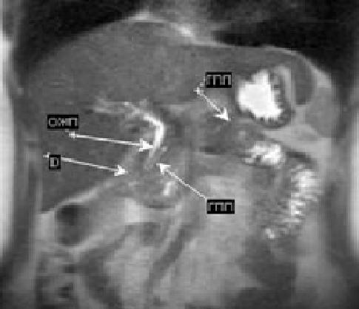
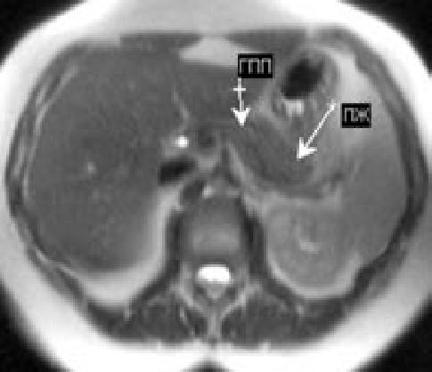
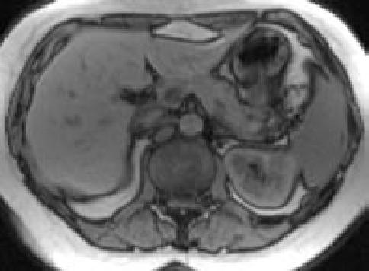
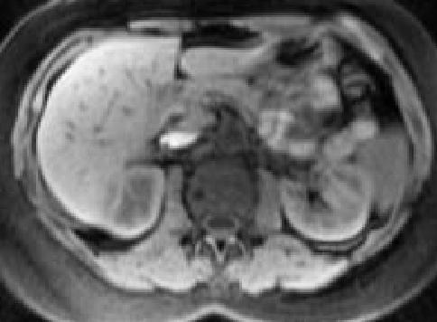
Fig. 1. MRI of patient W., 32 years old, with pain attacks in the upper abdomen, dyspeptic syndrome. It aims to survey the clinical diagnosis: postcholecystectomical syndrome, CP: a — T2-WI in the coronal projection visualized hepatopancreatoduodenal area: horseshoe of duodenum (D, the head of the pancreas, common bile duct (CBD) and MPD), b, c, d — T2-WI, T1 and T1-WI-WI with fat-suppression in the axial plane, the pancreas has isointensive signal liver and spleen, its dimensions correspond to age norm, contours precise, equal. On T2-WI visualized MPD non-expanded, the contours of which are lost in the tail of the pancreas parenchyma. Peripancreatic tissue is not changed.
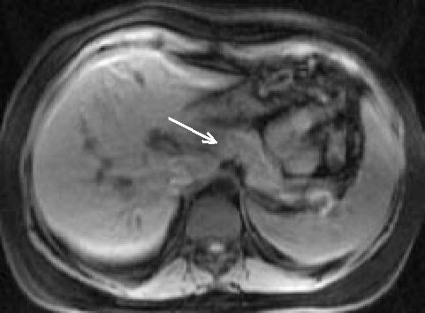
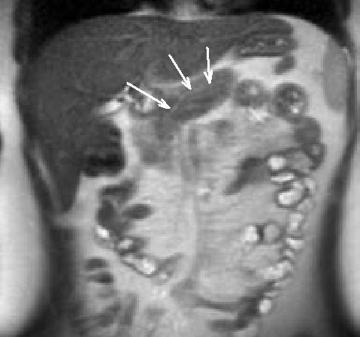
Fig. 2. MRI of patient M., 57 years old, clinical diagnosis of CP. Aimed at examination after an attack of biliary colic, chronic pain in the upper abdomen: a — T1-WI with fat-suppression, the prostate is of normal size, sufficiently clear contours in the area of the isthmus and the head of the pancreas marked local reduction signal without clear boundaries (arrow), b — HASTE T2-WI in the coronal plane is visible MPD non-expanded without side branches (arrows).
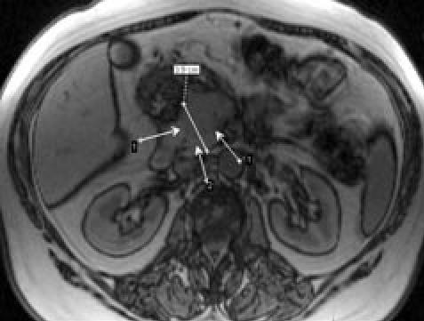
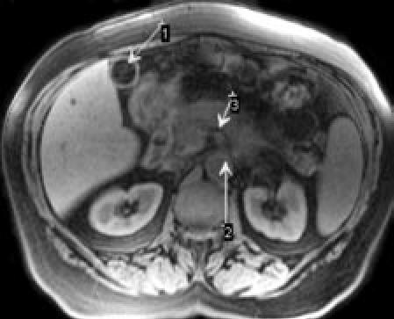
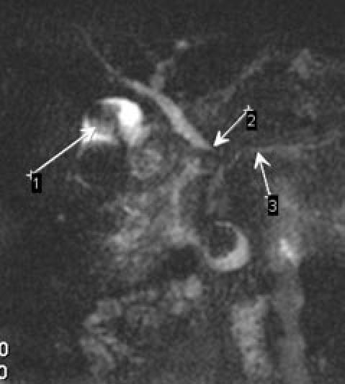
Fig. 3. MRI of patient A., 64 years old, suffering from gallstone disease, cholecystolithiasis, chronic cholangiogenic pancreatitis: a — T1-VI in the axial plane, the head of the pancreas is increased, it is visualized clearly delimited zone of low signal (arrow 1), the signal from the process not hooklike changed (arrow 2) b — "black pancreas" on T1-WI with fat suppression in the axial plane (arrow 1), stone large gall bladder, aorta to the outgoing superior mesenteric artery (arrow 2), unmodified perivascular tissue (arrow 3); c — MRCP: calculus in the gallbladder lumen (arrow 1), CBD, tapering in the distal (arrow 2), which penetrates the head of the pancreas fibrosis; MPD uneven, deformed (arrow 3).
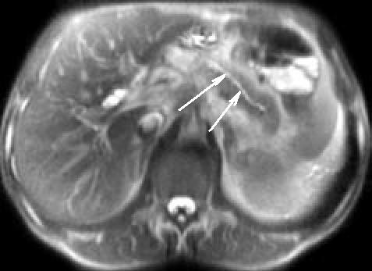
Fig. 4. MRI of patient Z., 47 years old, with recurrent pain in the upper part of the abdomen. T2-VI in the axial plane. In the field of body and tail of the pancreas visualized extended up to 5 mm and MPD ectatic lateral branches of the first order (arrows).
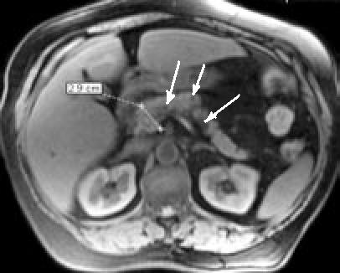
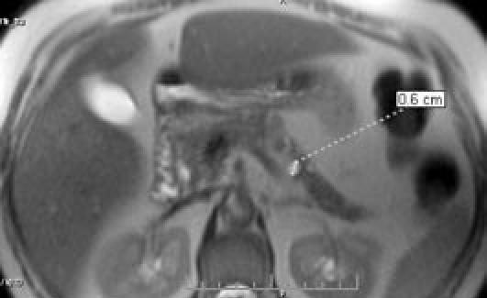
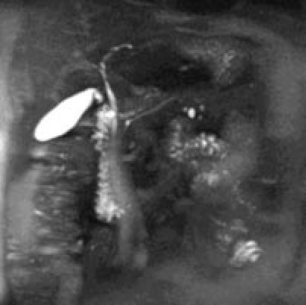
Fig. 5. MRI of patient B., 32 years old, with periodic pain in the upper abdomen, a history of attack of acute pancreatitis: a — T1-VI with the suppression of signal from fat tissue in the axial plane, the size of the head of the pancreas increased slightly (2.9 cm) , the signal from the pancreatic parenchyma with small foci of low signal on fat replacement acinar tissue (arrowheads), the size of the body and tail are reduced due to atrophic changes at the rear edge of the body of the pancreas is rendered small cystic formation with a diameter of 0.6 cm (large arrow); b — T2-VI in the axial plane on the same level, more clearly visible GLP and small pseudocyst (arrows); c — 3D-reconstruction of MR cholangiography visualized unmodified common bile duct, MPD without additional lateral jaws and cystic formation in the boundary regions of parenchymal the body of the pancreas is not communicating with the BPU.
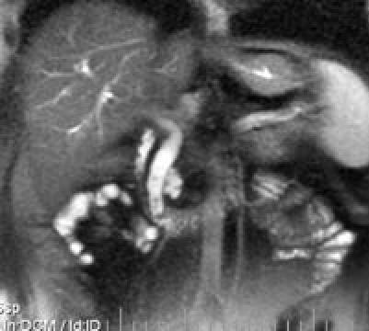
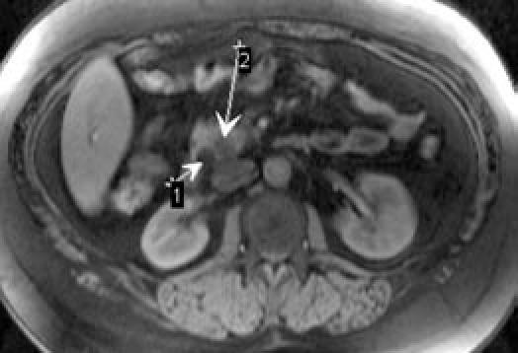
Fig. 6. MRI of patient D., 26 years old, with cholelithiasis and cholecysto-and choledocholithiasis, exacerbation of CP: a — T2-WI in the coronal plane, CBD is extended, in its lumen seen small stones in the pancreatic head — accumulation of fluid; b — T1 FS-VI in the axial plane is rendered advanced choledoch (arrow 1), atrophy and reducing the size of the head of the pancreas with paracholedochal fluid accumulation (arrow 2).
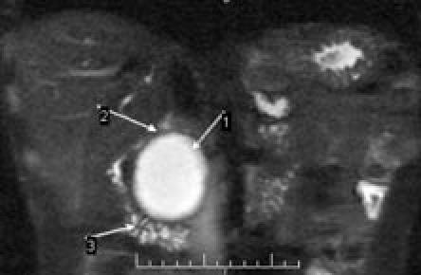
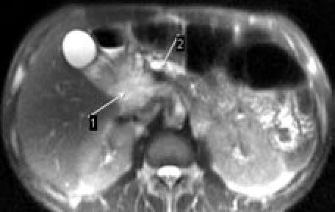
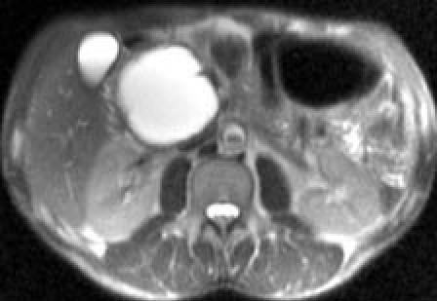
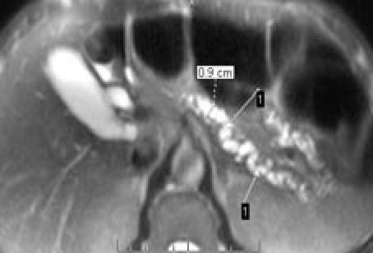
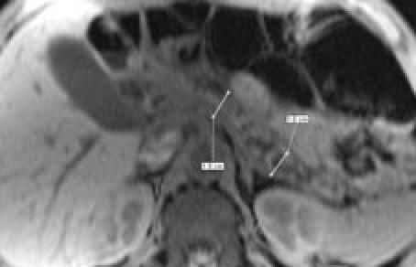
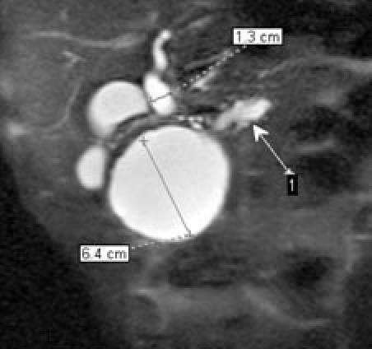
Fig. 7. MRI of patient P., 40 years old, with an attack of acute pancreatitis in history: a — T2-WI in the coronal plane, 1 — pseudocyst pancreatic head with a formed wall, 2 — I portion of the duodenum, 3 — down leg duodenum; b, c, d — T2-WI in the axial plane at different levels, pseudocyst occupies the entire head of the pancreas and compresses MPD at this level, MPD in the body and tail expanded to 0.9 cm, crimped, side ducts cystic dilated, twisted, e — T1-WI FS in the axial plane, with normal parenchyma anteroposterior size of the body and tail of the pancreas atrophied, its volume is reduced; f — MR-cholangiography, 1 — extended MPD above the obstruction, pseudocyst large (6.4 cm) deforms the duodenum, squeezes her I portion, CBD is extended to 1.3 cm and its pancreatic department is not visualized.

