Evidence-based pancreatology 2016–2017 (review of results of research on chronic pancreatitis)

N. B. Gubergrits^{1,2}, N. V. Byelyayeva^{1,2}, G. M. Lukashevich¹, P. G. Fomenko¹,

E. V. Berezhnaya², V. S. Rakhmetova³

¹Donetsk National Medical University, ²Medical Centre “Medicap” (Odessa), ³National Scientific Medical Centre (Astana, Republic Kazakhstan)

Key words: pancreatology, chronic pancreatitis, research, steatorrhea, diabetes mellitus, pancreatin

Facts are a thousand times more important than words.

I. P. Pavlov [1]

Of course, modern medicine must be based on the results of evidence-based research. This is an axiom that can not and should not be refuted. No matter how difficult the diagnosis and treatment, for example in pancreatology, the path to truth lies through highly predictive studies. With the development of pancreatology, new methods are emerging that require confirmation of efficacy and safety. The present review is devoted to the data of modern evidence-based research in the field of pancreatic pathology (PZ).

The highest level of evidence is a meta-analysis. Published results of new meta-analyzes in the field of pancreatology: in 2015 - 81, in 2016 - 23, in 2017 (before April) - 14. Most of them include randomized clinical trials comparing the evaluation of various surgical methods of treatment (More than 200 such studies) and devoted to cancer of the prostate (more than 300). In 2016 it published the first multidisciplinary clinical guidelines for pancreatic pain in chronic pancreatitis (CP) [8], and in 2017 - the first unified European clinical guidelines for the diagnosis and treatment of CP [17].

Not being able to because of the limited volume of the article to analyze in detail the recommendations for pain relief, give only three points from this document [8].

Question 1: The causes of pain in CP?

Pain in CP may be a consequence of a mechanical cause (intra-flow block), inflammation, malabsorption, or the nature of neuropathy in the prostate and / or surrounding tissues.

Level of Evidence: 2b.

Reliability recommendation: B.

Level Expert consensus: A 89%; B 9%; C 0%; D 0%; E 2%.

Question 8: Early correction of pain in patients with uncomplicated CP should be conservative?

Pharmacotherapy is the first-line therapy for abdominal pain in a patient with CP. With previously inadequately prescribed treatment, a modification of the scheme to the optimal one is necessary. In the presence of secondary psychiatric disorders, their specialized correction is necessary.

Level of evidence: 1b.

Reliability recommendation: B.

Level Experts Agree: A 65%; B 18%; C 8%; D 3%; E 6%.

Question 9: Does the value of lifestyle modification (cessation of alcohol consumption and smoking) to reduce pain in CP?

Stopping alcohol and smoking can reduce the severity of pain.

Level of Evidence: 2b.

Reliability recommendation: C.

Level Experts Agree: 49%; B 27%; C 19%; D 5%; E 0%.

Unfortunately, the questions of the specific conservative treatment of pain in these recommendations were not considered.

Unified European clinical guidelines for the diagnosis and treatment of CP are the result of a long (3 years) work of European experts, including from Ukraine. This document exhaustively covered all aspects of diagnosis and treatment of CP [17].

In our opinion, the most important aspect for the gastroenterologist is the aspect of substitution enzyme therapy for exocrine insufficiency of the prostate (EPI). We quote the relevant provisions of this from a voluminous document.
- 4.2-1 Question: What are the indications for a replacement enzyme therapy at CP?

Position 4.2-1: substitution therapy is indicated for KP EPI with the presence of clinical symptoms or laboratory evidence of malabsorption. An appropriate nutritional status study is recommended to identify signs of malabsorption.

Level 1A, strong agreement.
- Question 4.2-2: ako you to enzyme preparations choice?

Position 4.2-2: enteric coated microspheres or minimicrospheres smaller than 2 mm are the drugs of choice EPI. Micro- or mini tablets measuring 2.2-2.5 mm can also be effective, but scientific evidence of their effectiveness in CP is limited. Comparative clinical studies of various enzyme preparations are absent.

Level 1B, strong agreement.

Comments. The effectiveness of pancreatic enzyme preparations depends on several factors: 1) mixing with food; 2) evacuation from the stomach with food; (3) mixing with duodenal chyme and bile acids; 4) rapid release of enzymes in the duodenum.
- Question 4.2-3: ak to be at significant enzyme preparations?

The position of 4.2-3: enzyme preparations should be distributed between the main and intermediate meals.

Level 1A, strong agreement.
- 4.2-4 Question: What are the optimum dose to enzyme preparations with due EPI CP?

4.2-4 position: the minimum dose of lipase from 40 000 to 50 000 Ph. U. on the main meal and half the dose for an intermediate meal.

Level 1A, strong agreement.

Undoubtedly, all the necessary qualities and advantages are possessed by the minimosphere enzyme preparation Creon, which for several decades has reserved the right to be the "gold standard" of substitution enzyme therapy all over the world.

The European Pancreatology Club has released an application containing the "Unified European Clinical Recommendations for Diagnosis and Treatment of CP," which is available for both Android and iOS (Apple).

In order to download this application to your phone, it's enough to do 3 simple steps:
- Come in at Appstor (Apple) or Google Play (Android).
- Dial in search «Pancreatitis».
- Choose Free application UEG And upload it to your phone / tablet.

Evidence-based research in the field of pancreatology in recent years is divided into the following areas:
- n roteomnye Research - Search Of new Serological Markers Pancreatitis and Fibrosis pancreas;
- perfectioning of imaging techniques of pancreas;
- experimentally study with the study of new genetic factors, predictors of pancreatic diseases, including sah ary diabetes, various risks Of developmentHP and EPI.

Let us present the results of the studies that interested us.

A cross-sectional multicenter study "The risk of recurrence of acute pancreatitis (AP) and the development of CP after the first attack OP" [12]. The study included 669 patients from 15 centers (Netherlands). The study was conducted during 2003-2007, and the average follow-up period was 57 months.Clinical symptoms, data from radiation and laboratory studies, and the results of histology of the pancreas (not in all patients) with outpatient visits and repeated hospitalizations were analyzed. Particular attention was paid to abdominal pain, diabetes, steatorrhea, alcohol and smoking, medication. Regression analysis was performed with a Kaplan-Meier risk assessment. According to the results of the study, the incidence of recurrent OD was 17%, CP - 7.6%. Independent risk factors for the formation of recurrent OD and CP after the first episode of OP were smoking and pancreatic necrosis. The total risk of recurrent OD in 5 years: 40% for smokers, 18% for alcohol users, 13% for non-smokers. The frequency of causes of recurrent OD and CP after the first attack of OP is shown in Fig. 1.

According to the results previously published meta-analysis of risks of CP 10% and 36% of patients after myocardial OP and OP recurrent were obtained, respectively [6].

Based on the results of recent studies, it can be stated that there has been no significant "breakthrough" in the pharmacotherapy of CP. The leading drug for the treatment of HPA is Creon. As mentioned above, proteomic studies are being conducted, in particular, the indices of Mac-2-binding protein
(Mac-2-binding protein - Mac-2bp). During proteomic studies in the pathology of other organs was an increase in serum pathological glycoprotein Mac-2bp (not defined in the standard) in patients with breast cancer and lung, hepatitis C and autoimmune liver diseases (primary biliary cirrhosis, autoimmune hepatitis) [2]. As serological diagnostic biomarker of fibrosis Mac-2bp first identified in nonalcoholic steatohepatitis [9]. Currently, Mac-2bp seen as a potential serological marker of fibrosis in HCV and HBV-infection, idiopathic pulmonary fibrosis, hepatocellular carcinoma and pancreatic cancer [14].

T. Maekawa et al. (2016) surveyed 59 healthy volunteers, 162 patients with CP and 94 patients with pancreatic cancer. The level of Mac-2bp in serum was determined. Multivariate analysis showed that increasing Mac-2bp serum is an independent marker of CP (RV fibrosis). Serum levels of Mac-2bp were significantly higher in patients with CP than in healthy patients and patients with prostate cancer (Figure 2), highly correlated with ALT, GGTP, C-reactive protein levels, but not amylase, which suggests the production of Mac-2bp damaged liver [14].

Studies are continuing to assess the diagnostic information of various methods of visualization of the pancreas. According to some authors, leading endosonography (Fig. 3) [16]. The informativity of endosonography is even higher when using elastography with an estimation of quantitative indices. For example, deformation coefficient KP prostate tissue in case of EPI significantly higher than with the stored RV function (Fig. 4) [5].

Published systematic review and meta-analysis to assess the capabilities of the various imaging techniques in the diagnosis of CP (Table. 1) [3]. The meta-analysis included 43 studies (3460 patients with CP). The sensitivity of endosonography is comparable with the sensitivity of endoscopic retrograde cholangiopancreatography with a significantly lower risk of complications.

Table 1

Informativeness of various methods of visualization in CP

(by Y. Issa et al., 2017 [3])
Research | Sensitivity,%  (95% CI) | Specificity,%  (95% CI)
Endoscopic retrograde cholangiopancreatography | 82 (76 -87) | 94 (87-98)
transabdominal sonography | 67 (53-78) * | 98 (89-100)
Endosonography | 81 (70 -89) | 90 (82-95)
Magnetic resonance imaging | 78 (69 -85) | 96 (90-98)
CT scan | 75 (66 -83) | 91 (81-96)

Note. * P <0,05.

Interesting results were obtained in the meta-analysis pancreatitis risk assessment depending on the dose of alcohol consumed [13]. The results of 7 studies, which included 3618 patients with pancreatitis, including 1128 cases of CP, were analyzed. A dose-dependent relationship between the average volume of alcohol consumption and the risk of CP has not been proven (p = 0.091). It was obtained that abstinence from alcohol consumption determines the reduction in the risk of CP in women (RR 0.76, 95% CI: 0.60-0.97), but not in men (RR 1.1, 95% CI: 0.69- 1.74). The risk of developing CP was high only when using pure ethanol more than 100 g / day (RR 6.29, 95% CI: 3.04-13.02) (Figure 5).

Risk factors for diabetes when KP investigated in a study J. Pan et al. (2016) [10]. For the period 2000-2013. In China, 2011 patients with CP were examined (average duration of the disease is 22 years). At 564 patients during the observation, diabetes mellitus developed. The cumulative risk of diabetes mellitus for the period of 20 and 50 years from the onset of CP manifestation was 45.8% (41.8% -50.0% at 95% CI) and 90.0% (75.4% -97.7% At 95% CI), respectively. The risk factors for diabetes mellitus in patients with CP are presented in Table 2.

table 2

Risk factors for diabetes in CP (in J. Pan et al., 2016 [10])
Risk factors for diabetes mellitus in CP | Risk | 95% CI
Male | 1.51 | 1.08 -2.11
Alcohol abuse | 2.0 | 1.43 -2.79
Steatorrhea | 1.46 | 1.01 -2.11
Stricture of choledocha | 2.25 | 1.43 -3.52
Distal resection of the pancreas | 3.41 | 1.80 -6.44

A retrospective-prospective study of BR Li et al. (2016) have been devoted to the analysis of risk factors steatorrhea in CP [11]. For the period 2000-2013. 2153 patients with CP were examined. The average follow-up period for one patient was 9.3 years. In 291 patients (14%), steatorrhea developed. The results are presented in Tables 3 and 4. Factors that increase the risk of steatorrhea are male sex, alcohol abuse, diabetes mellitus, RV resection, and a long history of CP. The factor that reduces the risk of steatorrhea is adolescence.

Table 3

The frequency of steatorrhea in CP depending on the duration of the disease

(by BR Li et al., 2016 [11])
Duration in history  Risk factor | Risk [%] | 95% CI
1 year | 4.27 | 3.42 -5.34
5 years | 12.53 | 10.74 -14.59
10 years | 20.44 | 17.37 -23.98
20 years | 30.82 | 20.20 -45.21

Table 4

Factors that increase and reduce the risk of steatorrhea in CP

(by BR Li et al., 2016 [11])
Factors | n (%) | multivariate analysis
Factors | n (%) | Risk (95% CI) | P
Adolescence | 256 (13.75%) | 0.433 (0, 231-0,811) | 0.009
Male | 1286 (69.07%) | 1.771 (1, 195-2,623) | 0.004
Alcohol abuse | 341 (18.31%) | 1,503 (1, 053-2,145) | 0.025
Diabetes | 273 (14.66%) | 1,923 (1, 364-2,713) | <0.001
Resection of the prostate | 21 (1.13%) | 2,901 (1, 873-4,494) | <0.001

The systematic review and meta-analysis (21 studies in 2754 patients) comparing the results of relief of abdominal pain in CP surgical and endoscopic methods showed the benefits of surgical treatment [15].

Cochrane review to evaluate the efficacy of pregabalin for the relief of pain in CP included only one randomized clinical trial, which satisfied the selection criteria (other studies were irrelevant) [7]. The results of treatment of 64 patients with CP, who were receiving Increasing doses of pregabalin (from 150 mg / day to 600 mg / day, n = 34) or placebo (n = 30). The treatment lasted 3 weeks. The authors noted multiple defects in the design of the study, which do not allow judging the effectiveness definitely, despite the presence of a short-term positive effect of pregabalin. A conclusion was drawn on the necessity of carrying out more volumetric and design-corrected randomized studies with a longer observation period.

Significant to the practice of meta-analysis and systematic review was conducted to evaluate the effectiveness of enzyme therapy pancreatin in CP [4].The results of 17 randomized trials (511 patients with CP) were analyzed. A significant increase in the fat absorption coefficient was demonstrated when comparing the results before and after treatment with pancreatin, pancreatin and placebo. The efficacy of the treatment was increased by the appointment of optimal doses (40,000-50,000 Ph.U. for the main meal and 20,000-25,000 Ph.U. for intermediate meals). Moreover, a further dose increase is the significant growing fat absorption coefficient is not allowed. In addition, the effectiveness of substitution enzyme therapy was higher when using acid-tolerant drugs (with enteric coating), when taking the drug during meals, and when accompanied by proton pump inhibitors.

Summarizing, we emphasize that the development of innovative diagnostic methods and genetic screening will provide early diagnosis of CP and reduce the risk of functional failure of the pancreas. Improvement of clinical recommendations based on the results of evidence-based research is the most correct way to improve diagnosis and treatment in pancreatology. But this does not exclude, but involves taking into account the practical experience of the doctor. Like I. P. Pavlov said: "If there are no ideas in my head, then you will not see the facts" [1].

References:
- Мудрые мысли о медицине и врачевании: изречения, афоризмы, цитаты / Авт. композиции Я. С. Циммерман. — 4-е изд., доп. — М. : ГЭОТАР-Медиа, 2015. — 256 с.
- 90K (Mac-2bp) and galectins in tumor progression and metastasis / A. Grassadonia, N. Tinari, I. Iurisci [et al.] // Glycoconj. J. — 2004. — Vol. 19, No 7–9. — P. 551–556.
- Diagnostic performance of imaging modalities in chronic pancreatitis : a systematic review and meta-analysis / Y. Issa, M. A. Kempeneers, H. C. van Santvoort [et al.] // Eur. Radiol. — 2017. — [Epub ahead of print].
- Efficacy of pancreatic enzyme replacement therapy in chronic pancreatitis : systematic review and meta-analysis / D. de la Iglesia-Garcia, W. Huang, P. Szatmary [et al.] // Gut. — 2016. — [Epub ahead of print].
- EUS elastography to predict pancreatic exocrine insufficiency in patients with chronic pancreatitis / J. E. Dominguez-Munoz, J. Iglesias-Garcia, M. Castineira Alvarino [et al.] // Gastrointest. Endosc. — 2015. — Vol. 81, No 1. — P. 136–142.
- Frequency of progression from acute to chronic pancreatitis and risk factors : a meta-analysis / S. J. Sankaran, A. Y. Xiao, L. M. Wu [et al.] // Gastroenterology. — 2015. — Vol. 149, No 6. — P. 1490–1500.
- Gurusamy K. S. Pregabalin for decreasing pancreatic pain in chronic pancreatitis // K. S. Gurusamy, C. Lusuku, B. R. Davidson // Cochrane Database Syst. Rev. — 2016. — Vol. 2. — CD011522.
- Mechanism, assessment and management of pain in chronic pancreatitis / M. A. Anderson, V. Akshintala, K. M. Albers [et al.] // Pancreatology. — 2016. — Vol. 16, No 1. — P. 83–94.
- A novel noninvasive diagnostic method for nonalcoholic steatohepatitis using two glycobiomarkers / Y. Kamada, M. Ono, H. Hyogo [et al.] // Hepatology. — 2015. — Vol. 62, No 5. — P. 1433–1443.
- Risk factors for diabetes mellitus in chronic pancreatitis : a cohort of 2011 patients / J. Pan, L. Xin, D. Wang [et al.] // Medicine (Baltimore). — 2016. — Vol. 95, No 14. — e3251.
- Risk factors for steatorrhea in chronic pancreatitis : a cohort of 2,153 patients / B. R. Li, J. Pan, T. T. Du [et al.] // Sci. Rep. — 2016. — Vol. 6. — P. 21381.
- Risk of recurrent pancreatitis and progression to chronic pancreatitis after a first episode of acute pancreatitis / A. U. Ahmed, Y. Issa, J. C. Hagenaars [et al.] // Clin. Gastroenterol. Hepatol. — 2016. — Vol. 14, No 5. — P. 738–746.
- Samokhvalov A. V. Alcohol Consumption as a risk factor for acute and chronic pancreatitis : a systematic review and a series of meta-analyses / A. V. Samokhvalov, J. Rehm, M. Roerecke // EBioMedicine. — 2015. — Vol. 2, No 12. — P. 1996–2002.
- Serum Mac-2 binding protein is a novel biomarker for chronic pancreatitis / T. Maekawa, Y. Kamada, Y. Ebisutani [et al.] // World. J. Gastroenterol. — 2016. — Vol. 22, No 17. — P. 4403–4410.
- Surgery remains the best option for the management of pain in patients with chronic pancreatitis : a systematic review and meta-analysis / Z. A. Jawad, C. Kyriakides, M. Pai [et al.] // Asian J. Surg. — 2016. — [Epub ahead of print].
- Teshima C. W. Endoscopic ultrasound in the diagnosis and treatment of pancreatic disease // C. W. Teshima, G. S. Sandha // World J. Gastroenterol. — 2014. — Vol. 20, No 29. — P. 9976–9989.
- United European Gastroenterology evidence based guidelines for the diagnosis and therapy of chronic pancreatitis (HaPanEU) / J. M. Lohr, E. Dominguez-Munoz, J. Rosendahl [et al.] // United European Gastroenterology Journal. — 2017. — Vol. 5, No 2. — P. 153–199.
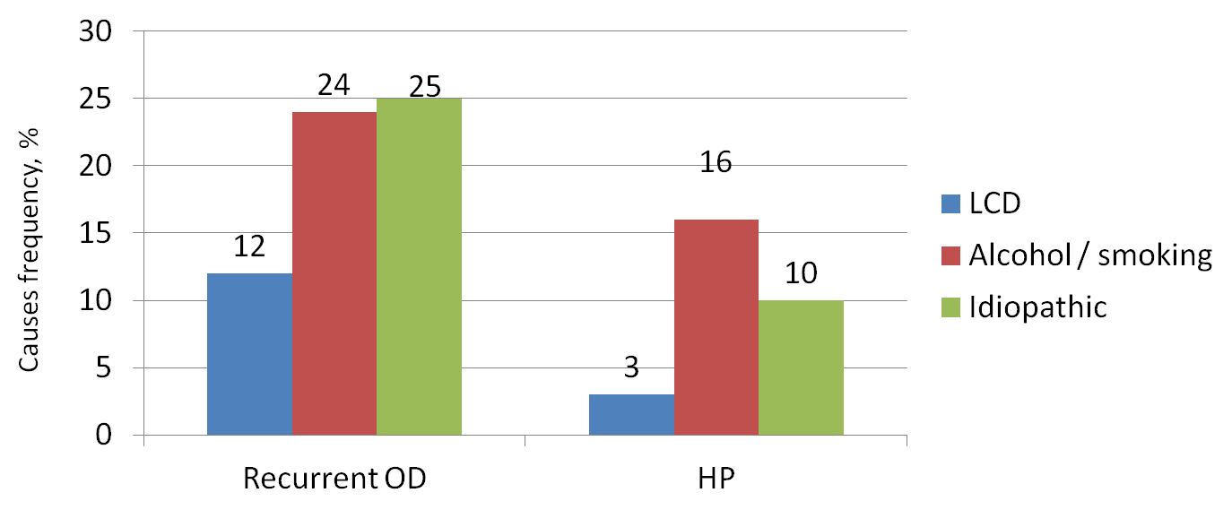

Fig. 1. Frequency and causes recurrent OP OP CP after the first attack (by AU Ahmed et al., 2016 [12]).

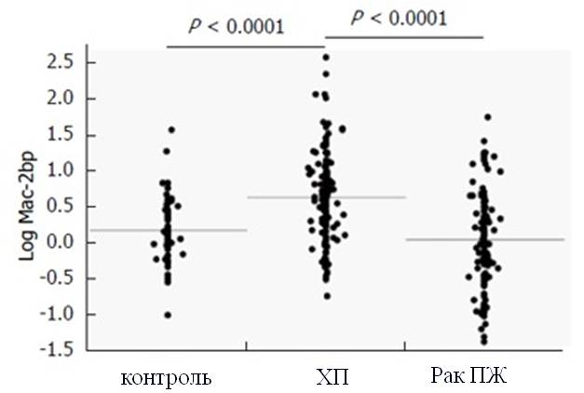

Fig. 2. Mac-2bp levels in patients and healthy examinees (by T. Maekawa et al., 2016 [14]).

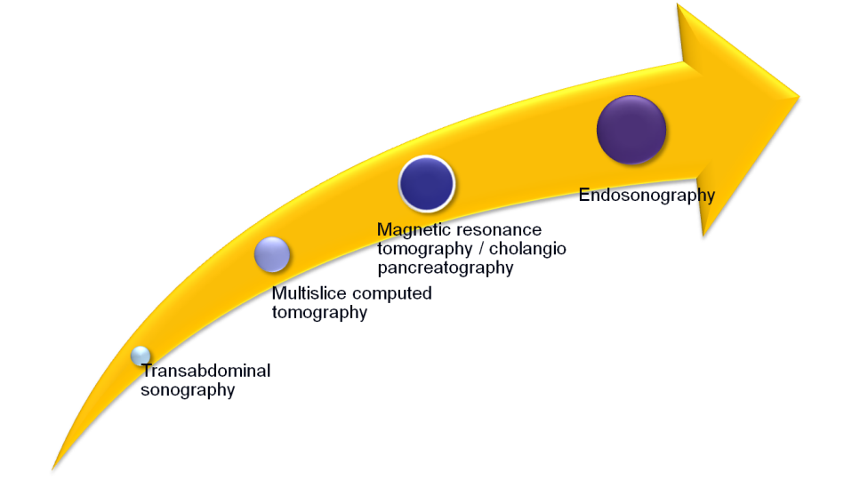

Fig. 3. The diagnostic information content different RV imaging techniques (for CW Teshima et al., 2014 [16]).

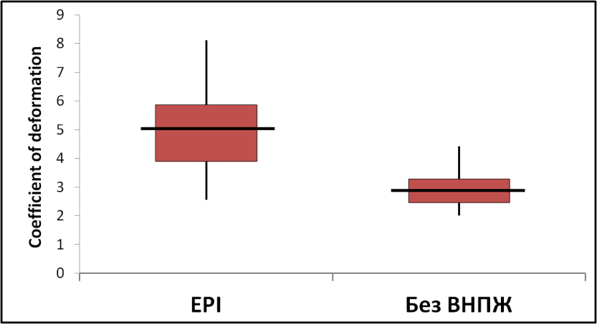

Fig. 4. Coefficient of deformation at prostatic tissue elastography in CP patients depending on the presence EPI (by JE Dominguez-Munoz et al., 2015 [5]).

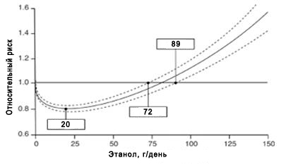

Fig. 5. The risk of CP in a dose dependent received ethanol (for AV Samokhvalov et al., 2015 [13]).

Evidence-based pancreatology 2016–2017 (review of results of research on chronic pancreatitis)

N. B. Gubergrits^{1,2}, N. V. Byelyayeva^{1,2}, G. M. Lukashevich¹, P. G. Fomenko¹,

E. V. Berezhnaya², V. S. Rakhmetova³

¹Donetsk National Medical University, ²Medical Centre “Medicap” (Odessa), ³National Scientific Medical Centre (Astana, Republic Kazakhstan)

Key words: pancreatology, chronic pancreatitis, research, steatorrhea, diabetes mellitus, pancreatin

The article reviews the European recommendations on diagnostics and treatment of chronic pancreatitis, pain relief upon chronic pancreatitis. The results of evidence-based studies on risk factors of functional pancreatic insufficiency in patients with chronic pancreatitis, assessments of the informative value of various imaging methods, treatment of pancreatic insufficiency, markers of pancreatic fibrosis are analyzed. A conclusion is drawn on the need for further conduction of evidence-based research.

