Duodenal dystrophy — an interdisciplinary problem
L. V. Vinokurova, I. Y. Khatkov, R. Y. Izrailov, D. S. Bordin, Y. A. Dubtsova, K. A. Nikol’skaya, M. A. Agafonov, A. V. Andrianov
Moscow Clinical Scientific Center, Russia

Key words: chronic pancreatitis, duodenal dystrophy, ectopic pancreas, treatment, mini-invasive surgical techniques
Duodenal dystrophy (DD) — lesion of the duodenum wall caused by chronic inflammation in its ectopic pancreatic tissue. Incremental (aberrant) of the pancreas is the most common abnormality of this organ. Additional pancreas has no anatomic or vascular connection with the main. The most frequently observed is the ectopy of pancreas in the stomach wall — a 25 — 60% of cases, and in the wall of the duodenum — a 25 — 35% [16, 19]. It can be caused metaplasia endodermal multipotent cells in situ, or moving embryonic pancreatic cells to neighboring structures [20]. Other sites of additional pancreas are described: ileum, Meckel diverticulum, bile duct, liver, spleen, omentum, mesentery, mediastinum, esophagus, colon, fallopian tubes. Most ectopic tissue is located in the submucosa (75%), at least — in the muscular layer (15%) or subserous (10%) [16].
DD was first described in 1970 by French authors F. Potet and N. Duclert [18]. DD is a fibrotic thickening of the wall to form a duodenum cysts in her muscle and/or submucosal layer [18]. Progression of chronic pancreatitis in orthotopic pancreas in the presence of an ectopic focus in the duodenum, usually accompanied by the development of DD. However, the sequence described, and other events when the progression of ectopic pancreatitis vertical branch duodenum can result in compression of the main pancreatic duct (GLP) and developing obstructive pancreatitis orthotopic prostate [12 22]. In this case, acute or chronic pancreatitis with a primary lesion of the head of the pancreas or at all over a period considered as a complication of DD [11].
Differential diagnosis of this pathology is performed with tumors, chronic pancreatitis of m and congenital abnormalities of the pancreas. Depending on the predominance of fibrotic or cystic changes secrete cystic and solid options of DD, which are the stages of the pathological process. Option is determined by the diameter of cysts detected imaging techniques: the cystic form of the disease the brush diameter is more than 1 cm, with a solid — not more than 1 cm, in addition there is a mixed version — a combination of soft tissue component with cysts of diameter larger than 1 cm [11]. The inner surface of the cysts formed in DD devoid epithelial lining, and in its lumen, in most cases, or hemorrhagic necrotic contained liquid can be formed concrements. The walls surrounding the duodenum marked hypertrophy of duodenal glands [3].
The main clinical manifestations of DD are epigastric pain, weight loss and jaundice. These symptoms are not specific and may indicate other disease pancreatoduodenal department, including: HP, pancreatic cancer, gallstones, which determines the difficulty of diagnosis of this disease. The pain may be constant or recurrent, accompanied by nausea and vomiting. The most commonly DD, as well as chronic pancreatitis suffer men aged 40 — 50 years who abuse alcohol.
In laboratory studies, there may be an increase in serum amylase in patients with jaundice — an increase in bilirubin, alkaline phosphatase and GGT. Level of oncomarkers is usually not changed. [3]
Upon endoscopic and radiographic studies can reveal Lena submucosal education duodenum, duodenal stenosis, and the only signs of duodenitis note by morphological study of biopsy material.
The leading role in the diagnosis of DD play modern ray imaging techniques. When computed tomography (CT), magnetic resonance imaging (MRI) and endoscopic ultrasound (EUS) cystic DD is defined as a thickened wall due to fibrosis WPC containing abdominal formation [10, 11]. A specific feature of DD with CT and MRI is the parietal cystic formation with the presence or absence of severe soft tissue component of the fibrous seal manifested compact layer of tissue between the duodenum and pancreas lumen [10].
In the literature there are reports of long-term treatment of DD by octreotide, using endoscopic method, how cystogastrostomy, fenestration, but their outcome remains unsatisfactory [1, 21]. The leading method of treatment of patients with DD is surgical [4, 7 8]. When expressed fibrocystic changes in pancreas and duodenum operation of choice recognized pancreatoduodenal resection (PDR) [7, 8]. The most promising is the use of laparoscopic techniques, for which X is characterized by less blood loss, the absence of inflammatory edited presumably, to changes from the wound, reducing Ohm severe pain in the postoperative period and quicker rehabilitation of patients [13, 14, 15 17]. However, laparoscopic PRD limited technical capabilities of the hospital, the need for special surgical skills and knowledge I have surgery this area. We did not encounter in the available literature sources publications on laparoscopic DA with DD.
The separate lesions and ectopic pancreatic duodenal resection is possible with preservation of the main pancreatic [4]. Nevertheless, the global experience in such interventions is minimal, and the benefits are not clear enough, which does not allow recommend this method for widespread use.
Clinical observations. Patient N., 44 years, for the first time addressed the MKNTS in July 2014 complaining of constant pain in the upper abdomen average intensity (6-7 on a 10-point verbal descriptive pain scale), radiating to the lumbar region, does not eliminate the reception antispasmodics, belching air, preferably on an empty stomach, bloating, rumbling in the abdomen, weight loss of 10 kg over the last year.
From anamnesis it is known that since 1998 the patient abused alcohol. In 2012, it began to concern pain in the upper abdomen. Upon outpatient examination, we diagnosed CP. In March of 2013 against the backdrop of uncertainty in the diet appeared intense pain in the upper abdomen. Upon emergency hospitalization, according to the ultrasound a cyst of the head of the pancreas was revealed. He received conservative treatment with a positive effect. With the February 2014 attacks of pain in the upper abdomen increased, disturbed month, leading to rehospitalization. In April 2014, along with the pain began to bother vomiting after every meal, complicated by gastrointestinal bleeding. He was urgently hospitalized. When endoscopy revealed a Mallory-Weiss syndrome, held gastrointestinal bleeding, signs of compression of the outside front wall of the bulbous transition and the upper horizontal branch of the duodenum. MRI in May 2014 revealed the expansion of the main pancreatic duct, polycystic transformation of pancreatic cysts in parapancreatic edematous tissue. In June 2014 the patient was hospitalized in the Department of Pathology of the pancreas and biliary tract of Moscow Clinical Scientific Center of the Central Research Institute of Gastroeneterology.
When ultrasound revealed diffuse changes in the liver, gall bladder deformation, the slurry in the gallbladder, calcification signs of chronic pancreatitis, cyst in the pancreatic head. The bulb and the descending duodenum department IME whether a circularly thickened walls up to 7-11 mm in the wall of the duodenum were single hypoechoic areas from 4 to 5 mm (cyst?), duodenum clearance was slightly narrowed. Therefore, we identified ultrasound signs of duodenal dystrophy.
As a result of endoscopy: a superficial gastritis. Duodenal bulb of the medium size. Exit bulbs narrowed by a circular wall thickening bulbous transition and the upper horizontal part.
Endoscopic ultrasonography (EUS) was performed to confirm the DD and uncovered ascites, sonographic signs of DD calcification chronic pancreatitis, pancreatic cysts forming head, pancreatic hypertension. Lymphadenopathy was noted in the course of hepato-duodenal ligament (Fig. 1).
These abdominal MSCT with contrast enhancement showed the presence of calcification in a patient pancreatitis virsungolitiaza, pancreatic hypertension with a block at the level of the head of the pancreas. We were yyavleny Postnecrotic cyst in the pancreatic head, duodenal dystrophy, ascites.
In the clinical analysis of blood hemoglobin level was 11.6 g/dl. Biochemical analysis of blood — without features. There was an increase of urine diastase to 804 IU/l (at a rate of 45-450 U/l). Tumor markers CA 19-9 and CEA — within the reference values. The level of fecal elastase-1 was 150 mg/g (<200 ug/g).
The patient was completely laparoscopically gastropankreatoduodenalnaya resection was performed. Such interference technology has been successfully used in the treatment of patients with biliary pancreatoduodenal cancer [5]. At post mortem examination and remote gastropancreatoduodenal complex revealed chronic calculous pancreatitis; duodenal dystrophy, cystic (Fig. 2).
Early postoperative period was uneventful. The patient was discharged on the 8th day in a satisfactory condition. Severity of pain was reduced to 2 points.
After 3 weeks after surgery the patient began to disturb frequent stools up to 4-6 times a day, changing its consistency to the pasty, the appearance of weakness, weight loss. At the laboratory study decreased the concentration of fecal elastase and 15 mcg/g of feces (severe degree of pancreatic insufficiency). Showed a reduction in blood levels of insulin and 2.0 uU/ml (normal 2.7-10.4) and C-peptide to 156 pmol/l (normal 258-1718), while glucose levels and glycosylated hemoglobin (5.4 %) remained in the norm.
The patient was recommended intake polyenzyme drugs minimicrospheres mini-pill or a dose of 40,000 IU for lunch and dinner, and 25,000 IU for breakfast and snacks. Compliance with a diet low in carbohydrate, measuring fasting blood glucose, once every 3 months determining the level of glycated hemoglobin monitoring gastroenterologist, endocrinologist on a residence.
After 5 months of starting enzyme replacement therapy the patient had no complaints, the pain is not disturbed, the chair was normalized (1 per day), there was an increase in weight of 5 kg.
In the present case, the clinical picture of the disease, endoscopy and ultrasound data allowed the suspect, and MSCT and EUS — confirm the diagnosis of DD.
Endoscopic and radiological examination allowing detect deformation and narrowing of the lumen of the duodenum. To exclude a malignant process is a mucous duodenal biopsy that a patient with DD usually reveals only signs of inflammation. Greatly facilitates the diagnosis of DD endoscopic ultrasonography, determining the affected area, its prevalence, character education, and to rule out other causes of narrowing of the duodenum, such as swelling and annular pancreas [1, 2, 9].
Thus, in the diagnosis and treatment of rare diseases such as duodenal dystrophy, requires close cooperation of doctors of several specialties: gastroenterologists, surgeons, endoscopists, beam diagnostics specialist. A careful analysis of the clinical picture of the disease and the specific visual research data allow us to establish the correct diagnosis. When expressed pain syndrome and violation of passage of food through the duodenum arises the need for surgical treatment. Operation of choice is the PRD, as a rule effectively eliminates u th pain. The use of laparoscopic approach in these patients it is advisable in the presence and in the clinic of relevant experience. However, the consequences and often develop pancreatic insufficiency requiring constant enzyme replacement therapy and correction of violations of carbohydrate metabolism. Observation of DD patients in a highly specialized centers, providing a multidisciplinary approach, contributes to the favorable course of the disease.
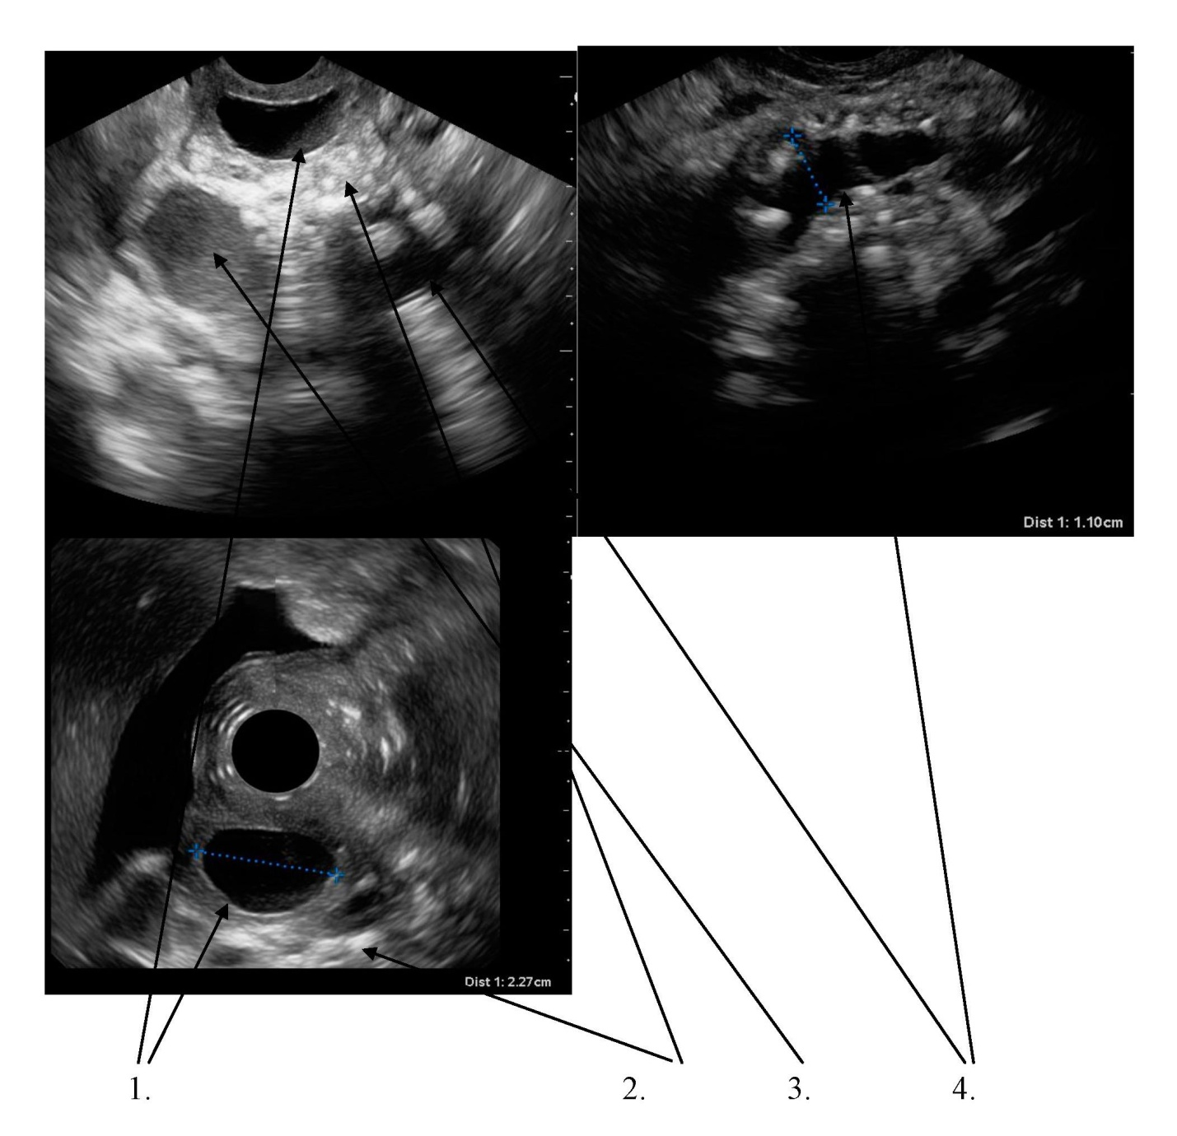

Fig. 1. EUS of the patient N.
1. A cyst in the duodenal wall
2. Calcinates in the parenchyma of the pancreas
3. The head of the pancreas cyst
4. Dilated main pancreatic duct

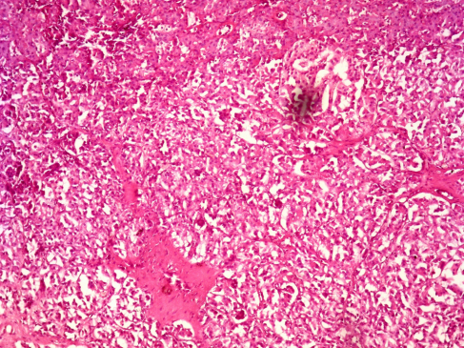
Fig. 2.
Histological examination: signs of chronic inflammation in the aberrant pancreas. Hematoxylin- eosin staining, × 100.

References:
- Диагностика и лечение дуоденальной дистрофии / В. И. Егоров, В. А. Вишневский, Г. Г. Кармазановский [и др.] // Новости хирургии. — 2009. — № 1 (17). — С. 20–28.
- Дуоденальная дистрофия: типичный и редкий случай / Г. Г. Кармазановский, В. И. Егоров, Ю. А. Щеголев [и др.] // Медицинская визуализация. — 2006. — № 6. — С. 51–59.
- Кубышкин В. А. Кистозные опухоли поджелудочной железы: диагностика и лечение / В. А. Кубышкин, Г. Г. Кармазановский, С. А. Гришанков. — М. : Видар, 2013. — 317 с.
- Резекции двенадцатиперстной кишки с сохранением поджелудочной железы и реимплантацией общего желчного и панкреатического протоков при кистозной форме дуоденальной дистрофии / В. И. Егоров, А. Ц. Буткевич, А. В. Сажин [и др.] // Хирургия. — 2010. — № 8 (16). — С. 16–23
- Технология и результаты лапароскопических панкреатодуоденальных резекций / И. Е. Хатьков, В. В. Цвиркун, В. К. Агапов, Р. Е. Израилов // Альманах Института Хирургии им. А. В. Вишневского. — 2008. — Т. 3. — № 3. — С. 90–99.
- Bauer P. Dystrophie kystique sur pancrias aberrant traitie par gastroenterostomie / P. Bauer, M. Smadja, J. P. Lechaux // Presse Med. — 1993. — Vol. 22. — P. 964–965.
- Cystic dystrophy of an aberrant pancreas. Surgery after failure of medical therapy / I. Bittar, J. L. Cohen Solal, P. Cabanis, H. Hagege // Presse Med. — 2000. — Vol. 29. — P. 1118–1120.
- Cystic dystrophy of the duodenal wall in a heterotopic pancreas / M. Glaser, Z. Roskar, M. Skalicky, I. Krajnc // Wien KlinWochenschr. — 2002. — Vol. 114. — P. 1013–1016.
- Cystic dystrophy of the duodenal wall is not always associated with chronic pancreatitis / R. Pezzilli, D. Santini, L. Calculli [et al.] // World J. Gastroenterol. — 2011. — Vol. 17, No 39. — P. 4349–4364.
- Cystic dystrophy of the duodenal wall: radiologic findings / C. Procacci, R. Graziani, G. Zamboni [et al.] // Radiology. — 1997. — Vol. 205. — P. 741–747.
- Diagnosis and therapeutic management of cystic dystrophy of the duodenal wall in heterotopic pancreas. A case report and revision of the literature / G. Galloro, V. Napolitano, L. Magno [et al.] // JOP. — 2008. — Vol. 9, No 6. — P. 725–732
- Duodenal pancreatic heterotopy diagnosed by magnetic resonance cholangiopancreatography : report of a case / M. Indinnimeo, C. Cicchini, A. Stazi [et al.] // Surg. Today. — 2001. — Vol. 31. — P. 928–931.
- Kendrick M. L. Total laparoscopic pancreaticoduodenectomy: feasibility and outcome in an early experience / M. L. Kendrick, D. Cusati // Arch. Surg. — 2010. — Vol. 145, No 1. — P. 19–23.
- L. Matsuoka. The minimally invasive approach to surgical management of pancreatic diseases / L. Matsuoka, D. Parekh // Gastroenterrology Clinics. —2012. — Vol. 41, No 1. — P. 77–101.
- Laparoscopic pancreaticoduodenectomy: technique and outcomes / C. Palanivelu, K. Jani, P. Senthilnathan [et al.] // J. Am. Coll. Surg. — 2007. —Vol. 205, No 2. — P. 222–230.
- Moen J. Small bowel obstruction caused by heterotopic pancreas in an adult / J. Moen, E. Mack // Am. Surg. — 1989. — Vol. 55. — P. 503–504.
- Postoperative infectious complications after pancreatic resection / K. Okano, T. Hirao, M. Unno [et al.] // Br. J. Surg. — 2015. — Vol. 102, No 12. — P. 1551–1560.
- Potet F. Dystrophiekystiquesur pancreas aberrant de la paroiduodenale / F. Potet, N. Duclert // Arch. Fr. Mal. App. Dig. — 1970. — Vol. 59. — P. 223.
- Skandalakis J. E. Congenital anomalies and variations of the pancreas and pancreatic and extrahepatic bile ducts / J. E. Skandalakis, L. J. Skandalakis, G. L. Colborn // The Pancreas / Ed. H. G. Beger [et al.]. — Oxford : Blackwell Science, 1998. — P. 28–30.
- Skandalakis J. E. Embriology for surgeons: the embryological basis for treatment of congenital anomalies / J. E. Skandalakis, S. W. Grey. — 2nd ed. — Baltimore : Williams Wilkins, 1994. — P. 366–387.
- Traitement endoscopique de la dystrophie kystique de la paroi duodenale (abstract) / T. Ponchon, B. Napoleon, F. Hedelius, R. Bory // Gastroenterol. Clin. Biol. — 1997. — Vol. 21. — P. A63.
- The various imaging aspects of chronic pancreatitis / R. Graziani, M. Tapparelli, R. Malago [et al.] // JOP (Online). — 2005. — Vol. 6, Suppl. 1.

Duodenal dystrophy — an interdisciplinary problem
L. V. Vinokurova, I. Y. Khatkov, R. Y. Izrailov, D. S. Bordin, Y. A. Dubtsova, K. A. Nikol’skaya, M. A. Agafonov, A. V. Andrianov
Moscow Clinical Scientific Center, Russia

Key words: chronic pancreatitis, duodenal dystrophy, ectopic pancreas, treatment, mini-invasive surgical techniques
Duodenal dystrophy is a chronic inflammation of the tissues of the pancreas, ectopic into the wall of the duodenum. Duodenal dystrophy is a variant of the aberrant pancreas. Its most frequent complications are acute or chronic pancreatitis, and a violation of duodenal passability, which, along with severe pain are indications for surgical treatment. Pancreaticoduodenal resection is recognized as an operation of choice. The data of patients with duodenal dystrophy observed in MCSC are presented. A clinical case is demonstrating the effective elimination of pain after the laparoscopic pancreaticoduodenal resection, albeit being accompanied by the development of pancreatic insufficiency which requires constant enzyme replacement therapy.

