Histostructure of pancreas in patients with autoimmune pancreatitis type I and II: connection with the level of IgG4-positive plasma cells
Y. A. Gaidar, N. Y. Oshmyanska, A. P. Halenko
Institute of Gastroenterology of the NAMS of Ukraine, Dnipro, Ukraine

Key words: pancreatitis, lgG4, histological techniques, histostructure of pancreas, plasma cells
The concept of autoimmune pancreatitis (AIP) proposed by K. Yoshida et al. [2] in 1995. Currently, there are two subtypes of autoimmune pancreatitis: Type I and Type II, which have a clearly defined characteristic pathological signs. Type I (lymphoplasmacytic sclerosing pancreatitis) more often diagnosed in the United States, Britain, Japan and Korea. AIP this type is distinguished tight periductal infiltrate consisting of lymphocytes and plasma cells, particularly IgG4-positive plasma cells (IgG4-PPK) (>30 cells on a large field of view) and a multi-tiered fibrosis around the main pancreatic and interlobular ducts and peripancreatic fat tissue. Slices of the pancreas (pancreatic) are relatively well preserved in the lobules of the mark foci of necrosis, is replaced by fibrous tissue.The tufts of fibrous tissue are mixed with inflammatory cells often exhibit eosinophil and mast cells [4, 5]. As is typical obliterating phlebitis, and in some cases can be observed and obliterating arteritis. The first type is referred to as AIP IgG4-associated sclerosing disease [6], it is often associated with Sjogren’s syndrome and/or retroperitonialnym fibrosis [7].
The infiltration of the epithelium of the main pancreatic duct and/or the interlobular ducts neutrophilic leukocytes — a characteristic feature of AIP type II (Idiopathic duct-centric pancreatitis) [5]. It is believed that with this type of AIP serum and tissue is not increased IgG4 [3, 7]. However, a case of atypical AIP I, flowing with leukocyte infiltration of the pancreatic ducts [1]. AIP type II combined with chronic inflammatory bowel disease: ulcerative colitis and Crohn’s disease [5]. For AIP type II is characterized by acute course.
Aim is to study the features of the histopathology of the pancreas at AIP I and II due to the level of IgG4-positive plasma cells in the body.
Materials and methods
The analysis of the surgical specimens of 54 patients with CP, biopsies of the head, body and tail of the pancreas and liver were taken for diagnostic purposes during routine surgical interventions for complicated forms of CP in the department of surgery GU "US Institute of Gastroenterology of Ukraine." The work was performed as part of research "Vivchiti mehanіzmi rozvitku fіbrotichnih protsesіv at hronіchnomu pankreatitі that udoskonaliti tehnologії їh hіrurgіchnoї korektsії», № state registration 0111U001065.
Histological examination. For histological biopsies were fixed in 10.0% neutral formalin, dehydrated in alcohols of increasing concentration and embedded in paraffin. Sections 3-5 microns thick were stained with hematoxylin and eosin and Mallory mod. Slinchenko. Stage AIP was determined by G. Zamboni et al. (2004, Tab. 1) [4].
AIP activity was evaluated as low and high.
At low activity rare intraepithelial granulocytes mark in one or several of the pancreatic ducts, lobules inside is rare granulocytes. When high activity visible damage to one or several of the pancreatic ducts mezhepitelialnymi granulocytes, in the ducts formed abscesses, leading to their destruction, is commonly found in the lobules and granulocytes between them.
Immunohistochemical study. IgG-positive plasma cells (IgG-PEP) was detected using sheep anti-human IgG FITC (Abeam, USA); subclass IgG4-positive plasma cells (IgG4-PPK) — by indirect immunoperoxidase reaction using rabbit monoclonal antibody IgG4 (Abeam, USA). Stellate cells were detected by specific monoclonal antibodies (VTІ-567, USA), using epifluorescence microscopy, confocal microscope "O1ympus-2500" (Japan).
This dyeing gave consistent results, which could be easily interpreted. After staining for the identification and quantification of in their greatest concentration of cells in 5 consecutive fields of view at high magnification light microscope (x40 objective, eyepiece x10) and using a fluorescent microscope LOMO ( "Mikmed", Russian Federation). We distinguish between these levels of IgG4-PPK in the large field of view (BAC): low (10-20 cells), medium (20-30 cells) and high (> 30 IgG4-PPK).
Results and its discussion
Of the surveyed 54 patients with chronic-degenerative fibrotic pancreatitis selected 15 cases with autoimmune pancreatitis. AIP type I and II, and its activity was determined step but histopathological changes characteristic of the pancreas, according to specified criteria autoimmune pancreatitis.
Table 1
Stages of the AIP by G. Zamboni et al. [4]
Stage | The infiltration of the prostate tissue | Involvement of ducts and/or blood vessels | Prevalence | Character fibrosis
1 | scattered periductal lymphoplasmatic infiltrates | slight narrowing of the duct | almost no involvement interlobular spaces and intralobular | light round-lobular fibrosis
II | multiple periductal lymphoplasmatic infiltrates | narrowing of the ducts, rare venulitis | little involvement of the interlobular spaces and intralobular | focal multilevel fibrosis
III | periductal lymphoplasmatic diffuse infiltration, lymph follicles | obstruction/destruction of ducts, obliterating phlebitis | moderate involvement interlobular spaces and intralobular | round-lobular multilevel fibrosis
IV | periductal lymphoplasmatic diffuse infiltration, lymph follicles with a bright center | often — venules, rarely — arteritis | expressed involvement interlobular spaces and intralobular | expressed periductal multilevel fibrosis and sclerosis

In the study, each patient was analyzed histostructure three topographical regions of the pancreas: a head, body and tail.
AIP type I was diagnosed in five male patients, mean age — 45.0 years; disease duration — from 1 to 4 years. In histological preparations of the pancreas of patients in all histographic areas of the pancreas marked III and stage IV AIP with a characteristic dense periductal lymphoplasmatic infiltrate (Fig. 1), stacked fibrosis, cellular basis of which were stellate cells (Fig. 2), and obliterative phlebitis (Fig. 3). In the liver, hepatitis observed light (Fig. 4) with a small amount IgG4PPK (RPD to 5) in the portal tracts expanded.
In the parenchyma of the pancreas of patients with AIP type I in a dense lymphoplasmacytic infiltrate around the main and interlobular pancreatic ducts and lymph follicles observed compact clusters, AUC IgG (Fig. 5), among which diffusely arranged of IgG4-PPK (>30 of IgG4-PPK to BPZ, Fig. 6).
The patients diagnosed with diffuse lesion in the pancreas III (3 cases) and IV (2 cases) stages of the AIP. In all cases we observed the complicated forms of current AIP: 60% (3 people) — a chronic fibro-cystic pancreatitis, 40% (2 people) — a chronic fibro-calculous pancreatitis.
It is known that the detection of three characteristic histological features in the damaged pancreas can be attributed to the AIP type I IgG4-assotsiirovannm sclerosing disease: lymphoplasmatic dense infiltrate around the main pancreatic duct, tiered fibrosis, obliterative phlebitis [1, 3]. These symptoms are found in all the cases examined by us. An important fact — finding in all patients with high levels of IgG4-PPK around the main pancreatic duct.
Histographic study of AIP type I allowed to mention a diffuse lesion of the pancreas. As is well known, often at AIP type I in the pathological process involves the whole gland. However, the shape and focal possible AIP type I lesions predominantly insulated head and/or tail [4]. Diffuse lesions of the pancreas in our cases we explain the complicated course of the disease (cysts, lithogenesis). The findings suggest that, along with the characteristic histopathology, high level of tissue IgG4-PPK (>30 IgG4-PPK to BPZ) is an objective diagnostic criterion for type I AIP.
AIP type II is set in 10 patients (1 woman and 9 men) with a mean age — 42.5 years. Histological study of the pancreas in 2 patients in this group marked diffuse, and 8 — focal form of AIP. One patient with diffuse form of AIP diagnosed with stage IV, the second — II stage of the AIP. AIP activity in these patients was minimal.
Alopecia type II form of AIP with isolated lesions of the pancreas body was recorded in 3 patients (with stage II-III AIP), at 2 marked the defeat of the tail (I and II stage AIP), 1 patient was limited to pancreatitis pancreatic head (I stage AIP); still found in 2 patients at the same time the body defeat and tail of the pancreas (II AIP stage) with an intact head.
As in diffuse and focal form of AIP with type II in the epithelium of the trunk, the collecting ducts and acinar pancreatic regularly defined single and multiple polymorphonuclear leukocytes, sometimes forming microabscesses. The ducts are marked as areas of desquamation of the epithelium, epithelial mitotic figures (Fig. 7, 8).
This high AIP type II activity was observed in half of the patients. Lymphoplasmacytic infiltration of the stroma encompassed not only channels but also segments of the pancreas (Fig. 9). In stage III-IV AIP type II in the fibrous tissue regularly noted obliterating phlebitis (Fig. 10). In periductal fibrous tissue and around the lobules showed congestion-PPK IgG. All the patients observed focal compact clusters IgG4-PPK in periductal round-lobular and fibrous tissue. The level of IgG4-PPK was 5-10 in the BAC (Fig. 11).
One patient in this group with stage IV AIP pancreatogenic diagnosed diabetes is characterized by the presence in the pancreas of small and medium-sized endocrine islets with hypoplasia of the P-cells (Fig. 12).
Thus, in our study we confirmed the existence of two well-defined histological types of AIP, which differed both the number and the location of the character of IgG4-PPK in the pancreas. When AIP type I highest concentration IgG4-PPK was noted in lymphoplasmacytic infiltrates around the main pancreatic duct, while AIP type II showed only a small number of cells (5-10 at BPZ) arranged in the form of small focal accumulations around the ducts and round-lobular fibrous tissue.
Different degrees of involvement in IgG4 etiopathogenesis of both types of AIP may be indicative of different molecular nature of autoantigens, causing the immunological process in the pancreas. For example, carbonic anhydrase type II, located in the epithelium of the pancreatic duct, may be targeted in autoimmune processes AIP type II.
Conclusions
1. Type I autoimmune pancreatitis exhibit tight lymphoplasmacytic periductal infiltration, fibrosis, multi-tiered, obliterating venulitis and high levels of IgG4-PPK in the pancreas (>30 IgG4-PPK to BPZ).
2. Type II autoimmune pancreatitis but typical histopathological signs of AIP typically leukocyte damage to the epithelium of the pancreatic duct and the low level of IgG4-PPK in the pancreas.
3. When the AIP and type in 80% of cases of focal lesions of the pancreas note on I-III stages of the disease.
A promising direction for further research consider the development of a simple and accessible method of diagnosis of AIP types I and II.

References:
- Autoimmune pancreatitis with histologically proven lymphoplasmacytic sclerosing pancreatitis with granulocytic epithelial lesions / T. Ikeura, M. Takaoka, K. Uchida [et al.] // International Medicine. — 2012. — Vol. 51, No 7. — P. 733–737.
- Chronic pancreatitis caused by an autoimmune abnormality. Proposal of the concept of autoimmune pancreatitis / K. Yoshida, F. Toki, T. Takeuchi [et al.] // Dig. Dis. Sci. — 1995. — Vol. 40, No 7. — P. 1561–1568.
- Deshpande V. The pathology of IgG4-related disease: critical issues and challenges / V. Deshpande // J. Semin. Diagn. Pathol. — 2012. — Vol. 29, No 4. — P. 191–196.
- Histopathological features of diagnostic and clinical relevance in autoimmune pancreatitis: a study on 53 resection specimens and 9 biopsy specimens / G. Zamboni, J. Liittges, P. Capelli [et al.] // Wirchows Arch. — 2004. — Vol. 445, No 6. — P. 552–563.
- Idiopathic chronic pancreatitis with periductal lymphoplasmacytic infiltration. Clinicopathologic features of 35 cases / K. Notohara, L. J. Burgart, D. Yadav [et al.] // American Journal of Surg. Pathol. — 2003. — Vol. 27. — P. 1119–1127.
- IgG4-related disease: historical overview and pathology of hematological disorders / Y. Sato, K. Notohara, M. Kojima [et al.] // Pathology International. — 2010. — Vol. 60. — P. 247–258.
- International consensus diagnostic criteria for autoimmune pancreatitis: guidelines of the International Association of Pancreatology / T. Shimosegawa, S. T. Chari, L. Frulloni [et al.] // Pancreas. — 2011. — Vol. 40. — P. 352–358.

Histostructure of pancreas in patients with autoimmune pancreatitis type I and II: connection with the level of IgG4-positive plasma cells
Y. A. Gaidar, N. Y. Oshmyanska, A. P. Halenko
Institute of Gastroenterology of the NAMS of Ukraine, Dnipro, Ukraine

Key words: pancreatitis, lgG4, histological techniques, histostructure of pancreas, plasma cells
Differential diagnosis of autoimmune pancreatitis apart from everything else is based on specifics of immunoglobulin G4 involvement into the pathogenesis.
Aim is to analyze two forms of autoimmune pancreatitis and their relation to the level of IgG4-positive plasma cells.
Methods and results. The present study was conducted on 54 patients with chronic pancreatitis, from which 15 cases with autoimmune pancreatitis were selected by using morphological and immunohistochemical methods.
Conclusion. It has been established that for autoimmune pancreatitis type I dense lymphocytic periductal infiltrate, multilevel fibrosis, obliterating venulitis and high IgG4-positive plasma cells in the pancreas (>30 per high power field) were typical. In the cases of autoimmune pancreatitis type II, besides the specific histopathological signs of AIP, significantly epithelial damage of pancreatic ducts by leukocytes, low levels of IgG4-PPC in the pancreas and focal lesions on stages I–III of disease (80%) were observed.

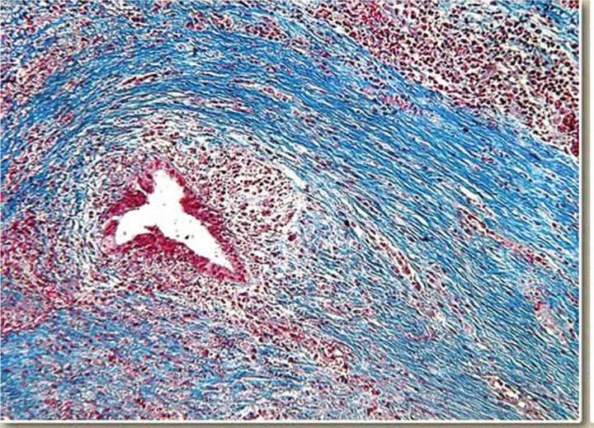
Fig. 1. AIP type I, IV stage. Dense infiltration around the main channel narrowed. Colouring by Mallory mod. Slinchenko. Enl. x100.
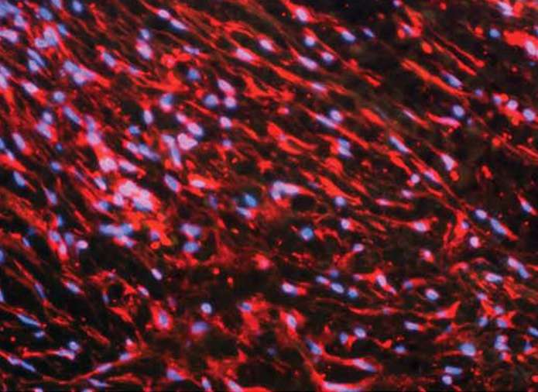
Fig. 2. AIP type II. Multi-storey fibrous tissue is formed by stellate cells. Confocal epifluorescence microscopy. Enl. X400.
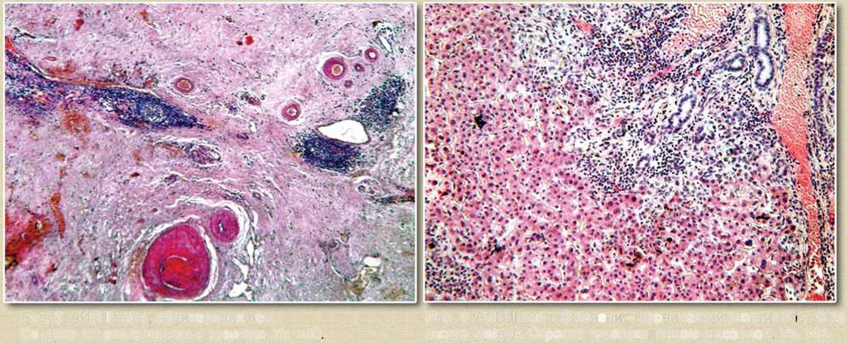
Fig. 3. AIP type II, obliteration of the veins. H & E stain. Enl. x40
Fig. 4. AIP type II. In the liver — chronic hepatitis F1, A0 to Metavir scale. H & E stain. Enl. x40.
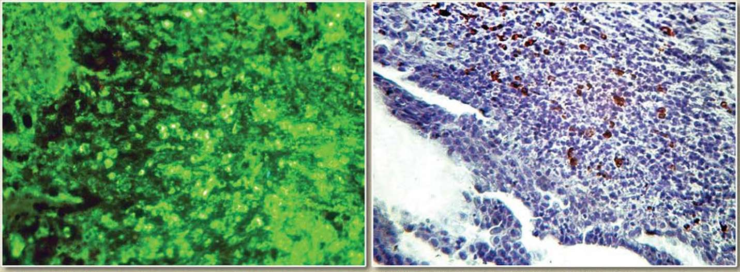
Fig. 5. AIP type II, obliterating phlebitis. Indirect immunofluorescence. Enl. x100.
Fig. 6. AIP type II. Accumulations of IgG4-PPK in lymphoplasmacytic infiltrate around the main pancreatic duct. Indirect immunohistochemical reaction. Enl. x200.
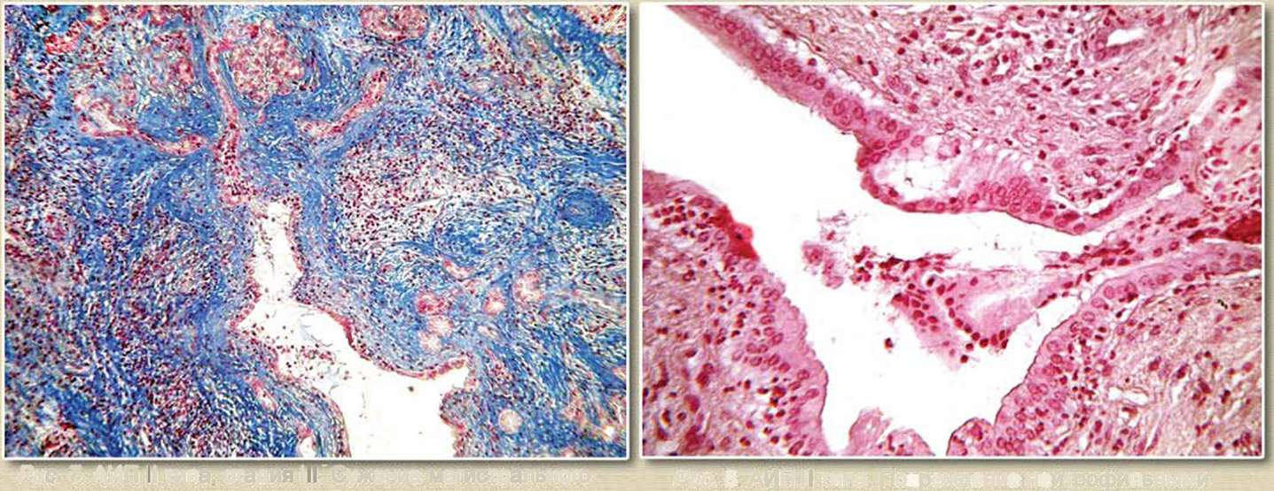
Fig. 7. AIP type II, stage III. The narrowing of the main pancreatic duct, stromal fibrosis, atrophy acinar tissue. Colouring by Mallory mod. Slinchenko. Enl. x100.
Fig. 8. AIP type II. Damage to neutrophilic leukocytes ductal epithelium. H & E stain. Enl. x200.
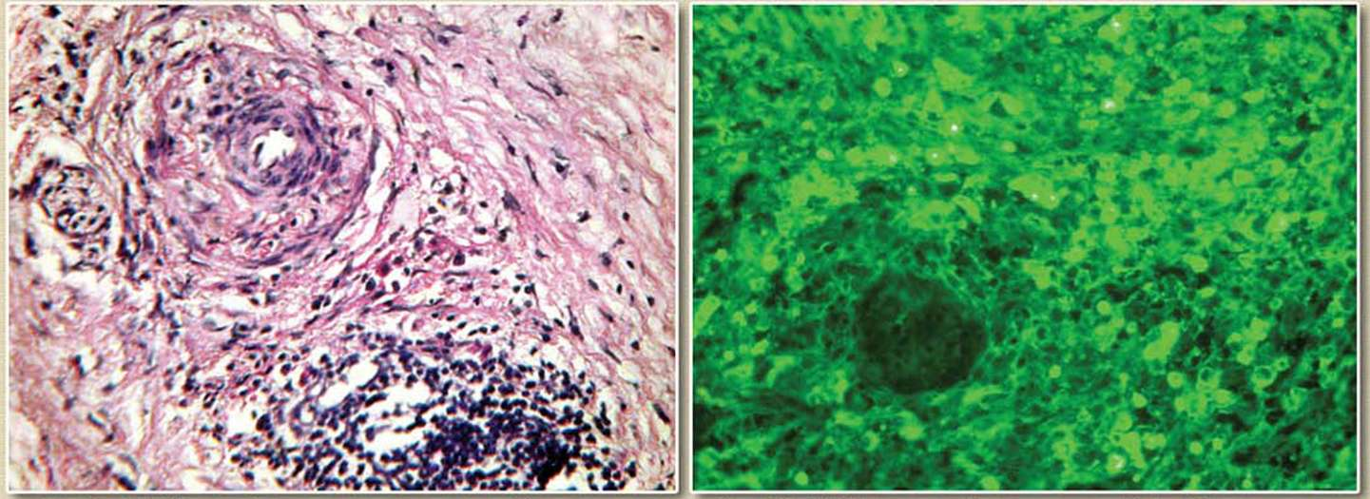
Fig. 9. AIP type II. Acinar tissue damage by inflammatory infiltrate. H & E stain. Enl. x200.
Fig. 10. AIP type II, obliterating phlebitis. The reaction of indirect immunofluorescence. Enl. x200.
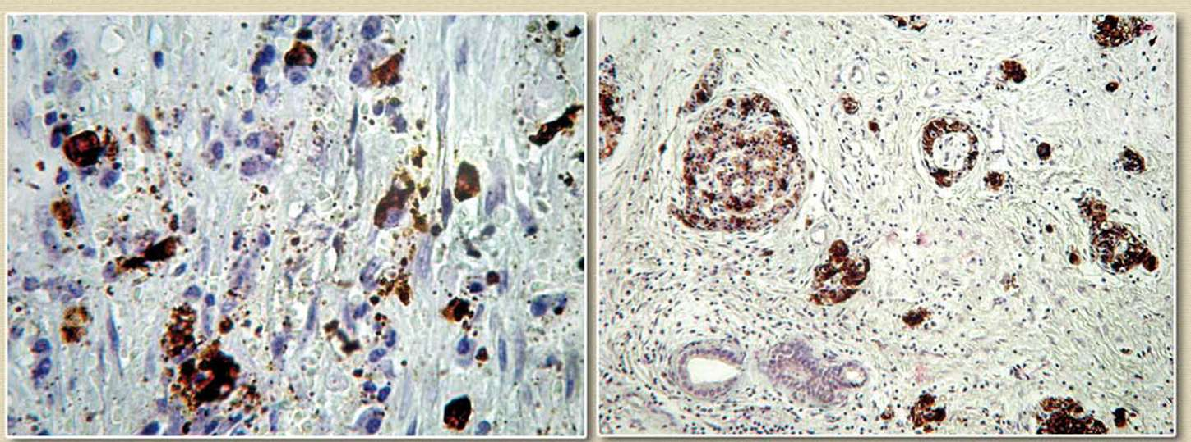
Fig. 11. AIP type II, stage III. IgG4-AUC in the fibrous tissue. Indirect immunoperoxidase reaction. Enl. X400.
Fig. 12. AIP type II, stage IV. Groups of islets with a small number of β-cells and a low content of insulin. Indirect immunoperoxidase detection of insulin. Enl. x100.

