NEWS OF WORLD PANCREATOLOGY
(according to the materials of the International Association of Pancreatology, the Japan Pancreas Society, the Asian Oceanic Pancreatic Association, Sendai, Japan, August 2016)
N. B. Gubergrits, N. V. Byelyayeva, A. D. Zubov, G. M. Lukashevich, P. G. Fomenko
Donetsk National Medical University n. a. M. Gorky, Ukraine

Key words: chronic pancreatitis, early pancreatitis, non-alcoholic fatty disease of the pancreas, modern methods of diagnosis of pancreatic diseases, treatment of pancreatic pathology
4-7 August 2016 joint meeting of the International Association of Pancreatology, the Japan Pancreas Society, the Asian Oceanic Pancreatic Association took place in the city of Sendai (Japan). At the meeting the latest achievements in the field of diagnostics and treatment of a wide variety of diseases of the pancreas were presented [7].
The Congress discussed a lot of problems related to pancreatic adenocarcinoma, neuroendocrine and cystic tumors of the pancreas, acute and chronic pancreatitis (AP and CP), non-alcoholic fatty disease of the pancreas (NAFLD). In this article we will cover only those aspects that relate to the diagnosis and surgical treatment of diseases (CP, NAFLD).
Let’s start from the role in the pathogenesis of obesity and diseases of the pancreas with NAFLD as a relatively new and less well-known practitioner of pathology.
K. Hosono et al. (Japan) reported the hypothesis of the pathogenesis of pancreatic cancer upon metabolic syndrome (Fig. 1). The cause of obesity is excess fat in the diet and lack of exercise. Visceral obesity, in turn, leads to insulin resistance, increased insulin content in blood. Hyperinsulinemia characteristic of the metabolic syndrome, has a mitogenic effect. At the same time, metabolic effects, and insulin characteristic is not realized due to the insulin resistance. Type 2 diabetes on the background of obesity leads to a proliferation of the pancreatic ducts, their blocking and destruction, and then — to the latent CP. At the same time having developed and are ductal metaplasia, dysplasia, and then cancer of the pancreas. The formation of adenocarcinoma contributes to the genetic predisposition and hyperinsulinemia. Upon metabolic syndrome develop NAFLD and cholelithiasis often develop (Fig. 1).
K. Hosono et al. examined 149 patients with pancreatic cancer and 547 healthy people. Volume of visceral adipose tissue was measured using a special mode of computed tomography (CT). It was found that the area of the visceral fat of significantly positively correlated with the risk of pancreatic cancer, and this area is significantly greater in patients compared with healthy. The area of the subcutaneous adipose tissue was not significantly different from patients and healthy.
K. Lin et al. (Japan) conducted an epidemiological study "Obesity and cancer of the pancreas" (multicenter study case-pin, limited by Japan). The study included more than 110,000 patients from 45 of regions of Japan, between 1990 and 2009. The authors did not receive accurate correlation between body mass index and the risk of pancreatic cancer that explain the relative rarity of obesity in the population of Asia, particularly in Japan. At the same time, the population of the US population proved positive association between the BMI and the risk of prostate cancer (Fig. 2).
Treatment NAFLD has not yet been developed. The experimental research of K. Minato et al. (Japan) is quite promising. The authors conducted a histological examination of the pancreas of mice with and without obesity. The study of the prostate was performed before and after treatment. Treatment consisted in limiting fat in the diet (group 1) or limitation and fat in combination with regular physical activity — running 6 days on average 1711±458 m/day (group 2). Animals with normal weight control group. In obese mice prior to treatment noted the presence of fat droplets in the acinar cells, parenchymal fibrosis, impaired β-cell structure. In mice with obesity weight of the pancreas, blood glucose and triglycerides, amylase content of pancreatic tissue were significantly overestimated. The increase in the blood were determined by interleukin-6, and the stress of the endoplasmic reticulum marker (XBP-1), insulin (insulin resistance). After treatment, the significant improvement in histological and biochemical parameters achieved in the 2nd group of animals (Fig. 3).
R. Igarashi et al. (Japan) conducted clinical observation of the patient 82 years old, suffering from diabetes and colorectal cancer. The patient in CT revealed patchy formation of pancreatic head. As a result of fine-needle biopsy under control endosonography formation turned focal fatty infiltration of the pancreas. We analyzed this observation in accordance with the differential diagnostic and recommendations by K. Satomi et al. (20 06). [6]
Several reports were devoted to NAFLD, developed after pancreatectomy and pancreatic resection. One of the reasons is a formal NAFLD that develops a number of diseases of the digestive system, including with exocrine pancreatic insufficiency.
K. Ishido et al. (Japan) studied 128 patients after the operations in the pancreas. Observation was carried out for the year after surgery (CT, nutritional status). According to CT NAFLD developed in 19 cases. The development of NAFLD is associated with atrophy of the pancreatic stump, extension of Wirsung’s duct, trophological insufficiency and atrophy of m. Iliopsoas.
Y. Uesato et al. (Japan) studied 64 patients who underwent pancreatic surgeries. They studied nutritional status, depending on the presence or absence of NAFLD. Albumin and total protein levels were significantly lower in patients with NAFLD. The authors concluded that for patients after pancreatic it was necessary to prescribe minimicrospheric enzyme preparation, i.e. Creon. It is needed both to substitution therapy in pancreatic insufficient and accuracy and to prevent the development of NAFLD.
It should be noted the expediency of Creon’s ppointment is confirmed by the S. Satoi et al. (Japan). The authors examined 57 patients after pancreatic duidenectomy: immediately after surgery, in 1 and 6 months. 29 patients received Creaon at dose of 50-90,000 U in the main food and 25-30,000 units in the break, 28 patients — microtableted enzyme preparation (control). Fig. 4 shows the results of research. It was found that treatment with Creon reduces the incidence of NAFLD for five hours in a 2-fold. This is due to a physiological minimicrospheres passage of t presence of asynchrony gastric emptying minimicrospheres and chyme, a large area of contact minimicrospheres and chyme.
J. Y. Tajima et al. (Japan) presented the results of histopathological examination for fibrosis of the pancreas cancer risk assessment (Fig. 5). Authors studied pancreatic tissue of 83 patients with pancreatic duodenectomy and 43 patients with distal pancreatectomy for adenocarcinoma (study of the surgical material). Wires and Measuring a size of fibrous tissue (fibrosis of the interlobular, intralobular fibrosis), evaluated the activity of stellar pancreatic cells. It was found that the degree of fibrosis of the pancreas to positively correlated with the level of glycated hemoglobin in the blood (Fig. 6), and stellar cell activity has a positive association with advanced adenocarcinoma. These data, in our opinion, are important prerequisites for the development of drugs that inhibit the development of fibrosis and activity of current stellar cells of the pancreas.
K. Kikuta et al. (Japan) reported on conservative treatment CP in Japan. We evaluated results of treatment more than 4 thousand. Patients treated into line with the recommendations of Japanese pancreatic society. All patients received advice on avoiding alcohol. In 40% of patients achieved a real withdrawal, of which 20% of cases — temporary pain relief, 13.4% of abstinence in reducing the pain was not effective.
About half of the patients receiving protease inhibitor into camostat mesylate: to prevent relapses, pain relief, etc. inhibition of progression of the disease, the treatment of acute pancreatitis.
Endoscopic extracting calculi was effective in 80% of cases. Indications for stenting the main pancreatic duct: duct strictures, the need for drainage of cysts or treatment of internal fistula, pancreas divisum.
The results of stenting:
- 60% of patients did not need restenting
- 22.5% of patients needed re-stenting
- 7.9% of patients admitted to on surgery
Indications of enzyme therapy:
- maldigestion in 68% (for treatment of trophological insufficiency Creon was prescribed)
- pain in 36% (Viokaze prescribed for pain relief)
- weight loss in 16%
Treatment of diabetes:
- 40% of patients were receiving insulin
- 30% of patients receiving oral hypoglycemic agents
Prof. D. Whitcomb (USA) spoke about the work on the new Intern etc. governmental recommendations for the diagnosis and treatment of CP. Formulated a new definition: CP — abnormal fibro-inflammatory syndrome in individuals with genetic, external and/or other risk factors that lead to the development of persistent pathological response to lesion of parenchyma or stress.
Features of CP. Common symptoms at diagnosis of CP and its later stages include atrophy and fibrosis of the parenchyma, abdominal pain, uneven ducts and stenosis, calcification, violation of exocrine and endocrine pancreatic function, dysplasia.
Using example of hereditary pancreatitis, D. Whitcomb showed that during the CP has a latent period before the onset of clinical manifestations (Fig. 7 — up to 20 years). On the basis of current CP and the presence of a latent period without clinical manifestations developed the hypothesis of "chain" of pathology of the pancreas, which leads from AP to adenocarcinoma of the pancreas (Fig. 8). In this chain, first proposed the term "early CP" corresponding to the latent period of current CP. There were also presented the characteristics of each stage of the current pathology of the pancreas (Table. 2) justification of the selection to the practice of early diagnosis of CP (Fig. 9).
The discussion was joined by Prof. L. Frulloni (Italy), which named "pros" and "cons" of such a diagnosis. "For": an explanation of pain, timely forecast, the selection of patients with an increased risk of pancreatic cancer, the possibility of comparing data from various researchers. "Against": absence of specific anti-fibrotic, anti-inflammatory therapy, i.e. early diagnosis of CP did not affect the progression of the disease; difficult to diagnose → big final financial costs; a late diagnosis does not affect the clinical outcome; many patients do not have symptoms at the early CP stage and diagnosed at a late stage of proven or CP in the presence of clinical symptoms, i.e. treatment in any case will be prescribed upon the appearance of symptoms. We can agree with the arguments of Professor. L. Frulloni. In our view, the early diagnosis of CP at this stage is not possible in clinical practice. It should be more widespread endosonography that will allow early diagnosis of CP.
In this regard, interest is the study of K. Ohtsubo et al. (Japan), who proposed to allocate the following early endosonographic changes in the pancreas, typical of the early CP: lobulation without ellularity of pancreatic parenchyma; hyperechoic foci that do not give a shadow; thin fibrous strands; hyperechogenicity wall of the main duct. According to the authors, and we agree with them, early CP can be diagnosed only by endosonography, while CT and MRI are insufficiently informative.
Important conclusions for the practice that upon the ineffectiveness of the endoscopic treatment of CP, surgical intervention should be held as soon as possible, was made by T. Matsui et al. (Japan). The operation of choice is Frey surgery. 26 CP patients with abdominal pain, not inferior to drug treatment, were examined. Frey surgery is carried out, then watching an average of 85 months. The results are shown in Fig. 10.
2 clinical observations remind us that pancreatic pathology is possible not only due to the cholelithiasis, but on the contrary: the pathology of bile ducts results in pancreatitis. This is an observation by O. Tsuyoshi Sanuki et al. (Japan) of acute cholecystitis caused by impaction pancreatic calculus in the Fater ampula, and E. Kimura et al. (Japan) — acute cholangitis that developed for the same reason.
H. Okamoto et al. (Japan) described several observations of hemosuccus pancreaticus in CP. This bleeding is usually associated with vessels arrosion with cystic formations of the pancreas. Gastrointestinal bleeding in 10-20% of cases are associated with pancreatic disease. Upon hemosuccus pancreaticus, plan of the study should include endoscopy with side optics, CT with contrast, Dopplerography and, if necessary, angiography.
Of course, at a at the joint meeting of the International Association of Pancreatology, the Japan Pancreas Society, the Asian Oceanic Pancreatic Association there were a lot more interesting things. Unfortunately, I found it difficult to interpret the surgical aspects, and surgeon-representative of our club was not on the Congress. Very interesting were video sessions, which demonstrated endoscopic and operative intervention in various diseases of the pancreas.
Achievements of pancreatology, which I heard of in Japan, seem breathtaking and inaccessible. However, we must take them into account and to strive for progress.

References:
- Association between variations in the fat mass and obesity-associated gene and pancreatic cancer risk : a case-control study in Japan / Y. Lin, J. Ueda, K. Yagyu [et al.] // BMC Cancer. — 2013. —Vol.13, No 337. — P.1471−2407.
- Chronic pancreatitis : an international draft consensus proposal for a new mechanistic definition / D. C. Whitcomb, L. Frulloni, P. Garg [et al.] // Pancreatology. — 2016. — Vol. 16, No 2. — P. 218−224.
- Clinical and genetic characteristics of hereditary pancreatitis in Europe / N. Howes, M. M. Lerch, W. Greenhalf [et al.] // Clin. Gastroenterol. Hepatol. — 2004. — Vol. 2, No 3. — P. 252−261.
- Clinical efficacy of pancrelipase delayed-release capsules on nonalcoholic fatty liver disease after pancreaticoduodenectomy / S. Satoi, M. Sho, M. Nagai [et al.] // Joint meeting of the International Association of pancreatology, the Japan Pancreas Society and Asian Oceanic Pancreatic Association 2016 // J. Jpn. Panc. Soc. — 2016. — Vol. 31, No 3. — P. 036.
- Do pancrelipase delayed-release capsules have a protective role against nonalcoholic fatty liver disease after pancreatoduodenectomy in patients with pancreatic cancer? A randomized controlled trial / S. Satoi, M. Sho, H. Yanagimoto [et al.] // J. Hepatobiliary Pancreat. Sci. — 2016. — Vol. 23, No 3. — P. 167−173.
- Focal pancreatic lesion: can a neoplasm be confidently excluded? / K. Satomi, S. S. Siegelman, D. A. Bluemke [et al.] // Br. J. Radiol. — 2006. — Vol. 79, No 943. — P. 627−629.
- Joint meeting of the International Association of pancreatology, the Japan Pancreas Society and Asian Oceanic Pancreatic Association 2016 // J. Jpn. Panc. Soc. — 2016. — Vol. 31, No 3. — 630 p.
- Minato K. Chronic exercise improves disruption of pancreatic B-cells morphology in WBN/Kob-Fatty rats / K. Minato, Y. Shiroya, H. Yamauchi // Joint meeting of the International Association of pancreatology, the Japan Pancreas Society and Asian Oceanic Pancreatic Association 2016 // J. Jpn. Panc. Soc. — 2016. — Vol. 31, No 3. — P. 258.
- Overweight, obesity, and mortality from cancer in a prospectively studied cohort of U.S. adults / E. E. Calle, C. Rodriguez, K. Walker-Thurmond, M. J. Thun // N. Engl. J. Med. — 2003. —Vol. 348, No 17. — P.1625−1638.
- The significance of histopathological evaluation of pancreatic fibrosis to estimate pancreas cancer progression / J. Y. Tajima, S. Osada, T. Sakuratani [et al.] // Joint meeting of the International Association of pancreatology, the Japan Pancreas Society and Asian Oceanic Pancreatic Association 2016 // J. Jpn. Panc. Soc. — 2016. — Vol. 31, No 3. — P. 076.
- Surgical outcomes and long-term pain relief after Frey procedure for chronic pancreatitis / T. Matsui, A. Tanemura, Y. Iizawa [et al.] // Joint meeting of the International Association of pancreatology, the Japan Pancreas Society and Asian Oceanic Pancreatic Association 2016 // J. Jpn. Panc. Soc. — 2016. — Vol. 31, No 3. — P. 224.
- Visceral abdominal obesity and pancreatic cancer risk / K. Hosono, A. Iwasaki, T. Sato [et al.] // Joint meeting of the International Association of pancreatology, the Japan Pancreas Society and Asian Oceanic Pancreatic Association 2016 // J. Jpn. Panc. Soc. — 2016. — Vol. 31, No 3. — P. 090.

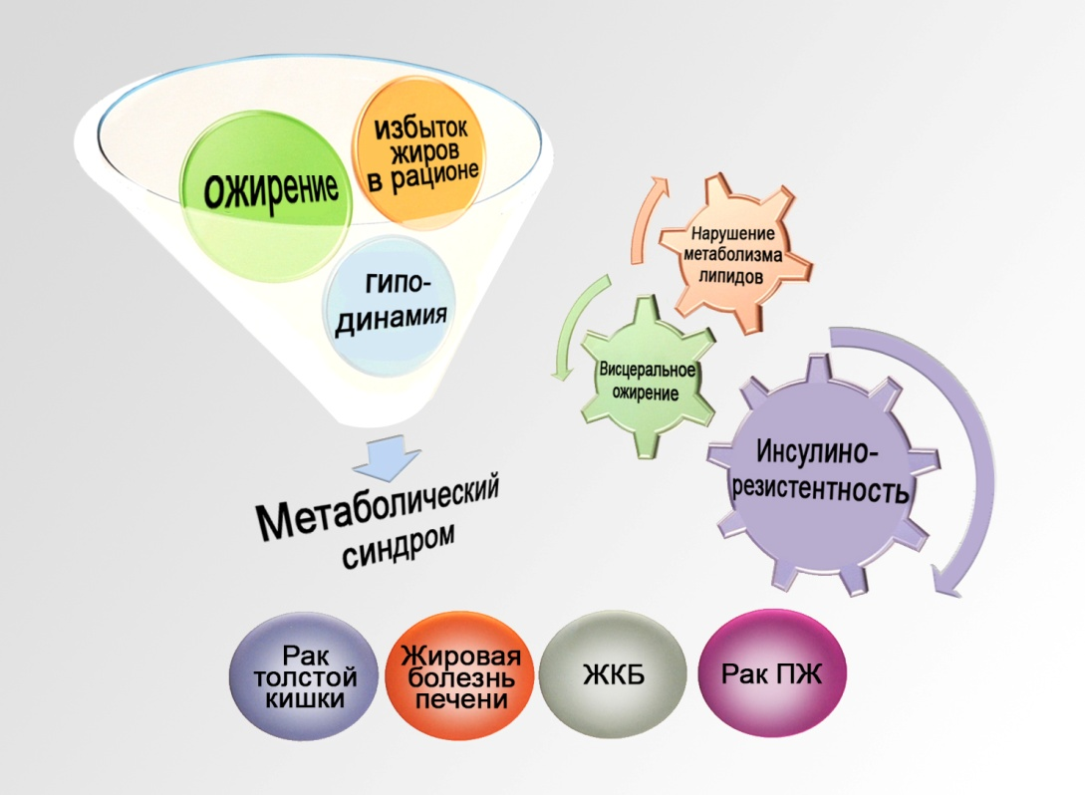
Fig. 1. Pathogenesis of cancer of different localization at metabolic syndrome (by K. Hosono et al., 2016 [12]).
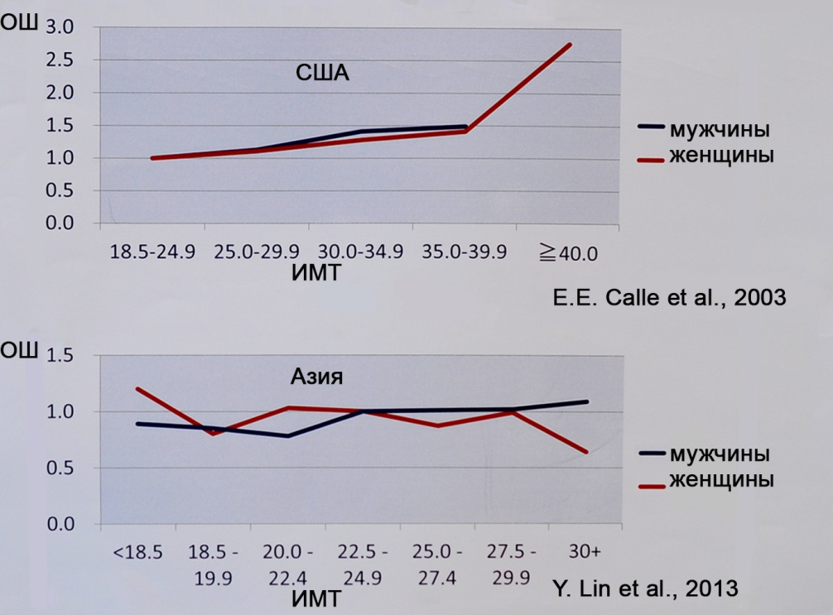
Fig. 2. Value between attitude odds ratio (OR) development of pancreatic cancer and BMI at American (top) and Asian (bottom) populations (by E. E. Calle et al., 2003 [9] Y. Lin et al., 2013 [1]).
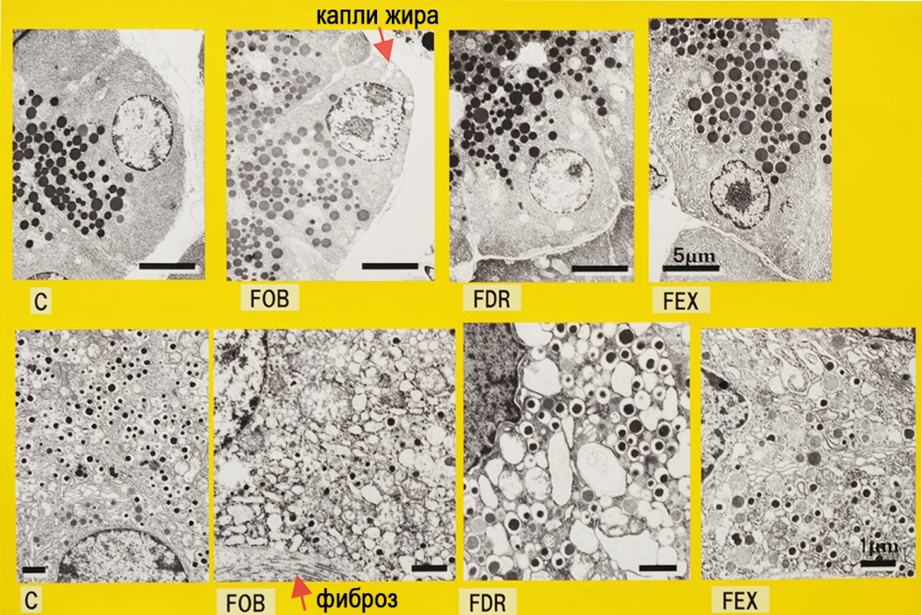
Fig. 3. Results of experimental research treatment of NAFLD — explanation at text (by K. Minato et al., 2016 [8]).
Above — acinar cells, at the bottom — β -cells.
C — control (non-obese); FOB — obesity; FDR — limiting fat in the diet; FEX — limit fat and + regular exercises — running 6 days on average in 1711±458 m/day.
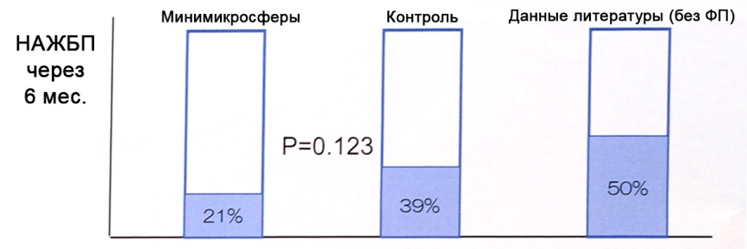
Fig. 4. Prevention of development of NAFLD after pancreatic duodenectomy at appointment of Creon, microtableted enzyme drug and according to literature data (by S. Satoi etal., 2016 [4]).
EP — enzyme preparation.
Data literature (without EP) — [5].
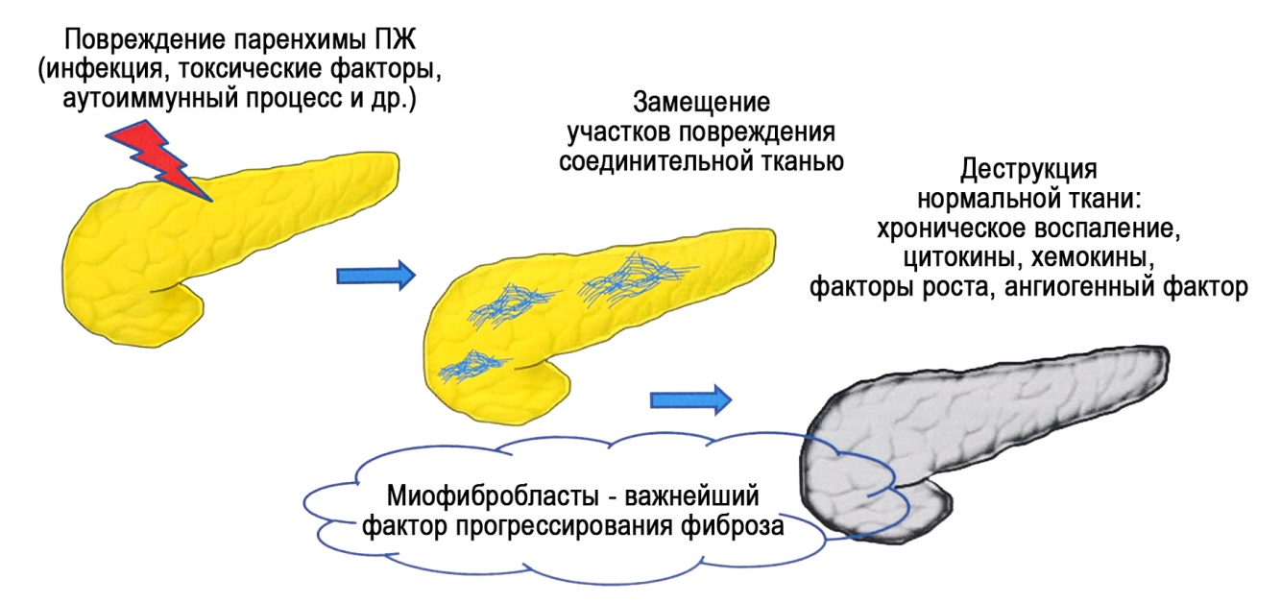
Fig. 5. Pathogenesis of pancreatic fibrosis (by J. Y. Tajima et al., 2016 [10]).
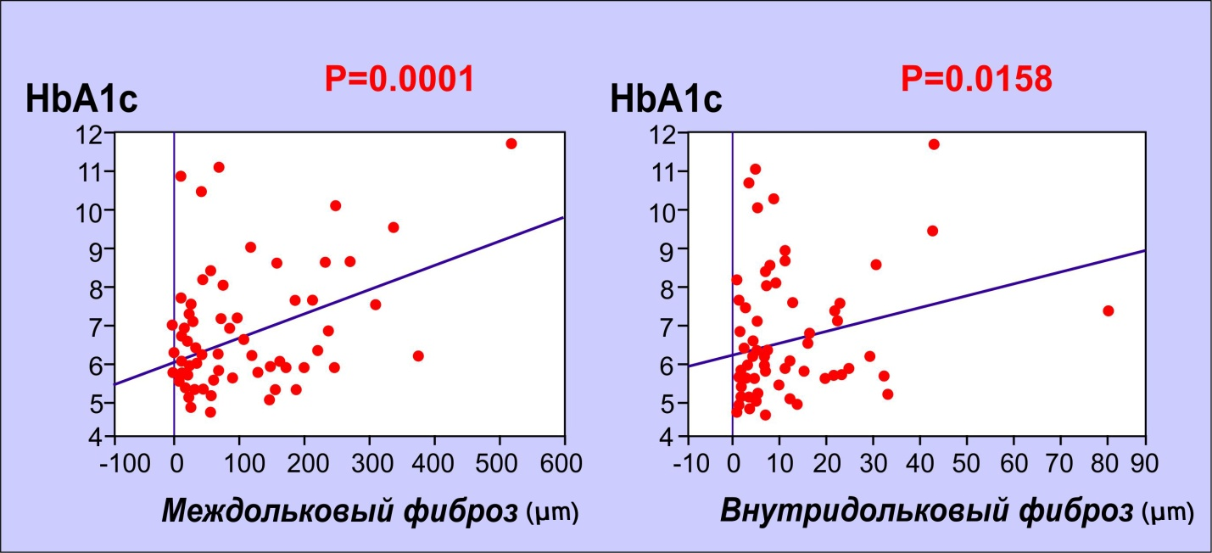
Fig. 6. Correlations between severity of pancreatic fibrosis and figures of glycosylated hemoglobin (by J. Y. Tajima et al., 2016 [10]).
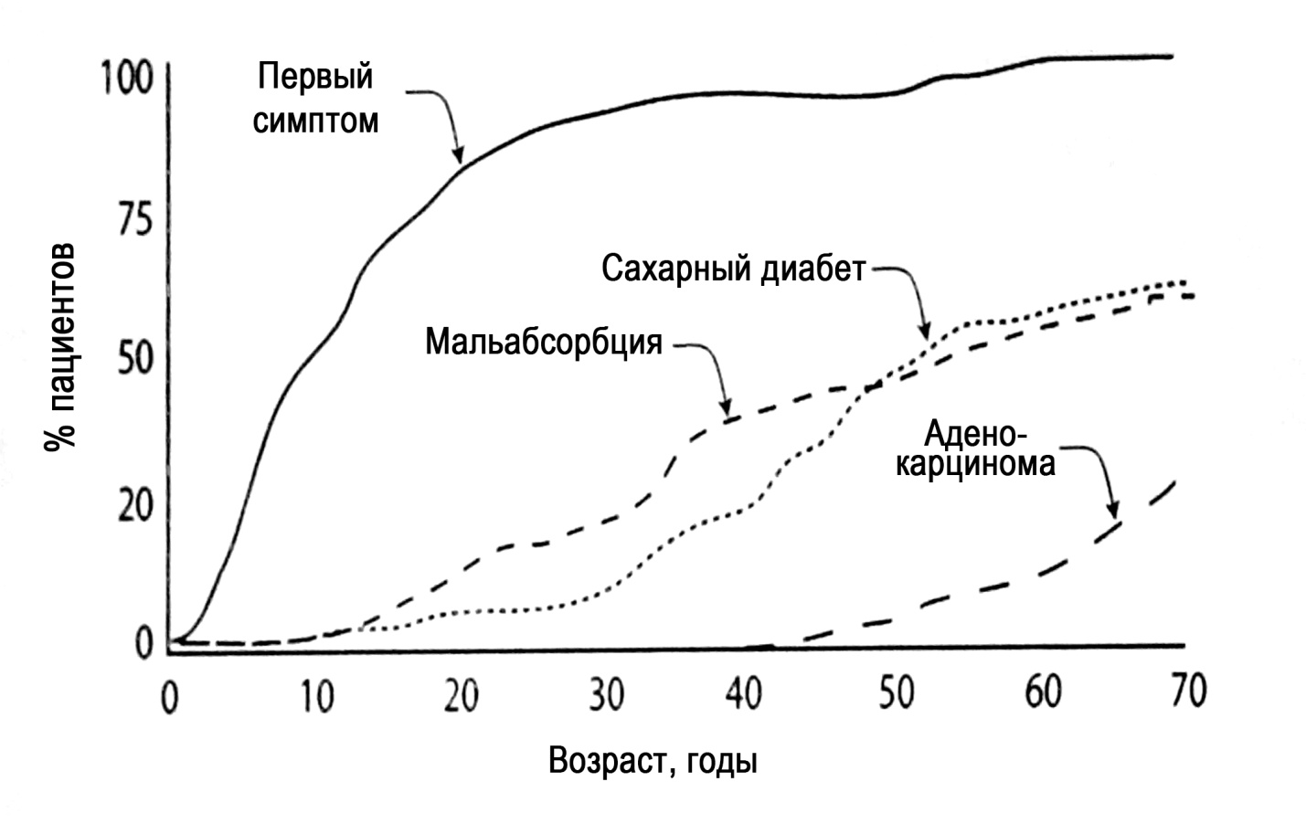
Fig. 7. CP course by example of hereditary pancreatitis (by N. R. Howes et al., 2004 [3]).
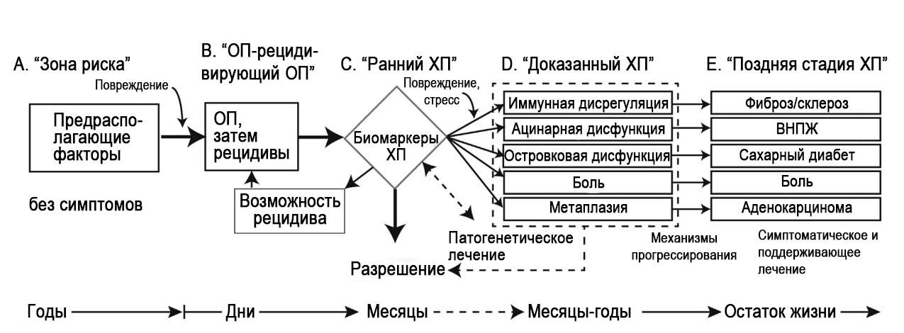
Fig. 8. Stages of course of pancreatic pathology (by D. Whitcomb et al., 2016 [2]).
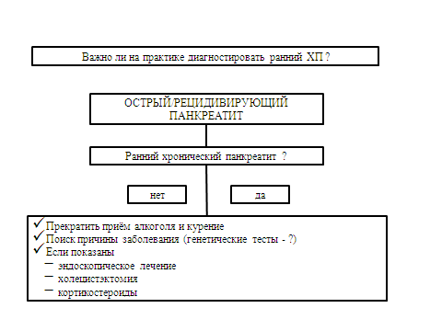
Fig. 9. Expediency of pointing out the diagnosis of early CP (by D. Whitcomb et al., 2016 [2]).
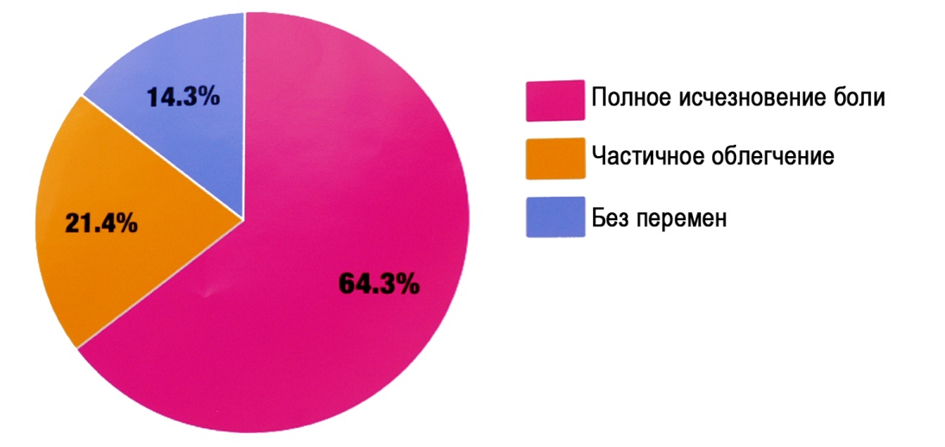
Fig. 10. Results of Frey surgery at CP (by T. Matsui et al., 2016 [11]).

NEWS OF WORLD PANCREATOLOGY
(according to the materials of the International Association of Pancreatology, the Japan Pancreas Society, the Asian Oceanic Pancreatic Association, Sendai, Japan, August 2016)
N. B. Gubergrits, N. V. Byelyayeva, A. D. Zubov, G. M. Lukashevich, P. G. Fomenko
Donetsk National Medical University n. a. M. Gorky, Ukraine

Key words: chronic pancreatitis, early pancreatitis, non-alcoholic fatty disease of the pancreas, modern methods of diagnosis of pancreatic diseases, treatment of pancreatic pathology
The article contains a short overview of the achievements of world pancreatology presented at the joint meeting of the International Association of Pancreatology, the Japan Pancreas Society, the Asian Oceanic Pancreatic Association (Japan, 2016). Particular attention is paid to the modern approaches of diagnostics and treatment of chronic pancreatitis and non-alcoholic fatty disease of the pancreas.

Table 1
Differential diagnosis of focal pancreatic formations on the results of radiological examinations (for K. Satomi et al., 2006 [ 6])
 | adenocarcinoma | Neuroendocrine tumor | lipoma | liposarcoma | Focal fatty infiltration
CT without contrast | iso | iso | decrease | decrease | Reduced - iso
CT scan with contrast | stitched contrasting | Early opacification | No contrast | opacifying | opacifying
MRI | T1: reduction  T2: iso-raising  DWI: increase | T1: reduction  T2: increased  DWI: increase | T1: improving  T2: increased | T1: improving  T2: increased  Diffusion-weighted study (DWI): improving | T1: reduction  T2: lower  Diffusion-weighted study (DWI): improving
Showing chemical shift (suppression adipose tissue) antiphase | iso | - | - | - | hypo-
EndoUSD | hypo- | hypo- | hyper-hypo | Hyper-hypo | Hyper-hypo

Table 2
Characteristic of stages of pathological process in the pancreas (by D. Whitcomb et al., 2016 [2])
 | step B | step C | step D | step E
 | AP / recurrent AP | Early CP | Proven CP | Late CP
Other definitions | Single (the completed) episode of AP | Interim | Certain | Certain
 | Recurrent AP
Essence | The natural inflammatory response to acute injury of the pancreas | The persistence of inflammation with the presence of biomarkers of CP, which does not meet the diagnostic criteria of proven or late CP | Pathologies associated with inflammation and / or dysfunction of two or more biological systems | Associated with inflammation pathologies and failure of two or more systems
Characteristics | Characterized by acute abdominal pain, the rise in the activity of the enzymes 3 times or more, the typical imaging findings | The persistence of post-AP: pain hyperenzymemia, inflammatory markers, imaging results | Imaging confirmed fibrosis, calcification, atrophy of the prostate; impaired glucose tolerance; pancreatic pain | The study
Fibrosis | The revised classification criteria of Atlanta
The markers of disease presence | The revised classification criteria of Atlanta | EndoUSD  CT  MRI | EndoUSD  CT  MRI | EndoUSD  CT  MRI
Biomarkers of disease activity | The revised classification criteria of Atlanta | The study | The study | The study
Pancreatic exocrine insufficiency | Not predictable | Reduction of functional test results up to 70% of normal | Reduction of functional test results up to 70% - 10% of normal | Reduction of functional test results to less than 10% of normal
The markers of disease presence |  | The study | The study | The study
Biomarkers of disease activity | C-reactive protein | The study | The study | The study
Pancreatogenic diabetes | First developed (with necrotizing pancreatitis) | Glycemia corrected diet | Hypoglycemic agents, insulin | Dependence on insulin.hypoglycemia
The markers of disease presence |  | The study | The study | The study
Biomarkers of disease activity | C-reactive protein | The study | The study | The study

