Laparoscopic resections for pancreatic neuroendocrine tumors: case series and discussion
I. V. Khomiak, O. V. Duvalko, A. I. Khomiak, I. S. Tereshkevich, A. V. Malik
Shalimov National Institute of Surgery and Transplantology, Kyiv, Ukraine

Key words: pancreas, surgical treatment, laparoscopic resection, neuroendocrine tumor, case report
Introduction
Neuroendocrine tumors of the pancreas (pNET) — a rare and dangerous oncological disease with a frequency of ≤1 per 100,000 people per year and account for from 1% to 2% of all tumor formation of the pancreas [3, 6, 10]. Formations can occur at any age, but are most common in people between 40 and 60 years. The problems of diagnosis and treatment of pNET in the early stages are extremely relevant in modern pancreatology. Timely detection and treatment of pNET can significantly improve the prognosis of the disease and achieve full recovery.
Case Report No 1
The patient, born in 1978, was admitted to the ward complaining of epigastric discomfort, a general weakness. She considered herself sick for about 10 years when she first noticed discomfort in an epigastrium that was unrelated to eating. She did not take medication to eliminate discomfort. The abdominal cavity revealed a pancreatic head, which was observed as benign for 7 years at the place of residence on multispiral multiple computed tomography (MCT) of the abdominal organs.
The patient did not smoke or use drugs, did not abuse alcohol. Lives in satisfactory social and living conditions. Heredity is not burdensome. There is no concomitant pathology.
Hypostenic structure, satisfactory nutrition. Consciousness is clear, ill contact, actively answers the question. Vesicular breathing, heart rhythmic tones. Body temperature 36.8, heart rate 64 beats/min, rhythmic, blood pressure — 115/65 mm Hg Skin and visible mucous membranes are unchanged. The abdomen is soft on palpation, painless, participates in the act of breathing. Appetite saved. Diuresis sufficient, chair daily.
The results of laboratory examination methods are within normal limits. CA 19-9 and CEA tumor markers within the reference values. The MBKT was re-performed, the results compared to previous studies. Diagnostic endoscopic ultrasonography was performed: On CT scan on the posterior surface of the pancreatic head, anterior to the portal vein and aorta, hypervascular formation of 2 × 1.6 × 2 cm is determined (Fig. 1, 2).
According to instrumental, laboratory, and clinical studies, the patient was diagnosed with a non-functioning neuroendocrine tumor of the pancreatic head T1N0M0, stage I according to AJCC (Fig. 3).
According to the latest NCCN guidelines (2017), this group of patients is shown to have local tumor resection within healthy tissues [7]. Surgery was performed: laparoscopic duodenum-preserving partial resection of the pancreatic head. There were 5 trocars installed: No 1 under the navel — 10 mm, No 2 on the right midclavicular line above the navel — 10 mm, No 3 on the left midclavicular line above the navel — 12 mm, No 4 on the left anterior axillary line below the costal arch — 5 mm, No. 5 along the right anterior axillary line below the costal arch — 5 mm (Fig. 4). Opened stuffing bag with Harmonic scalpel. In the stuffing bag, the conjunctive process is viscerolysis. No intra-operative pathology was detected in the abdominal cavity, no signs of tumor metastasis were present. Mobility of the duodenum on Kocher was performed with careful mobilization of the pancreatic head. On the back surface of the pancreatic head, closer to the lower edge, a tumor with clear uneven contours up to 2 cm in size was detected "palpatorally". A partial resection of the pancreatic head with the tumor was performed using a Harmonic scalpel. The vessels are additionally clipped. The main pancreatic duct of the pancreas is not damaged. Two drainages were installed to the resection site. The tumor was removed through the trocar site.
The postoperative period was without complications. The wounds healed with primary tension. On the second day, control drainage from the abdominal cavity was removed. On the sixth day the patient is in a satisfactory condition discharged from the hospital under the supervision of the surgeon at the place of residence. According to pathomorphological study: highly differentiated neuroendocrine tumor of the pancreas, G2, pT2. Immunohistochemical study results: Synaptophysin (DAK-SYNAP) — positive reaction; Chromogranin A (SP12) — a negative reaction; Ki-67 (MIB-1) — focal 10%.
The patient was examined 6 months after surgery. No complaints, feels satisfactory. Resides under the supervision of surgeon and oncologist at the place of residence.
Case Report No 2
The patient, born in 1963, was admitted to the clinic with complaints of periodic attacks of general weakness, accompanied by dizziness, darkening in the eyes and loss of consciousness. Such attacks helped to consume high glucose products. I considered myself sick for a year. The intensity and frequency of seizures increased over time, the patient's condition worsened between seizures, and general weakness increased.
The patient did not smoke or use drugs, did not abuse alcohol. He lives in satisfactory social and living conditions, works in the museum of local lore. Heredity is not burdensome.
Hyperstenic body, satisfactory nutrition, is excess body weight. Consciousness is clear, ill contact, actively answers the question. Vesicular breathing, heart rhythmic tones. Skin and visible mucous membranes are unchanged. The abdomen is soft, painless, involved in the act of breathing. Appetite saved. Diuresis sufficient, chair daily. Body temperature 36.4, heart rate 75 beats/min, rhythmic, blood pressure — 130/75 mm Hg
Fasting biochemical results revealed a fasting glucose level of 2.6 mmol/l (3.3–6.0 mmol/l norm), and overall blood counts were within the normal range. The fasting serum insulin level was 37 mU/l (norm 3–25 mU/l), the C-peptide level was 5.42 ng/ml (norm 0.8–3.1 ng/ml). The CA 19-9 and CEA tumor markers were determined within the normal range.
Transabdominal ultrasonography determines the hypoechoic formation of the isthmus of the pancreas.
According to the BMCT, at the lower edge of the pancreas, in the area of ​​the isthmus, a rounded volumetric formation with clear contours up to 2 cm in diameter is defined, which is not related to the main pancreatic duct (Figs. 5, 6).
Based on instrumental, laboratory, and clinical studies, the diagnosis was made of: Insulin of the pancreas, T2N0M0, stage II by AJCC (Fig. 7).
According to the latest NCCN International Guidelines (2017), the patient is shown radical surgical treatment [7]. Surgery was performed: laparoscopic cuneiform resection of the isthmus of the pancreas with insuloma. The patient has 4 trocars: No 1 under the navel — 10 mm, No 2 on the right midclavicular line above the navel — 10 mm, No 3 on the left midclavicular line above the navel — 12 mm, No 4 on the right axillary line below the costal arch — 5 mm ( Fig. 8). The Harmonic scalpel stuffing bag is disclosed. No intra-operative pathology was detected in the abdominal cavity, no signs of tumor metastasis were present. With the technical difficulties, the mobilization of the duodenum was performed. In the area of ​​the isthmus of the gland, at the lower edge is a tumorous hilly formation with clear contours, measuring 2x2 cm, which protrudes beyond the tissue of the gland. Using the Harmonic scalpel, a wedge-shaped resection of the pancreas was performed in the area of ​​tumor location. The main pancreatic duct of the pancreas is not damaged. Glucose control after neoplasm removal — 8.0 mmol/l. Two drainages were installed to the resection site. The tumor was removed through the location of the trocar 12 mm.
The postoperative period wasa without complications. The wounds healed with primary tension. On the third day, control drainage from the abdominal cavity was removed. On the 7th day the patient in a satisfactory condition was discharged from the hospital under the supervision of the surgeon at the place of residence.
According to pathomorphological study: highly differentiated neuroendocrine tumor of the pancreas, G2, pT2. Immunohistochemical study results: Synaptophysin (DAK-SYNAP) — positive reaction; Chromogranin (SP12) is a positive reaction; Ki-67 (MIB-1) — 19%.
The patient was examined 6 months after surgery. No complaints, feels satisfactory. Resides under the supervision of surgeon and oncologist at the place of residence.
Discussion
Neuroendocrine tumors (pNET) are fairly rare neoplasms that are described as epithelial tumors with predominantly neuroendocrine differentiation. Regardless of localization, these tumors have a tendency to metastasize into the liver. The expressed clinical picture of functional pNET, which make up 75% of all neuroendocrine entities, allows for early diagnosis and timely treatment. Immediately, insulinoma has episodic hypoglycemia, which can cause fading or loss of consciousness, unusual behavior, tachycardia, sweating, and trembling.
In 85% of patients, they are single tumors, almost always intra-pancreatic. At preoperative localization of pNET, the effectiveness of surgical treatment ranges from 70% to 100%. Surgical resection of pNET remains the most effective method and is therefore considered the gold standard of treatment for such a cohort of patients [1, 4, 9].
Laparoscopic removal plays an important role in the treatment of pNET. Laparoscopic resection and enucleation have been shown to be a safe and effective method for patients with endocrine tumors of the pancreas [1, 2, 4, 5, 9]. Insulinoma is increasingly being treated with laparoscopic interventions [8].
In our cases, the neuroendocrine pancreatic formation was revealed by multispiral multiple-section computed tomography, transabdominal ultrasonography. Clear localization of tumors is preoperatively established. According to the latest NCCN recommendations (2017), patients underwent laparoscopically wedge-shaped and partial resection of pNET of the pancreas [7]. The advantages of minimally invasive surgery are the reduction of postoperative pain, shorter length of stay in the hospital, better cosmetic effect and less disability. The risk of pancreatic fistula in the postoperative period is also lower compared with open surgery [1, 2, 5, 8, 9].
In these clinical cases, features of early diagnosis and successful laparoscopic surgical treatment of patients with pNET of the right anatomical segment of the pancreas are presented. The problem requires further study and development of optimal surgery for pancreatic tumors of different localization.

Laparoscopic resections for pancreatic neuroendocrine tumors: case series and discussion
I. V. Khomiak, O. V. Duvalko, A. I. Khomiak, I. S. Tereshkevich, A. V. Malik
Shalimov National Institute of Surgery and Transplantology, Kyiv, Ukraine
Key words: pancreas, surgical treatment, laparoscopic resection, neuroendocrine tumor, case report
Neuroendocrine tumor of the pancreas (pNET) is a wide-spread oncological disease, and its treatment is a widely discussed topic in modern pancreatology. Functioning pNET mainly manifest with hormonal hypersecretion syndrome (accordingly to the type of hormone), whereas nonfunctioning tumors may not produce any symptoms and remain unnoticed, complicating the diagnosis and postponing medical care. Course of the disease and patient’s prognosis largely depend on the stage of the disease and tumor histology. Higher tumor grade, lymph node and liver metastasis, and a larger primary tumor generally portend relatively poor survival. Prognosis of the patients with pNET improves substantially when the disease has been diagnosed and treated on the early stages. Endocrine testing, imaging modalities among which CT, MRI and endoscopic ultrasound are considered most useful; and histological evidence are all required to accurately diagnose pNETs. Recently an “aggressive” approach to pNET treatment has become most popular in academic centers throughout the world. Surgical resection of the tumor is considered the most effective treatment option and a gold treatment standard. Laparoscopic pancreatic resections also play major role in the treatment of pNET. Laparoscopic approach is safe and effective modality, so the number of laparoscopic operations has been growing last years. Among the benefits of minimally invasive surgery are lesser postoperative pain, shorter hospital length of stay, better cosmetic appearance and shorter disease-related inability of work period. In these case series characteristics of the early diagnosis and successful laparoscopic surgical treatment for the patients with pNET of the right anatomical segment of the pancreas are described.

References:
- Falconi M., Bartsch D.K., Eriksson B., Klöppel G., Lopes J.M., O’Connor J.M., Salazar R., Taal B.G., Vullierme M.P., O’Toole D. ENETS Consensus Guidelines for the management of patients with digestive neuroendocrine neoplasms of the digestive system: well-differentiated pancreatic non-functioning tumors. Neuroendocrinology. 2012. Vol. 95. P. 120–134.
- Fernandez-Cruz L., Blanco S., Cosa R., Rendon H. Is laparoscopic resection adequate in patients with neuroendocrine pancreatic tumors? World J Surg. 2008. Vol. 32, No 5. P. 904–917.
- Halfdanarson T.R., Rabe K.G., Rubin J., Petersen G.M. Pancreatic neuroendocrine tumors (PNETs): incidence, prognosis and recent trend toward improved survival. Ann Oncol. 2008. Vol. 19. P. 1727–1733.
- Jensen R.T., Cadiot G., Brandi M.L., de Herder W.W., Kaltsas G., Komminoth P., Scoazec J.Y., Salazar R., Sauvanet A., Kianmanesh R. ENETS Consensus Guidelines for the management of patients with digestive neuroendocrine neoplasms: functional pancreatic endocrine tumor syndromes. Neuroendocrinology. 2012. Vol. 95. P. 98–119.
- McKenna L.R., Edil B.H. Update on pancreatic neuroendocrine tumors. Gland Surgery. 2014. Vol. 3, No 4. P. 258–275.
- Milan S.A., Yeo C.J. Neuroendocrine tumors of the pancreas. Curr Opin Oncol. 2012. Vol. 24. P. 46–55.
- National Comprehensive Cancer Network. Neuroendocrine Tumors (Version 3.2017). URL: https://www.nccn.org/professionals/physician_gls/pdf/neuroendocrine.pdf (accessed: 10.02.2019).
- Partelli S., Maurizi A., Tamburrino D., Crippa S., Pandolfi S., Falconi M. Surgical management of pancreatic neuroendocrine neoplasms. Ann Saudi Med. 2014. Vol. 34, No 1. P. 1–5.
- Pavel M., Baudin E., Couvelard A., Krenning E., Öberg K., Steinmüller T., Anlauf M., Wiedenmann B., Salazar R. ENETS Consensus Guidelines for the management of patients with liver and other distant metastases from neuroendocrine neoplasms of foregut, midgut, hindgut, and unknown primary. Neuroendocrinology. 2012. Vol. 95. P. 157–176.
- Yao J.C., Hassan M., Phan A., Dagohoy C., Leary C., Mares J.E., Abdalla E.K., Fleming J.B., Vauthey J.N., Rashid A., et al. One hundred years after “carcinoid”: epidemiology of and prognostic factors for neuroendocrine tumors in 35,825 cases in the United States. J Clin Oncol. 2008. Vol. 26. P. 3063–3072.

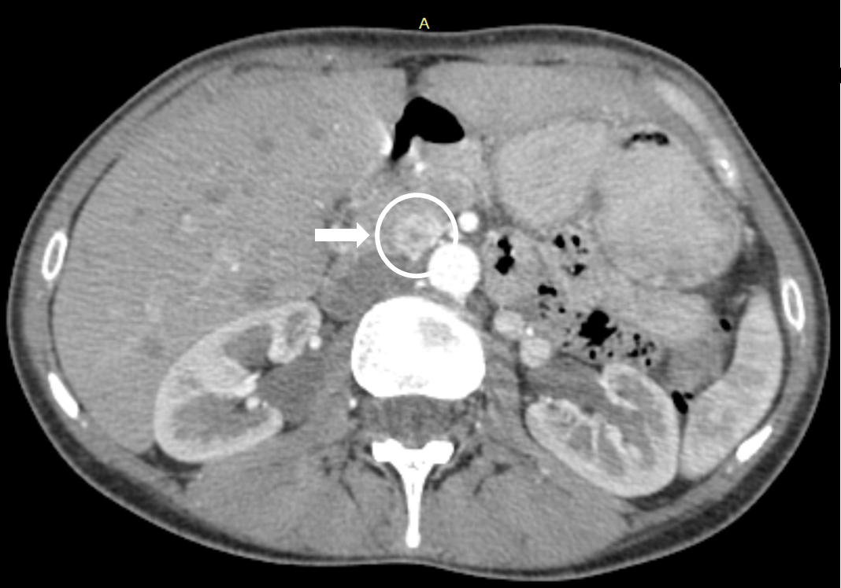
Fig. 1. MCT. Sagittal section. Tumor localization on posterior surface of head, isthmus of pancreas. Case No 1
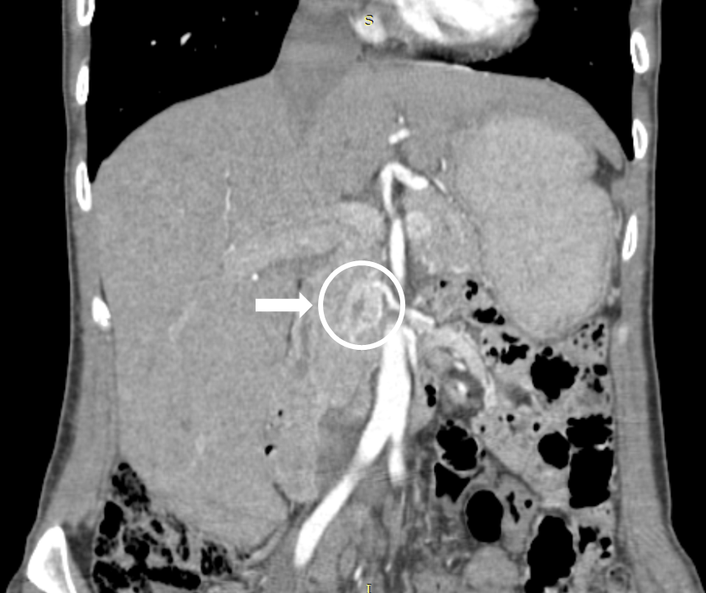
Fig. 2. MCT. Frontal section. Tumor localization on posterior surface of head, isthmus of pancreas. Case No 1
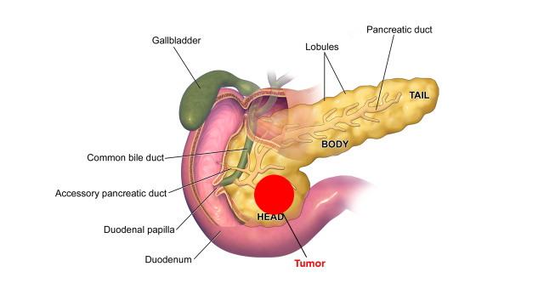
Fig. 3. Anatomic location of the neuroendocrine tumor of the pancreas. Case No 1

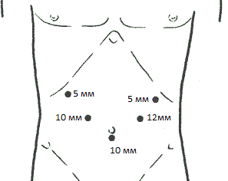
Fig. 4. Location of the trocar at laparoscopic duodenum-preserving partial resection of the pancreatic head. Case No 1

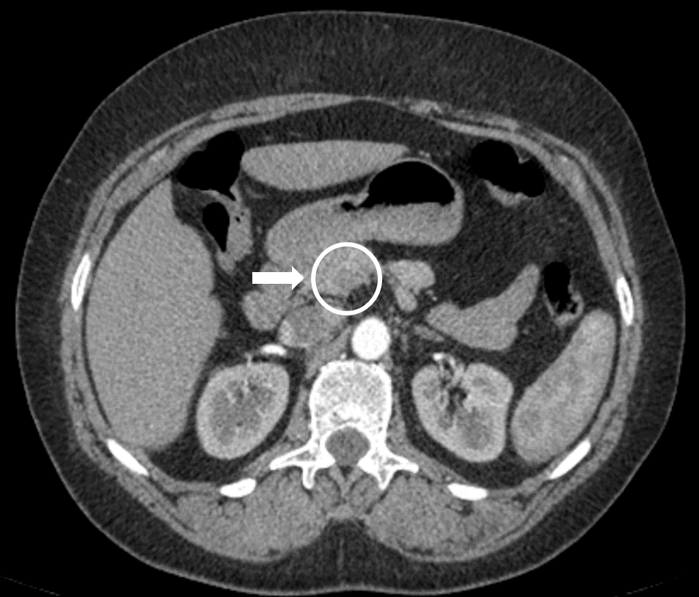
Fig. 5. MCT. Sagittal section. Tumor localization at the lower edge of the pancreas in the region of the isthmus of the pancreas. Case No 2
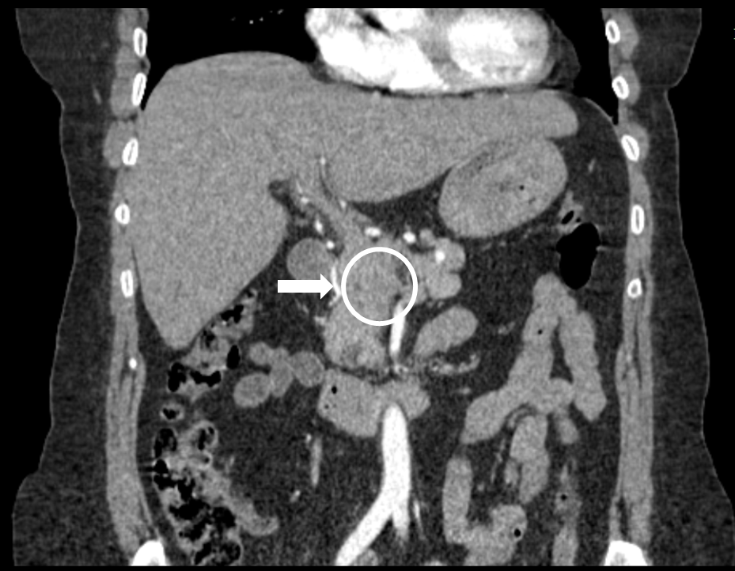
Fig. 6. MCT. Frontal section. Tumor localization at the lower edge of the pancreas in the region of the isthmus of the pancreas. Case No 2
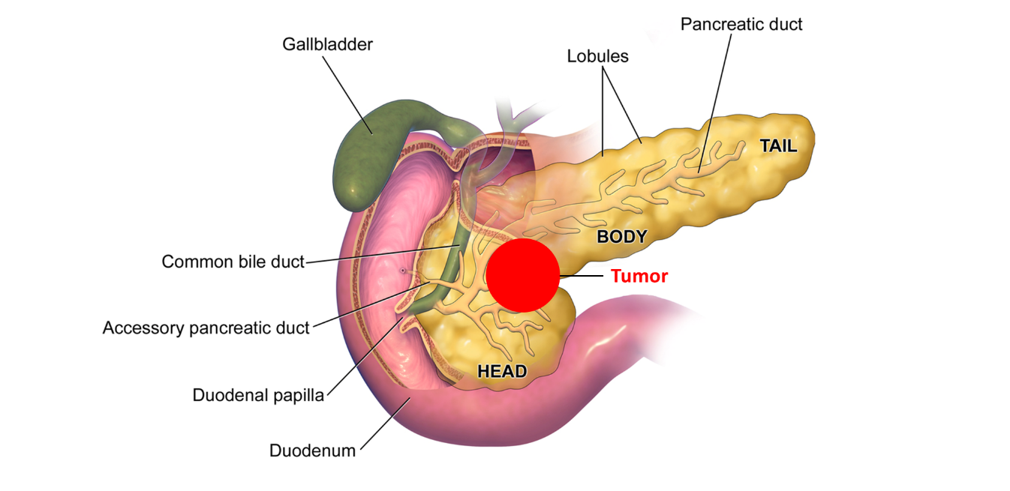
Fig. 7. Anatomic location of the neuroendocrine tumor of the pancreas. Case No 2
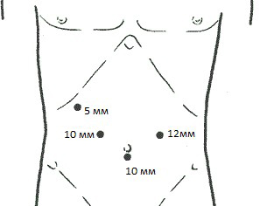
Fig. 8. Location of trocar at wedge resection of the isthmus of the pancreas. Case No 2

