Biliary dyskinesia: traditional and modern views
N. B. Gubergrits, N. V. Byelyayeva, G. M. Lukashevich, P. G. Fomenko, A. V. Yuryeva, E. N. Koval
Donetsk National Medical University, Ukraine

Key words: bile functions, gallbladder and biliary sphincters dysfunctions, hypokinetic and hyperkinetic dysfunctions of gallbladder, Rome Consensus IV, treatment, ursodeoxycholic acid

Gall bladder
It’s always grumpy and angry at someone,
Filled with its bile to the brim —
With a special bitter liquid
That we need to digest
Soup, cutlet and vinaigrette.
In a word, everything that we eat for lunch!
N. Knushevitskaya
The epigraph, although it has a playful (unscientific) hue, but, of course, reflects the important role of bile in the digestion process.
The main functions of bile in the digestive tract are as follows.
1. Participation in the digestive process:
- splitting and assimilation of neutral fat;
- stimulation of pancreatic function (due to bile acids).
2. Activation of motor function of the intestine (peristalsis):
- direct effect of bile acids on intestinal motility;
- indirect effect: increased fluid flow into the intestinal lumen and increased intraluminal volume and pressure.
3. Prevention of excessive bacterial growth in the intestine:
- direct bactericidal effect of bile acids.
4. Absorption of fat-soluble vitamins (A, D, E, K).
Biliary dyskinesias (dysfunctions, functional disorders) of the biliary tract (biliary tract) are diseases of a functional nature caused by impaired motor skills (development of biliary sphincter spasm and transient impairment of bile outflow) and increased visceral sensitivity, i.e., sensitivity of the walls of the biliary tract. In this case, structural (organic) pathology, for example, cholecystitis, gallstones, is not detected [3].
Dyskinesia of gallbladder (GB) and sphincter of Oddi (OS) are dyskinesia. The latter, in turn, is divided into biliary type dyskinesia and pancreatic type dyskinesia. In the first case, symptoms from the bile ducts prevail, in the second from the pancreas (see below). Timely diagnosis and treatment of functional biliary disorders is important both from the point of view of improving the well-being of patients, and that functional diseases can serve as a starting point and basis for further progression of biliary tract diseases up to cholelithiasis (Fig. 1).
Dyskinesia of the gastrointestinal tract and sphincter apparatus of the biliary tract are often diagnosed already in childhood. Using a retrospective analysis, it was possible to find out that many of these children were brought up in single-parent families (without a father) or lived with their stepfather, in an atmosphere of frequent family conflicts and quarrels. In this regard, they grew up as closed, unsociable children, deprived of parental affection, often experienced grievances from their peers, felt lonely, abandoned. The consequence of these psycho-traumatic influences was the development of child psychogeny. Most likely, it was children’s psychogeny and personality neurotization that became one of the reasons for the development of dyskinesia of the gastrointestinal tract and biliary tract, which was previously associated with the formation of this type of character — choleric (from the Greek “chole” — bile). No wonder Pierre Bouast said: “Bile is the ink of a bad heart”. A. S. Pushkin, in a letter to Natalya Nikolaevna on May 29, 1834, wrote: “I have bile, so excuse my angry letters. I kiss and bless you”.
In addition to psychogenic causes, genetic factors are important in the origin of dyskinesias; hormonal influences (for example, the onset of menstruation in girls); systematic violation of diet; unbalanced nutrition and gross dietary errors; various intoxications and infections, especially of a viral nature, parasitic diseases; autonomic dystonia; allergic reactions (food and drug allergies); violation of the production of cholecystokinin-pancreosimine (CCK-PS), etc.
The development of OS dyskinesia in patients undergoing cholecystectomy is probably associated with an increase in the volume load on the common bile duct (deposition of bile) and OS. With cholecystectomy, damage to the nerve pathways of regulation is possible. It was shown that over the next period after surgery, the relaxing effect of CCK-PS on OS is suppressed. In animal experiments after cholecystectomy, changes in the longitudinal and circular contractions of the final part of the common bile duct were revealed, which predisposes to the development of functional obstruction (spasm). A pathological spasm of OS causes a transient obstruction of the bile and/or pancreatic duct, the appearance of pain, and an increase in the activity of liver and/or pancreatic enzymes in the blood.
An important role in the development of dyskinesia of the gastrointestinal tract and OS is assigned to lithogenic bile, i.e., bile with an increased content of cholesterol, which leads to a high risk of the formation of gallstones. In patients, the formation of biliary sludge is possible — a precipitate in the cavity of the pancreas, consisting of crystals of cholesterol and gel-like mucus, which is produced by the mucosa of the biliary tract. Under conditions of oversaturation with cholesterol, contractility of muscle fibers and signal perception from receptors, which stimulate CCK-PS, are impaired. In addition, the passage of cholesterol crystals can cause repeated trauma to the sphincters, prolonged reflex spasm and the development of chronic inflammation [1].
The high prevalence of biliary dyskinesia in the modern world can be explained by the "epidemic" of obesity and the associated tendency to form lithogenic bile and the development of an inflammatory reaction in the stomach. As Igor Huberman accurately and figuratively noted: “The world is exhausted from bile, the planet is sick with liver...”
Biliary dyskinesia is diagnosed in 10–20% of patients, more often in women. The higher incidence of women can be explained by the influence of female sex hormones (estrogens) on the lithogenic potential of bile (a tendency to stone formation) and motility of the biliary tract, as well as more frequent seeking medical help.
In recent years, in industrialized countries there has been a tendency to increase the frequency of diagnosis of biliary dysfunction along with an increase in the prevalence of other functional diseases of the digestive system. This can be explained by the lifestyle features of modern residents of developed countries (excessive carbohydrate content in food and insufficient motor activity, resulting in an increased risk of lithogenic bile formation and biliary tract motility), an “epidemic” of obesity, and the emergence of highly accurate examination methods [3].
The diagnostic criteria for biliary pain associated with biliary dysfunction are defined in the European Consensus adopted in Rome in 2016 [6].
These criteria include the presence of episodes of pain in the epigastrium and/or in the right upper quadrant of the abdomen in combination with all of the following symptoms:
- duration of pain 30 minutes or more;
- constant level of pain during an attack;
- recurrence of symptoms at various intervals (optional daily);
- pains are moderate or severe, quite intense, capable of disrupting daily activity or leading to the emergency department;
- pain does not decrease after stool;
- pain does not decrease after taking antacids or proton pump inhibitors.
Confirming (optional) criteria for biliary pain.
Pain may be combined with one or more of the following symptoms:
- nausea or vomiting;
- irradiation in the back and/or right subscapular region;
- occurrence at night.
Diagnostic criteria for functional disorder of the pancreas [6]:
- presence of biliary pain;
- lack of stones or other structural changes in the stomach.
Confirming (optional) criteria:
- normal levels of hepatic enzymes, associated fractions of bilirubin and pancreatic enzymes (amylase/lipase) in the blood;
- low ejection fraction of the gastrointestinal tract (the proportion of evacuated bile from the gastrointestinal tract when it is reduced) with hepatobiliary scintigraphy.
Although in the Rome criteria IV they do not divide the dysfunction of the pancreatic hyperfunction and hypokinetic type, in the traditions of domestic medicine such a separation is still used, since its identification affects the tactics of treatment.
Features of the clinical manifestations of GB dysfunction according to the hyperkinetic type:
- seizures resemble biliary colic (acute, short-term);
- arise after unrest, less often after food provocation and physical exertion;
- pains are not so intense and not so long as with gallstone disease;
- pass independently, from applying heat to the right hypochondrium or after taking antispasmodics;
- rarely there is irradiation (if there is, then in the right shoulder blade);
- pain is not accompanied by vomiting (but nausea is possible), jaundice, fever;
- more than half of patients experience discomfort in the heart, tachy- or bradycardia;
- patients are emotionally labile, sometimes autonomic dysfunction is determined (sweating, easily redden, unstable blood pressure), some patients are choleric;
- reaction from the liver (reactive hepatitis, i.e., its increase, soreness) does not happen;
- with palpation at the height of the attack, pain (but not resistance) in the projection of the ventricle is determined, the objective symptoms of cholecystitis are negative.
Features of clinical manifestations of dysfunction of the pancreas by hypokinetic type:
- pain does not have the nature of attacks;
- pains are dull, aching, spilled, non-intense;
- pain can be constant with periodic intensification or periodic, but lasts from 30 minutes to several hours;
- pain occurs at night, with long breaks between meals;
- pain is relieved after eating, “blind” soundings, cholekinetics (for example, magnesium sulfate, sorbitol, xylitol, etc.);
- irradiation to the right shoulder or shoulder blade is noted in less than 10% of cases;
- nausea, bitterness in the mouth, loss of appetite, unstable stools (constipation with periodic diarrhea after eating fatty foods), bloating;
- patients are usually too calm, even phlegmatic, overweight, lead a sedentary lifestyle;
- symptoms of inflammation (fever, leukocytosis) are absent;
- reactive hepatitis does not happen;
- palpation tenderness in the projection of the posterior tract is possible, but objective symptoms of cholecystitis are not determined.
Diagnostic criteria for a functional disorder of OS biliary type [6]:
- presence of biliary pain;
- increase in the level of hepatic enzymes (transaminases), alkaline phosphatase of more than 2 norms, associated in time with at least two episodes of pain or an expansion of the common bile duct, but not both symptoms together;
- lack of stones or structural changes in the common bile duct.
Confirming (optional) criteria:
- normal indicators of pancreatic enzymes (amylase/lipase);
- change in the indicators of manometry OS — a predictor of a good response to sphincterotomy;
- pathological results of hepatobiliary scintigraphy.
Diagnostic criteria for a functional disorder of pancreatic type OS [6]:
- documented repeated episodes of acute pancreatitis with an increase in amylase/lipase more than 3 norms and/or instrumental evidence of acute pancreatitis (by ultrasound (ultrasound), etc.);
- exclusion of another etiology of pancreatitis;
- lack of organic pathology with endoscopic ultrasound;
- pathological results with manometry OS.
Diagnostic tests for diseases of the biliary tract are divided into primary (screening) and specifying.
Screening:
- functional liver tests, pancreatic enzymes in the blood and urine;
- ultrasound (it is important to verify the absence of stones in the stomach, cholecystitis; the presence of excesses and constrictions in the stomach in the vast majority of cases is of no clinical significance);
- fibroesophagogastroduodenoscopy with a detailed examination of the area of ​​the large duodenal nipple.
Clarifying:
- ultrasound with an assessment of the function of the gastrointestinal tract and OS (the so-called dynamic ultrasound — determine the volume of the gastric tract on an empty stomach, and then at certain intervals after taking a choleretic “breakfast”, for example, egg yolks, which allows to assess the contractility of the gastrointestinal tract and the presence of OS spasm) (Fig. 2);
- endoscopic ultrasound of the stomach and biliary tract;
- hepatobiliscintigraphy;
- magnetic resonance cholangiopancreatography;
- endoscopic retrograde cholangiopancreatography with OS manometry.
In the period of exacerbation of dyskinesia, it is advisable to observe the basic principles of dietary nutrition for diseases of the biliary tract, as well as protect the mucous membrane of the upper gastrointestinal tract from mechanical, thermal and chemical influences. The nature of nutrition can be approximated to diet No 5 according to M. I. Pevzner: food should be taken every 3 hours, refuse long breaks in eating, it is desirable to limit the consumption of animal fats, fried foods, extractives (strong meat and fish broths, smoked meats and canned food), spices, seasonings and spices (onions, garlic, peppers, mustard), marinades, carbonated fruit water, beer, dry white wine, champagne, coffee, citrus fruits. It is advisable to cook food mainly by boiling, stewing, baking, steaming. Within 1.5–2.0 hours after eating, prolonged inclines and horizontal position should be avoided. Dairy products (cottage cheese, kefir, low-fat yogurt), cereals (oatmeal, buckwheat) in water or low-fat milk, bananas, baked apples, mashed potatoes, vegetable soups, boiled meat (low-fat beef, chicken breast) are useful. It is also useful to take non-carbonated mineral water in a heated form, ½ cup 4 times a day half an hour before meals. Outside the period of exacerbation, the diet is expanded and, with good tolerance, meals are organized according to the usual rational principles. It is important to eat in a relaxed atmosphere, slowly [3].
You should pay attention to the normalization of the rhythm of sleep, daily routine, ensuring adequate rest. In the presence of mood disorders, psychoemotional state, it is advisable to consult a psychotherapist [1].
The following groups of drugs are indicated for the treatment of biliary dysfunctions: antispasmodics, ursodeoxycholic acid (UDCA), analgesics, if necessary prokinetics, antidepressants.
Antispasmodics are prescribed in almost all cases, including with hypokinetic dyskinesia of the gastrointestinal tract, since in 80% of cases it is associated with hypertonicity. Antispasmodics that affect the bile ducts are recommended, including OS: calcium channel blockers (nifedipine, pinaveria bromide), nitrates (nitroglycerin, nitrosorbide), M-cholinergic blockers (butyl bromide hyoscine), sodium channel blockers (mebeverine, drugs that affect the opioid receptors of the digestive tract (trimebutin), drugs with antispasmodic and choleretic properties (gimecromon), myotropic antispasmodics (drotaverin), etc.
The use of UDCA drugs for biliary dyskinesia is justified by its ability to reduce the lithogenicity of bile, as well as exert an anti-inflammatory effect on the mucous and muscle layer of the biliary tract, which indirectly contributes to the normalization of impaired motility and secretion. There is evidence that UDCA restores the sensitivity of bile duct receptors to CCK-PS. UDCA is usually prescribed as a course of treatment at a dose of 10 mg per 1 kg of body weight in 2 divided doses after meals for 2 weeks.
Side effects in the treatment of UDCA: in rare cases, loosening of the stool is possible, but it disappears in a few days. Stop taking the drug should not.
Below are some features of the treatment of hyper- and hypokinetic dysfunctions of the organ.
With hyperkinetic dysfunction of the organ, it is important to pay attention to the following features:
- frequent fractional food intake is needed (regular emptying of the stomach);
- it is important to exclude products that provoke a spasm of OS (fatty, fried, spicy, smoked, alcohol, carbonated and cold drinks);
- food rich in magnesium are shown (buckwheat, millet, wheat bran, white cabbage);
- appointment of antispasmodics is necessary;
- choleretic drugs are indicated: choleretics (drugs that increase the production of bile, including herbal — immortelle, turmeric, artichoke, etc.);
- important component of therapy is the administration of UDCA preparations;
- complex treatment also includes physiotherapy (electrophoresis with antispasmodics, paraffin, ozokerite, etc.) and reflexology.
Treatment of hypokinetic dysfunction of the pancreas has the following distinctive features:
- frequent fractional nutrition (regular emptying of the gastrointestinal tract);
- exclusion of products that provoke a spasm of OS (see above);
- weak meat broths, cream and sour cream with minimum fat content, soft-boiled eggs, vegetable oils (1 tsp. 2-3 times a day 30 minutes before meals up to 3 weeks) are shown;
- increase in motor activity — running, swimming;
- treatment of constipation;
- “blind” soundings;
- recommended antispasmodics;
- cholekinetics (turmeric, etc.) are shown;
- here also, as with hyperkinetic dysfunction, UDCA preparations are indicated;
- complex of treatment includes physiotherapy (sinusoidal modulated currents, low-intensity ultrasound, low-frequency pulsed current) and reflexology.
Given that biliary dysfunctions are often mixed (hypotonic-hyperkinetic or hypertonic-hypokinetic), it is advisable to choose choleretic drugs that have both choleretic and hypokinetic effects. An excellent example is the drug Angilen is a combined hepatoprotector, which includes turmeric, artichoke and silymarin. The latter has a pronounced hepatoprotective effect.
If the conservative treatment is ineffective and the examination results confirm structural changes (stenosis) in the region of the final part of the common bile and/or pancreatic duct, a decision can be made on endoscopic treatment, for example, on papillosphincterotomy.
An important place in rehabilitation after a period of exacerbations and in prevention is occupied by physical therapy, dosed walking, swimming, spa treatment in the sanatoriums of Truskavets, Morshin, etc., the use of mineral waters of small and medium mineralization (sulphate, sulphate-chloride with different cationic composition — Borzhomi, Essentuki No 4, Arzni, Smirnovskaya, Slavyanovskaya). Effective hydrotherapy (thermal and high thermal water), physiotherapeutic procedures that have antispasmodic and anti-inflammatory effects.
I would like to end with a statement by D. Pisarev “If there is no bile and laughter, there is no hope of renewal”.

References:
- Буеверов А. О. Хронические заболевания желчного пузыря и желчевыводящих путей. Москва, 2015. 144 с.
[Buyeverov A. O. Khronicheskiye zabolevaniya zhelchnogo puzyrya i zhelchevyvodyashchikh putey. Moskva, 2015. 144 s.]
- Иванченкова Р. А. Хронические заболевания желчевыводящих путей. Москва, 2006. 416 с.
[Ivanchenkova R. A. Khronicheskiye zabolevaniya zhelchevyvodyashchikh putey. Moskva, 2006. 416 s.]
- Ивашкин В. Т., Маев И. В., Шульпекова Ю. О., Баранская Е. К., Охлобыстин А. В., Трухманов А. С., Лапина Т. Л., Шептулин А. А. Клинические рекомендации Российской гастроэнтерологической ассоциации по диагностике и лечению дискинезии желчевыводящих путей. Рос. журн. гастроэнтерологии, гепатологии, колопроктологии. 2018. № 3. С. 6–80.
[Ivashkin V. T., Mayev I. V., Shul’pekova YU. O., Baranskaya Ye. K., Okhlobystin A. V., Trukhmanov A. S., Lapina T. L., Sheptulin A. A. Klinicheskiye rekomendatsii Rossiyskoy gastroenterologicheskoy assotsiatsii po diagnostike i lecheniyu diskinezii zhelchevyvodyashchikh putey. Ros. zhurn. gastroenterologii, gepatologii, koloproktologii. 2018. № 3. S. 6–80.]
- Drossman D. A. Functional gastrointestinal disorders: history, pathophysiology, clinical features and Rome IV. Gastroenterology. 2016. Vol. 150. P. 1262–1279.

Biliary dyskinesia: traditional and modern views
N. B. Gubergrits, N. V. Byelyayeva, G. M. Lukashevich, P. G. Fomenko, A. V. Yuryeva, E. N. Koval
Donetsk National Medical University, Ukraine
Key words: bile functions, gallbladder and biliary sphincters dysfunctions, hypokinetic and hyperkinetic dysfunctions of gallbladder, Rome Consensus IV, treatment, ursodeoxycholic acid
Traditional and modern views on pathogenesis, clinical manifestations, diagnosis and treatment of the gallbladder and biliary sphincters dysfunctions are analyzed in the article. Functions of bile and its role in the process of digestion are highlighted. Diagnostic criteria for biliary dysfunctions are described in detail in accordance with the Rome Consensus IV (mandatory and confirmatory); clinical and diagnostic criteria for the classical variants of biliary dyskinesia, namely hypo- and hyperkinetic dyskinesia of the gallbladder, are being presented. Treatment of biliary dysfunctions is described according to the Rome Consensus IV, taking into account the type of dyskinesia. It is reasonable to follow the basic principles of dietary nutrition in diseases of the biliary tract, as well as to protect the mucous membrane of the upper gastrointestinal tract from mechanical, thermal and chemical effects. It is important to eat in a relaxed atmosphere, not in a hurry. The antispasmodics that are used for biliary dysfunctions are listed: M-cholinolytics, myotropic antispasmodics, calcium and sodium channel blockers, etc. Importance of ursodeoxycholic acid in treatment of functional biliary diseases is emphasized. The use of ursodeoxycholic acid preparations in biliary dyskinesia is based on its ability to reduce the lithogenicity of bile, as well as exert an anti-inflammatory effect on the mucous and muscular layer of the biliary tract, which indirectly contributes to the normalization of impaired motility and secretion. Advantages of the combined drug Engilen consisting of milk thistle, artichoke and turmeric are highlighted. With the ineffectiveness of conservative treatment and the results of the examination, confirming structural changes (stenosis) in the ending area of common bile and/or pancreatic duct, decision on endoscopic treatment can be made.
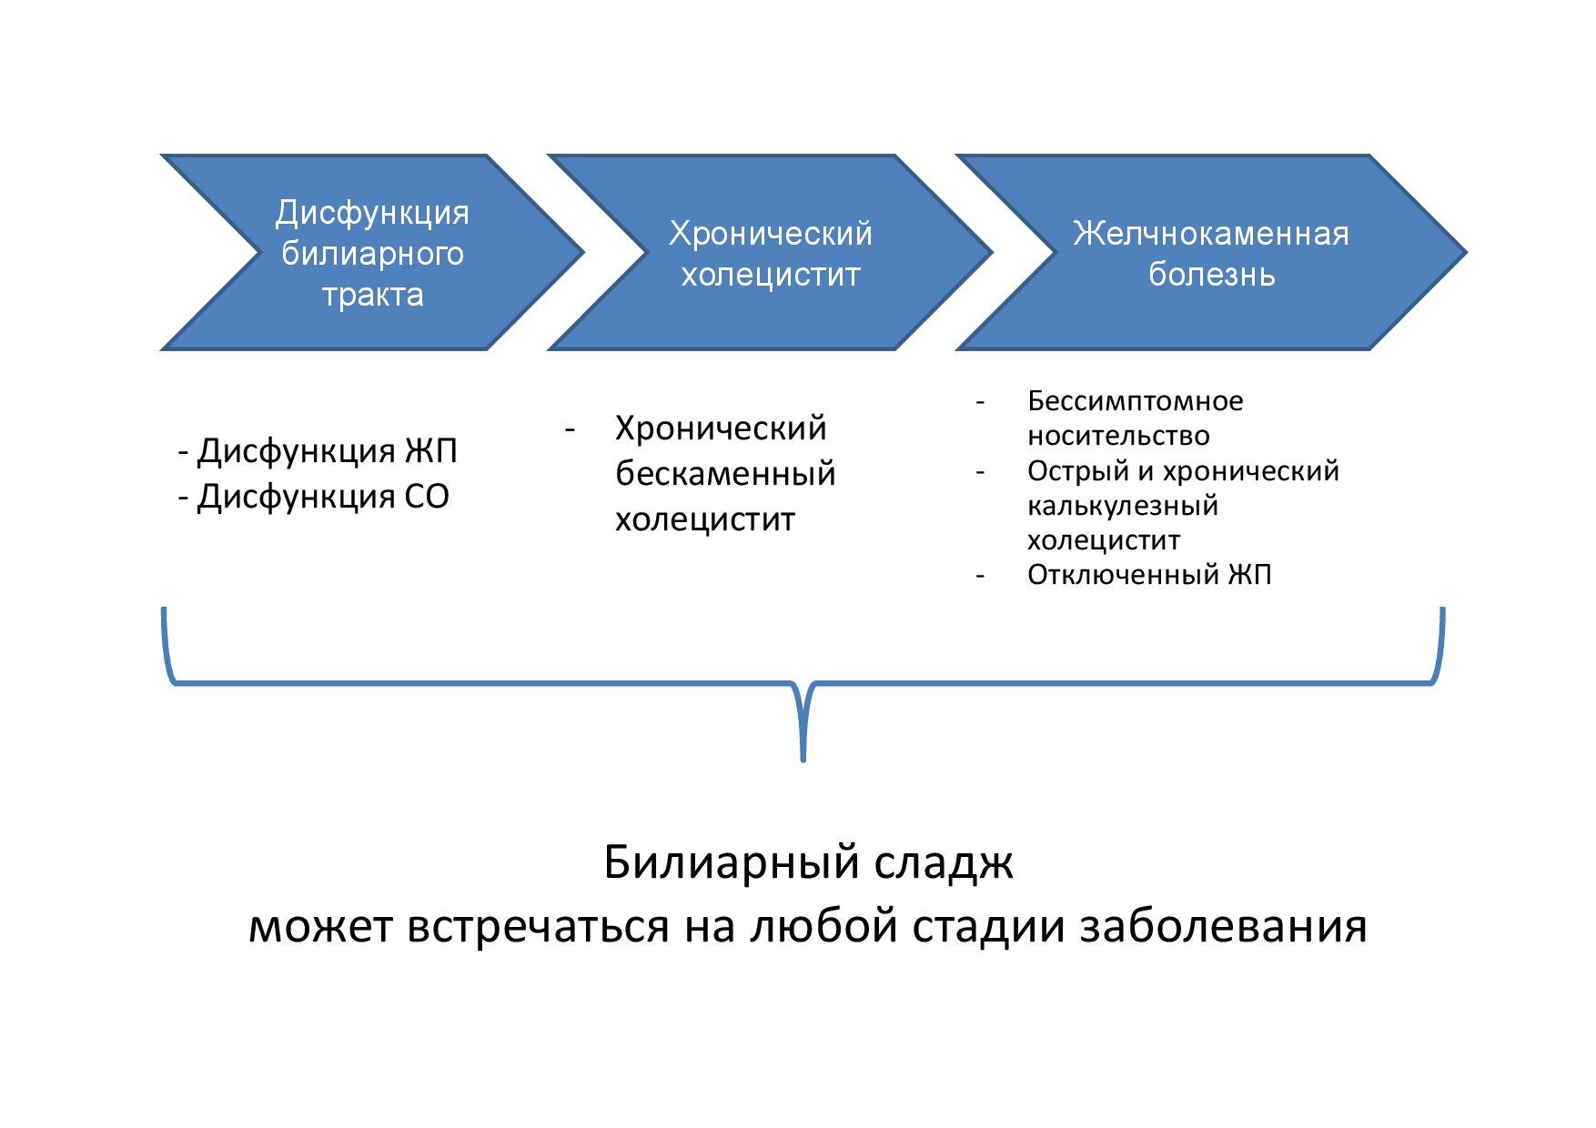
Fig. 1. Progression of the pathology of the biliary tract from functional disorders to structural (organic) pathology
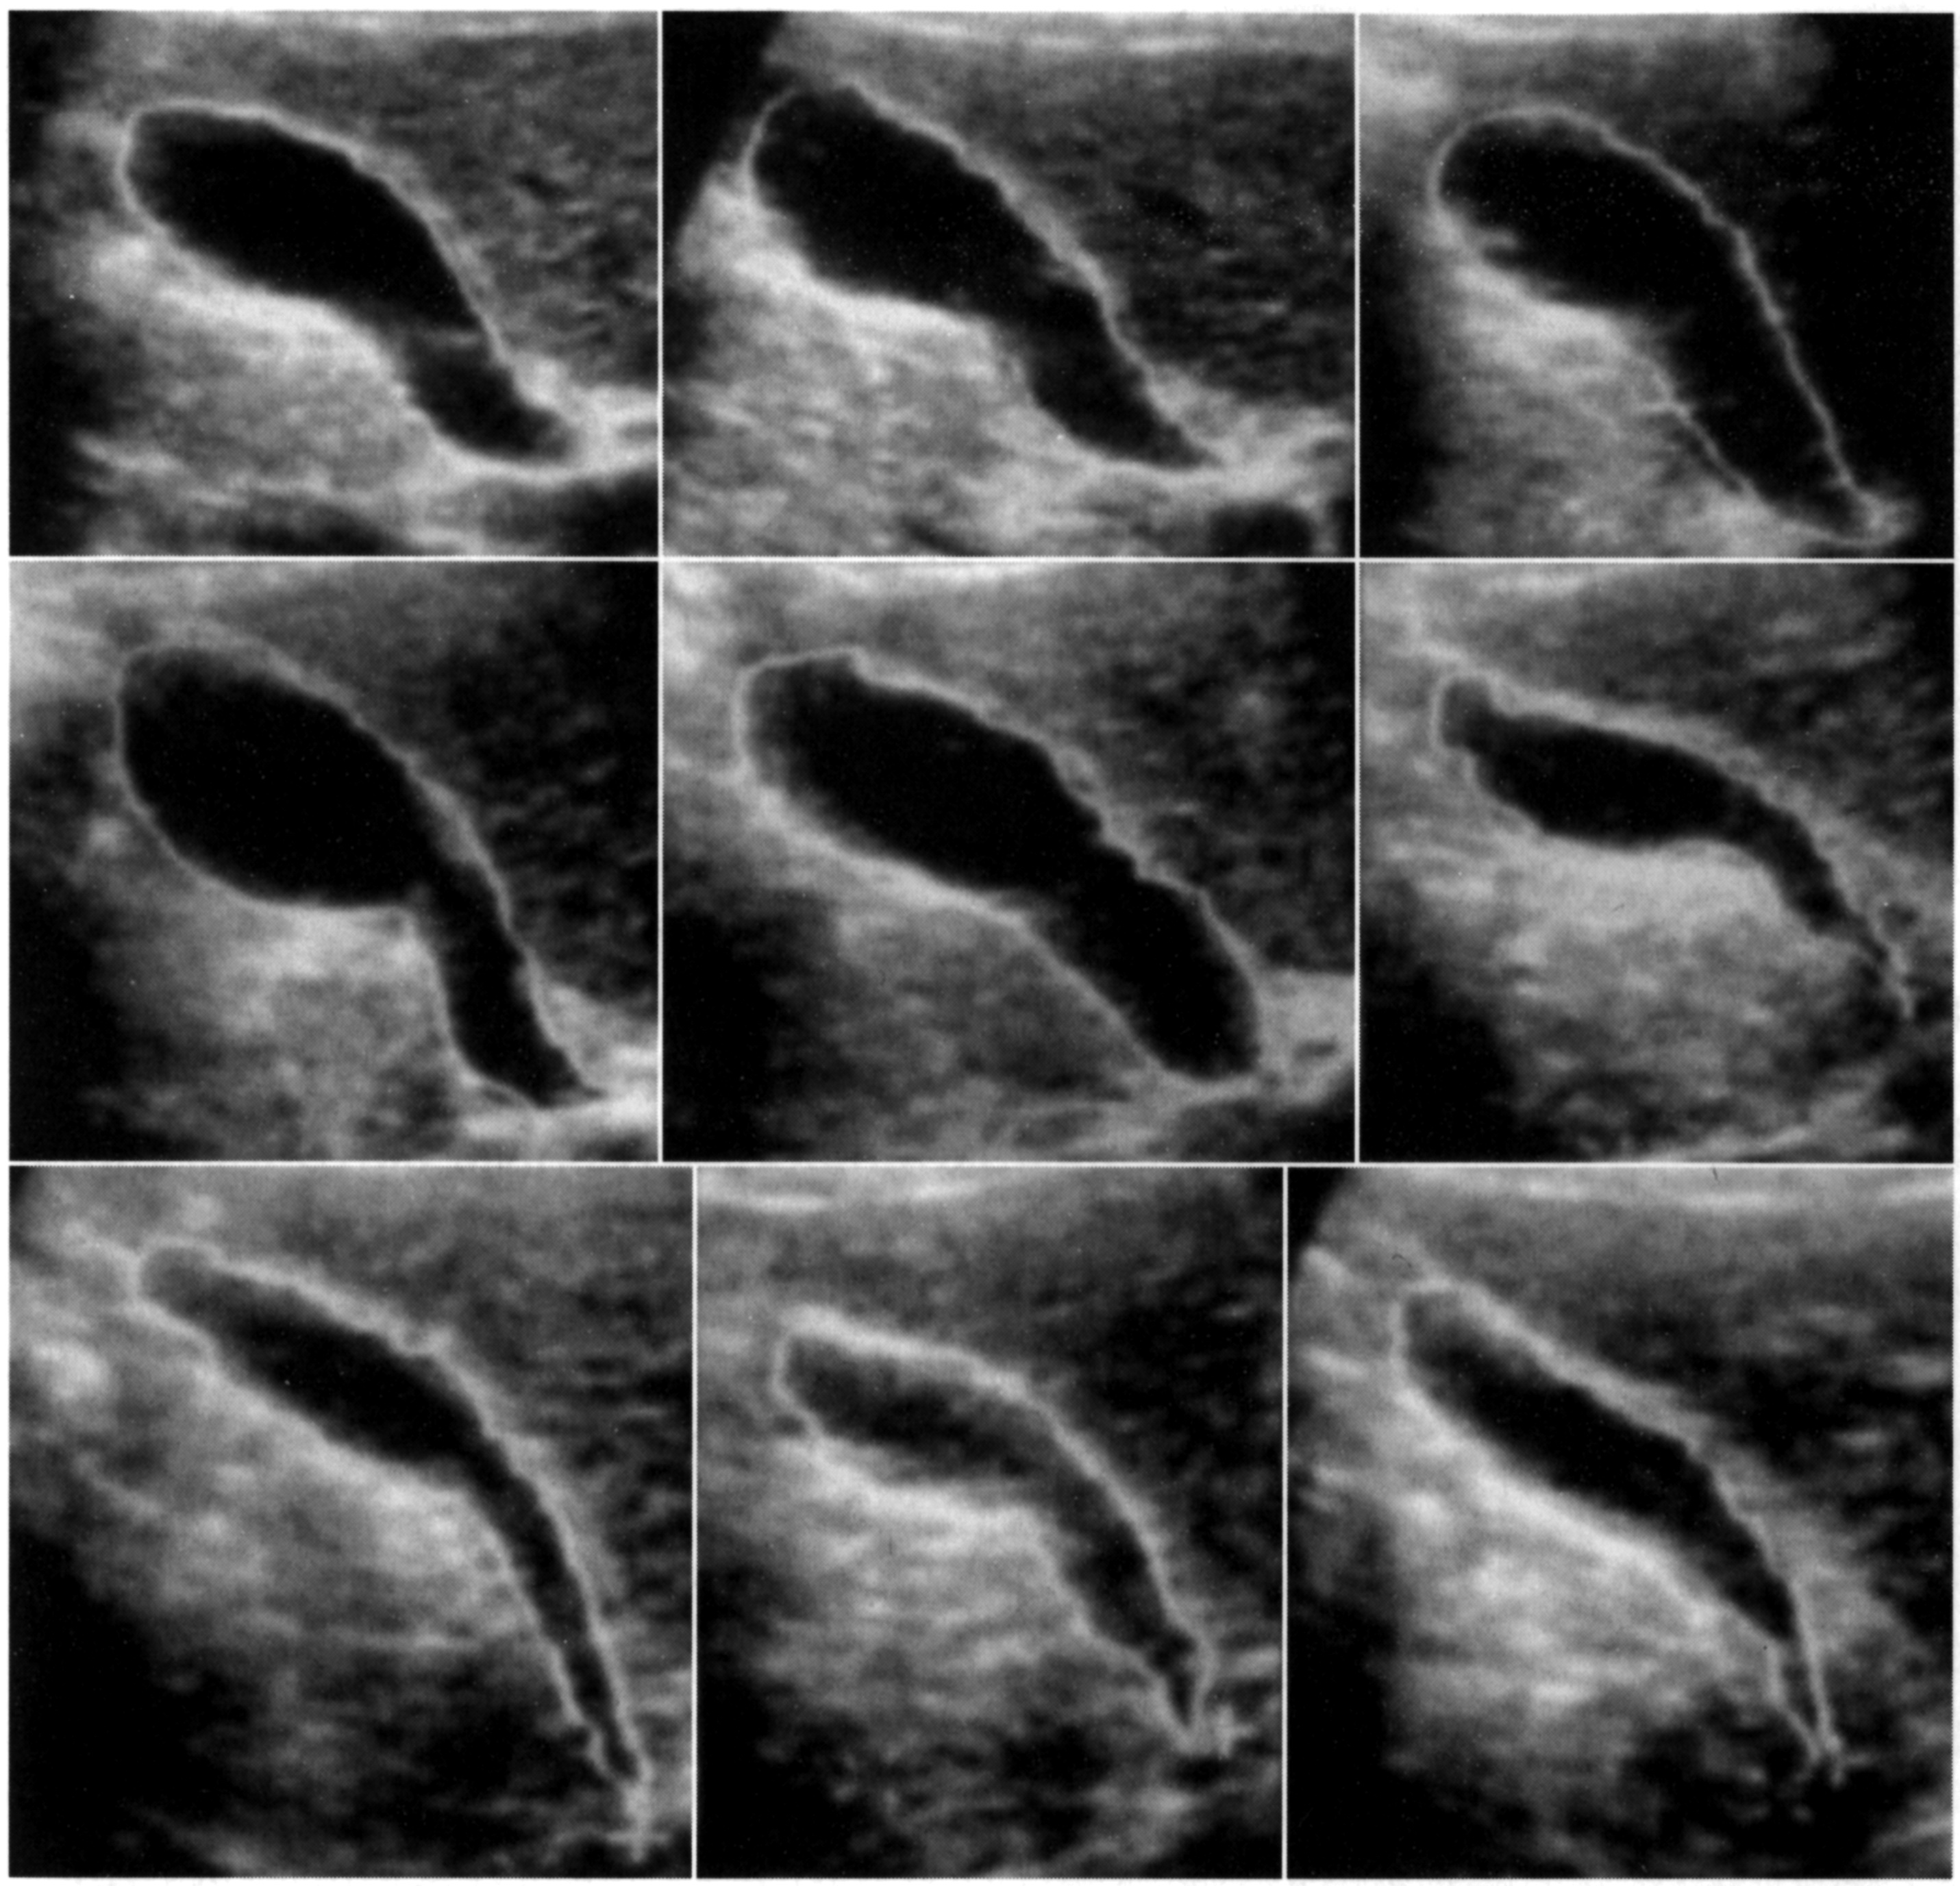
Fig. 2. Dynamic sonography of GB — hypotonic-hypokinetic dysfunction of GB is determined (according to R. A. Ivanchenkova, 2006 [2])

