Heavy smoking is associated with lower age at first episode
of acute pancreatitis and a higher risk of recurrence
S. Munigala¹, D. L. Conwell², A. Gelrud³, B. Agarwal¹
¹Division of Gastroenterology and Hepatology, Department of Internal Medicine, Saint Louis University, St Louis, USA
²Center for Pancreatic Disease. Division of Gastroenterology, Hepatology and Endoscopy, Brigham and Women’s Hospital, Harvard Medical School, Boston, USA
³Centre for Pancreatic Disorders, Division of Gastroenterology, University of Chicago, Chicago, USA

Pancreas. — 2015. — Vol. 44, No 6. — P. 876–881.

Key words: smoking, alcohol, acute pancreatitis, risk of acute pancreatitis, recurrence
Abbreviations: AP — acute pancreatitis, CI — confidence interval, FY — fiscal year, ICD-9-CM — International Classification of Diseases, Ninth Revision, Clinical Modification, RR — rate ratio, VA — Veteran’s Administration. VHA — Veteran Health Administration

Acute pancreatitis (AP) is one of the most common gastrointestinal causes of hospital admissions in the United States [1]. In 2009, approximately 275,000 hospitalizations were caused by AP [2]. The economic burden of pancreatitis is nearly 2.6 billion US dollars annually in direct and indirect medical costs [1]. Etiology of AP is complex [4] and little is known about the risk of AP other than gallstones and alcohol consumption [2].
Cigarette smoking is detrimental to pancreatitis [5]. According to Center for Disease Control and Prevention, tobacco smoking is the single largest preventable cause of disease and death. There are approximately 42 million active adult cigarette smokers in the United States [6]. Previous research established that smoking is associated with recurrent AP and chronic pancreatitis [4, 5, 7, 8, 9, 10, 11, 12, 13, 14, 15]; however, smoking association with AP is yet to be elucidated. Three published studies from Europe had suggested that smoking was an independent risk factor for the AP in a dose-dependent fashion [16, 17, 18]. The pooled population in these 3 studies was 135,918, with AP diagnosed overall in 880 patients. Of these 3 studies, two did not report whether the AP was related to a nongallstone cause.
The aim of this study was to evaluate the influence of cigarette smoking on AP risk and clinical presentation in patients with and without alcohol use in a large cohort of VA patients.
MATERIALS AND METHODS
Study Design and Participants
This was a retrospective study. Data for this study were obtained from Veteran Health Administration (VHA) inpatient and outpatient records using the International Classification of Diseases, Ninth Revision, Clinical Modification (ICD-9-CM) diagnoses maintained by the VHA national medical care datasets from the fiscal year (FY) 1998 [19]. International Classification of Diseases, Ninth Revision, codes were recorded if a patient had any diagnosis or symptom during each visit/encounter. All VHA patients from this national cohort were eligible for the study.
In an attempt to identify the first episode of AP, a 2-year washout period was applied to exclude patients with pre-existing AP (single episode or recurrent episodes between 1998 and 2000, n = 3046), pre-existing pancreatic disease (pancreatic adenocarcinoma, n = 361) and patients in the database who were lost to follow-up before October 2000 (n = 28,859). This study was approved by the institutional review board of Veteran Administration Saint Louis Health Care System (Protocol Number 1153766).
Exclusion Criteria
Patients with ICD-9 code 577.1 indicating diagnosis of chronic pancreatitis (n = 3222), patients with ICD codes 574. 574.1, 574.3, 574.5, 574.7, 574.8, and 574.9 indicating presence of gallstones (n = 14,574) and patients younger than 15 years (n = 270) at the time of entry into the database were excluded from the study. The final study cohort comprised 484,624 patients. Patients were followed from FY 2000 to 2007 (Fig. 1).
Measurements
Primary Dependent Variable
Primary outcome of interest was AP, defined as the presence of ICD-9 code 577.0. Two or more AP diagnoses coded within a 15-day period were considered as a single episode. Subsequent episodes of AP were considered as recurrent if an ICD-9 code for AP appeared at least 15 days after the previous episode of AP, respectively.
A follow-up period for patients with AP was until the dale of diagnosis of AP. Patients without AP were followed until the end of the study period (September 2007) and censored when they were lost to follow-up or deceased.
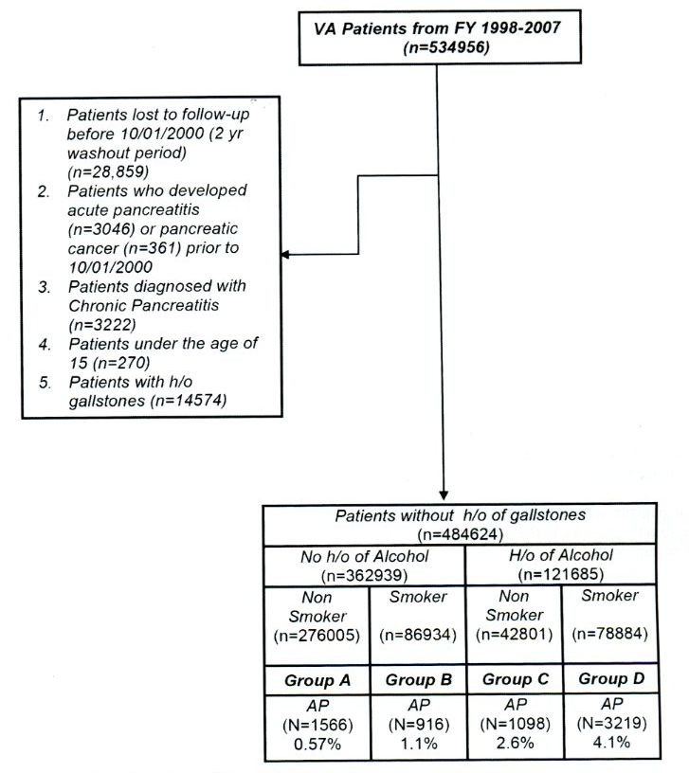
Fig. 1. Veteran’s Administration cohort by smoking and alcohol status.

Smoking Status
Smoking status was the primary independent variable of interest, defined as the presence of ICD-9 codes 305.1 or VI5.82, which indicated the tobacco abuse/dependence or personal history of tobacco use during the study period (FY, 2000-2007).
Covariates
Alcohol abuse/dependence (ICD-9 codes 303, 303.0, 303.9, 305.0), age at the time of entry into the study, race, and sex of the patients were other secondary predictors of interest considered in the study.
Reliability of ICD-9 Codes
Veteran’s Administration database has been used for many clinical epidemiological and outcomes research, and most of the studies showed consistent reliability when compared with written patient charts. Yadav et al. performed validation studies in VA patients from 2000 to 2001 for acute and chronic pancreatitis. The use of ICD-9 code for AP had a sensitivity of 93% and a specificity of 79% [20]. Also, the prevalence of smoking in our current data (34%) using ICD-9 codes was consistent with the prevalence of smoking reported in the general veteran population [21].
Statistical Analysis
Age of the patients was reported using mean (SD). Gender, race, as well as history of smoking and alcohol were reported using frequencies and proportions. χ² test was performed for categorical variables (gender, race, history of smoking and alcohol), and / test was conducted for continuous variables (age) to check for significance between AP versus rest of the patients without A P.
Study cohort was divided into the following 4 groups: group A (nonalcoholics and nonsmokers), group B (nonalcoholics and smokers), group C (alcoholics and nonsmokers), and group D (alcoholics and smokers). After stratification, the following analyses were performed:
A. Incidence rates of AP (with annual incidence) were calculated for smokers, nonsmokers, alcohol drinkers, and nondrinkcrs.
B. Rate ratios (RRs) with 95% confidence intervals (CIs) were computed for smokers versus nonsmokers and alcohol drinkers versus nondrinkers.
C. Multiple logistic regression analysis was performed to check for the independent association of history of tobacco use on AP diagnosis.
D. The test was performed to check for the significance in the age at the time of first episode of AP between alcoholics (smokers vs nonsmokers) and nonalcoholics (smokers vs nonsmokers).
E. Percentage of patients with recurrent AP was determined, and χ² (Fisher exact) test was performed to check for the significance of recurrence of AP attacks between alcoholics (smokers vs nonsmokers) and nonalcoholics (smokers vs nonsmokers).
F. Finally, time interval between recurrent AP episodes was also determined in these groups.
All the analyses for this study were done using SAS version 9.2 (SAS Inc, Cary, NC). All the analyses were 2-tailed and the level of significance (a) was set to 0.05.
RESULTS
Patient Demographics
After exclusions, the final cohort of patients included in the study was 484,624 (Fig. 1). Among 484,624 patients, 165,818 (34%) patients had a history of tobacco use and 6799 (1.4%) had a diagnosis of AP The demographic characteristics of the cohort arc summarized in Table 1. Patients presented with AP had a higher percentage of African Americans (30%), smokers (39%), and alcohol drinkers (37%) compared with patients without AP(P< 0.0001).
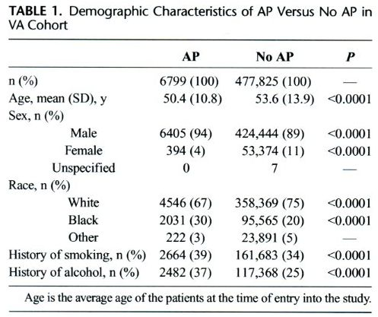

Risk of AP in Smokers and Alcoholics
Between 2001 and 2007, 6799 patients had AP (1.4%), including 1566 in group A (0.57%; annual incidence, 0.08%), 916 in group B (1.05%; annual incidence, 0.15%), 1098 in group C (2.57%; annual incidence, 0.36%), and 3219 in group D (4.08%; annual incidence, 0.58%). Patients with history of smoking had an increased risk of AP (RR, 1.86; 95% CI, 1.71-2.02; P< 0.0001), and smoking also potentiated the effect of alcohol on AP risk (RR, 1.61; 95% CI, 1.50-1.73; P < 0.0001) (Table 2).

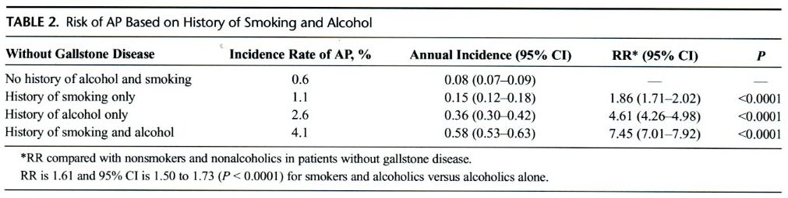
Predictors of AP
Table 3 shows results of multivariate analysis of factors influencing risk of nongallstone-associated AP. Patient age, race, as well as history of alcohol abuse and heavy smoking were included for analysis. African American race, history of alcohol abuse, history of smoking, as well as history of alcohol and smoking together were found to be independent risk factors for developing AP (P < 0.0001). The odds ratio (OR) of AP among smokers was 1.78 (95% CI, 1.64-1.94; P < 0.0001). In addition, smoking augmented the effect of alcohol and further increased the risk of AP in alcoholics (OR, 6.66; 95% CI, 6.24-7.10; P < 0.0001).
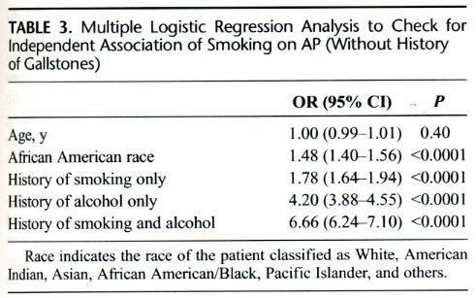
Patient Age at First Episode of AP
Figure 2 illustrates the age distribution of patients when they had the first episode of AP. Patients without history of heavy alcohol use or heavy smoking seemed to have bimodal distribution with 2 peaks at age 52 and 76 years. Both heavy alcohol use and smoking were independently associated with augmentation of the first peak at age approximately 53 and 55 years but loss the second peak later in life. Their combined effect was additive resulting in further lowering mean age at first episode of AP. Smoking lowered the mean (SD) age of the first episode of AP both in nonalcoholics (55 [0.7]years in smokers vs 62 [0.7]years in nonsmokers, P < 0.0001) and alcoholics (51 [0.3]years in smokers vs 54 [0.6] years in nonsmokers, P < 0.0001).
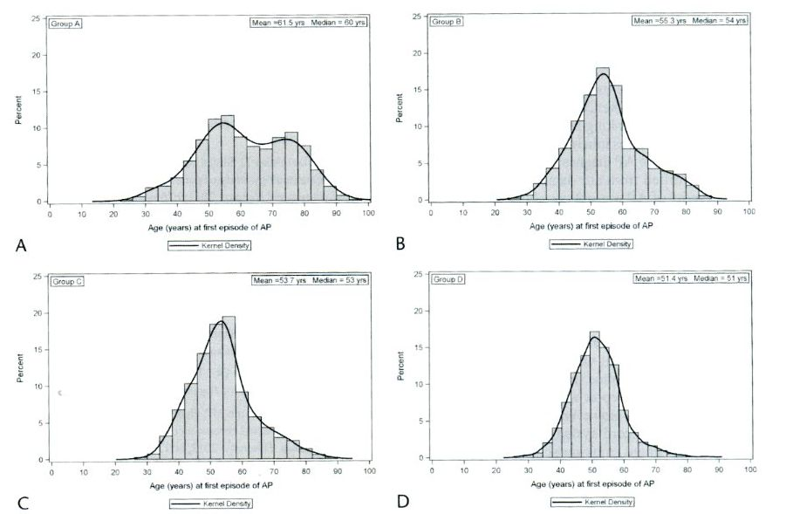
Fig. 2. Patient age at first episode of AP by smoking and alcohol status. Group A: nonalcoholics and nonsmokers. Group B: nonalcoholics and smokers. Group C: alcoholics and nonsmokers. Group D: alcoholics and smokers.

Smoking and Recurrent AP
As shown in Figure 3A, history of smoking was associated with a higher risk of recurrencc (S4 episodes) of AP both in nonalcoholic patients (11.9% in smokers vs 8.64% in nonsmokers. P = 0.0096) and those with heavy alcohol use (17.92% in smokers vs 12.93% in nonsmokers, P = 0.0001). However, smoking or alcohol alone or in combination did not reduce the time interval between recurrent episodes of AP (Fig. 3B).

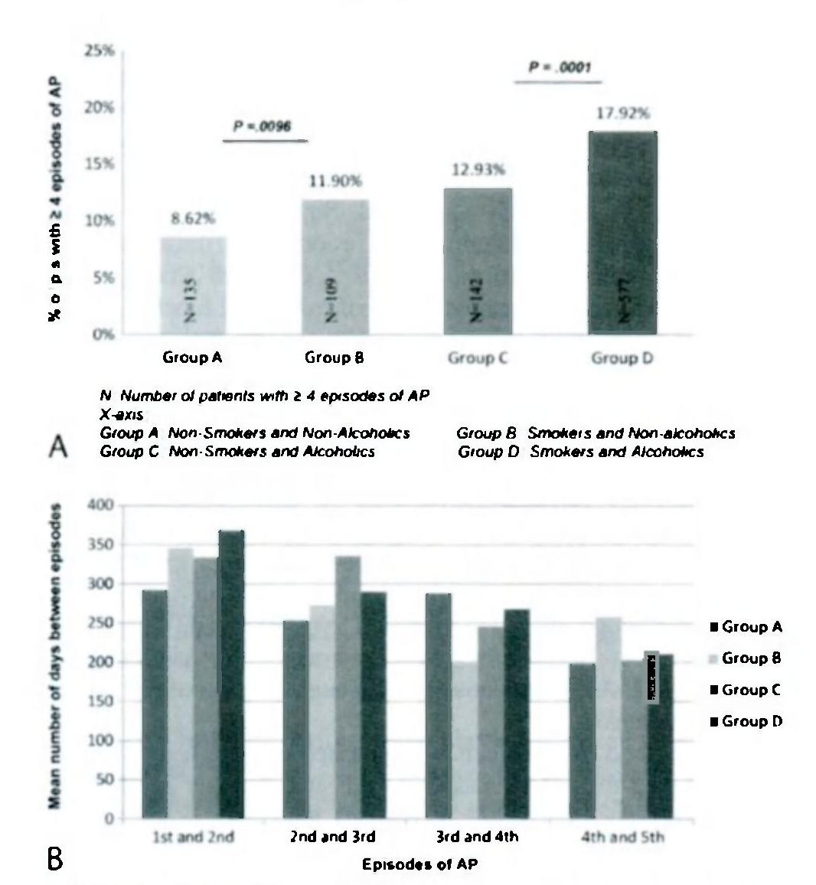
Fig. 3. A, Smoking and alcohol increase the risk of recurrent AP (>4 episodes). B, Time interval between recurrent AP episodes is not influenced by smoking or alcohol.

DISCUSSION
In a large VA cohort, smoking was an independent risk factor for AP and also augmented the risk of AP in patients related to heavy alcohol intake. Smoking and alcohol intake were independently associated with lower mean age at the time of first AP episode and a higher risk of recurrent AP (S4 episodes) and even more so in combination. However, neither smoking nor alcohol reduced the time interval between recurrent AP episodes.
Three studies from Europe evaluated the association between smoking and the risk of AP. Lindkvist et al. [16] followed 33,346 patients from 1974 to 1992 and identified 179 cases of A P yielding a RR of 2.14 and 95% CI of 1.48 to 3.09 (current vs never smokers) after adjusting for age, sex, body mass index, and alcohol consumption. Sadr-Azodi et al [17] followed 84,667 Swedish men and women for 12 years; 307 cases with nongallstone-related AP and 234 cases with gallstone-related AP were identified. The risk of nongallstone-related AP was more than double (RR, 2.29; 95% CI, 1.63-3.22; P < 0.01) among current smokers with 20 or greater pack years of smoking compared with never smokers. Tolstrup et al. [18] followed 9573 women and 8332 men for a mean period of 20.2 years and identified a total of 235 cases of pancreatitis during the follow-up period. A dose-response association between smoking and risk of acute and chronic pancreatitis was observed in both men and women with the hazard ratio of developing pancreatitis at 2.6 (95% CI, 1.5-4.7) for women and 2.6 (95% CI, 1.1-6.2) for men who smoked 15 to 24 g of tobacco per day. Combined together, the abovementioned 3 studies had 880 cases of AP (307 nongallstone related) with a total follow-up period of 50 years; our study included 6799 patients of AP encountered for 7 years (2000 2007) in a cohort of 484,624 patients.
The mechanism for smoking-induced acute damage to pancreas is yet to be clearly elucidated. Smoking has been shown to induce pancreatic inflammatory lesions and fibrosis that are associated with chronic pancreatitis [22]. Cigarette smoking was also shown to cause impaired pancreatic duct cell function. Mean peak pancreatic fluid (HCO₃–) was significantly lower in current smokers and past smokers compared with never smokers. Cigarette smoking was also found to have independent association with pancreatic duct cell dysfunction [7]. Animal smoking models and human autopsy studies show that smoking seems to incite and potentiate pancreatic inflammation and injury in a dose-dependent manner. Animal models also demonstrated that smoking causes "acinar cell stress" manifested as a net imbalance of proteases and their protective inhibitors, formation of protein precipitates/plugs, as well as increased trypsinogen and chymotrypsin secretion [7, 23]. These smoking-related changes could account for higher risk of AP in smokers and also augmentation of risk related to alcohol intake.
We found that subjects who smoked or were heavy alcohol drinkers had their first episode of AP at a younger age and the mean age was even lower in patients who both drank alcohol and smoked heavily. A larger part in shift of mean age of AP patients was due to abrogation of the late peak in the bimodal age distribution seen among nonsmokers and nonalcoholic patients that was curiously missing in patients who smoked or drank alcohol or both. The reasons for this loss of second later peak in AP in smokers and alcoholics probably merit investigation in future studies. There was gradual left shift in the first peak in the age incidence of AP in smokers and alcoholics. This could be related to the abovementioned cellular changes in pancreatic tissue, which make the pancreas more vulnerable to factors that precipitate AP attacks. Smoking and alcoholism were also independently and in combination associated with higher risk of recurrent episodes (≥4) of AP. Curiously, neither smoking nor alcohol ingestion reduced the time interval between subsequent episodes of AP. Cessation of not only alcohol but also smoking should be strongly recommended in patients with recurrent AP.
The present study has several strengths including the use of large, comprehensive database using veterans with AP, and the availability of comparable reference group. To our knowledge, this is the largest US study looking at the smoking and the risk of AP. Our study has limitations inherent to use of an administrative VA dataset. Whether the AP diagnosis was primary or secondary could not be identified from our dataset. The determination of etiology and severity of AP was not possible from the administrative database. Because our data is based on clinical diagnoses codes, we were not able to account for the AP cases that were never diagnosed/reported. Lack of laboratory confirmation of the AP results was also a limitation. The AP diagnoses have been validated by other researchers who found that approximately 93% diagnosed as AP from the administrative database actually had AP on chart review. This would, however, not undermine the conclusions of this manuscript. The use of administrative VA data may result in ascertainment bias with under detection or misclassification of smoking status (nicotine dependence) because it was entirely based on patient self-report as compared with physical examination-based diagnosis. However, clinical reminders were part of electronic medical record system and included prompts for clinicians to assess patient smoking status [19]. The prevalence of tobacco dependence (%) was consistent with 25% to 32% of prevalence of smoking reported in the general veteran population [21]. Lack of information about the smoking history limits the use of model based on number of packs or grams of tobacco per day. Although our study showed little lower risk of AP in smokers compared with the three European studies, [16, 17, 18] the risk was consistently within the range (95% CIs) specified in the studies. Also, the history of alcohol intake was based on ICD-9 codes for alcohol dependence and/or abuse, and the amount of alcohol consumption was not reported. This would mean that our alcoholic group comprises mostly of heavy drinkers. Residual confounding may be present because of unknown factors not available for multivariate model. Our data had only 11% of female veterans limiting the generalizability of results to women.
In conclusion, our study indicates that smoking is an independent risk factor for AP and also augments the alcohol-related risk. Smoking alone and in combination with alcohol increases the risk of AP, lowers the median age for onset of AP, and increases the risk of recurrent attacks. Further studies should focus on underlying mechanisms of smoking-induced AP.

References
- Alcohol and smoking as risk factors in an epidemiology study of patients with chronic pancreatitis / G. A. Coté, D. Yadav, A. Slivka [et al.] // Clin. Gastroenterol. Hepatol. — 2011. — Vol. 9. — P. 266–273.
- Alcohol consumption, cigarette smoking, and the risk of recurrent acute and chronic pancreatitis / D. Yadav, R. H. Hawes, R. E. Brand [et al.] // Arch. Intern. Med. — 2009. — Vol. 169. — P. 1035–1045.
- Anxiety disorders increase risk for incident myocardial infarction in depressed and nondepressed Veterans Administration patients / J. F. Scherrer, T. Chrusciel, A. Zeringue [et al.] // Am. Heart J. — 2010. — Vol. 159. — P. 772–779.
- Burden of gastrointestinal disease in the United States: 2012 update / A. K. Peery, E. S. Dellon, J. Lund [et al.] // Gastroenterology. — 2012. — Vol. 143. — P. 1179–1187.
- The burden of selected digestive diseases in the United States / R. S. Sandler, J. E. Everhart, M. Donowity [et al.] // Gastroenterology. — 2002. — Vol. 122. — P. 1500–1511.
- Centers for Disease Control and Prevention. Current Cigarette Smoking Among Adults — United Slates, 2005–2013 // MMWR. — 2014. — Vol. 63. — P. 1108–1112.
- Chronic pancreatic inflammation induced by environmental tobacco smoke inhalation in rats / U. A. Wittel, K. K. Pandey, M. Andrianifahanana [et al.] // Am. J. Gastroenterol. — 2006. — Vol. 101. — P. 148–159.
- Cigarette smoking as a risk factor for chronic pancreatitis : a case-control study in Japan. Research Committee on Intractable Pancreatic Diseases / Y. Lin, A. Tamakoshi, T. Flayakawa [et al.] // Pancreas. — 2000. — Vol. 21. — P. 109–114.
- Cigarette smoking impairs pancreatic duct cell bicarbonate secretion / V. Lee, L. S. Kadiyala, P. A. Banks [et al.] // JOP. — 2013. — Vol. 14. — P. 31–38.
- Cigarette smoking is independently associated with chronic pancreatitis / R. Law, M. Parsi, R. Lopez [et al.] // Pancreatology. — 2010. — Vol. 10. — P. 54–59.
- Cigarette smoking, smoking cessation and acute pancreatitis : a prospective population-based study / O. Sadr-Azodi, A. Andren-Sandbetg, N. Orsini [et al.] // Gut. — 2012. — Vol. 61. — P. 262–267.
- Comparing the smoking behavior of veterans and nonveterans / W. P. McKinney, D. D. Meintire, T. J. Carmody [et al.] // Public Health Rep. — 1997. — Vol. 112. — P. 212–217.
- The emerging role of smoking in the development of pancreatitis / M. Alexandre, S. J. Pandol, F. S. Gorelick [et al.] // Pancreatology. — 2011. — Vol. 11. — P. 469–474.
- Pancreatitis: prevalence and risk factors among male veterans in a detoxification program / D. Yadav, M. L. Eigenbrodt, M. J. Briggs [et al.] // Pancreas. — 2007. Vol. 34. — P. 390–398.
- A prospective cohort study of smoking in acute pancreatitis / B. Lindkvist, S. Appelros, J. Manjer [et al.] // Pancreatology. — 2008. — Vol. 8. — P. 63–70.
- Smoking and risk of acute and chronic pancreatitis among women and men : a population-based cohort study / J. S. Tolstrup, L. Kristiansen, U. Becker [et al.] // Arch. Intern. Med. — 2009. — Vol. 169. — P. 603–609.
- Smoking and the course of recurrent acute and chronic alcoholic pancreatitis: a dose-dependent relationship / V. Rebours, M. P. Vullierme, O. Hentic [et al.] // Pancreas. — 2012. — Vol. 41. — P. 1219–1224.
- Smoking as a cofactor for causation of chronic pancreatitis : a meta-analysis / A. Andriulli, E. Botteri, P. L. Almasio [et al.] // Pancreas. — 2010. — Vol. 39. — P. 1205–1210.
- Smoking is related to pancreatic fibrosis in humans / E. J. van Geenen, M. M. Smits, T. C. Schreuder [et al.] // Am. J. Gastroenterol. — 2011. — Vol. 106. — P. 1161–1166.
- Smoking is underrecognired as a risk factor for chronic pancreatitis / D. Yadav, A. Slivka, S. Sherman [et al.] // Pancreatology. — 2010. — Vol. 10. — P. 713–719.
- Yadav D. How accurate are ICD-9 codes for acute (AP) and chronic (CP) pancreatitis? A large VA hospital experience [abstr] / D. Yadav, R. Dhir // Pancreas. — 2006. — Vol. 33. — P. 508.
- Yadav D. The epidemiology of pancreatitis and pancreatic cancer / D. Yadav, A. B. Lowenfels // Gastroenterology. — 2013. — Vol. 144. — P. 1252–1261.
- Yadav D. The role of alcohol and smoking in pancreatitis / D. Yadav, D. C. Whitcomb // Nat. Rev. Gastroenterol. Hepatol. — 2010. — Vol. 7. — P. 131–145.

Heavy smoking is associated with lower age at first episode
of acute pancreatitis and a higher risk of recurrence
S. Munigala¹, D. L. Conwell², A. Gelrud³, B. Agarwal¹
¹Division of Gastroenterology and Hepatology, Department of Internal Medicine, Saint Louis University, St Louis, USA
²Center for Pancreatic Disease. Division of Gastroenterology, Hepatology and Endoscopy, Brigham and Women’s Hospital, Harvard Medical School, Boston, USA
³Centre for Pancreatic Disorders, Division of Gastroenterology, University of Chicago, Chicago, USA

Pancreas. — 2015. — Vol. 44, No 6. — P. 876–881.

Key words: smoking, alcohol, acute pancreatitis, risk of acute pancreatitis, recurrence
Objective: There is limited data on cigarette smoking and the risk of acute pancreatitis (AP). We evaluated the influence of cigarette smoking on AP risk and clinical presentation in a large cohort of Veteran’s Administration (VA) patients.
Methods: Retrospective study of VA patients from 1998 to 2007. Exclusion criteria included (I) history of chronic pancreatitis (n=3222) or gallstones (n=14,574) and (2) age younger than 15 years (n=270). A 2-year washout period was used to exclude patients with pre-existing recurrent AP.
Results: The study included 484,624 patients. From 2001 to 2007, a total of 6799 (1.4%) patients had AP. Alcohol (risk ratio, 4.20) and smoking (risk ratio, 1.78) were independent significant risk factors of AP on multi-pic regression analysis. Smoking increased the risk of AP in both nonalcoholics (0.57% vs 1.1%) and alcoholics (2.6% vs 4.1%). Smoking was associated with younger mean age at first episode of AP and higher likelihood of recurrent AP (≥4 episodes) in both nonalcoholics and alcoholics. The interval between recurrent episodes was not altered by alcohol or smoking.
Conclusions: In a large cohort of VA patients, smoking is an independent risk factor for AP and augmented the effect of alcohol on the risk, age of onset, and recurrence of AP.

