Сlinical case of pancreatic cancer
M. Kankia, I. Jikia, G. Mtskherashvili, G. Cucxubaia
Medical Center “Vivamedi”
Ivane Javakhishvili Tbilisi State University, Tbilisi, Georgia

Key words: pancreatic cancer, diagnosis, surgical treatment, clinical case, vascular anatomy
Malignant tumor of the pancreas is not uncommon. To date, the International Agency for Research on Tumors (IARC — International Agency for Research of Cancer) found about 18 million cases of malignant processes, among them about half a million cases of cancer of the pancreas. So, the disease turns into a global problem. Interestingly, men suffer from this type of cancer much more often than women. The most common form of pancreatic cancer is adenocarcinoma, an intraductal cancer that develops from the epithelium of the pancreatic duct or from the acinus of the pancreas.
The reason for the high mortality from cancer of the pancreas is that it is clinically manifested only in a complicated condition. Jaundice is one of the most frequently confirmed clinical signs. Cancer of the pancreas head grows into the common bile duct or into the papilla of Vater and into the duodenum, blocking the biliary tract.
Diagnosis of the disease requires high-tech research. The first step is, of course, an echoscopic examination of the abdominal cavity, but it should be noted that ultrasonography is not highly sensitive to a particular type of cancer, therefore, magnetic resonance imaging with cholangiography and contrast enhancement is necessary to determine the level of biliary tract blockage. Contrasting helps to eliminate the germination of a cancerous tumor in the blood vessels and consider the tactics of the operation. If the tumor grows into the papilla of the veins or into the duodenum, endoscopy with biopsy must be done. Endoscopic echoscopy provides great help in determining the exact location and size of cancer.
Computed tomography is also very informative, but there are cases when it does not show a small-sized tumor. So, contrast-enhanced magnetic resonance imaging is the gold standard.
A morphological study of a cancer tumor provides important information — this way excludes benign tumors and pre-determines the scale of the operation, although morphological research before the operation is often impossible, since performing a biopsy is very difficult.
Cancer of the pancreas, clearly, requires surgical intervention. Intervention can be both palliative and radical. In the case of a radical operation, cancer and regional lymph nodes are completely excised. The difficulty of this operation lies in the anatomical location of the pancreas. The organ is connected to many large and important vessels, the portal vein and the splenic vein, the inferior vena cava, the superior mesenteric vein and artery, the aorta, the celiac trunk, etc. pass behind it. The technical separation of a cancerous tumor from these structures is a complex task. Therefore, it is believed that prostate surgery is one of the most difficult sections of surgery.
In our clinic, such operations are carried out. After excision of cancer, patients undergo a course of chemotherapy.
During surgical treatment of cancer of the pancreas, it is important to conduct large-scale lymphadenectomy (excision of lymph nodes). There should be no regional (nearby) lymph nodes to prevent further postoperative complications.
Researchers at the Dana–Farber Cancer Institute, from Massachusetts (USA), have discovered several early symptoms that help identify pancreatic cancer at its early stage when it is being treated. In particular, an increase in the number of several amino acids can be a sign of a disease at its early stage.
Significance
According to the literature of the last decade, prostate cancer is a common disease. Description of a rare case of pancreas body tumor, which was grown into celiac trunk, is presented.
Aim is a clinical case description.
Materials and methods
Patient Z.V, 60 years old, from Batumi, came to the clinic with such complaints as general weakness, pain and heaviness in the epigastrium, in the right hypochondrium and in the lumbar region, nausea with vomiting episodes. He felt bad for 1 month, that is why he turned to the clinic.
Objectively: pulse 88 per minute, rhythmic, stretched, blood pressure 135/90 mm. Hg Art., heart tones clear, rhythmic. Pulmo: vesicular breathing, palpation of the stomach slightly stretched, sensitive mesogastrium. A dense formation is palpated in the right subcostal area. The liver protrudes 2 cm from the edge of the costal arch, the spleen is normal.
Oncomarkers: CEA — 2,22 mg/ml (norm 0–5.5).
CA19.9 — 1,88 mg/ml (norm 0–27).
Magnetic resonance imaging of the abdominal organs: the transverse dimensions of the liver are not enlarged. Intrahepatic and external bile ducts are not expanded. The lateral dimensions of the spleen are within the normal range, the contours are straight, sharp, homogeneous structure. At the gate of the spleen, there are several lymph nodes 0.8 cm in size. The contours of the pancreas are uneven and pale, inhomogeneous structure, the tail is not differentiated. In the area of ​​the body revealed inhomogeneous formation of a length of 5.7 cm and a width of 3.2 cm. The structure of the head is within the normal range.
Formation is common in the walls of the splenic and portal vein. The superior mesenteric artery passes through the thickness of the formation, where reliable visualization of its walls is not carried out.
The study of the abdominal cavity intravenous contrast: PZH manifests itself in the entire length. Dimensions are normal. The contours are dull, inhomogeneous parenchyma. In the area of the tail and the head, there is a hyposensitized formation of 51 x 22 mm in size, of irregular shape and with soft contours. This formation spreads retroperitoneally and tightly adjacent to the bifurcation zone of the celiac trunk. The common hepatic artery is secreted from the celiac trunk, and the right hepatic is from the superior mesenteric artery.
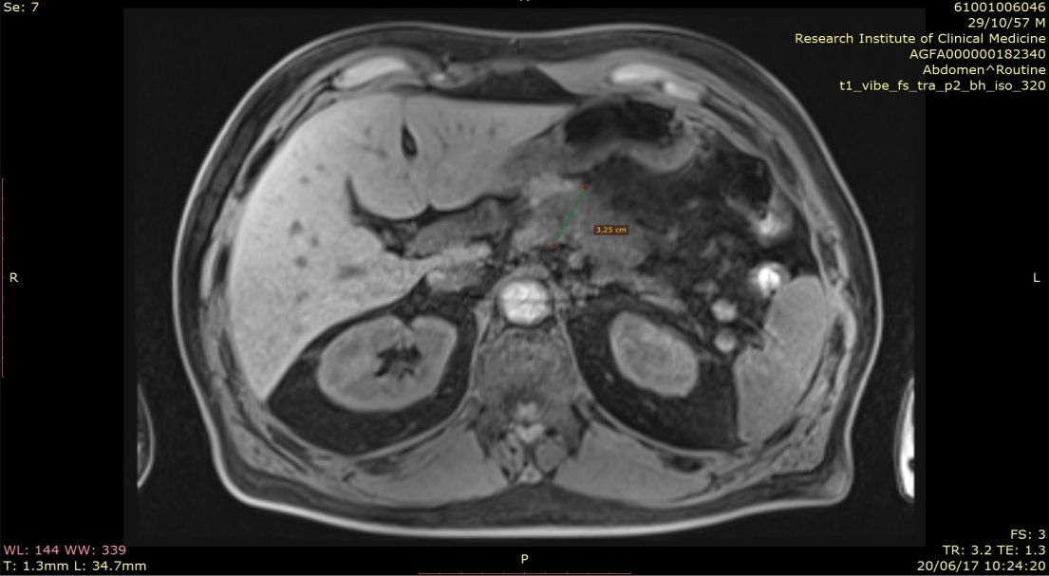
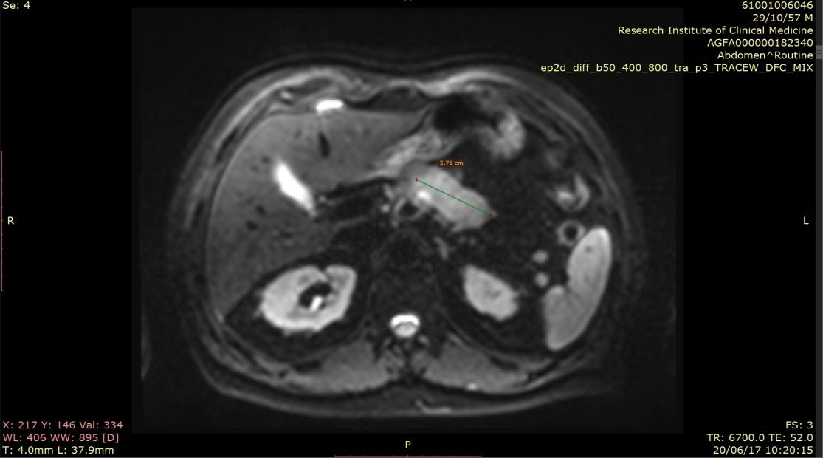
Fig. 1. Patient Z.V, 60 years old. Magnetic resonance imaging of the abdominal organs before surgery. Preliminary diagnosis: pancreatic cancer.

Description of surgery
4–5 cm tumor of pancreas body was detected during surgery. The tumor had grown into celiac trunk and into left adrenal gland. The branches of the celiac trunk are represented by the left artery of the stomach, the artery of the spleen, the common hepatic artery. The left hepatic artery and the gastroduodenal artery leaves the common hepatic artery, the right hepatic artery leaves the superior mesenteric artery. Intestines, peritoneum are intact.
Intraoperative diagnosis: cancer of the body of pancreas grown into celiac trunk.
Step-by-step description of surgery
The operation took place under general endotracheal anesthesia.
The small omentum was cut, the friable tissue of hepato-duodenal ligament was dissected during the surgery, elements of the ligament, common hepatic artery were visualized, big omentum was opened and mobilized. The surgeons mobilized duodenum using Koxer technique. As a result of this manipulation, the following blood vessels were visualized: inferior vena cava and abdominal aorta, celiac trunk, superior mesenteric artery.
Surgeons conducted a dissection of para-aortic and para-cava tissues.
Surgical team opened ligament of Treitz and mobilized the pancreas. They excised pancreas body 2.5 cm away from the tumor distally by Harmonic ultrasound scalpel. The stump was sewed with “mattress stich”. Celiac trunk was sectioned and entangled, surgeons also dissected common hepatic artery. After section they checked blood supply of liver. The pressure of blood flowing from gastro-duodenal and pancreato-duodenal artery was enough for providing normal blood flow in the left hepatic artery. An outlet stump of the common hepatic artery was tied, a resection of the left gastric artery and its branches was performed near the curvature of the stomach; spleen ligaments, body and tail of the pancreas were mobilized. Surgeons dissected the left gastroepiploic vessels and short vessels of the stomach. The arteries and veins of the left adrenal gland were also dissected and tied, the preparation was excised in one block.
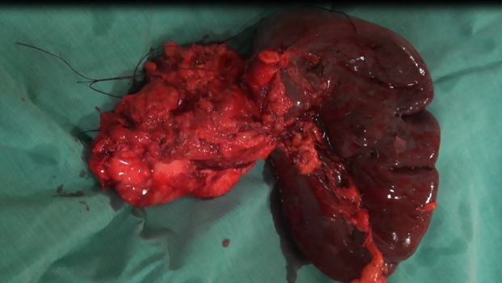
Fig. 2. Surgical material (drug).

Histomorphology: ductal adenocarcinoma of surgical material No 672.
The postoperative period was calm.
We presented a description of a clinical case of pancreatic cancer, which is interesting due to anatomical vascular variant found in a patient — the right artery of the liver exited the superior mesenteric artery.
If there was no such a vascular feature, the excision of a cancer that had grown into the celiac trunk would be disastrous for the patient. The fact that the right artery of the liver came out of the superior mesenteric artery contributed to the preservation of the nutrition of the liver and the rescue of the patient.
The patient was discharged from the hospital in a satisfactory condition. He passed clinical medical examination on the 3rd, 6th and 11th month. He feels well, his state of health is normal. Patient is capable of working.
Conclusion
This case is interesting as the right artery of the liver was a branch of the superior mesenteric artery, and this placement of the supplying arteries of the liver actually determined the successful outcome of a surgery.

Сlinical case of pancreatic cancer
M. Kankia, I. Jikia, G. Mtskherashvili, G. Cucxubaia
Medical Center “Vivamedi”
Ivane Javakhishvili Tbilisi State University, Tbilisi, Georgia

Key words: pancreatic cancer, diagnosis, surgical treatment, clinical case, vascular anatomy
Description of a rare case of pancreas body tumor, which was grown into celiac trunk, is presented. The patient was saved due to anftomy of right hepatic artery, which was a branch of superior mesenteric artery.
Patient Z.V, 60 years old, came to the clinic with such complaints as pain, heaviness in abdomen and waist area, weakness. 4–5 cm tumor of pancreas body was detected during surgery. The tumor had grown into celiac trunk and into left adrenal gland.
The friable tissue of hepato-duodenal ligament was dissected during the surgery. The surgeons mobilized duodenum using Koxer technique. As a result of this manipulation, the following blood vessels were visualized: inferior vena cava and abdominal aorta, celiac trunk, superior mesenteric artery. Surgical team opened ligament of Treitz and excised pancreas body 2.5 cm away from the tumor proximally. The stump was sewed with “mattress stich”, celiac trunk was sectioned and entangled, surgeons also dissected common hepatic artery. After section they checked blood supply of liver. The pressure of blood flowing from gastro-duodenal and pancreato-duodenal artery was enough for providing normal blood flow in the left hepatic artery.
Morphological result of the excised tissue — Ductal adenocarcinoma (No 672).
The patient’s state was satisfactory when he left the clinic. He underwent medical check-up three times next year. He feels well, his state of health is normal. Patient is capable of working.
This case is interesting due to the anatomy of right hepatic artery (which was a branch of superior mesenteric artery) that saved patient’s life.

