Early chronic pancreatitis: is a clinical diagnosis possible?
¹N. B. Gubergrits ¹N. V. Byelyayeva, ¹A. Ye. Klochkov, ¹G. M. Lukashevich, ²V. S. Rachmetova, ¹P. G. Fomenko
¹Donetsk National Medical University, Ukraine
²Medical University Astana, Kazakhstan

For the doctor, the best thing is to take care of the ability of foresight...
Hippocrates [2]

Key words: chronic pancreatitis, early pancreatitis, diagnosis, visualization, functional state of the pancreas, biomarkers, treatment
Over time, and as new knowledge of pancreatic pathology is acquired, an evolution of ideas about the pathogenesis, diagnosis and treatment of this disease occurs. One of the achievements of modern pancreatology was the understanding of the presence of so-called. “Fatal chain” not only in hepatology, but also in pancreatology [1, 14, 15]. What is the “fatal chain”? Recall that by this term Academician E. M. Tareev meant “cirrhosis and the whole complex of its development: acute hepatitis, chronic hepatitis, cirrhosis and liver cancer” [3]. At the present stage of development of pancreatology, we can confidently say: “Yes, the“ fatal chain ”also unfolds in pancreatology: from acute pancreatitis (OP) to its recurrence and chronic pancreatitis (CP), progression of CP with the development of cirrhosis of the pancreas and adenocarcinoma.” It should be noted that cirrhosis of the pancreas is a pathological term and is not a nosological unit. But in pancreatology, the “fatal chain” includes another link — the early CP (Fig. 1). Does this link exist, and can/should one diagnose early CP in practice?
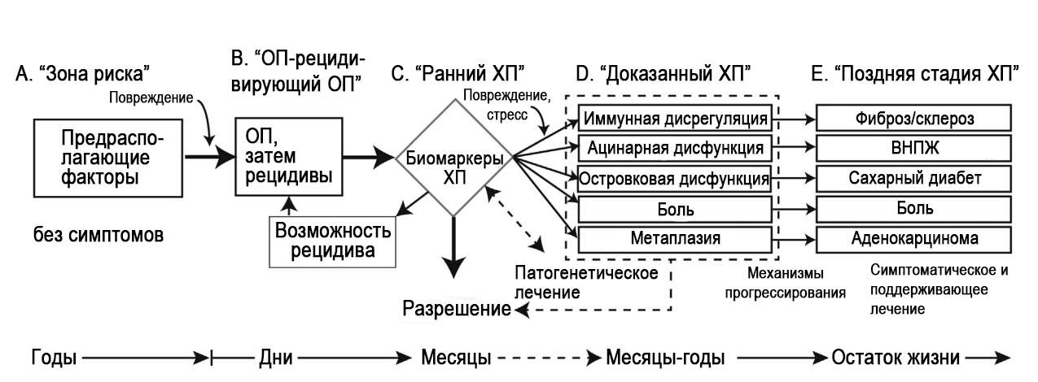
Fig. 1. Stages in the course of RV pathology (according to D. C. Whitcombetal., 2016 [20]).

Prof. D. Whitcomb (USA) formulated a new definition: "CP is a pathological fibro-inflammatory syndrome in individuals with genetic, external and/or other risk factors that lead to the development of a persistent pathological response to damage to the parenchyma or stress."
Common signs in the established diagnosis of CP and in its late stages include atrophy and fibrosis of the parenchyma, abdominal pain, irregularity of the ducts and their stenosis, calcification, violation of the external and intrasecretory functions of the pancreas, dysplasia.
For example, hereditary pancreatitis prof. D. Whitcomb showed that during CP there is a latent period before the onset of clinical manifestations, the duration of which can be 20 years (Fig. 2).

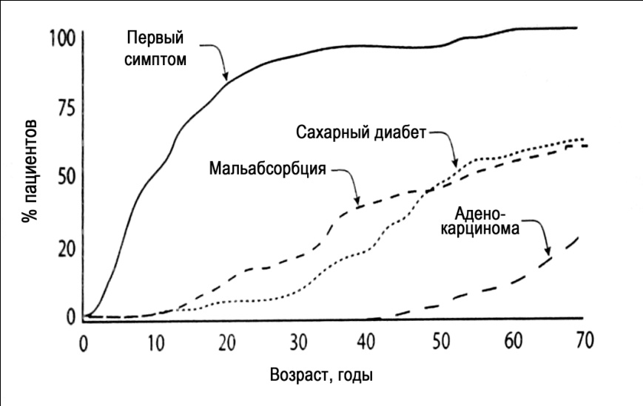
Fig. 2. The course of CP by the example of hereditary pancreatitis (according to N. R. Howesetal., 2004 [5]).

Based on the analysis of the course of CP and the presence of a latent period without clinical manifestations, a hypothesis of a “chain” of pancreatic pathology was developed, leading from OP to pancreatic adenocarcinoma (Figure 1) [20]. In this chain, the term “early CP”, corresponding to the latent period of CP, was first used. There were also presented the characteristics of each stage of the course of the pathology of the pancreas (Table 1), justifying the expediency of identifying in practice the diagnosis of early CP (Fig. 3) [20].
Table 1
Characteristics of the stages of the pathological process of the pancreas (according to D. C. Whitcomb et al., 2016 [20])
 | Stage B | Stage C | Stage D | Stage E
 | OP/recurrent OP | Early CP | Proven CP | Late CP
Other definitions | Single (completed) episode OP | Intermediate | Certain | Certain
Other definitions | Recurrent OP | Intermediate | Certain | Certain
Essence | Natural inflammatory response to acute damage to the pancreas | Persistence of inflammation with the presence of CP biomarkers that do not meet the diagnostic criteria of proven or late CP | Inflammation-associated pathology and/or dysfunction of two or more biological systems | Inflammation associated pathology and failure of two or more systems
Characteristics | Characterized by acute abdominal pain, increased activity of enzymes 3 times or more, the characteristic results of visualization | Persistence-OP: pain, hyperfermentemia, inflammation markers, visualization results | Visualization methods confirm fibrosis, calcification, pancreatic atrophy; impaired glucose tolerance; pancreatic pain | In the process of research
Fibrosis | Revised Atlanta Classification Criteria | In the process of research | In the process of research | In the process of research
Disease markers | Revised Atlanta Classification Criteria | EUS  CT  MRI
Biomarkers ofdisease activity | Revised Atlanta Classification Criteria | In the process of research
Excessive pancreatic insufficiency | Not predictable | Reducing the results of functional tests to 70% of normal | Reducing the results of functional tests to 70% — 10% of normal | Reducing functional test results to less than 10% of normal
Disease markers |  | In the process of research
Biomarkers ofdisease activity | C-reactiveprotein | In the process of research
Pancreatogenic diabetes | First developed (with pancreatic necrosis) | Glycemia is corrected by diet | Sugar-reducing drugs, insulin | Dependence on insulin. Hypoglycemia
Disease markers |  | In the process of research
Biomarkers ofdisease activity | C-reactiveprotein | In the process of research
Notes: CT scan — computed tomography; MRI — magnetic resonance tomography; EUS — endoscopic ultrasound.

The frequency of early CP is not precisely determined due to the complexity of its diagnosis. According to A. Masamune et al. [12], the prevalence of early CP in Japan is 1 case per 100,000 population, while the prevalence of a specific CP is 37-42 cases per 100,000 population.

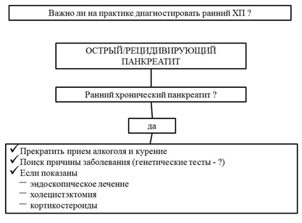
Fig. 3. Justification of the expediency of the diagnosis of early CP (according to D. C. Whitcomb et al., 2016 [20]).

In the literature there is a discussion about the feasibility of the allocation and the possibility of diagnosis in practice early CP. Prof. L. Frulloni cited the pros and cons of such a diagnosis. “Pros”: explanation of pain; timely forecast; the selection of patients with an increased risk of prostate cancer; the ability to compare data from different researchers. "Against": the absence of specific antifibrotic, anti-inflammatory therapy, i.e., early diagnosis of CP will not affect the progression of the disease; it is difficult to diagnose, which would entail large financial expenses; a later diagnosis does not affect the clinical outcome; many patients have no symptoms at the stage of early CP, and the diagnosis is made at the stage of proven or late CP with clinical symptoms, that is, treatment will be prescribed in any case when symptoms appear [18]. We can agree with the arguments of Prof. L. Frulloni. In our opinion, the diagnosis of early CP at the present stage is impossible in clinical practice. More widespread endosonography is needed, which will make it possible to diagnose early CP.

The International Consensus on Early CP has recently been published [21].
The first question in the Consensus is: “What is an early CP”?
Statement: The term “early CP” describes the initial stage of a specific CP.
The quality assessment of the recommendation is low; conditional recommendation, conditional consent.
The consensus discusses issues related to the diagnosis of early CP; it is argued that this disease cannot be diagnosed only on the basis of one symptom/sign, in particular, pancreas imaging data. It is necessary to consider a combination of different manifestations.
In this regard, the question “Is it possible to diagnose early CP taking into account a combination of symptoms?” The following statement was stated: “Yes, it is possible. Should be considered:
- presence of risk factors for CP;
- low risk of other diseases;
- clinical manifestations;
- biomarkers.
The quality assessment of the recommendation is low; the recommendation is strict, the agreement is weak.
The Consensus provides diagnostic criteria for early CP that meet the modified criteria of the Japanese Society of Pancreatology [7]:
- Clinical/functional criteria:
- recurrent abdominal pain in the upper abdomen (2 or more attacks);
- abnormal serum/urine enzyme levels;
- reduction of exocrine function of the pancreas;
- prolonged alcohol abuse (more than 80 g/day).
- Visualization — EUS (a or b):
a) more than 2 of the following characteristics, including one of the first four:
- lobulation with cellularity;
- lobulation without cellularity;
- hyperechoic tricks without shadow;
- hardness;
- cysts;
- dilation of the lateral ducts;
- hyperechogenicity of the main duct walls.
b) uneven expansion over 3 — branches of the main duct at ERCP.

Clinical symptoms are unreliable in the diagnosis of CP. A population study conducted by J. D. Machicado et al. Included 89 patients with CP, and in 21 (23.6%) they did not experience pain [11]. In a study by C. M. Wilcox et al. pain syndrome was absent in 81 (15.6%) of 521 patients with CP, despite the existing changes in the pancreas during imaging [22].
Nevertheless, visualization of the pancreas and, above all, endoscopic sonography, is given the leading role in the diagnosis of early CP, while CT and MRI are considered insufficiently informative (Fig. 4) [8].

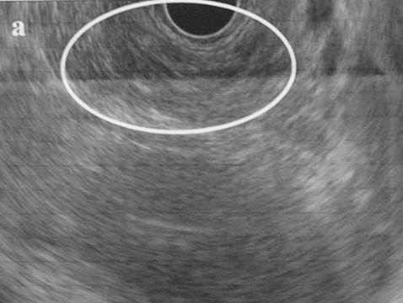 | 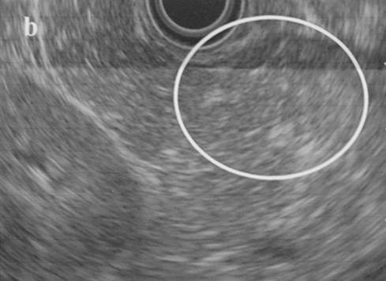
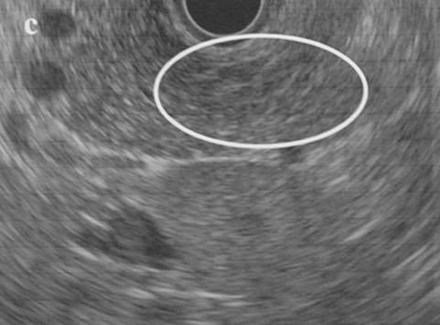 | 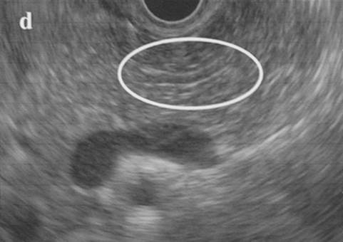

Fig. 4. An example of pancreatic endosography data for early CP (according to T. Ito et al., 2016 [8]): a — lobulation without cellularity; b — hyperechoic tricks without shadow; c — thin strands; d — hyperechoic wall of the main duct.

It is important to understand what is the probability of progression of early CP according to endosonography data to a certain CP. A. Sheel et al. [16] conducted a retrospective single-center cohort study, which included 40 patients with minimal changes in the pancreas according to the results of endosonography. The observation lasted more than three years. 12 (30%) patients developed CP; 8 (67%) of them abused alcohol, 10 (83%) were intensive smokers. These patients more often needed surgical treatment, they developed exocrine pancreatic insufficiency (EPI), the mortality rate exceeded that in CP patients who did not abuse alcohol and did not smoke. The authors concluded that the cessation of alcohol abuse and smoking can reduce the risk of progression early to a certain CP. Examples of the dynamics of the results of pancreas imaging are presented in Fig. 5.

А
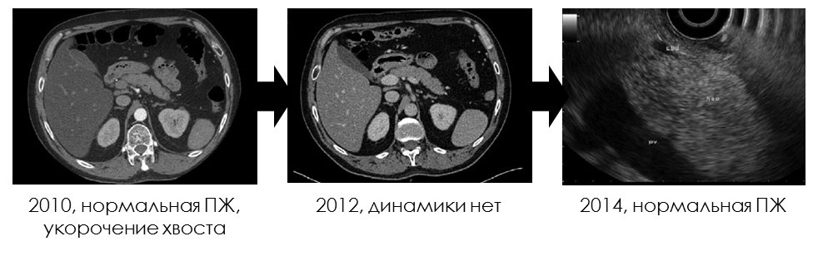
В
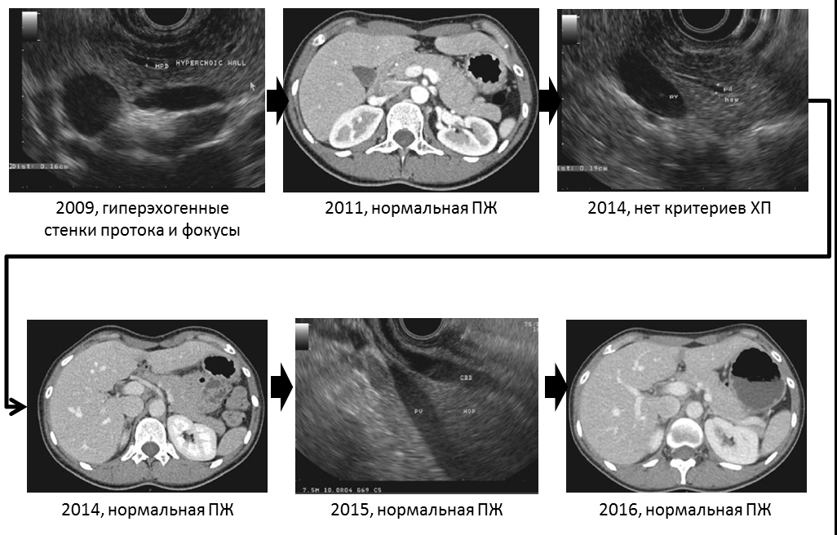
С
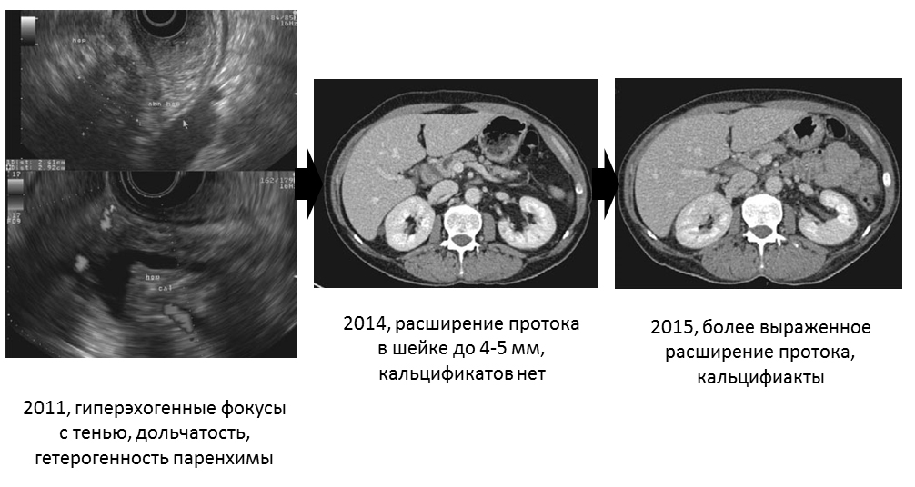

Fig. 5. Dynamics of results of pancreas imaging in patients with early CP (according to A.Sheel et al., 2018 [16]). A — minor changes in the pancreas without progression and development of CP. B — regression of changes in the pancreas. C — progression to CP.

It should be noted that the fine-needle biopsy of the pancreas during endosonography was not informative [6].
It is important that minimal changes in the pancreas during endosonography and other imaging methods can be associated not only with early CP. In this respect, the results of the B. H. Stamm study [17] are indicative. In the analysis of 112 randomly taken autopsies of adults who did not have a diagnosed pancreatic pathology, the results are obtained, which are presented in Fig. 6
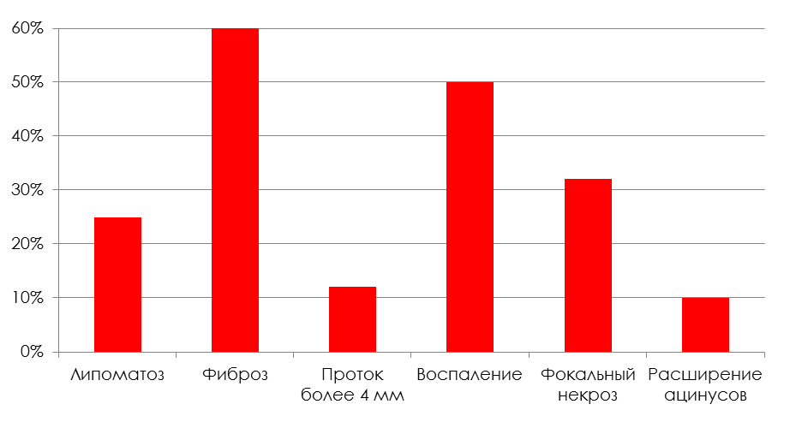

Fig. 6. Changes in the pancreas identified at 112 autopsies in the absence of known pathology of the pancreas (according to B. H. Stamm, 1984 [17]).

Therefore, minimal changes in the pancreas are not necessarily due to early CP. They can be associated with pancreatic steatosis, the patient's age and other causes, such as smoking. It has been proven that smoking contributes to the prostate fibrosis (Fig. 7) [19]. The authors analyzed the results of the autopsy of 11 patients who had no clinical manifestations of pancreatic pathology.
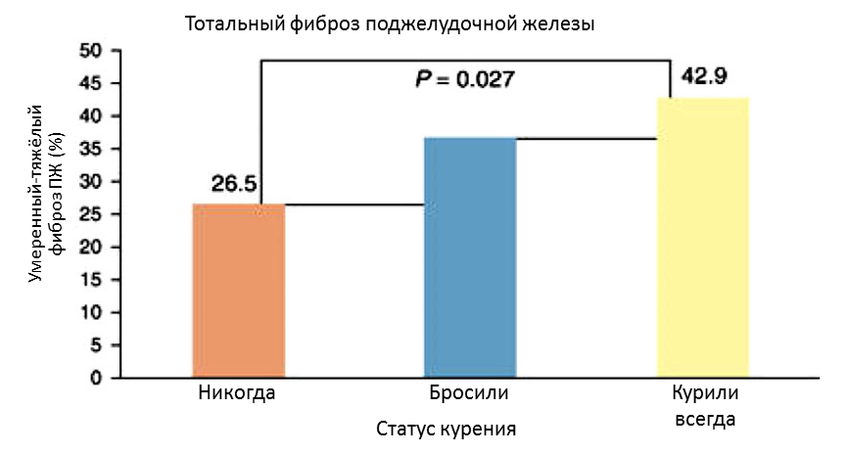

Fig. 7. Changes in the pancreas revealed at 111 autopsies in the absence of clinical manifestations of pancreatic pathology depending on smoking (according to E.J. van Geenen et al., 2011 [19]).

Functional tests for early CP are also not always informative. So, G. Ketwaroo et al. [9] conducted a retrospective single-center cohort study and examined 116 patients with suspected CP (there is a clinic, but there are no changes in the pancreas during imaging). Patients underwent magnetic resonance cholangiopancreatography (MRCP) with secretin. EPI was diagnosed in 27 patients, and in 7 patients it was not possible to conduct the observation Over 4.8 years, 9 of 27 patients with EPI developed CP. In 89 patients, EPI was not detected, in 19 of them the observation was not carried out. With a longer observation period (7 years), CP was diagnosed in 2 patients without a EPI. The sensitivity of MRCP with secretin in the diagnosis of early CP was 82%, specificity — 86%, positive predictive level — 45%, negative predictive level — 97%.
According to the results of an endoscopic functional test with secretin, EPI was diagnosed in 8 of 27 patients with early CP and in 1 examined control group. The sensitivity of the test in the diagnosis of early CP was 66%, specificity — 98%. The positive predictive level is 95%, the negative predictive level is 85% [10].
The literature data indicate the possibility of using biomarkers for the diagnosis of early CP. K.W. Noh et al. studied the concentration of cytokines in pancreatic juice, which was obtained from the duodenum after administration of secretin. Scientists examined 118 patients with pancreatic pain and the control group. Only the concentration of interleukin-8 was significantly different in healthy individuals and CP patients (p = 0.011), pancreatic cancer (p = 0.044), in healthy people and in the presence of pancreatic pathology (p = 0.007). The individual concentration of individual cytokines in CP was not significantly different from pancreatic cancer (Fig. 8) [13].

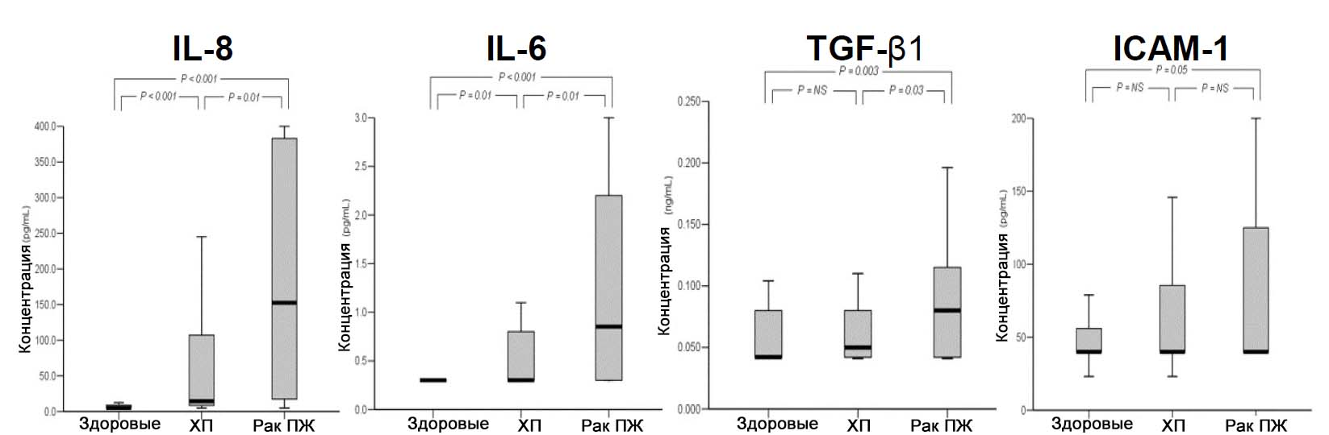
Fig. 8. The concentration of interleukins in the secret of the pancreas (according to K. W. Noh et al., 2006 [13]).
Notes. IL is interleukin; TGF β1 — transforming growth factor β1; ICAM-1 is a cell adhesion molecule-1.

B. K. Abu Dayyeh et al. [4] studied the concentration of prostaglandin E2 in pancreatic secretion in 10 patients with CP, 25 patients with minimal changes in the pancreas (early CP) and 10 healthy volunteers. Prostaglandin E2 is a powerful mediator of inflammation, and also regulates the profibrotic activity of pancreatic stellate cells. It has been proven that the concentration of prostaglandin E2 in the secret of the pancreas increases both with the established diagnosis of CP and with early CP (Fig. 9), i.e. This indicator can serve as a marker for early CP.
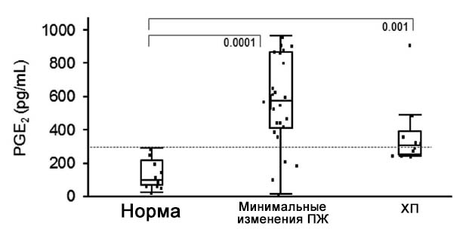

Fig. 9. The concentration of prostaglandin E2 in the pancreatic juice with minimal changes of the pancreas and CP (according to BK AbuDayyehetal., 2015 [4]).

Thus, the diagnosis of early CP is difficult in practice. It is necessary to continue the search for available and informative diagnostic methods (possibly, elastography of the pancreas, blood flow assessment of the pancreas, other biomarkers, etc.). Modern approach to the diagnosis of HP, including early HP is presented in Fig. 10.

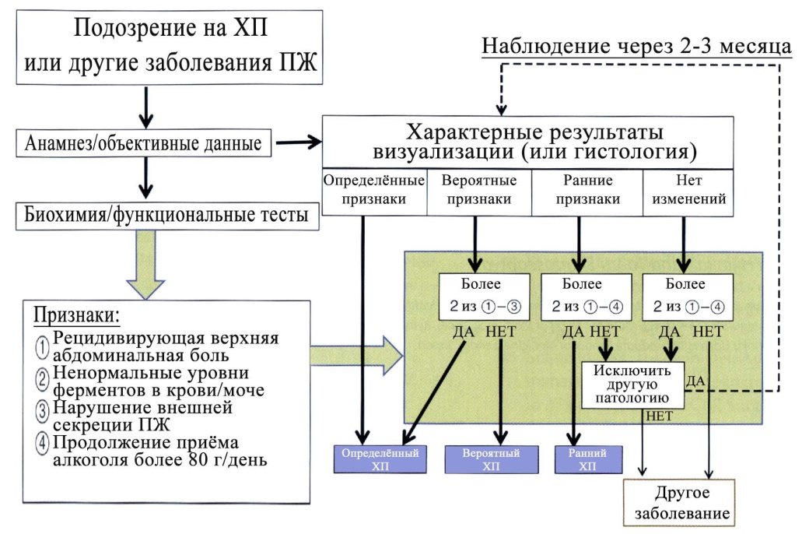

Fig. 10. “Roadmap” for CP diagnostics (according to H. G. Begeretal., 2018 [18]).

Increase the risk of progression of changes in the pancreas from early to certain CP alcohol abuse and smoking. Therefore, it is important to recommend patients with early CP to stop smoking and drinking alcohol. It should be monitored external and intrasecretory function of the pancreas for the timely appointment of replacement therapy. The best would be the appointment of antifibrotic drugs. Currently proved the possibility of inhibition of fibrosis of the pancreas by means presented in Table 2.
Table 2
Drugs inhibiting activity of star cells of the pancreas (according to H. G. Begeretal., 2018 [18])
Antioxidants | Vitamin E, N-acetylcysteine, oksipurinola, L-cysteine, ellagic acid,Salvianolic kis Lot
Cytokine inhibitors | TGF- β: antibodies to TGF- β, halofuginon, Saiko-keishi-to  TNF- α: antibodies to TNF- α, soluble receptors for TNF- α, pentoxifylline
Anti-inflammatory agents | Protease inhibitors (camostat mesilate), IS-741
Modulation of signaling cells | Mitogen-activated inhibitors protein kinases, phosphatidylinositol-3-kinases, protein kinases-C, troglitazone (ligand of receptors activated by peroxisome proliferators — γ)
Angiotensin Inhibitors | Captopril (angiotensin-converting enzyme inhibitor), losartan (angiotensin II receptor antagonist)
Vitamin A | Retinol, retinol acid

In conclusion, we cite the statement of Goethe: “Man must believe that the incomprehensible can be understood; otherwise he would not reflect on it”.

References:
- Губергриц Н. Б., Беляева Н. В., Фоменко П. Г. «Роковая цепочка»: и в панкреатологии тоже. Сучасна гастроентерологія. 2016. № 5. С. 76 –86.
[Gubergrits N. B., Belyayeva N. V., Fomenko P. G. «Rokovaya tsepochka»: i v pankreatologii tozhe. Suchasna gastroyenterologiya. 2016. № 5. S. 76 –86.]
- Мудрые мысли о медицине и врачевании: изречения, афоризмы, цитаты. Автор композиции Я. С. Циммерман. 4-е изд., доп. Москва: ГЭОТАР-Медиа, 2015. 256 с.
[Mudryye mysli o meditsine i vrachevanii: izrecheniya, aforizmy, tsitaty. Avtor kompozitsii Ya. S. Tsimmerman. 4-ye izd., dop. Moskva: GEOTAR-Media, 2015. 256 s.]
- Практическая гепатология. Под ред. акад. РАМН Н. А. Мухина. Материалы «Школы гепатолога», проводимой на базе клиники нефрологии, внутренних и профессиональных заболеваний им. Е. М. Тареева ММА им. И. М. Сеченова. Москва, 2004. 294 с.
[Prakticheskaya gepatologiya. Pod red. akad. RAMN N. A. Mukhina. Materialy «Shkoly gepatologa», provodimoy na baze kliniki nefrologii, vnutrennikh i professional'nykh zabolevaniy im. Ye. M. Tareyeva MMA im. I. M. Sechenova. Moskva, 2004. 294 s.]
- Abu Dayyeh B. K., Conwell D., Buttar N. S., Kadilaya V., Hart P. A., Baumann N. A. Pancreatic juice prostaglandin E2 concentrations are elevated in chronic pancreatitis and improve detection of early disease. Clin Transl Gastroenterol. 2015. Vol. 2, No 6. P. e72.
- Howes N. R., Lerch M. M., Greenhalf W. Clinical and genetic characteristics of hereditary pancreatitis in Europe. Clin. Gastroenterol. Hepatol. 2004. Vol. 2, No 3. P. 252−261.
- Iglesias-García J., Lariño-Noia J., Abdulkader-Nallib I., Lindkvist B., Domínguez-Muñoz J. E. Endoscopic ultrasound (EUS) guided fine needle biopsy (FNB) with the Procore™ needle provides inadequate material for the histological diagnosis of early chronic pancreatitis. Rev Esp Enferm Dig. 2018. Vol. 110, No 8. Р. 510–514.
- Ito T., Ishiguro H., Ohara H., Kamisawa T., Sakagami .J, Sata N. Evidence based clinical practice guidelines for chronic pancreatitis 2015. J Gastroenterol. 2016. Vol. 51, No 2. Р. 85–92.
- Ito T., Kataoka K., Irisawa A., Hirota M., Miyakawa H., Okazaki K. Prospective follow-up study of the patients with early CP or possible CP (The final report of the RCIPD chaired by Shimosegawa T). The RCIPD Report. 2015. Vol. 145. P. e9. (In Japanese) Presented by Shimosegawa T. “Clinical diagnostic criteria for early chronic pancreatitis.” Presentation at the international (IAP/EPC/APA/JPS) chronic pancreatitis guidelines working group meeting; the 47th meeting of the Japanese pancreatic society. Sendai, Japan, 6 August 2016 (In English).
- Ketwaroo G., Brown A., Young B. Defining the accuracy of secretin pancreatic function testing in patients with suspected early chronic pancreatitis. Am J Gastroenterol. 2013. Vol. 108, No 8. Р. 1360–1366.
- Lara L. F., Takita M., Burdick J. S., DeMarco D. C., Pimentel R. R., Erim T., Levy M. F. A study of the clinical utility of a 20-minute secretin-stimulated endoscopic pancreas function test and performance according to clinical variables. Gastrointest Endosc. 2017. Vol. 86, No 6. Р. 1048–1055.
- Machicado J. D., Chari S. T., Timmons L., Tang G., Yadav D. A population-based evaluation of the natural history of chronic pancreatitis. Pancreatology. 2018. Vol. 18, No 1. Р. 39–45.
- Masamune A., Kikuta K., Hamada S., Nakano E., Kume K., Inui A., Shimizu T., Takeyama Y., Nio M., Shimosegawa T. Nationwide epidemiological survey of early chronic pancreatitis in Japan. J Gastroenterol. 2018. Vol. 53, No 1. Р. 152–160.
- Noh K. W., Pungpapong S., Wallace M. B., Woodward T. A., Raimondo M. Do cytokine concentrations in pancreatic juice predict the presence of pancreatic diseases? Clin Gastroenterol Hepatol. 2006. Vol. 4, No 6. Р. 782–789.
- Pancreatitis: medical and surgical management. Ed. D. B. Adams. Chichester: Wiley Blackwell, 2017. 326 p.
- Pancreatology: a clinical casebook. Eds.: T. B. Gardner, K. D. Smith. Cham (Switzerland): Springer International Publishing AG, 2017. 193 p.
- Sheel A. R. G., Baron R. D., Sarantitis I., Ramesh J. The diagnostic value of Rosemont and Japanese diagnostic criteria for ‘indeterminate’, ‘suggestive’, ‘possible’ and ‘early’ chronic pancreatitis. Pancreatology. 2018. Vol. 18, No 7. Р. 774–784.
- Stamm B. H. Incidence and diagnostic significance of minor pathologic changes in the adult pancreas at autopsy: a systematic study of 112 autopsies in patients without known pancreatic disease. Hum Pathol. 1984. Vol. 15, No 7. Р. 677–683.
- The Pancreas: an integrated textbook of basic science, medicine and surgery. Eds.: H. G. Beger, A. L. Warshaw, R. H. Hruban. Oxford: Willey Blackwell, 2018. 1173 p.
- Van Geenen E. J., Smits M. M., Schreuder T. C., van der Peet D. L., Bloemena E., Mulder C. J. Smoking is related to pancreatic fibrosis in humans. Am J Gastroenterol. 2011. Vol. 106, No 6. Р. 1161–1166.
- Whitcomb D. C., Frulloni L., Garg P. Chronic pancreatitis: an international draft consensus proposal for a new mechanistic definition. Pancreatology. 2016. Vol. 16, No 2. P. 218−224.
- Whitcomb D. C., Shimosegawa T., Chari S. T. International consensus statements on early chronic Pancreatitis. Recommendations from the working group for the international consensus guidelines for chronic pancreatitis in collaboration with The International Association of Pancreatology, American Pancreatic Association, Japan Pancreas Society, PancreasFest Working Group and European Pancreatic Club. Pancreatology. 2018. Vol. 18. Р. 516–527.
- Wilcox C. M., Yadav D., Ye T., Gardner T. B., Gelrud A., Sandhu B. S. Chronic pancreatitis pain pattern and severity are independent of abdominal imaging findings. Clin Gastroenterol Hepatol. 2015. Vol. 13, No 3. Р. 552–560.

Early chronic pancreatitis: is a clinical diagnosis possible?
¹N. B. Gubergrits ¹N. V. Byelyayeva, ¹A. Ye. Klochkov, ¹G. M. Lukashevich, ²V. S. Rachmetova, ¹P. G. Fomenko
¹Donetsk National Medical University, Ukraine
²Medical University Astana, Kazakhstan

Key words: chronic pancreatitis, early pancreatitis, diagnosis, visualization, functional state of the pancreas, biomarkers, treatment
A “fatal chain” in pancreatology is discussed in the present article; peculiar attention is paid to an early chronic pancreatitis (CP), being one of the little-studied “links” in this range and corresponding to the latent period of CP. Features of the different stages of the pancreatic diseases’ course are presented, substantiating a need for a practical identification of the “early CP” diagnosis. Advantages and disadvantages of using the “early CP” diagnosis in practice are considered. The authors cite the provisions of the International Consensus on early CP, and list the current diagnostic criteria for this disease elaborated by the Japanese Pancreas Society. Advantages and disadvantages of the instrumental and laboratory diagnostic methods are analyzed, including probable early CP biomarkers (interleukin-8, prostaglandin E2). The most suitable therapeutic tactics for management of patients with early CP are presented, including correction of the exocrine and endocrine pancreatic function, as well as the use of antifibrotic drugs.

