Evidence-based pancreatology 2018
(review of research results on diseases and exocrine pancreatic insufficiency)
N. B. Gubergrits^{1,2}, N. V. Byelyayeva^{1,2}, A. Ye. Klochkov¹, G. M. Lukashevich¹,
P. G. Fomenko¹, E. V. Berezhnaya²
¹Donetsk National Medical University, Ukraine
²Medical Center «Medicap», Odessa, Ukraine

Key words: pancreatology, chronic pancreatitis, exocrine pancreatic insufficiency, studies, steatorrhea, diabetes mellitus, enzyme replacement therapy

Facts are thousand times more important than words.
I. P. Pavlov [2]
We decided to make the tradition of publishing the results of the most significant studies on pancreatic pathology. Some of these data, published in early 2018, we outlined in our article on evidential pancreatology, published last year [1]. In this article we will continue to talk about the most interesting achievements in the field of pancreatology.
Pathogenesis of pancreatic diseases.
Recently, in the pathogenesis of various diseases of the pancreas great importance is attached to the syndrome of bacterial overgrowth (SIBO) in the small intestine. In a single-center study, using the hydrogen test with glucose, we studied the incidence of SIBO in 35 non-surgical patients with chronic pancreatitis and 31 practically healthy [26]. The incidence of SIBO in patients was 15%, whereas in healthy people it was not detected in any case. More often SIBR occurred when alcoholic etiology of pancreatitis, taking proton pump inhibitors and in the presence of exocrine pancreatic insufficiency (EPI), as well as diabetes mellitus (DM). It was found that weight loss was more characteristic and expressed in the presence of SIBO. Given that the effectiveness of enzyme replacement therapy decreases with SIBO, it should be diagnosed and treated promptly.
L.V. Vinokurova et al. studied the metabolic activity of the intestinal microbiota in adult patients with cystic fibrosis [37]. The study included 14 patients aged 20–34 years. We studied the level of C-peptide in the blood, the content of short-chain fatty acids in the feces and performed fecal elastase test. Severe pancreatic insufficiency was diagnosed in 9 patients, diabetes — in 3 patients. The metabolic activity of the intestinal microbiota was reduced: the rate of short-chain fatty acids in patients was 6.03±4.11 mg/g, at a rate of 10.61±5.11 mg/g (p <0.05). In patients who received probiotics, the content of short-chain fatty acids was close to normal, while those who received antibiotics were sharply reduced. A relationship was found between the fecal elastase dough and short-chain fatty acids. It was concluded that not only enzyme preparations, but also probiotics should be included in the treatment of cystic fibrosis.
A. Sheel et al. conducted a single-center retrospective cohort study, which lasted 3 years, to assess the role of alcohol abuse and smoking in the progression from suspected chronic pancreatitis (pancreatitis with minimal changes in the pancreas) to a certain chronic pancreatitis [31]. 807 patients who underwent endoscopic sonography were examined. Minimal changes in the pancreas were revealed in 40 patients. In the process of observation, 12 (30%) patients developed chronic pancreatitis, 5 (12.5%) patients experienced complete regression of changes in the pancreas, 23 (57.5%) changes remained stable (there was no regression or progression). Of the 12 patients with progression of changes in the pancreas, 8 (67%) were abusing alcohol, 10 (83%) had ever smoked, and 9 (75%) continued to smoke during the observation period. In 8 (67%) patients with progression of changes, pancreas developed in the pancreas. On average, the period from detecting minimal changes in the pancreas to a certain chronic pancreatitis was 30 months. Among patients with regression and stable changes in the pancreas, alcohol abuse and smoking occurred significantly less frequently, the incidence of pancreatic insufficiency was significantly lower. 6 (50%) patients with progressive changes in the pancreas underwent surgical treatment, 3 (25%) died. Thus, alcohol abuse and smoking contribute to the progression from pancreatitis with minimal changes to the pancreas to a certain chronic pancreatitis.
Diagnostics.
C. V. Gil et al. conducted a single-center retrospective observational study to assess the relationship between the results of the fecal elastase test and pancreatic endoscopic sonography [15]. The study included 61 patients with suspected chronic pancreatitis. The “large” endosonographic criteria for chronic pancreatitis (hyperechoic foci with shadow and concrements in the Wirsung duct) corresponded to low fecal elastase-1 indices: 106 μg/g and 114 μg/g, respectively.
A similar one-center study was performed in Romania [5]. The study included 42 patients with chronic pancreatitis. Endosonography and fecal elastase test were performed. A correlation was found between the degree of decrease in elastase-1 and severity of structural changes in the pancreas. Especially reduced exocrine function of the pancreas occurred in patients who abuse alcohol, smokers and with the expansion of the Wirsungian duct. The authors concluded that the fecal elastase test was informative as a predictor of the degree of pancreatic morphological changes in chronic pancreatitis.
A cross-sectional study to study the informativeness of various diagnostic methods for assessing the risk of developing EPI in chronic pancreatitis was performed by S. Pongprasobchai et al. [27]. A total of 49 patients were examined who were given a fecal elastase test, and then were divided into a group of patients with severe (elastase-1 less than 15 μg/g; 27 patients) and mild (elastase-1 more than 15 μg/g; 22 patients) pancreatic insufficiency. In severe insufficiency, macroscopically definable steatorrhea, pancreatic atrophy with computed tomography (CT) and a greater number of endosonographic criteria for chronic pancreatitis occurred significantly more often. Severe insufficiency occurred in all patients with 7 or more endosonographic criteria of chronic pancreatitis. Accordingly, it was concluded that the occurrence of steatorrhea, pancreatic atrophy during imaging (7 or more endosonographic criteria of chronic pancreatitis) indicate a high risk of severe pancreatic insufficiency.
Autoimmune pancreatitis.
Autoimmune pancreatitis is still being studied in Europe, Asia and the United States. H. W. Lee et al. published the results of a single-center observation of the course of autoimmune pancreatitis type I in a large cohort of patients [20]. The study included 138 patients who, after successful initial therapy with corticosteroids, were observed for at least two years. The study did not include patients who underwent surgery for pancreas, as well as patients whose treatment with corticosteroids was not sufficiently effective. In 66 (47.8%) patients, despite the initial success of the therapy, a relapse of the disease developed. The observation lasted an average of 60 months (24–197 months). Among those patients who developed relapse, in 74% of cases this relapse was diagnosed during the first three years of follow-up.
In 60% of cases (82 of 138 patients) there was involvement of other organs, mainly the bile ducts (26.8%). It was sclerosing cholangitis with multivariate analysis that was an independent risk factor for recurrence (p<0.002). During the observation period, in 11.6% of cases, external and/or intrasecretory pancreatic insufficiency developed, and in 23.2% of cases, calcification of the pancreas occurred. Prostate cancer is not diagnosed in any patient. The authors concluded that long-term maintenance corticosteroid therapy is needed, especially in the presence of sclerosing cholangitis.
In a single-center study, it was studied whether blood IgG4 influences the diagnosis of autoimmune pancreatitis on the course and outcome of a disease [25]. The study included 47 patients, in 66% of cases the level of IgG4 was increased by 2 or more times. The observation lasted an average of 40 months. In these patients, EPI was significantly more frequently detected (78.9% compared with 46.2% in patients with a less pronounced increase in IgG4; p=0.035). Other characteristics of the disease (response to corticosteroids, frequency of recurrences and involvement of other organs, endocrine insufficiency of the pancreas) did not have significant differences in the two groups. Nevertheless, the authors note that the difference in the frequency of relapses was close to a significant (36.8% vs. 15.4%; p=0.160). Conclusion: when the level of blood IgG4 rises 2 times more, it is necessary to carefully monitor the excretory function of the pancreas and the IgG4 index itself for timely treatment correction.
Hereditary pancreatitis.
In a national study of hereditary pancreatitis in Japan, the epidemiology and features of the course of the disease were analyzed [23]. The study included 271 patients with hereditary pancreatitis from 100 families. In 41% of cases, PRSS1 mutations were detected (R122H 33%, N29I 8%) and in 37% of cases the SPINK1 mutation (N34S 22%, p.194 + 2T> C 14%, P45S 1%). The average age of onset of symptoms was 17.8 years. The frequency of EPI and diabetes were respectively 16.1% and 5.5% at the age of 20 years, 45.3% and 28.2% at the age of 40 years. 44% of patients underwent endoscopic and/or surgical treatment. The frequency of diagnosis of cancer of the pancreas was 2.8% at the age of 40 years, 10.8% at the age of 60 years and 22.8% at the age of 70 years. It was concluded that hereditary pancreatitis in Japan is characterized by early onset of clinical manifestations, frequent development of exocrine insufficiency of the pancreas and diabetes, the need for endoscopic and/or surgical treatment and an increased risk of pancreatic cancer. In Japan, with hereditary pancreatitis, PRSS1 and SPINK1 mutations are more common.
Exocrine and endocrine pancreatic insufficiency.
Part of the work is devoted to EPI with diabetes.
A systematic review of the pathogenesis, frequency, diagnosis and treatment of EPI in patients with diabetes has been published [35]. The pathogenesis of EPI with diabetes is not completely clear, but the main mechanisms are presented in Fig. 1. Insulin stimulates the growth of pancreatic acinar cells through the insulin-like growth factor receptor 1, i.e. it has a trophic effect on exocrine pancreatic tissue. The trophic and immunostimulating effects of insulin are reduced in diabetes. In addition, the morphological special system of the blood flow (the insuloacinar system) provides a functional interaction between the endocrine and exocrine tissue of the pancreas, and the stimulating and inhibiting effects on the external pancreatic secretion of islet hormones matter. In addition, elevated levels of pancreatic secretion of islet hormones (glucagon, somatostatin) inhibiting external secretion additionally contribute to the development of EPI with CP. The decrease in fecal elastase-1 in patients with diabetes is associated with poor glycemic control. Diabetic neuropathy matters in the formation of EPI. In addition, with diabetes, the release of certain gastrointestinal hormones (motilin, cholecystokinin, etc.) is altered, which is also important for changes in the basal and postpradnial secretion of pancreatic enzymes. In diabetes, antibodies to pancreatic lipase are found in the blood of patients (75% in patients with type I diabetes and 17% of patients with type II diabetes). Gene disregulation is involved in the pathogenesis of EPI with diabetes. Upon diabetes, angiopathy develops, which leads to interlobular fibrosis of the pancreas with a decrease in the production of digestive enzymes.
A study by J.J. Ross et al. [30] is based on recent data on the decrease in trypsinogen production, mass, volume of the pancreas in type I diabetes. The authors suggested that the production of amylase and lipase can also be reduced in type I diabetes, as well as in patients without diabetes, but having autoantibodies characteristic of type I diabetes. 70 patients with type I diabetes who have recently developed the disease (less than three months ago) were examined; 57 patients with type I diabetes in whom the disease developed a long time ago (more than three months ago); 56 patients with autoantibodies characteristic of type I diabetes, but not patients with diabetes; 110 practically healthy (without autoantibodies and diabetes) — control group. The activity of amylase and lipase in the blood of the patients was significantly lower in patients with type I diabetes, including those who were ill recently, compared with those who had autoantibodies characteristic of type I diabetes but did not suffer from diabetes. Amylase and lipase values ​​were significantly lower in the above groups compared to the control. A preliminary conclusion was drawn that a decrease in the production of pancreatic enzymes may be a predictor of the development and progression of type I diabetes.
B. Lindkvist et al. [21] is devoted to the frequency of EPI and trophological disorders in type II diabetes. In an open, randomized crossover study, 315 patients with type II diabetes were examined, who were given a fecal elastase test and examined nutritional indicators. Severe EPI was diagnosed in 5.2%, moderate in 4.9% of cases. A decrease in the indicators of eicosapentaenoic acid and 25-hydroxycalciferol in the blood of patients was found.
H. R. Prasanna Kumar et al. [28] conducted a prospective cross-sectional study of patients with type II diabetes; a fecal elastase test was performed. Significant correlations were found between indicators of fecal elastase-1 and glycosylated hemoglobin, as well as the severity of retinopathy.
Interesting data was obtained in a prospective study assessing the exocrine function of the pancreas in patients with functional dyspepsia [34]. 35 patients with functional dyspepsia and 35 practically healthy people without dyspeptic complaints were examined. Evaluation of exocrine function was performed using a fecal elastase test. The values ​​of fecal elastase-1 in patients were significantly lower than in the controls (367.47±43.27 µg/g and 502.48±50.94 µg/g, respectively; p=0.04). The number of patients with reduced fecal test was greater in the group of functional dyspepsia than in the group of practically healthy ones. The authors concluded that in some patients with a preliminary diagnosis of functional dyspepsia, complaints were due to an EHPV. This is the basis for the fecal elastase test, especially in cases of insufficient efficacy in the treatment of functional dyspepsia.
The likelihood of endocrine insufficiency of the pancreas after acute pancreatitis was studied in a single center study by J. Tu et al. [36]. The state of endocrine function of the pancreas was assessed using the determination of fasting blood glucose and glucose tolerance test. Comparison was made with the results of CT (the presence or absence of pancreatic necrosis), the severity of acute pancreatitis, the development of multiple organ failure according to the records of the disease during hospital stay. 256 patients were examined, in 154 (60.2%) of whom diabetes was first diagnosed. In these patients, the severity of pancreatitis on the APACHE II and Balthazar scale was significantly greater than in patients without diabetes after acute pancreatitis. The frequency of pancreatic necrosis was 64.7% and 53.0%, respectively (χ=3.506, p=0.06). There was also a higher incidence of diabetes after surgical treatment of pancreatic necrosis, in the presence of multiple organ failure. In the DM group, the HOMA index was significantly higher. Thus, the risk factors for the development of diabetes after acute pancreatitis are severe pancreatitis, pancreatic necrosis and its surgical treatment, multiple organ failure. The main mechanism leading to diabetes after acute pancreatitis, according to the authors, is insulin resistance.
A review of the literature over the past 10 years on the problem of pancreatic diabetes was published by N. Ewald et al. [13]. Pancreatic diabetes is more common than type I diabetes, and is often misinterpreted. It should be suspected in each case of newly diagnosed diabetes. The examination should include a study of complaints with particular emphasis on symptoms of EPI, glucose, C-peptide on an empty stomach and after a special load, glycated hemoglobin, if possible, the level of pancreatic blood polypeptide, autoimmune markers (antibodies to insulin and insulin), test for estimates of pancreatic exocrine function, blood level of vitamin D and pancreas imaging methods. With a normal level of C-peptide in the blood and the presence of EPI, enzyme replacement therapy is necessary, which can help improve the endocrine function of the pancreas, prevent the development of pancreatogenic diabetes. If necessary, metformin can be prescribed. In the case of reduced C-peptide, insulin is indicated. It must be borne in mind the possibility of reducing the production of glucagon, which leads to hypoglycemia.
A systematic review and meta-analysis of studies to determine the frequency of EPI after acute pancreatitis is published [8]. The meta-analysis included the results of 37 prospective and randomized studies with a patient follow-up of at least 1 month (1700 patients). The frequency of EPI in the hospital stay was 62% with a gradual decrease to 35% in the observation period. Moreover, after mild acute pancreatitis, this frequency was 21%, after severe pancreatitis — 42%. The rate was especially high in patients with acute alcoholic pancreatitis (50%). The results of the fecal elastase test revealed less frequently pancreatic insufficiency than data from other functional studies (triglyceride breath test, etc.). The results of the meta-analysis indicate the need to control external secretion of the pancreas after acute pancreatitis, since the frequency of its decrease is high. These patients need enzyme replacement therapy.
The relationship between functional insufficiency of the pancreas in chronic pancreatitis and cardiovascular pathology was the subject of a prospective cohort study [7], which included 430 patients with chronic pancreatitis. The diagnosis was confirmed using CT and/or endoscopic sonography. Endocrine (fasting blood glucose, glycated hemoglobin) and exocrine (triglyceride respiratory test) functions of the pancreas were evaluated. The frequency of cardiovascular events (acute coronary syndrome, stroke, peripheral artery disease) was taken into account during the observation period, which lasted on average 8.6±4.6 years. EPI and diabetes were diagnosed respectively in 29.3% and 29.5% of cases, and in 72.4% of cases exo- and endocrine insufficiency of the pancreas were detected. Overall, 45 (10.5%) cardiovascular events were recorded; 21 patients developed “large” cardiovascular events (acute coronary syndrome or stroke) and 27 patients had clinically significant peripheral cardiovascular events (peripheral arterial disease). Patients with cardiovascular events were older (53.7 vs. 46.5 years; p=0.001), more often men (97.8% vs. 76.9%; p=0.001), smokers (86.7% vs. 59.7%; p=0.001), suffered from diabetes (57.8% vs. 26.2%; p=0.001) and had EPI (64.4% vs. 25.2%; p<0.001). In a multivariate analysis, the following independent risk factors were identified: classical risk factors for cardiovascular diseases, alcohol abuse and smoking, diabetes, and EPI. Thus, functional insufficiency of the pancreas is a significant risk factor for cardiovascular pathology in chronic pancreatitis.
Of particular interest are the results of a prospective study to determine the frequency of EPI in patients with HIV infection receiving antiretroviral therapy [40]. The study included 100 patients over the age of 18 who received antiretroviral therapy for 6 months or more. They performed fecal elastase test. 32% of the surveyed had EPI (fecal elastase-1 <200 µg/g) and 20% had severe pancreatic insufficiency (fecal elastase-1 <100 µg/g). However, no correlation was found between the symptoms and the fecal elastase test values. All patients with low rates were given enzyme replacement therapy, but only 12 patients began to take enzyme preparations. The authors concluded that it is advisable to diagnose EPI in patients with HIV infection who are receiving antiretroviral therapy, because enzyme preparations can reduce complaints from the digestive tract and improve the quality of life of patients.
Recommendations on the diagnosis and treatment of EPI at the level of primary care in Canada are published [11]. The most characteristic symptoms of EPI are steatorrhea, i.e., bulky fatty stools; weight loss and deficiency of fat-soluble vitamins and other micronutrients. Enzyme replacement therapy can alleviate the symptoms and prevent complications of EPI. Diagnosis of EPI and initiation of replacement therapy are usually the responsibility of the gastroenterologist. However, primary care physicians may also be suspicious of EPI and take part in the long-term treatment of patients already consulted by a specialist. In the recommendations, a group of Canadian gastroenterologists conducted an analysis of the literature and developed practical recommendations for the diagnosis and treatment of EPI. These recommendations contain the main positions on the identification of patients at risk of EPI, its diagnosis and joint treatment with gastroenterologists.
F. Antonini et al. published a systematic review of the pathogenesis, diagnosis and treatment of EPI after resection of the stomach [4]. The main pathogenetic mechanisms of pancreatic insufficiency after gastrectomy are the following:
• violation of gastric relaxation due to lack of physiological reflexes;
• lack of adequate gastric secretion to ensure the stimulation of external secretion of the pancreas;
• rapid emptying of the stomach stump and asynchronism between the entry of chyme and bile, pancreatic secretion into the small intestine;
• SIBO in the small intestine;
• denervation of the pancreas due to vagotomy and dissection of lymph nodes.
After Billroth I resection, pancreatic insufficiency develops less frequently, since less than after Billroth II resection, asynchronism of chyme and bile passage, pancreatic secretion is expressed.
Among the diagnostic tests, the fecal elastase test is optimal as sufficiently informative and accessible in practice.
After gastrectomy, patients should be advised to frequent fractional food intake, it is necessary to prescribe enzyme preparations in the form of mini-spheres at a dose of 40–50 thousand units for the main meal. When accelerating the evacuation from the stomach, it is recommended to open the capsule and mix minimicrospheres with food. In some cases, to optimize the effect of enzyme preparations, it is advisable to prescribe proton pump inhibitors. With severe EPI patients need to receive fat-soluble vitamins.
Course of chronic pancreratitis.
Chinese pancreatologists conducted a single-center study, the purpose of which was to compare the course of alcoholic and idiopathic chronic pancreatitis [16]. The study included 2037 patients. Among them, 19.8% (404) suffered from alcohol and 80.2% (1633) — idiopathic chronic pancreatitis. With alcoholic pancreatitis, diabetes, steatorrhea, calcification of the pancreas, and biliary strictures more often developed before (Fig. 2). There was no significant difference in the incidence of pancreatic adenocarcinoma. After detection of calcification of the pancreas in alcoholic pancreatitis, external and intrasecretory pancreatic insufficiency more often developed (Fig. 3).
Interesting results were obtained in a population-based cohort study that analyzed the natural course of chronic pancreatitis [22]. The study included 89 patients with certain chronic pancreatitis (46 with alcohol and 43 with pancreatitis of a different etiology). The observation lasted until death or until the loss of communication with the patient. The average age of diagnosis was 56 years. 56% of patients are men. During follow up for 10 years, 68 (76%) patients experienced abdominal pain. But only 27 out of 89 patients (30%) needed any invasive intervention: endoscopic aids were performed in 23% of cases and surgical treatment was used in 11% of cases. Patients with alcoholic pancreatitis significantly more often than with non-alcoholic pancreatitis (in all cases p<0.05) pain occurred (87% vs. 65%), recurrent acute pancreatitis (44% vs. 23%), pancreatic pseudocyst (41% vs. 16%), EPI (60% vs. 21%) and annual hospitalization (0.79 vs. 0.25). The cumulative risk of developing diabetes, calcification of the pancreas, surgery and overall survival was similar for alcoholic and non-alcoholic pancreatitis. Conclusions: chronic alcoholic pancreatitis is more severe than pancreatitis of a different etiology.
Pancreatic diseases in children.
Consensus recommendations have been published by the North American and European Society for Pediatric Gastroenterology, Hepatology and Nutrition for the nutrition of children with pancreatitis [3]. It is noted that literature data on nutrition in children with pancreatitis is limited. In children with mild acute pancreatitis, early enteral feeding is more effective. The same food is advisable in severe acute pancreatitis, if the patient's condition allows; enteral nutrition is preferred over parenteral nutrition. Children with recurrent acute pancreatitis should constantly receive diet food. Children with chronic pancreatitis need a constant assessment of the trophological status, external and intrasecretory function of the pancreas, and their nutrition. Future studies should examine gaps in knowledge, in particular, concerning optimal nutrition in acute pancreatitis in children, the role of diet in repeated attacks of pancreatitis, monitoring methods for detecting trophological insufficiency in chronic pancreatitis and risk factors that predispose to a decrease in nutritive indicators in children.
Encouraging results were obtained in a multicenter study of the effectiveness of Ivacaftor in patients with cystic fibrosis at the age of 1–2 years [29]. Ivacaftor is an oral drug that increases the ionic function of CFTR (Cystic Fibrosis Transmembrane conductance Regulator), a protein involved in the transport of chlorine ions through the cell membrane. The study included 7 patients who received 50–75 mg (depending on body weight) of Ivacaftor every 12 hours for three days (group A) and 18 patients who received 50 mg of Ivacaftor 2 times a day for 24 weeks (group AT). In 74% of cases in group B, a side effect in the form of cough developed, but it did not require discontinuation of the drug. In group B, after treatment, there was a significant improvement in the indices of chlorides in sweat, trypsinogen, amylase, blood lipase and fecal elastase-1. It is concluded that Ivacaftor is an effective and safe treatment for cystic fibrosis. Probably, in the case of early treatment, it contributes to the preservation of the excretory function of the pancreas.
A one-site study of the effect of the presence of pancreas divisum on the course of chronic pancreatitis in children has been conducted in Poland [38]. The study included 327 patients. Pancreas divisum was detected in 34 (10.4%) children. At the same time, pancreatitis developed earlier, the frequency of exacerbations and calcification of the pancreas was higher, endoscopic treatment was more often carried out, including stenting of the Wirsung’s duct, as well as operative treatment. The frequency of exocrine insufficiency was similar in children with pancreas divisum and without it, and the incidence of diabetes was higher in patients with chronic pancreatitis without pancreas divisum. It was concluded that the course of pancreatitis is more severe in the presence of pancreas divisum (more frequent exacerbations, the need for endoscopic and surgical treatment).
A single-center study in Finland confirmed the link between EPI and the development of diabetes in children [19]. Indicators of the fecal elastase test in children when diagnosing newly diagnosed type I diabetes were significantly lower than in the control group (without diabetes). However, this difference was not before — when the autoantibodies to the islets were first detected. The authors suggested that the pancreatic exocrine function decreases after the formation of autoantibodies. The data obtained require further research.
J. Garah et al. examined 27 children (1 month — 18 years) with transient EPI [14]. The average age of diagnosis (using the fecal elastase test) of transient pancreatic insufficiency was 5.3 years. Controlled the dynamics of indicators of fecal elastase-1, indicators of nutritional status, as well as height and body weight of patients. The average period of normalization of fecal elastase test results is 11.8 months (2–36 months). All patients with sonography revealed no changes on the part of the pancreas. In addition, none of the patients had serologic markers for celiac disease. All children were given preparations of pancreatic enzymes before normalization of fecal elastase-1. According to the authors, transient pancreatic insufficiency may be associated with an unknown infectious agent. The question requires further study.
Therapy.
J. E. Dominguez-Munoz et al. published recommendations on nutrition with EPI [10]. According to the authors, the depreciation in case of pancreatic insufficiency is not only its consequence, but also the result of alcohol abuse, impaired transit through the digestive tract. Malnutrition in chronic pancreatitis is associated with osteoporosis, sarcopenia, poor quality of life and high mortality. Patients need observation with an assessment of anthropometric and nutritional indicators. The main directions of treatment are good nutrition and constant intake of adequate doses of a minimicrospheric enzyme preparation (40–50,000 Units for the main meal and 20–25,000 Units for snack).
J. E. Dominguez-Munoz et al. conducted a retrospective study of the effect of enzyme replacement therapy on the survival of patients with unresectable pancreatic cancer [9]. Exocrine insufficiency in cancer of the pancreas often develops due to obstruction of the pancreatic duct tumor. 160 patients were examined, they all received chemotherapy. Patients were divided into two groups: group 1 (86) — only chemotherapy; group 2 (74) — chemotherapy + enzyme replacement therapy. Survival in group 2 was 189 days, and in group 1, 95 days (p<0.001). In addition, enzyme replacement therapy was also an independent factor in lengthening the life expectancy of patients with inoperable pancreatic cancer.
The results of a study assessing the economic benefits of compliance of patients with EPI to treatment with enzyme preparations have been published [17]. In a retrospective study included patients with chronic pancreatitis, cancer of the pancreas and those who underwent resection of the pancreas (pancreatectomy), who were given enzyme preparations at least twice. Observation lasted for a year from the first appointment. Among 5358 patients, 35.9% underwent surgical treatment. Adherence to enzyme therapy was 48% in chronic pancreatitis, 52% in pancreatic cancer, 52% in patients after surgical treatment. The overwhelming majority of patients (about 70%) stopped taking enzyme preparations within a year after administration. It has been proven that patients adhering to appointments are less likely to be hospitalized, and they rarely need emergency medical care.
Special attention deserves the treatment of EPI with diabetes. The advantages in terms of efficacy and safety have a minimicrospherical enzyme preparation (Creon). It is important that the result of therapy is not only compensation for a decrease in pancreatic secretion, but also an improvement in the course of diabetes (Table 1).

Table 1
Efficacy and safety of Creon in the treatment of EPI with diabetes (R. Talukdar et al., 2017) [35]

Authors | Research design | Treatment | Efficacy | Side effects
N. Ewald et al., 2007 [12] | Prospective multicenter | Creon/placebo | Increased vitamin D levels in the Creon group and increased levels of vitamin E in the blood in both groups during the observation period. Reduced incidence of mild to moderate hypoglycemia in the Creon group in week 16 | Similar in both groups (headache, infections, diarrhea, dyspepsia)
F.K. Knop et al., 2007 [18] | Open | Creon /standard nutrition | Total glucogon-like peptide-1 (7.8±1.2 vs. 5.3±1.6 nM, P=0,01) and total insulinotropic polypeptide (375±77 vs. 270±84 nM, Р=0,04) increased after the appointment of Creon with increasing levels of insulin and total insulin secretion | Side effects are not indicated
D.C. Whitcomb et al., 2016 [39] | Analysis after the end of a randomized clinical trial | Creon/placebo | The increase in fat absorption index from the start of the study with diabetes was 36% (18.6%) in the Creon group and 7.5% (12.3%) in the placebo group (P <0.0001). The change in the nitrogen absorption coefficient from the start of the study with DM was 33.4% (30.5%) in the Creon group and 3.7% (29%) in the placebo group (P <0.0002). The mean change in both coefficients in the Creon group was significantly higher than in the placebo group (P <0.0001) | Most patients with diabetes had no side effects. However, in one patient with diabetes in the Creon group, the chair changed and became more frequent, and glycemic control became inadequate. Episodes of hyper- and hypoglycemia were recorded in one patient with diabetes.

U. C. Bang et al. conducted a case-control study that included 4807 patients with chronic pancreatitis [6]. The observation lasted up to 20 years. Patients were divided into 2 groups: receiving and not receiving statins. The use of statins was associated with a reduction in the progression of chronic pancreatitis and a lower risk of pancreatic cancer (Fig. 4).
In a single-center study conducted in Japan, the immediate and long-term results of Frey’s operation for chronic pancreatitis were studied [32]. The study involved 11 men and 1 woman with chronic pancreatitis who underwent Frey surgery (91.7% vs. 8.3%, mean age 50.3±6.8 years). Pancreatitis was caused by alcohol in 9 (75%) patients and was idiopathic in 3 (25%) patients. The mean follow-up period was 82.5±46.5 months (range 16.9–152.1 months). There was no operative lethality. At discharge from the hospital abdominal pain was not in any case. There were no cases of newly diagnosed diabetes after surgery, in 1 patient (8.3%) developed EPI. In the observation period, all patients had an increased body mass index. With long-term follow-up, only 1 patient had abdominal pain. Conclusion: the results of monitoring patients who underwent Frey surgery suggest that this intervention is safe and effective in relieving pain.
A summary of 35 years of experience in performing distal pancreas resection for pancreatic neuroendocrine tumors at the Center for Surgical Pancreatology of Padua (Italy) [24].
Concerning neuroendocrine tumors of the pancreas, 82 distal resections of the pancreas were performed. In 48 cases, the tumors were non-functional, and in 34 cases they function, of which 25 were insulinomas). Diabetes after surgery developed in 19.5%, and EPI — in 6% of cases. The 20-year survival rate after surgical treatment was 75%. After 5 years, less than 15% of the operated and 40% of non-operated patients died (p<0.001).
A. Szentesi et al. they analyzed the activity of research work in the field of gastroenterology and noted that research on pancreatitis is being performed less frequently (Fig. 5) [33]. Especially it concerns works on pancreatitis and pancreatic cancer. Only the number of works in the field of diabetology is increasing. We present this publication in 2016 because of its special importance. The authors concluded that pancreatology is in real danger. We join their opinion.

References:
- Губергриц Н. Б., Беляева Н. В., Лукашевич Г. М., Фоменко П. Г., Бережная Э. В., Рахметова В. С. Доказательная панкреатология 2017/2018 (обзор результатов исследований по хроническому панкреатиту и внешнесекреторной недостаточности поджелудочной железы). Вестник Клуба панкреатологов. 2018. № 2. С. 12–20.
[Gubergrits N. B., Belyayeva N. V., Lukashevich G. M., Fomenko P. G., Berezhnaya E. V., Rakhmetova V. S. Dokazatel'naya pankreatologiya 2017/2018 (obzor rezul'tatov issledovaniy po khronicheskomu pankreatitu i vneshnesekretornoy nedostatochnosti podzheludochnoy zhelezy). Vestnik Kluba pankreatologov. 2018. № 2. S. 12–20.]
- Мудрые мысли о медицине и врачевании: изречения, афоризмы, цитаты / Авт. композиции Я. С. Циммерман: 4-е изд., доп. Москва: ГЭОТАР-Медиа, 2015. 256 с.
[Mudryye mysli o meditsine i vrachevanii: izrecheniya, aforizmy, tsitaty / Avt. kompozitsii Y. S. Tsimmerman: 4-ye izd., dop. Moskva: GEOTAR-Media, 2015. 256 s.]
- Abu-El-Haija M., Werlin S. L., Freeman A. J., Georgieva M., Jojkic-Pavkov D., Kalnins D., Kochavi B., Koot B. G. P., Van Biervliet S., Walkowiak J., Wilschanski M., Morinville V. D. Nutritional considerations in pediatric pancreatitis: a position paper from the NASPHAN Pancreas Committee and ESPHAN Cystic Fibrosis/Pancreas. J. Pediatr. Gastroenterol. Nutr. 2018. Vol. 67, No 1. P. 131–143.
- Antonini F., Crippa S., Falconi M., Macarri G., Pezzilli R. Pancreatic enzyme replacement therapy after gastric resection: an update. Dig. Liver Dis. 2018. Vol. 50, No 1. P. 1–5.
- Balaban D. V., Robu G., Zoican A., Ciochina M., Jinga M. Does fecal elastase correlate with EUS morphologic alterations of chronic pancreatitis? Pancreatology. 2018. Vol. 18, Iss. 4 (suppl.). P. S172.
- Bang U. C., Watanabe T., Bendtsen F. The relationship between the use of statins and mortality, severity, and pancreatic cancer in Danish patients with chronic pancreatitis. Eur. J. Gastroenterol. Hepatol. 2018. Vol. 30, No 3. P. 346–351.
- De La Iglesia-Garcia D., Vallejo-Senra N., Lopez-Lopez A., Prada-Ramallal G., Iglesias-Garcia J., Larino-Noia J., Nieto-Garcia L., Dominguez-Munoz J. E. Effect of pancreatic exocrine and endocrine insufficiency in cardiovascular events in patients with chronic pancreatitis (CP). A prospective cohort study. Pancreatology. 2018. Vol. 18, Iss. 4 (suppl.). P. S170–S171.
- De La Iglesia-Garcia D., Huang W., Baston-Rey I., Calvino-Suarez C., Larino-Noia J., Iglesias-Garcia J., Shi N., Zhang X., Cai W., Moore D., Szatmary P., Nunes Q. M., Mukherjee R., Sum X., Singh V. K., Xia Q., Dominguez-Munoz J. E., Sutton R. Exocrine pancreatic insufficiency following acute pancreatitis: systematic review and meta-analysis. Pancreatology. 2018. Vol. 18, No 4 (Suppl.). P. S102.
- Dominguez-Munoz J. E., Nieto-Garcia L., Lopez-Diaz J., Larino-Noia J., Abdulkader I., Iglesias-Garcia J. Impact of the treatment of pancreatic exocrine insufficiency on survival of patients with unresectable pancreatic cancer: a retrospective analysis. BMC Cancer. 2018. Vol. 18, No 1. P. 534.
- Dominguez-Munoz J. E., Phillips M. Nutritional therapy in chronic pancreatitis. Gastroenterol. Clin. North Am. 2018. Vol. 47, No 1. P. 95–106.
- Durie P., Baillargeon J.-D., Bouchard S., Donnellan F., Zepeda-Gomez S., Teshima C. Diagnosis and management of pancreatic exocrine insufficiency (PEI) in primary care: consensus guidance of a Canadian expert panel. Curr. Med. Res. Opin. 2018. Vol. 34, No 1. P. 25–33.
- Ewald N., Bretzel R. G., Fantus I. G., et al. Pancreatin therapy in patients with insulin-treated diabetes mellitus and exocrine pancreatic insufficiency according to low fecal elastase 1 concentrations. Results of a prospective multi-centre trial. Diabetes Metab. Res. Rev. 2007. Vol. 23. P. 386–391.
- Ewald N., Hardt P., Andersen D. Pancreatogenic diabetes: peculiarities in diagnosis and treatment. Pancreatology. 2018. Vol. 18, No 4 (Suppl.). P. S39–S40.
- Garah J., Rosen I., Shaoul R. Transient exocrine pancreatic insufficiency in children. J. Pediatr. Gastroenterol. Nutr. 2018. Vol. 66 (Suppl. 2). P. 257.
- Gil C. V., Luque R. S., Viedma B. L., Portugues M. U., Munoz J. R., Rincon L. Role of faecal elastase in predicting echoendoscopic findings in chronic pancreatitis. Pancreatology. 2018. Vol. 18, Iss. 4 (suppl.). P. S111.
- Hao L., Wang L. S., Liu Y., Wang T., Guo H. L., Pan J., Wang D., Bi Y. W., Ji J. T., Xin L., Du T. T., Lin J. H., Zhang D., Zeng X. P., Zou W. B., Chen H., Xie T., Li B. R., Liao Z., Cong Z. J., Xu Z. L., Li Z. S., Hu L. H. The different course of alcoholic and idiopathic chronic pancreatitis: a long-term study of 2,037 patients. PLoS ONE. 2018. Vol. 13, No 6. e0198365.
- Khandelwal N., Wang S., Johns B., Vora J., Castelli-Haley J., Singh V. K. Economic impact of treatment adherence in exocrine pancreatic insufficiency (EPI) patients treated with pancreatic enzyme replacement therapy (PERT). Value in Health. 2018. Vol. 21 (Suppl.). P. S85–S86.
- Knop F. K., Vilsboll T., Larsen S., et al. Increased postprandial responses of GLP-1 and GIP in patients with chronic pancreatitis and steatorrhea following pancreatic enzyme substitution. Am. J. Physiol. Endocrinol. Metab. 2007. Vol. 292. P. E324–E330.
- Kondrashova A., Nurminen N., Lehtonen J., Hyoty M., Toppari J., Ilonen J., Veijola R., Knip M., Hyoty H. Exocrine pancreas function decreases during the progression of the beta-cell damaging process in young prediabetic children. Pediatric Diabetes. 2018. Vol. 19, No 3. P. 398–402.
- Lee H. W., Moon S.-H., Kim M.-H., Cho D. H., Jun J. H., Nam K., Song T. J., Park D. H., Lee S. S., Seo D.-W., Lee S. K. Relapse rate and predictors of relapse in a large single center cohort of type 1 autoimmune pancreatitis: long-term follow-up results after steroid therapy with short-duration maintenance treatment. J. Gastroenterol. 2018. Vol. 53, No 8. P. 967–977.
- Lindkvist B., Nilsson C., Kvarnström M., Oscarsson J. Importance of pancreatic exocrine dysfunction in patients with type 2 diabetes: a randomized crossover study. Pancreatology. Vol. 18. 2018. P. 550–558.
- Machicado J. D., Chari S. T., Timmons L., Tang G., Yadav D. A population-based evaluation of the natural history of chronic pancreatitis. Pancreatology. 2018. Vol. 18, No 1. P. 39-45.
- Masamune A., Kikuta K., Hamada S., Nakano E., Kume K., Inui A., Shimizu T., Takeyama Y., Nio M., Shimosegawa T. Nationwide survey of hereditary pancreatitis in Japan. J. Gastroenterol. 2018. Vol. 53, No 1. P. 152–160.
- Milanetto A. C., Menato R., Lio V., Pedrazzoli S., Pasquali C. 35 years of distal pancreatectomy for neuroendocrine neoplasms in a single centre. Pancreatology. 2018. Vol. 18, Iss. 4 (Suppl.). P. S157.
- Nayar M., Oppong K., Leeds J., Bekkali N., Tsang P. Does IGG4 level at the time of diagnosis correlate with outcome in IGG4-related disease? Gut. 2018. Vol. 67 (suppl.). P. A153.
- Ni Chonchubhair H. M., Bashir Y., Dobson M., Ryan B. M., Duggan S. N., Conlon K. C. The prevalence of small intestinal bacterial overgrowth in non-surgical patients with chronic pancreatitis and pancreatic exocrine insufficiency (PEI). Pancreatology. 2018. Vol. 18, Iss. 4. P. 379–385.
- Pongprasobchai S., Thanathanee P., Pausawasdi N., Prachayakul V., Leelakusolvong S., Tanwandee T. Clinical, radiological, and endosonographic features to predict severe pancreatic exocrine insufficiency in patients with chronic pancreatitis: a cross-sectional study. J. Med. Ass. Thailand. 2018. Vol. 101, No 5. P. 643–650.
- Prasanna Kumar H. R., Basavana Gowdappa H., Tejashwi Hosmani, Tejashri Urs. Exocrine dysfunction correlates with endocrinal impairment of pancreas in type 2 diabetes mellitus. Indian J. Endocrinol. Metab. 2018. Vol. 22, No 1. P. 121–125.
- Rosenfeld M., Wainwright C. E., Higgins M., Wang L. T., McKee C., Campbell D., Tian S., Schneider J., Cunningham S., Davies J. C., ARRIVAL study group. Ivacaftor treatment of cystic fibrosis in children aged 12 to <24 months and with a CFTR gating mutation (ARRIVAL): a phase 3 single-arm study. Lancet Respir. Med. 2018. Vol. 6, No 7. P. 545–553.
- Ross J. J., Wasserfall C., Perry D. J., Mcgrail K. M., Posgai A. L., Brusko T. M., Schatz D., Haller M. J., Atkinson M. A., Ocala F. L., Gainesville F. L. Exocrine pancreatic function as a novel biomarker in pre-T1D. Diabetes. 2018. Vol. 67 (Suppl.). P. A412–A413.
- Sheel A., Baron R., Ramesh J., Ghaneh P., Raraty M., Yip V., Sutton R., Campbell F., Farooq A., Halloran C., Neoptolemos J. Alcohol excess and continued smoking are risk factors for progression from minimal change chronic pancreatitis to established chronic pancreatitis. Pancreatology. 2018. Vol. 18, Iss. 4 (suppl.). P. S103–S104.
- Suzumura K., Hatano E., Okada T., Asano Y., Uyama N., Nakamura I., Hai S., Fujimoto J. Short- and long-term outcomes of the Frey procedure for chronic pancreatitis: a single-center experience and summary of outcomes in Japan. Surgery Today. 2018. Vol. 48, No 1. P. 58–65.
- Szentesi A., Toth E., Balint E., Fanczal J., Madacsy T., Laczko D., Ignath I., Balazs A., Pallagi P., Maleth J., Rakonczay Z. Jr., Kui B., Illes D., Marta K., Blasko A., Demcsak A., Parniczky A., Par G., Godi S., Mosztbacher D., Szucs A., Halasz A., Izbeki F., Farkas N., Hegyi P., Hungarian Pancreatic Study Group. Analysis of research activity in gastroenterology: pancreatitis is in real danger. PLoS One. 2016. Vol. 11, No 10. e0165244.
- Tahtaci M., Koseoglu H., Alisik M., Tayfur Yurekli O., Tahtaci G., Erel O., Ersoy O. Association of low fecal elastase-1 and non-ulcer dyspepsia. J. Clin. Med. 2018. Vol. 7, No 6.
- Talukdar R., Reddy D. N. Pancreatic exocrine insufficiency in type 1 and 2 diabetes: therapeutic implications. J. Assoc. Physicians India. 2017. Vol. 65, No 9. P. 64–70.
- Tu J., Yang Y., Zhang J., Yang Q., Lu G., Li B., Tong Z., Ke L., Li W., Li J. Effect of the disease severity on the risk of developing new-onset diabetes after acute pancreatitis. Medicine. 2018. Vol. 97, No 22. P. e10713.
- Vinokurova L., Baimakanova G., Krasovsky S., Silvestrova S., Varvanina G., Dubtsova E., Bordin D. Functional insufficiency of the pancreas and the metabolic activity of the microbiota in cystic fibrosis adults patients. Pancreatology. 2018. Vol. 18, Iss. 4 (suppl.). P. S54.
- Wejnarska K., Kolodziejczyk E., Rygiel A. M., Bal J., Oracz G. Does the pancreas divisum reflect the clinical course of chronic pancreatitis in children? Pancreatology. 2018. Vol. 18, Iss. 4 (suppl.). P. S22.
- Whitcomb D. C., Bodhani A., Beckmann K., et al. Efficacy and safety of pancrealipase/pancreatin in patients with exocrine pancreatic insufficiency and a medical history of diabetes mellitus. Pancreas. 2016. Vol. 45. P. 676–686.
- Yilmaz A., Hagberg L. Exocrine pancreatic insufficiency is common in people living with HIV on effective antiretroviral therapy. Infectious Diseases. 2018. Vol. 50, No 3. P. 193–199.

Evidence-based pancreatology 2018
(review of research results on diseases and exocrine pancreatic insufficiency)
N. B. Gubergrits^{1,2}, N. V. Byelyayeva^{1,2}, A. Ye. Klochkov¹, G. M. Lukashevich¹,
P. G. Fomenko¹, E. V. Berezhnaya²
¹Donetsk National Medical University, Ukraine
²Medical Center «Medicap», Odessa, Ukraine

Key words: pancreatology, chronic pancreatitis, exocrine pancreatic insufficiency, studies, steatorrhea, diabetes mellitus, enzyme replacement therapy
The article presents a detailed review of the research results in the field of pancreatology published in 2018. Certain parts of the review are devoted to the pathogenesis, diagnostics, course of pancreatitis, its treatment, as well as autoimmune, hereditary pancreatitis, pancreatic pathology in children, as well as treatment.
In studying the pathogenesis of pancreatitis, attention is paid to genetic markers of pancreatitis along with a role of bacterial overgrowth syndrome in the small intestine, both in terms of worsening of the course of pancreatitis and the lack of effectiveness of enzyme replacement therapy. The study of the role of alcohol abuse and smoking in the pathogenesis of pancreatic pathology is still in progress.
Diagnostics is going on. Endosonography remains the most informative method.
A number of studies have been devoted to the studying of exocrine and endocrine pancreatic insufficiency both upon pancreatitis, pancreatic tumors, and in functional dyspepsia and HIV infection.
Autoimmune pancreatitis is increasingly being diagnosed, a number of studies are devoted to its diagnostics and treatment.
Pancreatic diseases in children develop mainly on the background of genetic predisposition, while functional pancreatic insufficiency occurs in adult patients.
The study of the peculiarities of the effect of enzyme replacement therapy continues. The immediate and remote results of the surgical treatment of pancreatic pathology are assessed.

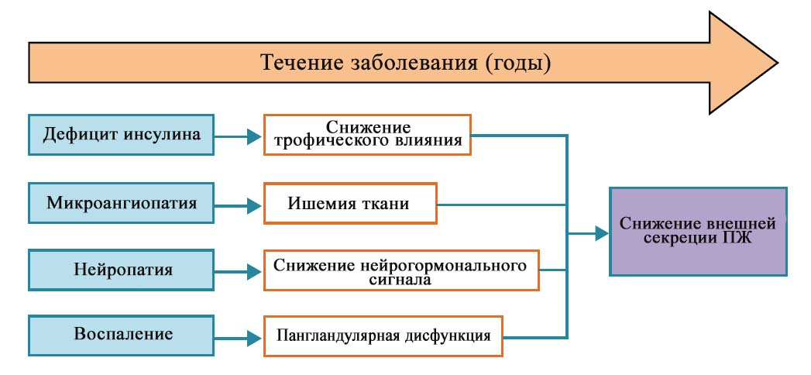
Fig. 1. Pathophysiology of the development of EPI in DM (R. Talukdar et al., 2017 [35]).

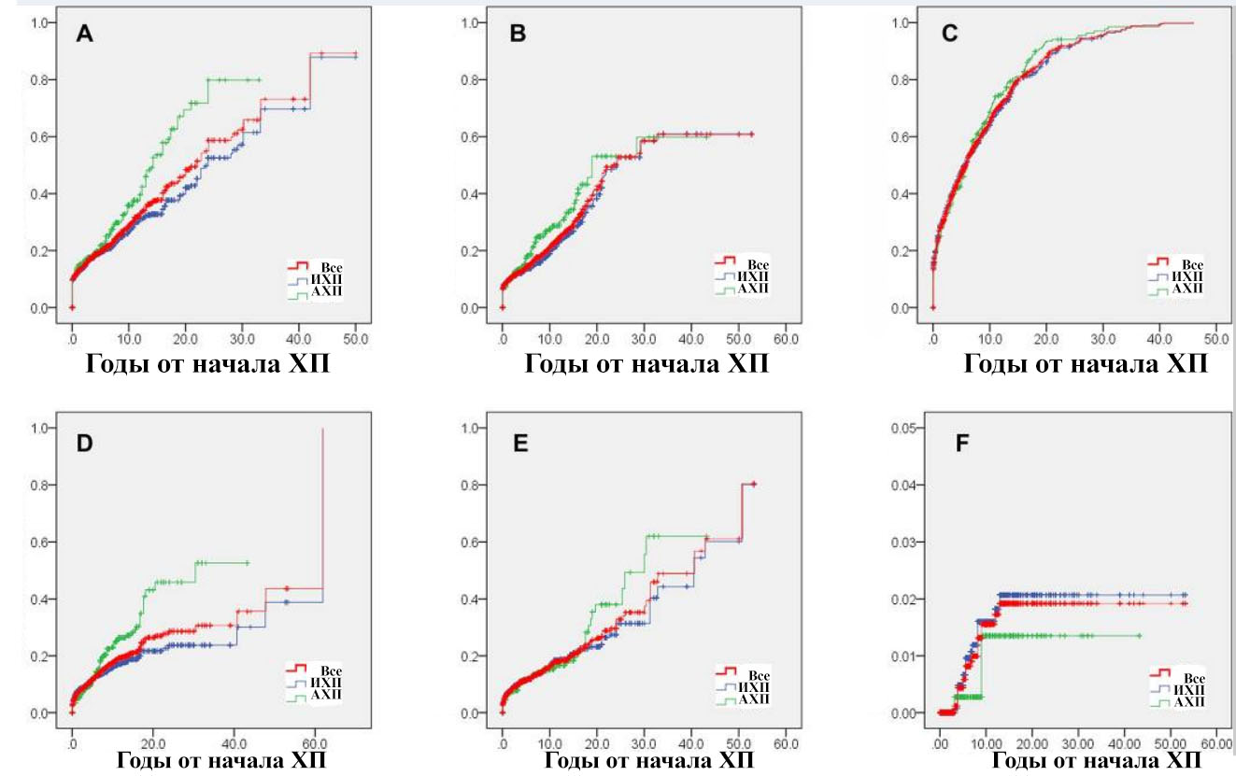
Fig. 2. Cumulative level after the onset of chronic pancreatitis (L. Hao et al., 2018 [16]).
А — diabetes mellitus
В — steatorrhea
С — calcification of the pancreas
D — pancreatic pseudocysts
Е — biliary strictures
F — pancreatic cancer
АХП — alcoholic chronic pancreatitis
ХП — chronic pancreatitis
ИХП — idiopathic chronic pancreatitis

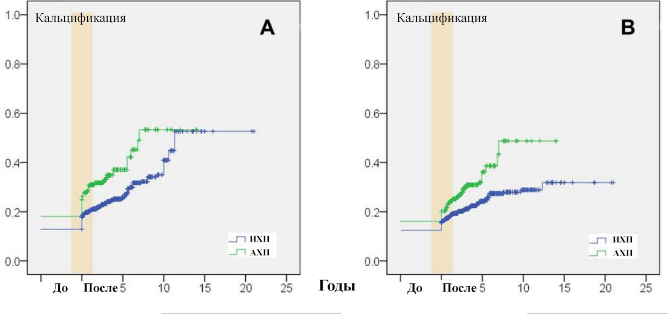
Fig. 3. Cumulative levels after detection of calcification of the pancreas (L. Hao et al., 2018 [16]):
А — diabetes mellitus
В — steatorrhea
АХП — alcoholic chronic pancreatitis
ИХП — idiopathic chronic pancreatitis

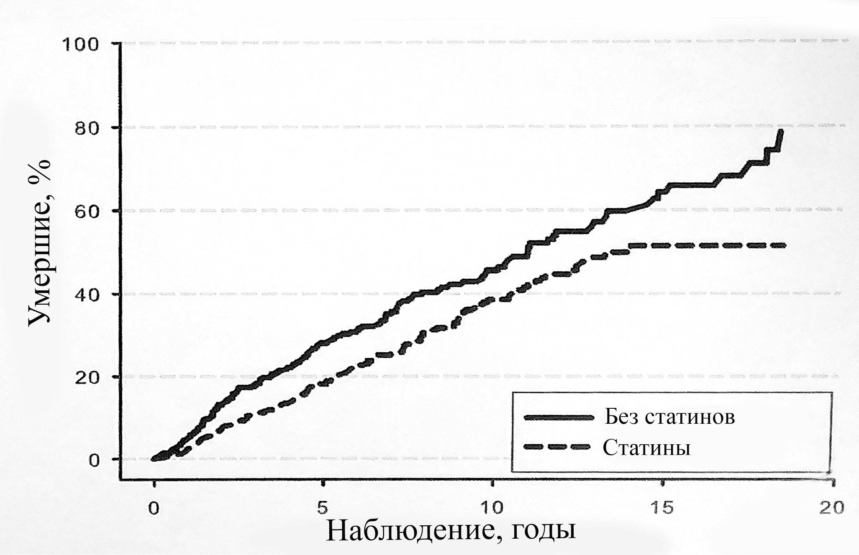
Fig. 4. The proportion of dead patients with CP in the observation process (U. C. Bang et al., 2018 [6]).

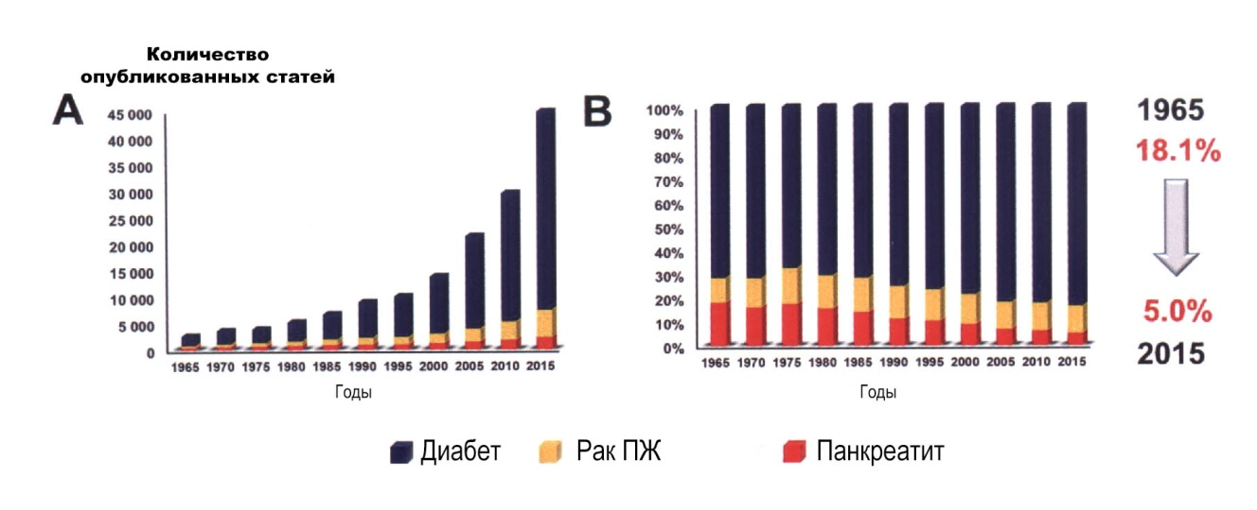
Fig. 5. Published articles on pancreatic diseases (A. Szentesi et al., 2016 [33]).

