Antibiotics as modulators of the intestinal microbiota: between good and evil
E. Y. Plotnikova, Y. V. Zakharova
Kemerovo State Medical University, Kemerovo, Russia

Key words: obesity, antibiotics, antibiotic therapy, probiotics, evidence-based research
The prevalence of obesity in the world has reached epidemic proportions over the past few decades. In 2013, 36.9% of adult men and 29.8% of women (age ≥20 years) are overweight (body mass index (BMI) 25–29.9 kg/m²) or obesity (BMI ≥30 kg/m²) [63], and recent trend analyzes show that the number of patients who are overweight or obese continues to grow worldwide [24]. Due to the multifaceted nature of obesity, there is no single or simple solution to combat this growing epidemic. Thus, new, highly productive individual interventions are needed for effective prevention and treatment of overweight and obesity.
Studies in animals and humans show that trillions of bacteria in the intestine are associated with energy homeostasis [51, 81]. Intestinal bacteria ferment indigestible carbohydrates, synthesize short-chain fatty acids (SCFA) and amino acids from them, and can thus make an "energy" contribution to the host [3, 65]. The byproducts of the bacterial fermentation process can affect the appetite and increase saturation [20], also by modulating the metabolism of bile acids [72] the microbiota can “control” alimentary obesity, “increasing” the caloric intake of food [2, 85]. In addition, intestinal bacteria can manipulate the individual's taste and dietary preferences [6].
Bacteria have mastered our planet for themselves about three billion years ago. Dr. M.J. Blaser describes this very interestingly in his book “Missing microbes: Our modern plagues“, which came out in 2014 and became a bestseller: “They (bacteria) made the oxygen we breathe, the soil, support our oceans. Slowly, inexorably, through trial and error throughout time, they invented sophisticated and reliable feedback systems that still support all of life on Earth. Ancient, but not primitive, bacterial cells, self-sufficient creatures — reach different shapes and sizes and adapt to almost every ecosystem on Earth ”[13]. From seventy to ninety percent of all cells in the human body are bacteria, represented by more than 10,000 different species. 99 percent of the unique genes in our bodies are bacterial. This population of more than 100 trillion microorganisms constitutes our microbiome: a collection of microbial communities that has evolved with homo sapiens to help organize basic life processes starting from the moment of birth.
Metabolic changes can be caused by a primary violation of the microbiota [22], which is associated with modern changes in human physiology [15, 30], which are initiated by external factors. Epidemiological studies with people have shown that treatment with antibiotics for the first six months of life [80] or giving birth to a child by caesarean section [16, 46] may increase the risk of overweight accumulation at a later age. These two interventions have no direct effect on calorie intake or on host metabolism [23], but have a large effect on microbiome [27, 30]. The mutually beneficial interactions of humans with their own microbes can be changed by many aspects of the modern lifestyle, including urbanization, international travel and dietary changes [28], as well as antibiotics [75].
Microbiome plays an important role in maintaining health, especially immunity and metabolism. It is also possible that the destruction of this ancient equilibrium can have serious consequences. But it was the last in people's minds when antibiotics that kill bacteria or slow down their growth appeared on the scene in the 1940s. Deadly previously could be prevented or cured. Surgery has become much safer. Side effects in antibiotics seemed few and insignificant. Today, antibiotics are invaluable for treating many serious infections and continue to save countless lives. The side effects of antibiotic treatment on the intestinal microflora range from self-sustaining “functional” diarrhea to life-threatening pseudomembranous colitis [12, 86]. The long-term effects of changes in the intestinal microbial landscape of humans are difficult to detect, but chronic conditions such as asthma and atopic diseases are often associated with the use of antibiotics in childhood and changes as a result of the intestinal microbiota [53, 66, 69]. Many chemical transformations in the intestine are mediated by specific microbial populations [64], which can provoke the development of cancer [56, 67] and obesity [9, 51], changes in the composition of the intestinal microflora can have other delayed serious health consequences [74]. The consequent of even one course of antibiotics on specific microbial populations under natural conditions can persist for many years [10, 52, 73].
The problem is not the use of antibiotics, but their use without indications. On average, Americans spend about 30 courses of antibiotics in 40 years of life. At the same time, over the past five decades, the number of overweight people has doubled, and with obesity, more than three times [68]. With overweight and obesity, there is an increased risk of serious diseases such as cardiovascular, cancer and diabetes. M. Nestle, head of nutrition and food research at New York University and the author of the Food Policy, argues that the cost of the disease associated with obesity will be “astronomical” [62]. For example, childhood obesity is a costly epidemic that affects every fifth child and can cost $ 19,000 per obese patient in life-long medical expenses [36]. In 2016, it was found that obese Australian preschoolers have 60% higher health care costs compared to children with normal weight, similar financial costs are expected in the US and the UK [41]. And in adult patients, obesity can be a greater health burden than smoking [58].
A study of a cohort of Danish women revealed that more than 40% of them received the antibiotic at least once during pregnancy [18]. In addition to disrupting microbiota transmission from mother to child, prenatal antibiotic effects have been shown to influence the weights of newborns, increasing the risk of obesity and associated metabolic disorders later in the child's life [47, 84].
An analysis of the database of antibiotic resistance in the United States in 2010, containing information on more than 70% of American prescriptions [44], demonstrated the widespread use of antibiotics, especially in infancy and childhood, which varied greatly depending on the region. Extrapolation of the data shows that, at the age of 2, an average American child received almost three courses of antibiotics (mainly for the treatment of acute infections of the ears and upper respiratory tract), about ten courses at the age of under 10 years and ≈17 courses at the age of under 20 years. Although these figures are strikingly high, they are consistent with previous national surveys [40, 55]. The relationship between the number of prescribed antibiotics and the level of obesity in the United States is shown in Fig. 1.
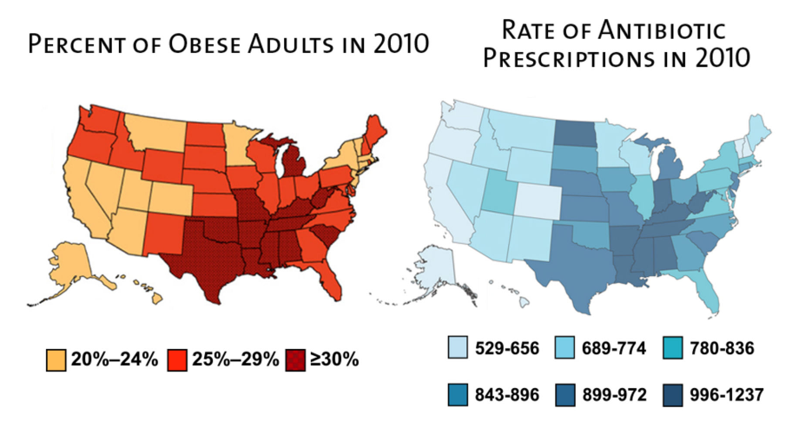
Fig. 1. On the left — BMI of US residents, on the right — the number of antibiotic therapy courses per 1000 US population [14].

As can be seen from fig. 1, in those states where courses of antibiotic therapy are prescribed most often, the most obese people live. In contrast, in Sweden, the use of antibiotics from infants to adult patients is ≈40% of the amount prescribed in the United States [78]. This dichotomy suggests that most of the prescribed use of antibiotics in children in the United States is not needed, which is widely recognized by professional bodies, including the American Academy of Pediatric [43] and the Center for Disease Control and Prevention [37]. Nevertheless, the rate of pediatric use of antibiotics in the United States increased from 2000 to 2010 [50]. Even within the same region, there is a significant variation in the prescription of medicines among physicians, as evidenced by the recent extensive review of the practice conducted by a large medical academic center [39].
New epidemiological studies have confirmed the hypothesis that the effects of antibiotics in early life are associated with an increased risk of excessive obesity. In a study of more than 28,000 mother-child pairs of the Danish national cohort of newborns [5], it was found that antibiotic exposure in children during the first 6 months was associated with an increased risk of overweight at the age of 7, this effect in boys was more pronounced than in girls. These results were confirmed in the Avon Longitudinal Study of Parents and Children (ALSPAC) study, which involved more than 10,000 children. In the cohort of newborns ALSPAC, in which all known factors were controlled, the use of antibiotics during the first 6 months of life was associated with an increase in BMI at the age of 10, 20 and 38 months. The ALSPAC study also determined that maternal BMI is the second factor contributing to the development of obesity after exposure to antibiotics at an early age, and this effect is enhanced with age in children from mothers of normal weight compared with mothers who are overweight. In this large study, ≈11500 children born in the United Kingdom in 1991–1992 who received antibiotics for up to 6 months were observed, they had a greater risk of developing obesity at the age of 38 months (odds ratio 1.22) [80].
In studies with Canadian babies, antibiotics administered in the first year of life increased the likelihood that the child would be overweight at the age of 9 years and 12 years, as well as increased central obesity (a marker of metabolic syndrome) [8]. These effects were observed after the correction of other factors that affect body weight, such as diet, physical activity and smoking of mothers during pregnancy. A pronounced sexual dimorphism manifested itself, the effect was more pronounced in male children. A longitudinal study in the United States from 2001 to 2009 involving 65,480 children from Philadelphia also showed a link between antibiotics used in early life and childhood obesity, which was enhanced by early radiation and several treatments. The study authors concluded that repeated exposure to broad-spectrum antibiotics between the ages of 0 and 23 months is associated with obesity in early childhood. Since common childhood infections were the most common diagnoses associated with prescribing broad-spectrum antibiotics, narrowing the choice of antibiotics can potentially be a volatile risk factor for the formation of obesity in children [11]. Interestingly, these effects were significantly associated with the use of broad-spectrum antibiotics, but not with narrow-spectrum antibiotics. Finally, in a global cross-sectional study, antibiotics in the first year of life modulated body weight in children, and changes in both directions (increase or decrease) depended on where they lived, which was associated with an increased risk of overweight at the age of 5–8 years in boys [61]. In the same study, the increase in body weight or weight loss in girls depended on the geographic location, however, in general, these participants did not have statistically significant effects. All these epidemiological studies suggest that the effects of antibiotics on a very early lifespan (that is, in the first year of life) may affect the risk of obesity in the future. The gender specificity of these effects is still being studied [26].
The formation of the normal intestinal microflora of the infant depends on the vertical transmission of bacteria from the mother during labor; Thus, the use of antibiotics by the mother during pregnancy or a violation in childbirth can also affect the formation of the normal microbial landscape in the child and the subsequent increase in his weight. A study of 436 mother-child couples found an increased risk of obesity by 84% (33–154%) at the age of 7 if the mother received antibiotics in the second or third trimester of pregnancy [45]. An increased risk of obesity or overweight has been associated with cesarean delivery in several independent studies [16, 46]. Regardless of the prenatal use of antibiotics and other factors by the mother, babies born by caesarean section had a 46% higher risk of obesity than babies born naturally [59]. These studies suggest that the transmission of maternal normal microflora is likely to be a significant factor that forms the metabolic development in children.
In a 10-month, prospective, experimental study of three adults who received two courses of ciprofloxacin, Dethlefsin and Relman showed that the intestinal microbiota changed rapidly against the background of an antimicrobial effect. The composition of the microbiota stabilized after 10 months, but in an altered state [29].
French researchers observed forty-eight adult patients diagnosed with bacterial endocarditis (BE) (a group of antibiotics) who were compared with 48 people of comparable sex and age without bacterial endocarditis. Their BMI was determined one month before the first symptoms of BE and one year after discharge from the hospital. BMI increased significantly and significantly in patients who received vancomycin-plus-gentamicin (C + D) (p=0.03), but not in controls or in patients who received other antibiotics. Seventeen patients received an increase in BMI of ≥10%, and five of the group of antibiotics B + D developed obesity. Treatment C + D was an independent predictor of an increase in BMI of ≥10% (p=0.02). Weight gain was particularly pronounced after a six-week intravenous treatment of bacterial endocarditis B + D in men over 65 who did not undergo cardiac surgery [79].
The mechanism by which antibacterial agents increase growth and weight is not well known, but several hypotheses have been suggested [35]:
- nutrients are more efficiently absorbed due to the thinner intestinal epithelium, and violation of its permeability;
- nutrients are retained due to the reduction of competing microorganisms;
- microorganisms responsible for subclinical infections are reduced or eliminated;
- decreases the number of bacteria stimulating the growth of toxins and metabolites;
- changes in the activity of bacterial enzymes that improve the efficiency of food metabolism.
Thus, there is growing evidence of the role of intestinal microorganisms in relation to the energy conversion of nutrients [9] and their implications for obesity.
Violations of the intestinal microflora occur not only because of antibiotic treatment. Drugs accumulate in the meat of animals and poultry that we eat. Antibiotics are widely used as growth promoters in agriculture. In the 1940s. the use of Streptomyces aureofaciens contributed to weight gain in animals, leading to the discovery of chlortetracycline. Tetracyclines, macrolides, avoparcin, and penicillins are commonly used in animal husbandry to accelerate growth by increasing food intake, weight gain, and improving herd health [7]. Avoparcin, a glycopeptide structurally related to vancomycin, has been widely used in Europe as a growth promoter since the early 1970s until recently banned by the emergence of vancomycin-resistant enterococci [1]. This antibiotic has been shown to improve feed efficiency and increase weight in animals [33]. As a result, vancomycin-resistant enterococci are found in the meat, which have been released during infections in humans. In this regard, today the World Health Organization (WHO) recommends to minimize the use of antibiotics in animal husbandry. However, only in the European Union listened to her advice. The United States, China and Russia continue to actively feed them to animals, as well as end users. From 2005 to 2009 alone, the Russian market of antibiotics grew 2.3 times [1]. As a result, we can get meat, milk and other products with the presence of antibiotics in quantities exceeding the permissible sanitary norms. Their presence in products is marked as food additives Е700–Е800. For example, milk and meat may contain up to 100 micrograms per kilogram of tetracycline, a broad-spectrum antibiotic, according to the norms. This means that a person who drinks two glasses of milk per day consumes about 50 micrograms of tetracycline daily. This is not much, but it must be borne in mind that many people drink milk every day throughout their lives.
The use of the same antibiotics in animal husbandry and medicine is especially dangerous, since it contributes to the emergence of antibiotic-resistant bacterial strains that adversely affect human health, which is a long-standing problem in many countries. In the US, 80% of the total amount of antibiotics produced is used for livestock, and about 60% of them are the same names that are used in medicine. Their use is prohibited from 01/01/2017 [54]. In addition, in new studies, attention was paid to the question of whether there are direct metabolic effects on human health as a result of the consumption of contaminated products [31, 70, 77]. Approximately 70 years ago, veterinary scientists showed that the addition of low (subtherapeutic) doses of antibiotics to livestock feed or water led to the stimulation of its growth [76]. This effect was subsequently demonstrated in main domestic mammals (cows, pigs, and sheep), and in poultry [48]. A wide variety of antimicrobial agents represented these effects, regardless of the class of drugs (antibiotic or antiseptic), chemical structure, mode of action, and spectrum of activity [19, 38].
Pigs have the most antibiotics in their meat, fewer of them in chickens and even less in beef. In addition, farm shrimp and fish, even farmed salmon, have high levels of antibiotics because they are necessary for the prevention of disease. Even organic vegetables contain antibiotics, because they concentrate about 75% of the antibiotics obtained by domestic animals, and more precisely in their manure, which is used to fertilize the earth [83]. It is important to note that animals are fed with antibiotics at an early stage of life, because growth stimulation and feed efficiency (the ability to convert food calories to body weight) is higher than the use of antibiotics at an older age [38, 60]. The effects associated with age are consistent with the concept of a critical period in the formation of the host metabolism, with early age being more capable of change than older. According to experts, the use of antibiotics for domestic animals will increase by 67 percent by 2030, as the demand for protein is growing worldwide. In China, India, Brazil and Russia, it is expected that the use of antibiotics will increase by 99% — much more than the increase in the population of these countries. Many of these products will be exported [83].
How to prevent and correct metabolic disorders associated with the effects of antibiotics on the human body at different stages of his life? Obesity in humans is associated with a dysbiotic shift in the fecal microbiota, as well as with a low content of bifidobacteria [21]. On the other hand, energy restriction and weight loss are associated with increased levels of bacteria [25]. The altered microbiota in the intestines of obese subjects appears to be more effective in “assimilating” energy from the diet and may contribute to further weight gain [82]. Therefore, the intestinal microbiota is a potentially variable target for the prevention and/or treatment of obesity.
Probiotics (mainly bifidobacteria and lactobacilli) enter the human colon, where they are involved in processes such as modulating colon microflora, immunogenic reactions and metabolic processes. Probiotics can prevent infectious diseases, reduce cholesterol levels, stimulate the synthesis of vitamins and cytokines, and inhibit carcinogenesis. The safety and efficacy of certain strains in the context of these properties must be scientifically proven in order to consider them probiotic. In combination, prebiotics and probiotic bacteria form synbiotics that can provide even more benefits than probiotics or prebiotics separately [42].
The introduction of viable bacterial strains (probiotics) as a way to manipulate the intestinal ecosystem in order to reduce weight is currently being seriously studied [71]. A number of studies show that probiotics can affect the function of various types of bacteria in the intestines [34, 57], in several recent studies it has been found that probiotic supplements may contribute to weight loss [32].
Q. Zhang et al. published a meta-analysis of 19 studies, which showed a significant reduction in BMI of 0.49 kg / m2 (p <0.01) and a significant decrease of 0.54 kg (p <0.01) of body weight compared with control groups, the results of the meta-analysis are presented in fig. 2. Probiotic species and doses used varied in different studies. Eight tests used certain types of probiotics, and the rest used more than one type of probiotics. The total daily intake of probiotics varied from 106 colony forming units (CFU) to 1012 CFU. The duration of the test ranged from three to 24 weeks (average 8.76 weeks). A meta-analysis demonstrated that probiotics may be more effective in reducing BMI in people who are overweight or obese than people with a normal BMI. The study also showed a greater effect from the consumption of several, rather than individual types of probiotics [87].

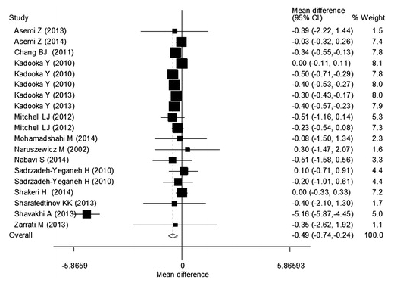 | 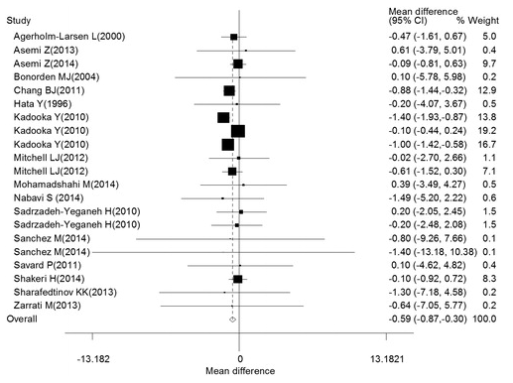
Impact of probiotics on BMI | Impact of probiotics on body mass

Fig. 2. Results of meta-analysis by Q. Zhang et al. [87].

H. Borgeraas et al. conducted another meta-analysis of 15 recent studies to identify the effects of the use of probiotics in overweight and obese patients. Two thirds (n = 10) of studies included one type of probiotic, and the remaining studies (n = 5) included two or more types of probiotics. The daily dose of probiotics varied from 1,0×10⁹ to 4,8×10¹¹ КОЕ, and the duration of the test ranged from 3 to 12 weeks (median: 8 weeks). Changes in body mass, BMI, fat mass / fat percentage, or related results, such as abdominal fat mass changes. The results of this meta-analysis are presented in Fig. 3. Evaluation of data showed that probiotic supplements reduce body mass (BM [95% CI], -0.60 [-1.19, -0.01] kg), BMI (-0.27 [-0.45, -0.08] kg/m²) and the percentage of fat (-0.60 [-1.20, -0.01] %), but the effect was small. Probiotic supplements also reduced body fat, although not significantly (-0.42 [-1.08, 0.23] kg) [17].

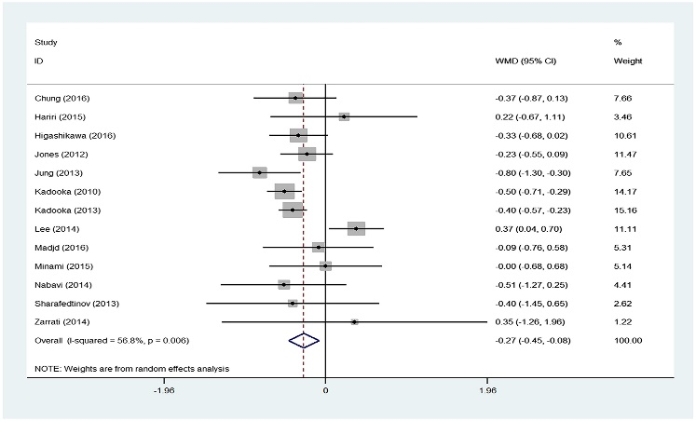 | 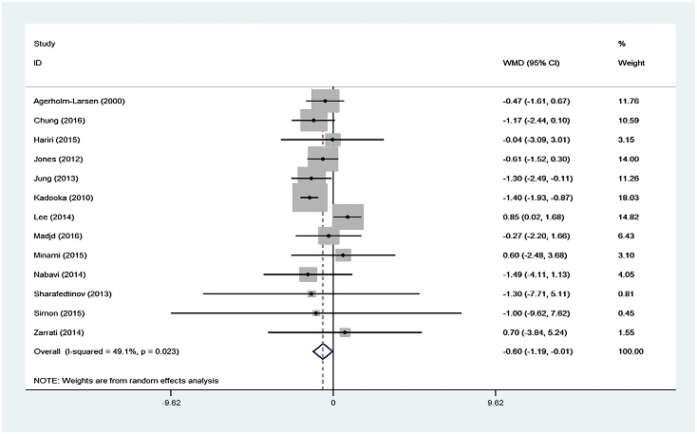
Impact of probiotics on BMI | Impact of probiotics on body mass

Fig. 3. Results of meta-analysis by H. Borgeraas et al. [17].

In a multicenter, double-blind, randomized, placebo-controlled clinical interventional study, 87 subjects with high BMI (24.2–30.7 kg/m²) and increased abdominal visceral fat (81.2–178.5 cm²) were randomized to receive either fermented milk (FM) containing LG2055 (active FM, n=43), or FM without LG2055 (control FM; n=44). Subjects consumed 200 g/day FM for 12 weeks. In the active FM group, the area of ​​abdominal visceral and subcutaneous fat significantly (р<0.01) decreased from the initial level on average from 4.6 to 3.3%. Body mass and other parameters also significantly decreased (р<0,001) as follows: body mass — by 1.4%; BMI — by 1.5%; waist size — by 1,8% and hips — by 1,5%. None of these parameters was statistically significantly reduced in the control group [49].
Thus, antibiotics reduce the variety of intestinal microflora. They reduce the population of the main bacteria living in the intestines, paving the way for the growth of conditionally pathogenic, pathogenic bacteria and fungi. Also, the use of antibiotics can induce overweight and obesity in people. Probiotics are the "antidote" of antibiotic therapy — or at least this is the best "antidote" that today has a scientific and practical basis.
Conclusion. If antibiotics make people fat, then probiotics can be a saving grace. Antibiotics are necessary and potentially vital drugs that significantly reduce mortality and morbidity in humans. Today we get a clear idea of ​​how these bacterio-modulating agents can contribute to obesity. Understanding the costs of complications and the associated treatments, reasonable use of antibiotics is necessary. And all courses of antibiotic therapy — in pregnant women, newborn babies, children of different ages and adult patients — must be accompanied by the use of probiotics. Currently, many studies are being conducted in this area, and progress will continue in identifying specific types and strains of probiotics that are most effective in each specific situation.
Probiotics not only prevent and treat antibiotic-associated diarrhea, but also contribute to weight loss and reduce BMI, they can help improve immunity, prevent colds and atopic diseases, reduce stress and anxiety, improve cognitive abilities in Alzheimer's patients, help recover from injury, minimize complications of liver diseases, regulate blood pressure, reduce glycemia in diabetes and many other diseases.

References:
- Война миров: антибиотики в сельском хозяйстве. The Dairy News. URL: http://www.dairynews.ru/dairyfarm/voyna-mirov-antibiotiki-v-selskom-khozyaystve.html (дата обращения: 19.10.2018).
- Гриневич В. Б., Сас Е. И. Физиологические эффекты желчных кислот. РМЖ «Медицинское обозрение». 2017. № 2. С. 87–91.
- Плотникова Е. Ю., Краснов О. А. Метаболический синдром и кишечная микрофлора; что общего? Экспериментальная и клиническая гастроэнтерология. 2015. № 112 (12). С. 64–73.
- Acar J., Casewell M., Freeman J., Friis C., Goossens H. Avoparcin and virginiamycin as animal growth promoters: a plea for science in decision-making. Clin. Microbiol. Infect. 2000. Vol. 6. P. 477–482.
- Ajslev T. A., Andersen C. S., Gamborg M., Sørensen T. I. A., Jess T. Childhood overweight after establishment of the gut microbiota: the role of delivery mode, pre-pregnancy weight and early administration of antibiotics. Int. J. Obes. 2011. Vol. 35. P. 522–529.
- Alcock J., Maley C. C., Aktipis C. A. Is eating behavior manipulated by the gastrointestinal microbiota? Evolutionary pressures and potential mechanisms. Bioessays. 2014. Vo. 36, No 10. P. 940–949.
- Angelakis E. Weight gain by gut microbiota manipulation in productive animals. Microb. Pathog. 2017. Vol. 106. P. 162–170.
- Azad M. B., Bridgman S. L., Becker A. B., Kozyrskyj A. L. Infant antibiotic exposure and the development of childhood overweight and central adiposity. Int. J. Obes. 2014. Vol. 38. P. P. 1290–1298.
- Backhed F., Ding H., Wang T., Hooper L. V., Koh G. Y., et al. The gut microbiota as an environmental factor that regulates fat storage. Proc. Natl. Acad. Sci. USA. 2004. Vol. 101. P. 15718–15723.
- Bäckhed F., Ley R. E., Sonnenburg J. L., Peterson D. A., Gordon J. I. Host-bacterial mutualism in the human intestine. Science. 2005. Vol. 307. P. 1915–1920.
- Bailey L. C. Association of antibiotics in infancy with early childhood obesity. JAMA Pediatr. 2014. Vol. 168, No 11. P. 1063–1069.
- Beaugerie L., Petit J. C. Microbial-gut interactions in health and disease. Antibiotic-associated diarrhoea. Best Pract. Res. Clin. Gastroenterol. 2004. Vol. 18. P. 337–352.
- Blaser M. J. Missing microbes: how the overuse of antibiotics is fueling our modern plagues. New York: Henry Holt and Company, 2014. 288 р.
- Blaser M. J. Слайд-шоу из лекции «Антибиотики и ожирение». URL: https://www.amnh.org/explore/science-topics/health-and-our-microbiome/meet-your-microbiome (дата обращения: 19.10.2018).
- Blaser M. J., Falkow S. What are the consequences of the disappearing human microbiota? Nat. Rev. Micro. 2009. Vol. 7. P. 887–894.
- Blustein J. Association of caesarean delivery with child adiposity from age 6 weeks to 15 years. Int. J. Obes. 2013. Vol. 37. P. 900–906.
- Borgeraas H., Johnson L. K., Skattebu J., Hertel J. K., Hjelmesæth J. Effects of probiotics on body weight, body mass index, fat mass and fat percentage in subjects with overweight or obesity: a systematic review and meta‐analysis of randomized controlled trials. Obes Rev. 2018 Vol. 19, No 2. P. 219–232.
- Broe A., Pottegård A., Lamont R. F., Jørgensen J. S., Damkier P. Increasing use of antibiotics in pregnancy during the period 2000–2010: prevalence, timing, category, and demographics. BJOG. 2014. Vol. 121. P. 988–996.
- Butaye P., Devriese L., Haesebrouck F. Antimicrobial growth promoters used in animal feed: effects of less well known antibiotics on gram-positive bacteria. Clin. Microbiol. Rev. 2003. Vol. 16. P. 175–188.
- Cani P. D., Lecourt E., Dewulf E. M. et al. Gut microbiota fermentation of prebiotics increases satietogenic and incretin gut peptide production with consequences for appetite sensation and glucose response after a meal. Am. J. Clin. Nutr. 2009. Vol. 90, No 5. P. 1236–1243.
- Chatelier E., Nielsen T., Qin J., Prifti E., Hildebrand F., Falony G. Richness of human gut microbiome correlates with metabolic markers. Nature. 2013. Vol. 500. P. 541–546
- Cho I., Yamanishi S., Cox L., Methe B. A., Zavadil J., Li K., Gao Z., Mahana D., Raju K., Teitler I., et al. Antibiotics in early life alter the murine colonic microbiome and adiposity. Nature. 2012. Vol. 488. P. 621–626.
- Coates M. E., Fuller R., Harrison G. F., Lev M., Suffolk S. F. A comparison of the growth of chicks in the Gustafsson germ-free apparatus and in a conventional environment, with and without dietary supplements of penicillin. Br. J. Nutr. 1963. Vol. 17. P. 141–150.
- Collaboration NCDRF. Trends in adult body‐mass index in 200 countries from 1975 to 2014: a pooled analysis of 1698 population‐based measurement studies with 19.2 million participants. Lancet. 2016. Vol. 387, No 10026. P. 1377–1396.
- Cotillard A., Kennedy S. P., Kong L. C., et al. Dietary intervention impact on gut microbial gene richness. Nature. 2013. Vol. 500, No 7464. P. 585–588.
- Cox L. M., Blaser M. J. Antibiotics in early life and obesity. Nat. Rev. Endocrinol. 2015. Vol. 11, No 3. P. 182–190.
- Dethlefsen L., Huse S., Sogin M. L., Relman D. A. The pervasive effects of an antibiotic on the human gut microbiota, as revealed by deep 16S rRNA sequencing. PLoS Biol. 2008. Vol. 6. P. e280.
- Dethlefsen L., McFall-Ngai M., Relman D. A. An ecological and evolutionary perspective on human-microbe mutualism and disease. Nature. 2007. Vol. 449. P. 811–818.
- Dethlefsen L., Relman D. A. Incomplete recovery and individualized responses of the human distal gut microbiota to repeated antibiotic perturbation. Proc. Natl. Acad. Sci. USA. 2011. Vol. 108, Suppl. 1. P. 4554–6110.
- Dominguez-Bello M. G., Blaser M. J., Ley R. E., Knight R. Development of the human gastrointestinal microbiota and insights from high-throughput sequencing. Gastroenterology. 2011. Vol. 140. P. 1713–1719.
- Donoghue D. J. Antibiotic residues in poultry tissues and eggs: human health concerns? Poultry Sci. 2003. Vol. 82. P. 618–621.
- Drissi F., Raoult D., Merhej V. Metabolic role of lactobacilli in weight modification in humans and animals. Microb. Pathog. 2016. Vol. 106. P. 182–194.
- Dyer I. A., Koes R. M., Herlugson M. L., Ojikutu L. B., Preston R. L., et al. Effect of avoparcin and monensin on performance of finishing heifers. J. Anim. Sci. 1980. Vol. 51. P. 843–846.
- Eloe‐Fadrosh E. A., Brady A., Crabtree J., et al. Functional dynamics of the gut microbiome in elderly people during probiotic consumption. MBio. 2015. Vol. 6, No 2. P. 1–12.
- Feighner S. D., Dashkevicz M. P. Subtherapeutic levels of antibiotics in poultry feeds and their effects on weight gain, feed efficiency, and bacterial cholyltaurine hydrolase activity. Appl. Environ Microbiol. 1987. Vol. 53. P. 331–336.
- Finkelstein E. A., Graham W. C. K., Malhotra R. Lifetime direct medical costs of childhood obesity. Pediatrics. 2014. Vol. 133. P. 1–9.
- Fridkin S. Vital signs: improving antibiotic use among hospitalized patients. MMWR. Morbidity and mortality weekly report. 2014. Vol. 63. P. 194–200.
- Gaskins H., Collier C., Anderson D. Antibiotics as growth promotants: mode of action. Anim. Biotechnol. 2002. Vol. 13. P. 29–42.
- Gerber J. S. Variation in antibiotic prescribing across a pediatric primary care network. J. Pediatric Infect. Dis. Soc. 2015. Vol. 4, No 4. P. 297–304.
- Grijalva C. G., Nuorti J., Griffin M. R. Antibiotic prescription rates for acute respiratory tract infections in us ambulatory settings. JAMA. 2009. Vol. 302. P. 758–766.
- Hayes A., Chevalier A., D’Souza M., Baur L., Wen L. M., Simpson J. Early childhood obesity: Association with healthcare expenditure in Australia. Obesity. 2016. Vol. 24, No 8. P. 1752–1758.
- He M., Shi B. Gut microbiota as a potential target of metabolic syndrome: the role of probiotics and prebiotics. Cell Biosci. 2017. Vol. 7. P. 54.
- Hersh A. L., Jackson M. A., Hicks L. A. Principles of judicious antibiotic prescribing for upper respiratory tract infections in pediatrics. Pediatrics. 2013. Vol. 132. P. 1146–1154.
- Hicks L. A., Taylor T. H., Hunkler R. J. US. Outpatient Antibiotic Prescribing. 2010. New Engl. J. Med. 2013. Vol. 368. P. 1461–1462.
- Hooper L. V., Littman D. R., Macpherson A. J. Interactions between the microbiota and the immune system. Science. 2012. Vol. 336. P. 1268–1273.
- Huh S. Y., Rifas-Shiman S. L., Zera C. A., Edwards J. W. R., Oken E., Weiss S. T., Gillman M. W. Delivery by caesarean section and risk of obesity in preschool age children: a prospective cohort study. Arch. Dis. Childhood. 2012. Vol. 97. P. 610–616.
- Jepsen P. A population-based study of maternal use of amoxicillin and pregnancy outcome in Denmark. British Journal of Clinical Pharmacology. 2003. Vol. 55. P. 216–221.
- Jukes T. H., Williams W. L. Nutritional effects of antibiotics. Pharmacol Rev. 1953. Vol. 5. P. 381–420.
- Kadooka Y., Sato M., Imaizumi K., Ogawa A., Ikuyama K., Akai Y., Okano M., Kagoshima M., Tsuchida T. Regulation of abdominal adiposity by probiotics (Lactobacillus gasseri SBT2055) in adults with obese tendencies in a randomized controlled trial. Eur. J. Clin. Nutr. 2010. Vol. 64, No 6. P. 636–643.
- Lee G. C. Outpatient antibiotic prescribing in the United States: 2000 to 2010. BMC medicine. 2014. Vol. 12. P. 96.
- Ley R. E., Backhed F., Turnbaugh P., Lozupone C. A., Knight R. D., Gordon J. I. Obesity alters gut microbial ecology. Proc. Natl. Acad. Sci. USA. 2005. Vol. 102, No 31. P. 11070–11075.
- Lofmark S., Jernberg C., Billstrom H., Andersson D. I., Edlund C. Restored fitness leads to long-term persistence of resistant Bacteroides strains in the human intestine. Anaerobe. 2008. Vol. 14. P. 157–160.
- Marra F., Lynd L., Coombes M., Richardson K., Legal M., et al. Does antibiotic exposure during infancy lead to development of asthma?: a systematic review and metaanalysis. Chest. 2006. Vol. 129. P. 610–618.
- Marshall B. M., Levy S. B. Food animals and antimicrobials: impacts on human health. Clin. Microbiol. Rev. 2011. Vol. 24. P. 718–733.
- McCaig L. F., Besser R. E., Hughes J. M. Trends in antimicrobial prescribing rates for children and adolescents. JAMA. 2002. Vol. 287. P. 3096–3102.
- McGarr S. E., Ridlon J. M., Hylemon P. B. Diet, anaerobic bacterial metabolism, and colon cancer: a review of the literature. J. Clin. Gastroenterol. 2005. Vol. 39. P. 98–109.
- McNulty N. P., Yatsunenko T., Hsiao A., et al. The impact of a consortium of fermented milk strains on the gut microbiome of gnotobiotic mice and monozygotic twins. Sci. Transl. Med. 2011. Vol. 3, No 106.
- Moriarty J. P., Branda M. E., Olsen K. D., Shah N. D., Borah B. J., Wagie A. E., Egginton J. S., Naessens J. M. The Effects of incremental costs of smoking and obesity on health care costs among adults. Journal of Occupational and Environmental Medicine. 2012. Vol. 54, No 3. P. 286.
- Mueller N. T., Whyatt R., Hoepner L., Oberfield S., Dominguez-Bello M. G., Widen E. M., Hassoun A., Perera F., Rundle A. Prenatal exposure to antibiotics, cesarean section and risk of childhood obesity. Int. J. Obes. 2015. Vol. 39, No 4. P. 665–670.
- Muir L. A. Mode of action of exogenous substances on animal growth — an overview. Journal of animal science. 1985. Vol. 61. P. 154–180.
- Murphy R. Antibiotic treatment during infancy and increased body mass index in boys: an international cross-sectional study. Int. J. Obes. 2013. Vol. 38. P. 115–119.
- Nestle M. Food politics: how the food industry influences nutrition and health. Berkeley: Un-ty of California, 2002. 457 р.
- Ng M., Fleming T., Robinson M., et al. Global, regional and national prevalence of overweight and obesity in children and adults 1980–2013: a systematic analysis. Lancet. 2014. Vol. 384, No 9945. P. 766–781.
- Nicholson J. K., Holmes E., Wilson I. D. Gut microorganisms, mammalian metabolism and personalized health care. Nat. Rev. Microbiol. 2005. Vol. 3. P. 431–438.
- Nieuwdorp M., Gilijamse P. W., Pai N., Kaplan L. M. Role of the microbiome in energy regulation and metabolism. Gastroenterology. 2014. Vol. 146, No 6. P. 1525–1533.
- Noverr M. C., Huffnagle G. B. The ‘microflora hypothesis’ of allergic diseases. Clin. Exp. Allergy. 2005. Vol. 35. P. 1511–1520.
- O’Keefe S. J., Chung D., Mahmoud N., Sepulveda A. R., Manafe M., et al. Why do African Americans get more colon cancer than Native Africans. J. Nutr. 2007. Vol. 137. P. 175S–182S.
- Parikh N. I., Pencina M. J., Wang T. J., Lanier K. J., Fox C. S., D’Agostino R. B., Vasan R. S. Increasing trends in incidence of overweight and obesity over 5 decades. Am. J. Med. 2007 Mar. Vol. 120, No 3. P. 242–250.
- Prioult G., Nagler-Anderson C. Mucosal immunity and allergic responses: lack of regulation and/or lack of microbial stimulation. Immunol. Rev. 2005. Vol. 206. P. 204–218.
- Riley L. W., Raphael E., Faerstein E. Obesity in the United States — dysbiosis from exposure to low-dose antibiotics? Front Public Health. 2013. P. 1–8.
- Sanders M. E. Probiotics and microbiota composition. BMC Med. 2016. Vol. 14, No 1. P. 82.
- Sayin S. I., Wahlstrom A., Felin J., et al. Gut microbiota regulates bile acid metabolism by reducing the levels of tauro‐beta‐muricholic acid, a naturally occurring FXR antagonist. Cell Metab. 2013. Vol. 17, No 2. P. 225–235.
- Sjolund M., Wreiber K., Andersson D. I., Blaser M. J., Engstrand L. Long-term persistence of resistant Enterococcus species after antibiotics to eradicate Helicobacter pylori. Ann. Intern. Med. 2003. Vol. 139. P. 483–487.
- Stewart C. S., Duncan S. H., Cave D. R. Oxalobacter formigenes and its role in oxalate metabolism in the human gut. FEMS Microbiol. Lett. 2004. Vol. 230. P. 1–7.
- Sullivan A., Edlund C., Nord C. E. Effect of antimicrobial agents on the ecological balance of human microflora. Lancet Infect. Dis. 2001. Vol. 1. P. 101–114.
- Taylor J. H., Gordon W. S. Growth-promoting activity for pigs of inactivated penicillin. Nature. 1955. Vol. 176. P. 312–313.
- Ternak G. Antibiotics may act as growth/obesity promoters in humans as an inadvertent result of antibiotic pollution? Medical Hypotheses. 2005. Vol. 64. P. 14–16.
- Ternhag A., Hellman J. More on U.S. outpatient antibiotic prescribing. 2010. New Engl. J. Med. 2013. Vol. 369. P. 1175–1176.
- Thuny F., Richet H., Casalta J.-P., Angelakis E., Habib G., Raoult D. Vancomycin treatment of infective endocarditis is linked with recently acquired obesity. PLoS One. 2010. Vol. 5, No 2. P. e9074.
- Trasande L., Blustein J., Liu M., Corwin E., Cox L. M., Blaser M. J. Infant antibiotic exposures and early-life body mass. Int. J. Obes. 2013. Vol. 37. P. 16–23.
- Tremaroli V., Backhed F. Functional interactions between the gut microbiota and host metabolism. Nature. 2012. Vol. 489, No 7415. P. 242–249.
- Turnbaugh P. J., Ley R. E., Mahowald M. A., Magrini V., Mardis E. R., Gordon J. I. An obesity‐associated gut microbiome with increased capacity for energy harvest. Nature. 2006. Vol. 444, No 7122. P. 1027–1031.
- Van Boeckel T. P., Brower C., Gilbert M., Grenfell B. T., Levin S. A., Robinson T. P., Teillant A., Laxminarayan R. Global trends in antimicrobial use in food animals. Proc. Natl. Acad. Sci. USA. Vol. 112, No 18. P. 5649–5654.
- Vidal A. C. Associations between antibiotic exposure during pregnancy, birth weight and aberrant methylation at imprinted genes among offspring. Int. J. Obes. 2013. Vol. 37. P. 907–913.
- Watanabe M., Morimoto K., Houten S. M., et al. Bile acid binding resin improves metabolic control through the induction of energy expenditure. PLoS One. 2012. Vol. 7, No 8. P. e38286.
- Wilcox M. H. Gastrointestinal disorders and the critically ill. Clostridium difficile infection and pseudomembranous colitis. Best Pract. Res. Clin. Gastroenterol. 2003. Vol. 17. P. 475–493.
- Zhang Q., Wu Y., Fei X. Effect of probiotics on body weight and body‐mass index: a systematic review and meta‐analysis of randomized, controlled trials. Int. J. Food Sci. Nutr. 2015. Vol. 67, No 5. P. 571–580.

Antibiotics as modulators of the intestinal microbiota: between good and evil
E. Y. Plotnikova, Y. V. Zakharova
Kemerovo State Medical University, Kemerovo, Russia

Key words: obesity, antibiotics, antibiotic therapy, probiotics, evidence-based research
In some countries of the world, the prevalence of obesity is increasing at the rate of an epidemic. A significant role in the staying healthy, strengthening immunity and normalizing metabolism is assigned to microbes. Among the drugs that are used to treat serious infectious diseases, antibiotics dominate as the drugs that keep on saving precious human lives. The side effects of antibiotic therapy on the intestinal microflora range from self-leveling and fast-passing “functional” diarrhea to life-threatening pseudomembranous colitis. Recently conducted epidemiological studies have shown that antibiotics are associated with a high risk of weight gain and the development of obesity. Violation of the intestinal microflora is caused not only by antibiotic therapy, but also by the intake of a number of products. Antibacterial drugs are widely used in agriculture as growth promoters, they are stored in the meat of animals and poultry that we eat. Obesity has been proven to be associated with a dysbiotic shift in the fecal microbiota and a low content of bifidobacteria. The hypothesis according to which the intestinal microbiota is a potentially variable target for the prevention and/or treatment of obesity is described in detail. Probiotics are agents capable of modulating and improving the intestinal microflora during antibiotic therapy. The review presents data demonstrating the ability of probiotics not only to prevent the development of dysbiosis that occurs when using antibiotics, but also to impede the emergence of overweight and obesity. The advantages of the use of probiotic Maksilak® containing lacto-, bifidobacteria, and oligofructose, during antibiotic therapy are considered.

