Pancreatic ascites: another one of many manifestations of pancreatitis
N. B. Gubergrits, N. V. Byelyayeva, P. G. Fomenko
Donetsk National Medical University n. a. M. Gorky

Key words: acute and chronic pancreatitis, pancreatic ascites, pancreatic hydrothorax, pathogenesis, diagnostics, treatment
Pancreatitis still means many things to many people.
R. Ammann, outstanding
pancreatologist

We have presented the original epigraph, as translation, in our opinion, can not accurately reflect the thought of R. Ammann: “Pancreatitis still means different things to different people”. We understand that the manifestations of the disease are extremely diverse, and each patient may have some or other, sometimes unusual for a doctor, rare manifestations. They include ascites, which clinicians usually associate with liver cirrhosis or, in extreme cases, a right ventricular circulatory failure, or with peritoneal carcinomatosis. But pancreatitis as the cause of ascites is recalled in the last turn. As for pathogenesis, pancreatic hydrothorax (PH) is quite similar.
The first description of pancreatic ascites (PA) was made ​​in 1953, when E.B. Smith published a description of two patients with chronic pancreatitis and serosanguineous ascites [12]. This was followed by the description of sporadic cases. In 1962, R.L. Baura et al. reported 4 cases of pancreatic pseudocysts, accompanied by tense ascites with yellowish fluid in the abdominal cavity [2]. In 1967, J.L. Cameron et al. not only described, but also analyzed the etiology and pathogenesis of PA in 13 patients. The same authors proposed simple diagnostic criteria for this condition: high amylase activity and protein content ≥30 g/l of ascitic fluid [4]. Since then, the world literature presented more than 250 cases of PA and/or PH. For example, P.A. Lipsett et al. conducted a retrospective study at John Hopkins medical institutions and presented 34 patients treated in the period from 1963 to 1975, and 16 patients in the period from 1975 to 1990. 7 of those 50 patients (14%) had PA and PH, and 9 (18%) — only PH [7].
The pathogenesis of PA and PH is most often associated with rupture of pseudocysts or pancreatic duct. J.L. Cameron showed that in case of rupture or front pseudocyst fluid flow enters the abdominal cavity with the formation of PA. Upon the backside rupture usually PH is usually formed [3].
PA may be the result of the process of effusion in the abdominal cavity in acute pancreatitis or severe attacks of chronic pancreatitis. As a rule, after the acute pancreatitis the amount of exudation is reduced, and it is gradually reabsorbed, but sometimes fluid accumulation proceeds slowly [6]. The latter is due to a low plasma oncotic pressure and high oncotic pressure of ascitic fluid. The pressure gradient promotes exudation and subsequent extravasation. D. Parekh et al. proved that the volume of circulating blood is reduced, activation of the renin-angiotensin cascade, sodium and liquid retention occured [9]. Accumulation of fluid in the abdominal cavity is continued at an initial decrease in plasma oncotic pressure (in patients with chronic pancreatitis with trophological failure due to the reduction of exocrine pancreatic function) and/or concomitant liver cirrhosis with decreased albumin production and portal hypertension [6].
Thrombosis in the portal vein system may participate in the formation of PA, which is developed at the height of a pancreatic attack due to changes in the coagulation/fibrinolysis ratio (splenic vein is often thrombosing, portal and mesenteric veins — rarely). In addition, portal hypertension can cause pancreatic fibrosis, scarring, big cysts of the pancreas with compression of blood vessels in patients with chronic pancreatitis. The possibility of parapancreatitis in violation of the retroperitoneal lymph nodes and hypertension in the thoracic duct should be also considered [6].
PA clinical manifestations are non-specific. They usually take place on the background of clinical pancreatitis, but PA may be the first and only one "insidious" manifestation. In this case, to find out its cause is very difficult, it requires differential diagnosis of a tumor, cardiac, tuberculous ascites, portal hypertension.
The average age of patients with PA is 43, with the grand scale from children to the elderly. Male to female ratio is 3: 1 [5, 10].
Patients complain of bloating, sometimes low-intensity diffuse abdominal pain, rarely accompanied by nausea, vomiting, but often — weight loss that progresses after paracentesis.
J. Vantini et al. define 2 options of the clinical course of PA. The first option is the rapid accumulation of ascites in the background or after the pain attack (pancreatic necrosis, damage of the duct, pseudocyst rupture with the formation of its communication with the abdominal cavity). The second option is the slow accumulation of fluid in the abdominal cavity with damage to a small area of pseudocysts of the pancreas on the background of usually latent flow of chronic pancreatitis [14].
Approximately one-third of PA is combined with PH. In these patients, there are complaints of shortness of breath, cough. Hydrothorax usually unilateral (left-side), at least — two-sided. In patients with PH without PA and distinct clinical pancreatitis it is very difficult to attribute symptoms of the respiratory disease to the pancreas [7].
In rare cases, PA and PH may be accompanied by hydropericarditis with its corresponding symptoms.
In the anamnesis of patients we should pay attention to alcohol abuse, acute or chronic pancreatitis, abdominal trauma, congenital abnormalities of the pancreas.
Upon regional portal hypertension, patients indicate gastrointestinal bleeding, while survey reveals splenomegaly, esophageal varices, splenic vein. Upon thrombosis of the portal vein, concomitant liver cirrhosis, dilatation of the portal vein is possible.
PA diagnostics is based on physical findings, results of ultrasound, endoscopic retrograde cholangiopancreatography (Fig. 1). In the study by P.A. Lipsett et al., 20 of 50 patients with PA and/or PH underwent pancreatography, and in 10 (50%) cases pancreatic pseudocyst rupture was diagnosed. Upon ductal rupture, it is often localized in the body or tail of the pancreas. It is also advisable to carry out a CT scan (Fig. 2, 3) and X-ray study of the chest (Fig. 4a, b).
The volume of fluid in the abdominal cavity may reach 10-15 liters. More often liquid is yellowish, but may be chylous, hemorrhagic (in this case it requires differential diagnosis with peritoneal carcinomatosis). It is characterized by the predominance of lymphocytes, a protein of more than 30 g/l and high amylase, lipase (much higher than in blood serum), as mentioned above. Upon PH after the puncture of the pleural cavity, pleurography with water soluble contrast is desirable for detection of cystic-pleural fistula [6].
Conservative treatment of PA is usually inefficiently. Attempt of treatment by octreotide drugs for 2-3 weeks seems possible to create a "functional rest" for the pancreas and reduce the amount of pancreatic secretion [13]. Some authors for the same purpose recommended total parenteral nutrition [8]. With the ineffectiveness of conservative therapy, endoscopic or surgical treatment is carried out, a variant of which depends on the specific situation. Upon the rupture of the pancreatic duct, its stenting or longitudinal pancreatojejunostomy are performed. Upon the rupture of the pseudocyst, its drainage is necessary, mostly internal. In some cases, a pancreatectomy is needed [6].
If PA is associated with thrombosis in the portal vein system, heparin, anti-aggregants, activators of fibrinolysis, preparations improving rheological properties of blood are prescribed. However, their systemic use often does not give the desired result. In these cases, the introduction of direct activators of fibrinolysis is applied through a portal catheter [1].
Upon concomitant cirrhosis of the liver, exocrine pancreatic insufficiency, appropriate therapy is prescribed, as well as transfusion of albumin to increase plasma oncotic pressure, aldosterone antagonists (veroshpiron).
Laparocentesis is carried out as a last resort upon a tense ascites. However, repeated puncture lead to increased extravasation, increasing trophological insufficiency up to kwashiorkor clinical picture.
Attempts of PA treatment using peritoneojejugular bypass were undertaken, but the experience is negligible [8].
Another option for the treatment of PA is low-dose radiation therapy. It is used in patients after failure of conservative treatment and contraindications to surgery. Radiation therapy reduces pancreatic secretion, but treatment with drugs of octreotide has a similar effect with less risk of side effects [8].
We end the article by saying of the eminent physiologist Professor G.F. Korotko: “Pancreas slowly and reluctantly reveals its secrets”. We have tried to lift the veil only of one of these mysteries — pancreatic ascites. But its pathogenesis and treatment are still being not completely clear. They need further research.

References
- Костюченко А. Л. Неотложная панкреатология / А. Л. Костюченко, В. И. Филин. — СПб. : Деан, 2000. — 480 с.
- Baura R. L. Massive ascites due to pancreatitis / R. L. Baura, F. Villa, F. Stergman // Am. J. Dig. Dis. — 1962. — Vol. 7. — P. 900–906.
- Cameron J. L. Chronic pancreatiс ascites and pancreatic pleural effusions / J. L. Cameron // Gastroenterology. — 1978. — Vol. 74. — P. 134–140.
- Cameron J. L. Pancreatic ascites / J. L. Cameron, R. D. Anderson, G. Zuidema // Surg. Gynecol. Obstet. — 1967. — Vol. 125. — P. 328–332.
- A continuing appraisal of pancreatic ascites / D. W. Weaver, A. J. Walt, C. Sugawa, D. L. Bouwman // Surg. Gynecol. Obstet. — 1982. — Vol. 154. — P. 845–848.
- Lankisch P. G. Pancreatitis / P. G. Lankisch, P. F. Banks. — Berlin [et al.] : Springer, 1998. — 377 p.
- Lipsett P. A. Internal pancreatic fistula / P. A. Lipsett, J. L. Cameron // Am. J. Surg. — 1992. — Vol. 163. — P. 216–220.
- Lipsett P. A. Treatment of ascites and fistulas / P. A. Lipsett, J. L. Cameron // In : The pancreas / Eds. : H. G. Beger, A. L. Warshaw, V. W. Buchler [et al.]. — Oxford [et al.] : Blackwell Science, 1998. — P. 788–793.
- Parekh D. Pancreatic ascites and effusion: risk factors for failure of conservative therapy and the role of octreotide / D. Parekh, I. Segal. // Arch. Surg. — 1992. — Vol. 127. — P. 707–712.
- Sankaran S. Pancreatic ascites, recognition and management / S. Sankaran, A. J. Walt // Arch. Surg. — 1976. — Vol. 111. — P. 430–434.
- Seiler C. A. Thrombosis of the portal and splenic vein / C. A. Seiler, H. Friess, M. W. Buchler / In : The pancreas / Eds. : H. G. Beger, A. L. Warshaw, V. W. Buchler [et al.]. — Oxford [et al.] : Blackwell Science, 1998. — P. 761–765.
- Smith E. B. Hemorrhagic ascites and hemothorax associated with benign pancreatic disease / E. B. Smith // Arch. Surg. — 1953. — Vol. 67. — P. 52–56.
- Treatment of pancreatic ascites and external pancreatic fistulas with a long-acting somatostatin analog (Sandostatin) / I. Segal, D. Parekh, J. Lipschitz [et al.] // Digestion. — 1993. — Vol. 54S. — P. 53–58.
- Vantini J. Indications for surgical treatment of chronic pancreatitis /J. Vantini, G. Gavallini / In : Topics in acute and chronic pancreatitis. — Berlin [et al.] : Springer, 1981. — P. 173–182.

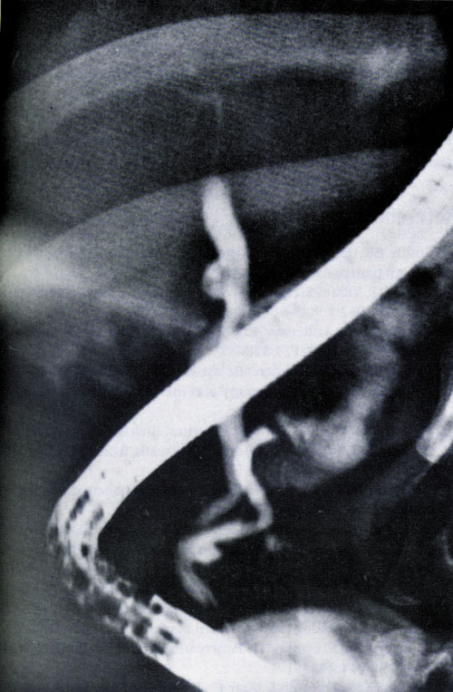
Fig. 1. Endoscopic retrograde cholangiopancreatography of a patient with PA associated with rupture of the pseudocyst of the body of the pancreas. The patient successfully underwent pancreatojejunostomy Roux anastomosis (according to P.A. Lipsett et al., 1998 [8]).

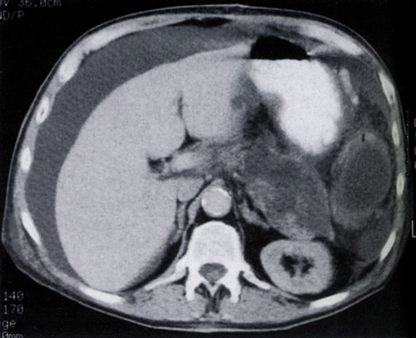
Fig. 2. Computed tomography of a patient with a pancreatic pseudocyst rupture and PA. Laparocentesis allowed to gain liquid with a protein content of about 30 g/l and amylase activity higher than 10000 units (according to C.A. Seiler et al., 1998 [11]).
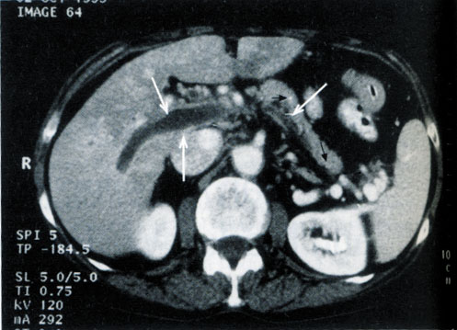
Fig. 3. CT scan with intravenous contrast shows signs of thrombosis of portal and splenic vein in a patient with chronic pancreatitis. Because of thrombosis these veins are not contrasted (white arrows). A thin rim around the thrombus is defined, corresponding well-contrasted vascular wall. Black arrows indicate calcifications of the pancreas (according to P.A. Lipsett et al., 1998 [8]).
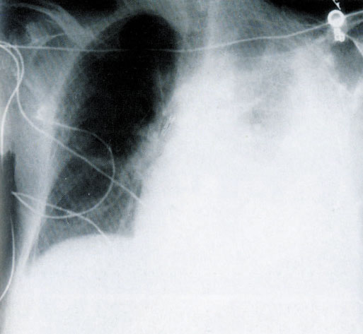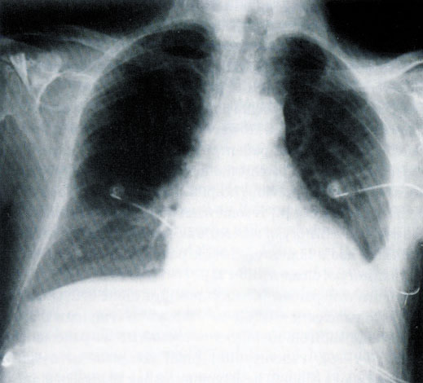
Fig. 4. Radiographs of the chest of the patient cells with PH (according to P.A. Lipsett et al, 1998 [8]):
a) before treatment (left subclavian catheter);
b) one week after diagnostic and therapeutic puncture of the pleural cavity (the amount of fluid decreased significantly).

Pancreatic ascites: another one of many manifestations of pancreatitis
N. B. Gubergrits, N. V. Byelyayeva, P. G. Fomenko
Donetsk National Medical University n. a. M. Gorky

Key words: acute and chronic pancreatitis, pancreatic ascites, pancreatic hydrothorax, pathogenesis, diagnostics, treatment
The article presents an overview of the literature on one of the relatively rare manifestations (complications) of acute and chronic pancreatitis — pancreatic ascites. Pathogenesis, variants of clinical course, diagnostics and treatment of this condition have been analyzed.

