Supervision of patients with chronic pancreatitis according to the last Ukrainian guidelines
K. A. Prosolenko
Kharkov National Medical University, Ukraine

Key words: chronic pancreatitis, classification, standards of diagnostics and treatment, pancreatic insufficiency, stage therapy
The main disease of the pancreas, facing a physician, a gastroenterologist, is a chronic pancreatitis (CP). Analyzing epidemiological data, we must note a significant difference in statistical terms by CP in Ukraine and other countries in Europe and the world. So, incidence of CP in the world - 3,1-8 cases, in Europe - 4-8 cases, prevalence - 25 cases per 100 thousand population. In Ukraine, the incidence of pancreatic pathology in 2012 amounted to 226 cases per 100 thousand of population, the prevalence - 2471 per 100 thousand of population. This difference in the number of patients with CP in Ukraine and in other countries in Europe and the world seems to us striking and may be associated with overdiagnosis in setting CP diagnosis, as well as higher levels of alcohol abuse, which is one of the main causes of CP development [1, 2].
It is well known that patient’s supervision is very important in the correct formulation of the diagnosis, which is carried out using the classification approved in one or another country. To date, there is no recognized CP classification in Ukraine. In Europe the most often used is Marseille-Roman classification, M-ANNHEIM classification, etc. Table 1 shows, in our opinion, the most clinically adapted variant [2].
Table 1
Marseille-Roman classification (1989)
with the amendments by Ya. S. Zimmerman (1995) and updates (ICD -10)
A. Etiology
- - Primary
- alcoholic (K86.0)
- in kwashiorkor
- hereditary ("family")
- drug-induced, toxic (K86.1)
- - Secondary
- with biliary pathology
- in chronic hepatitis, cirrhosis of the liver
- in duodenal pathology
- in parasitic infestation (opistorhoz et al.)
- in hyperparathyroidism
- in cystic fibrosis
- in hemochromatosis
- in mumps
- Crohn's disease and ulcerative colitis
- allergic diseases
- hyperlipidemia
- pancreatic trauma
B. Morphological features
- Calcificating pancreatitis K 86.1
- Obstructive CP K 86.1
- Inflammatory CP K 86.0
- Fibrosis of the pancreas K 86.8
B. Clinical variants
- - Continuously relapsing
- - Pain
- - Pseudotumor (with cholestasis, with duodenal obstruction)
- - Latent (silent)
- - Mixed
D. Functional state
- - Violation of the exocrine pancreatic function
- hypersecretion type;
- hyposecretion type (compensated, decompensated);
- obstructive type;
- ductular type
- - Violation of endocrine pancreatic function
- hyperinsulinism;
- hypothyroidism of insular apparatus (diabetes type II)
D. Dates:
- - Acute episodes
- - Remission
E. Degree of severity
- - Easy
- - Moderate
- - Heavy
J. Complications
- - Diabetes
- - Pancreatic cancer
- - Mechanical jaundice
- - Pancreatic coma
- - Retention cysts and pseudocysts of the pancreas (K86.2, K86.3)
- - Abscess of pancreas
- - Pancreatonecrosis
- - Reactive pleurisy
- - Reactive hepatitis
- Anemia

Examples of the formulation of a diagnosis
- Chronic primary pancreatitis, obstructive, pseudotumor with cholestasis, severe course, during an exacerbation, in violation of the exocrine pancreas by hyposecretion type.
- Chronic initial pancreatitis, calcificating, painful, relapsing, moderate severity, period of aggravation, with violation of exocrine pancreatic function.
It should be noted the significant progress in Ukraine regarding the development of standards for diagnosis and treatment of CP. It is important to note that the position of Ukrainian regulatory documents developed by leading Ukrainian experts-pancreatologists and based on the latest European and international recommendations on the diagnosis and treatment of CP [5, 6, 7]. In this case, in terms of practical health care, in some cases, you can still encounter erroneous approach of some doctors, which is based on some subjective preferences in the selection of diagnostic and therapeutic measures. This approach, in our opinion, often leads to poor clinical outcomes in supervision of patients with CP, and recently often to the "legal consequences".
Laboratory and instrumental diagnosis of CP in Ukraine today is strictly regulated and must be carried out according to the order from the Ministry of Health of Ukraine № 638 from 10.09.2014, the provisions of which are closely related to Ukrainian Pancreatic Club recommendations in the diagnosis and treatment of exocrine pancreatic insufficiency [1, 3].
According to the order, laboratory and instrumental studies are carried out at various stages of care in different amounts. At institutions that provide primary medical care, studies carried out at least minimally (I stage), in a step of providing a secondary (specialized) ambulatory (phase II) and secondary (specialized) stationary (III stage) using a wide range of advanced research.
At the I stage of laboratory examination methods are carried out within the scope of clinical blood tests (at an aggravation - leukocytosis with a shift to the left, neutrophilia, accelerated ESR) and urine (without features), as well as determine the level of blood glucose (may increase in the presence of diabetes mellitus - DM) . Instrumental methods of examination: ultrasound of the abdomen and kidney (Table 3), ECG (normal or non-specific repolarization disorders). Also, the I-level physician refers the patient to the consultation of:
1. Gastroenterologist - within a week to confirm or clarify the diagnosis of CP.
2. Surgeon - in the presence of anxiety symptoms: fever, intoxication, severe pain, unmotivated weight loss, with suspected acute pancreatitis, the presence of complications - immediately.
3. Endocrinologist - if diabetes symptoms within a week.
On the II and III stage of the diagnostic measures aimed at establishing CP diagnosis, differential diagnosis with other diseases, assess the risk of serious complications.
Mandatory laboratory research stage II:
1. Biochemical analysis of blood with a certain level of amylase (may increase), glucose (if it was not made in the provision of primary health care), the glycosylated hemoglobin.
2. Analysis of urine amylase determination level (may increase).
3. Scatoscopy (possibly - amylorrhea, steatorrhea, creatorrhea).
4. Fecal elastase-1 (may fall).
Required tools II study stage:
1. Ultrasonography of the abdomen and kidneys.
2. Endoscopy inspection department retrobulbar duodenal (first of all to eliminate the pathology of a large duodenal papilla, atrophic duodenitis and others).
3. ECG.
To send a patient for consultation to:
1. Surgeon - in the presence of anxiety symptoms (fever, intoxication, severe pain), unmotivated weight loss; with suspected acute pancreatitis, the presence of complications.
2. Oncologist - for suspected malignancy.
3. Endocrinologist - diabetes symptoms.
It is desirable to define gene mutations in PRSS1, CFTR, and SPINK1 CTRC patients with CP of unknown aetiology and a family history of CP. A significant reduction in the level of fecal elastase is reason to suspect the presence of exocrine pancreatic insufficiency. The criteria for diagnosis of diabetes mellitus is the level of fasting blood glucose ≥126 mg/dL and/or HbA1c≥6,5%.
On stage III (specialized inpatient treatment) is carried out at hospitalization:
- CP in the acute stage;
- Pseudotumor CP;
- Obstructive CP;
- Bacterial complications of CP;
- Pancreatogenic gastroduodenal ulcers;
- Identification of areas of ultrasound pancreatic tissue that resemble pancreatic necrosis;
- Thrombosis splenic / portal vein;
- Pseudocyst of the pancreas, increase in size, complications of pseudocysts;
- Fistula pancreas.
Diagnosis at the third step comprises:
1. Complete blood count.
2. Biochemical analysis of blood with determination:
- The level of amylase, pancreatic isoamylase, lipase (may increase)
- Glucose, glycated hemoglobin,
- Liver function tests (normal or increased values ​​of bilirubin, mainly direct and alkaline phosphatase - the syndrome of cholestasis, increased blood parameters of transaminases, and lactate dehydrogenase, gamma-glutamyl transpeptidase - can be caused by a block of common bile duct, the development of reactive hepatitis in patients with alcoholic CP).
3. Analysis of urine amylase determination level (may increase).
4. Scatoscopy.
5. Fecal elastase-1.
Instrumental methods of examination:
1. ECG.
2. The ultrasound of the abdomen and kidneys.
3. EGDS with inspection of retrobulbar department of the duodenum.
4. CT of the abdomen and retroperitoneal space (Table 3).
5. Magnetic resonance imaging / magnetic resonance cholangiopancreatography (reveal the heterogeneity of structure, the presence of cysts or pseudocysts, pancreatic necrosis zone using staining) - upon insufficient informative value of ultrasound and CT.
6. Endoscopic ultrasonography of the pancreas (parenchyma changes, identify change pancreatic ducts, biliary tree) - if necessary.
7. Endoscopic retrograde cholangiopancreatography - ERCP (identifying changes in pancreatic duct and its branches (intermittent expansion of ducts - "chain of lakes" or the norm) - when there is insufficient information of all of these instrumental methods of examination, when the diagnosis of CP can’t be set using a non-invasive and less invasive research methods.
Changes on the abdominal CT are difficult to be detected in the early stages of CP. CT is the best imaging method for non-endoscopic diagnosis of CP to identify the localization of the pancreatic calcification. CT is more informative for the diagnosis of CP in the later stages.
Diagnostic system proposed for simplification and objectification of setting CP diagnosis is presented in Table 2 [2]
Table 2
CP diagnostics for point system (according to P. Layer and Melle, 2005)
Assessed parameters | Points
Calcification of the pancreas | 4
Characteristic histological changes | 4
Characteristic changes in ultrasound or ERCP (Table 3) | 3
Pancreatic exocrine insufficiency | 2
Attacks of pancreatitis and / or chronic abdominal pain | 2
Diabetes | 1
CP is diagnosed in the case of 4 points or more
Today, many practical public health doctors, faced with a patient with a presumptive CP, oriented in the diagnosis solely on the results of transabdominal ultrasonography. At the same time faced with the findings of medical specialists in ultrasound diagnostics, which sounds the phrase "chronic pancreatitis". Analyzing the same study protocol, often found information concerning only increased echogenicity of the pancreas. It should be noted that in these cases the correct wording in the conclusion is "diffuse changes of the pancreas". The decision on what the diagnosis in the patient should take a clinician, comparing ultrasound data with the clinical picture, the presence of pancreatic insufficiency, etc. It is possible to use the Cambridge classification of structural changes in the pancreas in CP (Table 3).
Table 3
Cambridge classification of structural changes in the pancreas in CP
Changes | ERCP | Ultrasound or CT
Normal pancreas | The main pancreatic duct (MPD) and the side duct branches are not changed | Normal size, clear contours of the pancreas. MPD - 2 mm. Pancreatic parenchyma homogeneous
Doubtful changes | MPD not altered, less than three lateral branches are changed | One of the following: MPD = 2 - 4 mm. Dimensions of the pancreas within 1 - 2 norms. Heterogeneous parenchyma of the pancreas
Mild changes | MPD not altered, more than 3 lateral branches are changed | Two or more of the features: MPD = 2 - 4 mm. A slight increase in size of the pancreas. The heterogeneity of the parenchyma.
Moderate changes | Changes of MPD and more than 3 lateral branches | Unclear pancreatic contours. Small cysts (less than 10 mm). Uneven MPD. Acute focal necrosis. Increased echogenicity of the duct wall. Roughness of contours of the pancreas.
Significant changes | All of the above symptoms plus one or more of the following features:  • Cysts over 10 mm in diameter  • Intraductal filling defects  • Stones / pancreatic calcification  • Obstruction or stricture of MPD  • Severe dilatation and irregularity of MPD  • Invasion of adjacent organs

It is necessary to ascertain the prevalence of lack of highly informative diagnostic methods such as endoscopic ultrasound and magnetic resonance cholangiopancreatography, even in highly specialized clinics.
Treatment of patients with CP should be carried out according to the same regulatory documents, as well as recommendations of the Ukrainian Pancreatic Club on relief of abdominal pain in CP [1, 3, 4].
Aims of treatment:
- relief of clinical symptoms of the disease;
- decrease in the activity of the inflammatory process in the pancreas tissue;
- improvement in general condition of patients, results of laboratory tests;
- positive dynamics by ultrasound of the pancreas (normalization size, echogenicity of the pancreas, contour definition, lack of parapancreatic infiltration);
- compensation for exocrine pancreatic insufficiency;
- achievement of stable remission;
- prevention of complications.
In patients with mild course of the disease may outpatient treatment. Patients with acute exacerbation of CP moderate and severe degrees of severity should have inpatient treatment, preferably - in the departments of gastroenterological profile, complications of treatment are carried out in the surgical wards. Clinical supervision: examination by gastroenterologist and ultrasound - not less than 1 time in 6 months.
Treatment for stage I (see below):
1. Assign the correct lifestyle, particularly diet, work and rest.
2. Provide medical assistance to phase out the use of alcohol and tobacco.
3. To provide pain relief.
4. If there are failure symptoms of exocrine pancreatic function, assign pancreatine preparations.
5. If you have diabetes, endocrinologist appoints specific treatment.
Treatment for stage II (see below):
1. Assign the correct lifestyle, particularly diet, work and rest.
2. Provide medical assistance to phase out the use of alcohol and tobacco.
3. To provide pain relief.
4. If there are failure symptoms of exocrine pancreatic function, assign pancreatine preparations.
5. Assign a proton pump inhibitor (PPI) to create a "functional rest" of the pancreas.
6. To appoint preparations containing vitamins for correction of vitamin A deficiency.
7. If you have diabetes, endocrinologist appoints specific treatment.
Treatment at the third stage:
1. To provide pain relief.
2. Assign antispasmodics with sphincter of Oddi dysfunction.
3. To ensure the "functional rest" the pancreas by appoint ing PPI, if necessary - octreotide.
4. If there is failure symptoms of exocrine pancreatic function, assign pancreatine preparations.
5. Assign preparations that contain vitamins for correction of vitamin A deficiency.
6. Assign infusion therapy for the purpose of detoxification.
7. If you have diabetes, endocrinologist appoints specific treatment.
8. In the presence of bacterial complications assign antibacterial drugs.
9. The surgical / endoscopic treatment is considered after failure of medical treatment and the presence of complications.
The algorithm of non-drug and drug treatment
Drug-free treatment
A) Complete rejection of alcohol, smoking.
B) Nutrition in diseases of the pancreas in their quantitative and qualitative composition and energy value should correspond to the physiological needs of man. Diet therapy should be carried out according to the nature and stage of disease, the degree of metabolic disorders, the presence of comorbidity.
Diet in CP should contain optimal amounts of protein (80-100 g/day, including animal - 45-50 g/day), moderately restricted fats (up to ≈60 g/day, including plant - 25-30 g/day; fat is distributed uniformly on main meals 3-4). If you have diabetes carbohydrates that are easily digested, they should be excluded from the diet.
Need rejection of products and dishes that stimulate gastric and pancreatic secretion (acute, smoked, roasted, freshly baked, sweet food, chocolate, cocoa, coffee, spices, broth, crude fiber).
Important cooking type (preferably decoction, baking), adherence rate meal (4-6 times a day), reducing the amount of salt (up to 6-8 g/day), sufficient amount of liquid (1-1.5 liters per day). The temperature of food 15-60º , dietary energy - 2000-2500 kcal/day.
Additionally, administration of drugs recommended: omega-3 fatty acids, lecithin, fat-soluble vitamins after eating multienzyme coupled with drugs.
Medication:
A) Symptomatic treatment of pain:
- Pain begins with the appointment of non-narcotic analgesics (paracetamol, metamizole sodium), in the absence of contraindications - NSAIDs (ibuprofen)
- If necessary (strong, steady pain) - narcotic analgesics short courses (tramadol);
- Antispasmodics (mebeverin, drotaverinum, papaverine).
B) When the sphincter of Oddi dysfunction to correct tone - the appointment of selective antispasmodics (mebeverin).
It should be noted that in clinical practice, the use of analgesics and muscle relaxants to relieve pain is enough. In addition, there are two types of pain in CP: Ttype A (recurrent abdominal pain with pain-free episodes) and type B (constant, varying intensity of abdominal pain) The recommendations of the Ukrainian Pancreatic Club-2014 presented an algorithm of treatment of abdominal pain [4].
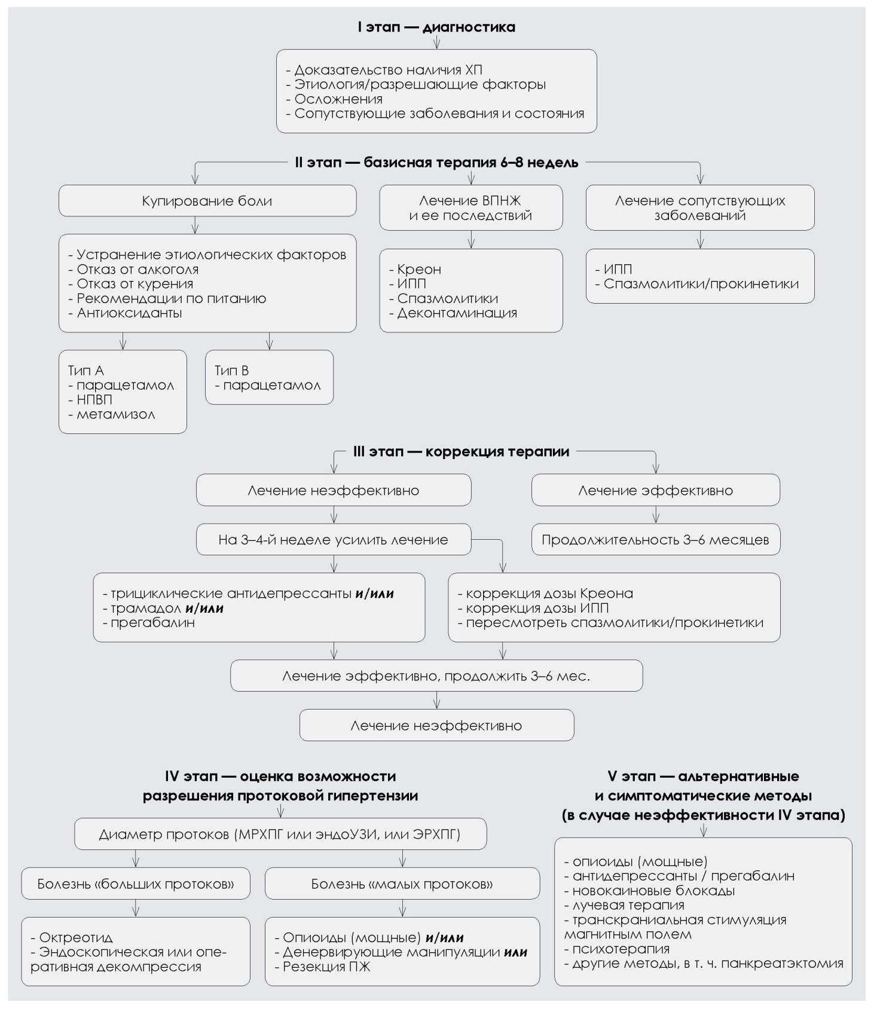
Fig. 1. Algorithm for treatment of abdominal pain in CP adapted to practical health care of Ukraine (according to N. B. Gubergrits).

It should be noted that the algorithm at different stages includes drugs and non-drug treatments that are not included in the Order No 638: tricyclic antidepressants, pregabalin, antioxidants, prokinetics, procaine blockade, radiation therapy, transcranial magnetic field stimulation and psychotherapy.
C) In the presence of disease symptoms of exocrine pancreatic insufficiency we appointed polyenzyme drugs (pancreatine) for 25,000-40,000 units of lipase at the main meal and 10,000-20,000 units of lipase for minor meal.
Treatment of exocrine pancreatic insufficiency is often problematic. The Order No 638 recommended sequence of actions in these cases [1].
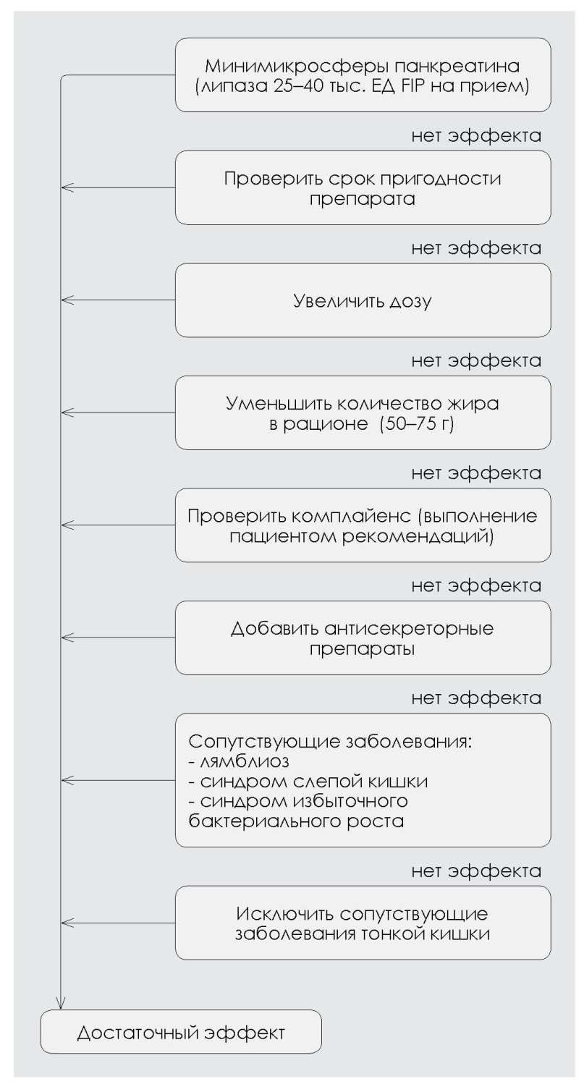
Fig. 2. Algorithm of replacement therapy in CP (according to P. Layer, et al., 2003, approved by the Order No 638 of Ministry Health of Ukraine, 2014)
D) To reduce the external secretion of the pancreas (the creation of "functional rest" of the pancreas) are assigned:
- Proton pump inhibitors in a standard dose 2 times a day;
- Octreotide (in complicated CP course).
Note the absence of the Order №638 of previously frequently used drugs in Ukraine as aprotinin and blockers of H₂ histamine receptors (ranitidine and famotidine).
E) Vitamins for correcting vitamin deficiencies (monopreparations and combinations): menadione / fitomenadion, retinol, ergocalciferol, tocopherol, multivitamin complexes containing these vitamins.
F) In the treatment of exacerbations and complications of CP in the hospital appointed by blood substitutes and infusion therapy solutions for the purpose of detoxification:
- electrolytes in combination with other drugs: sorbitol + sodium lactate + sodium chloride + calcium chloride + potassium chloride + magnesium chloride i/v - 400 ml per day;
- blood protein fractions: human Albumin 10% solution in a solvent 100 milliliters i/v per day;
- carbohydrates: glucose 5-10% solution - 500 ml per day.
G) If you want to reduce the risk of or treatment of bacterial complications CP appointed antibacterial drugs, which are used for treatment of gastrointestinal infections, taking into account the type of possible pathogen that infects the prostate: carbapenems, fluoroquinolones, cephalosporins of III-IV generations, nitroimidazole derivatives.
H) In secondary CP, which developed as a result of other diseases of the digestive system, the treatment of the underlying disease is conducted.
The surgical / endoscopic treatment is considered after the ineffectiveness of drug treatment and the presence of complications.
Indications for endoscopic treatment:
- Compression of the common bile duct by enlarged head of the pancreas;
- Pain that is associated with the expansion of the main pancreatic duct;
- Papillostenosis;
- Stricture of prepapillar department;
- Stones in Wirsung’s duct;
- Pancreatic fistulas of the distal parts of the main pancreatic duct;
- Cysts and pseudocysts of the pancreas.
Indications for surgery:
- Calcification pancreatic duct stones with severe pain;
- Obstructive CP - at impossibility of endoscopic decompression;
- Obstructive jaundice due to compression of the common bile duct;
- Duodenostenosis;
- Obstructive portal hypertension;
- Cysts are more than 6 cm in diameter or fistula of the pancreas, can’t be treated conservatively for 3 months;
- Secondary CP associated with gallstone, penetrating ulcer, duodenostasis, abdominal ischemic syndrome;
- Ineffectiveness of conservative therapy, persistent pain;
- The presence of malignancy;
- Bacterial purulent complications after failure of minimally invasive surgery and medical treatment;
- Parafateral diverticula.
Medical rehabilitation is also regulated in the order. CP patients in remission or unstable remission are subject to sanatorium-and-spa treatment. Spa treatment is not indicated in patients in the acute stage of CP. The main therapeutic effects are expected - the reduction or elimination of the inflammatory process, the restoration of exo- and endocrine functions of the pancreas. Sanatorium mode: II-III. Climatotherapy: total. Traction mode: morning hygienic gymnastics, therapeutic exercise (group).
Mineral water: mineral water of low and average mineralization of hydrocarbonate and sulfate composition. Middle-mineralized warm mineral waters of hydro-sulfate formulation (t = 37-38 ° C) are prescribed in the conditions of moderate insufficiency of endocrine function of the pancreas and the absence of loose stool. Water is taken warm, starting with 50-100 ml 1-2 times a day, increasing the subject well tolerated up to 150-200 ml 3 times a day for 30-40 minutes before eating. Low-mineralized water of the same chemical composition is prescribed in cases of excessive exocrine function of the pancreas. Drinking water in the form of heat, ranging from 50-100 ml 1-2 times a day, increasing provided good tolerance to 150-200 ml 3 times per day 60-90 minutes before meals. Among the mineral water with a high content of bicarbonate ions patients recommend the following packaged mineral water "Polyana Kvasova", "Luzhanska", "Svalyava", "Polyana Kupel", "Ploskivskaya", "Arkhyz", "Dragovskaya". Mineral water is degassed in advance.
Resorts recommended for the treatment of patients with CP: drinking resorts in Transcarpathia (the sanatorium - "Shayan", "Svalyava", "Sunny Transcarpathia", "Kvіtka Polonyny"), the resort Berezovsky mineral water (Kharkiv region), the resort Morshyn (sanatorium - "Dniester", "Lavender","Pearl of the Carpathians"), Odessa resort (sanatorium n.a. Gorky). The term of spa treatment — 21-30 days.
In conclusion, it is necessary to identify the main action that will reduce the significant difference in the incidence and prevalence of CP in Ukraine and in other countries in Europe and the world. The first is, in our opinion, the fight against major etiological factors of CP: struggle with alcoholism and smoking, as well as the timely diagnosis and treatment of diseases of the biliary tract. And from our point of view, the main thing is the need for widespread introduction into clinical practice of modern domestic Ukrainian Pancreatic Club recommendations and Order No 638 of Ministry Health of Ukraine on diagnostics and treatment of CP, which are based on evidence-based data.
References
- Наказ МОЗ України від 13.09.2014 р. № 638 «Про затвердження та впровадження медико-технологічних документів зі стандартизації медичної допомоги при хронічному панкреатиті».
- Рациональная диагностика и фармакотерапия заболеваний внутренних органов / Под ред. А. Н. Беловола, Г. Д. Фадеенко, О. Я. Бабака // Справочник врача «Семейный врач, терапевт». — К.: ООО «Библиотека «Здоровье Украины», 2013. — 438 с.
- Рекомендации Украинского Клуба Панкреатологов по диагностике и лечению внешнесекреторной недостаточности поджелудочной железы / Н. Б. Губергриц, С. М. Ткач, О. В. Швец [и др.] // Вестник Клуба Панкреатологов. — 2014. — Дод. до № 3. — С. 4–11.
- Рекомендации Украинского Клуба Панкреатологов по купированию абдоминального болевого синдрома при хроническом панкреатите / Н. Б. Губергриц, С. М. Ткач, О. В. Швец [и др.] // Вестник Клуба Панкреатологов. — 2014. — Дод. до № 3. — С. 12–28.
- Delhaye M. Belgian consensus on chronic pancreatitis in adults and children: statements on diagnosis and nutrinutritional, medical, and surgical treatment / M. Delhaye, W. Van Steenbergen, E. Cesmeli // Acta Gastroenterol. Belg. — 2014. — Vol. 77. — P. 47–65.
- Italian consensus guidelines for chronic pancreatitis / L. Frulloni, M. Falconi, A. Gabbrielli [et al.] // Dig. Liver Dis. — 2010. — Vol. 42, Suppl. 6. — S381e406.
- Lerch M. M. New guidelines on chronic pancreatitis: interdisciplinary treatment strategies / M. M. Lerch, K. A. Bachmann, J. R. Izbicki // Chirurg. — 2013. — Vol. 84, No 2. — P. 99–105.

Supervision of patients with chronic pancreatitis according to the last Ukrainian guidelines
K. A. Prosolenko
Kharkov National Medical University, Ukraine

Key words: chronic pancreatitis, classification, standards of diagnostics and treatment, pancreatic insufficiency, stage therapy
The article presents modern approaches towards management of patients with chronic pancreatitis according to the latest Ukrainian guidelines. Issues of incidence, prevalence and classification of chronic pancreatitis are also discussed.

