From edematous syndrome to the diagnosis of "intestinal lymphangiectasia" (clinical observation of a rare disease)
N. B. Gubergrits, K. Y. Linevskaya, K. A. Voronin
Donetsk National Medical University, Ukraine (Lyman),
National Medical University A. A.Bogomolets, Ukraine (Kyiv),
"Vivamedika" (Kyiv)

Key words: intestinal lymphangiectasia, clinical picture, diagnosis, treatment, prognosis

Logic is the anatomy of thinking.
It is more valuable to think correctly than to know a lot.
John Locke

Starting our narrative with the quote of the great English philosopher John Locke, we would like to emphasize that the solution of this interesting clinical case lay on the surface, but it was possible to find it only thanks to the clinical thinking and close-knit work of the team of professionals.

Clinical case
In 2007, the gastroenterological department of the Donetsk Regional Clinical Territorial Medical Union (DRCTMU) hospitalized patient L., 29 years old, which is when you receive a complain weight gain, swelling of the face, extremities, anterior abdominal wall weakness. Particular excitement patient caused weight gain without an apparent gain in appetite or a significant increase in the volume of food consumed over the past few months. By carefully observing the operation selection bodies, the patient is not marked tendency to constipation (intestinal emptying 1-2 times/day) and the appearance of pathological contaminants in the stool; also there were no visual changes in urine and dysuric complaints, and the volume of urine released during the day was about 1 liter.

Anamnesis of the disease
The patient began to notice the first signs of an increase in body weight six months ago, when habitual clothing suddenly became cramped and uncomfortable. Analyzing her own eating behavior, the patient did not notice the presence of any significant errors: the amount of food consumed and the frequency of meals did not increase, the diet contained products of plant and animal origin, the volume of normal physical activity did not decrease. The patient somewhat reduced the share of bakery products and sugar-containing drinks in her diet, but this did not have a significant effect. Concerned about her health, she went to a polyclinic at the place of residence, where, after excluding pregnancy, the patient was recommended to undergo a comprehensive examination in the nephrological department of DRCTMU. The results of the laboratory-instrumental study made it possible to omit the version about nephrologic pathology and, with the purpose of excluding cirrhosis of the liver of unknown etiology, the patient was transferred to the gastroenterological department of DRCTMU.

Anamnesis of life
Tuberculosis, typhus, malaria, venereal diseases, HIV, viral hepatitis, blood transfusion, trauma and surgical intervention denies. From the accompanying pathology chronic rhinosinusitis. The allergic anamnesis is not burdened. Hereditary anamnesis is burdened with cardiovascular diseases: the mother of the proband is diagnosed with arterial hypertension, and her father has ischemic heart disease. Harmful habits do not have (does not abuse alcohol, denies the use of drugs).

Data of objective examination and laboratory-instrumental examination at the time of treatment (2007)
With objective examination, the general condition is relatively satisfactory, the position is active, the consciousness is clear. Height — 160 cm, weight — 78 kg, BMI — 27.0 kg/m². Skin covers and visible mucous membranes are clean, pale, there are no traces of community-acquired injections. The face is puffy, on the upper and lower extremities, the anterior abdominal wall, the lower back — soft swelling. Peripheral lymph nodes are not palpable. Body temperature is 36.6°C. The thyroid gland is not enlarged in size. Musculoskeletal system without visible pathology, active and passive movements in the joints are preserved in full. When palpation, the chest is resistant, painless. The thorax is cylindrical, percussionally over the entire surface of the lungs, a clear pulmonary sound, auscultatory vesicular breathing. When examining the atrial region, abnormal pulsation is not revealed, percutaneously the boundaries of relative cardiac dullness are within the normative boundaries. Heart sounds are sonorous, activity is rhythmic, additional noise is not heard. The heart rate is 78 beats per minute, the pulse is 78 beats per minute, satisfactory qualities, rhythmic. The arterial pressure on the right arm corresponded with that on the left and was 110 and 65 mm Hg. The tongue is pink, sparsely coated with a white coating, moist, with pronounced imprint of the teeth at the edges. The abdomen is rounded, symmetrical, not enlarged in size, actively participates in the act of breathing. With superficial palpation the abdomen is soft, painless. Symptoms of Kera, Ortner, irritation of the peritoneum are negative. The liver does not protrude from under the edge of the right costal arch, the lower edge is smooth, smooth, painless. Dimensions of the liver according to Kurlov — 9:8:7 cm. The spleen is not palpable. Pasternatsky's symptom is negative from both sides. Daily diuresis — up to 1.0 liters. Physiological management — bowel evacuation once a day, feces of a mushy consistence, brown color, without pathological impurities. Urination is painless, not difficult.
In the clinical analysis of the blood, phenomena of hypochromic anemia (erythrocytes 3,3 ∙ 1012/l, gmohalobin — 89 g/l, color index — 0,8) and lymphocytopenia (12%) were detected with preservation of the remaining parameters. In the biochemical analysis of blood, hypoproteinemia (total protein — 35 g/l), hypoalbuminemia (albumins — 16 g/l), hypoglobulinemia (globulins — 19 g/l), a decrease in the values ​​of the albumin/globulin index (0.84) was noted. Other functional tests of the liver, as well as renal washes were within the normative values. All the indicators of the clinical analysis of urine corresponded to the normative indices. Analysis of the data of the coprogram allowed us to conclude that there is a steatorrhea. The content of fecal elastase-1 was within the limits of normative values. Violation of electrolyte composition?
When carrying out an X-ray examination of the thoracic organs, no pathology was found. Similarly, in the course of ultrasound of the abdominal and pelvic organs, there were no deviations in the location, shape, structure and structure of the liver, gall bladder, spleen, pancreas, kidneys, uterus, bladder, and major arterial and venous vessels. Echocardiography provided convincing data on the excellent structural and functional state of the myocardium, pericardium, valvular apparatus, dopplerography — on the satisfactory state of the vessels, their patency and the preservation of blood flow. Duplex angioscanning made it possible to exclude acute thrombotic lesion and chronic pathology of veins.
The study of the hormone-producing function of the thyroid gland confirmed the safety of its functional activity (T3 free, T4 free, thyroid-stimulating hormone) and the absence of autoimmune lesion of the gland (antibodies to thyroid peroxidase). At US of a thyroid gland pathological changes in its structure are not found out.
During endoscopic examination of the upper gastrointestinal tract (GIT), pathology from the esophagus was not revealed, signs of superficial gastritis and duodenitis were noted, urease test was negative. A biopsy of the stomach mucosa, 12 duodenal ulcer, the initial part of the jejunum was performed. The results of the histological examination (Fig. 1) made it possible to eliminate Whipple's disease, amyloidosis, and cancer.

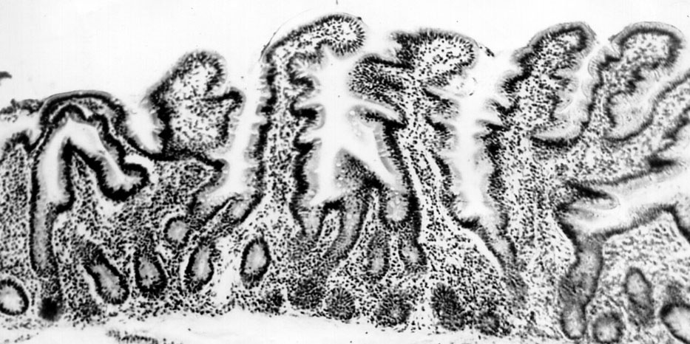

Fig. 1. Mucous membrane of the jejunum of patient L., 29 years old.
Description in the text. Stained with haematoxylin-eosin, increase ×90.

Separately, we emphasize that the villi of the duodenum were not shortened, not thickened, enlarged lymphatic vessels and PAS-positive foamy macrophages were absent.
Based on the history of the disease, life, objective examination, the results of laboratory-instrumental research, the following alleged clinical diagnosis is formulated:

Main diagnosis: Edematous syndrome of unknown etiology.
Concomitant diagnosis: Secondary hypochromic anemia?

Differential diagnosis
The absence of visible pathological abnormalities according to the ultrasound of various organs and systems in the presence of clinically significant edema caused a careful analysis of the results obtained and a logical exclusion of probable causes of edema.
Our reasoning proceeded in the following direction. Swelling can occur with the following diseases (Table 1).
Table 1
Causes of edema (R. А. Libis et al., 2011 [1])
Etiology
- Heart disease, leading to the development of chronic heart failure
- Kidney disease, leading to the development of nephrotic or nephritic syndrome
- Liver pathology (cirrhosis or liver cancer)
- Lymphatic edema
- Chronic venous insufficiency
- Acute disorders of venous circulation (deep vein thrombosis)
- Enteropathy with increased protein loss (intestinal lymphangiectasia, sprue syndrome, small intestinal tumors, Whipple's disease)
- Neuroendocrine conditions and diseases (hypothyroidism, premenstrual syndrome)
- Edema of the pregnant
- Cachectic edema (tumors, infections, prolonged starvation, alcoholism)
- Osteoarticular pathology (deforming osteoarthritis, reactive polyarthritis)
- Idiopathic orthostatic edema
- Medicinal edema
- Mixed edema
Pathogenesis
Increased venous (hydrostatic) pressure | Heart failure
 | Venous outflow disorder
 | Idiopathic (static) edema
Decreased oncotic pressure (hypoproteinemia) | Nephrotic syndrome
 | Diseases of the liver parenchyma
 | Enteropathy with increased loss of protein
 | Cachexia
Disturbance of metabolism of electrolytes and hormones | Kidney diseases
 | Premenstrual edema
 | Hypokalemia
 | Hypothyroidism
Damage to the wall of capillaries | Glomerulonephritis
 | Inflammation
 | Allergy
 | Hereditary angioedema
 | Lesion of the nervous system
Impaired lymph drainage | Peripheral lymphatic edema
 | Secondary lymphatic edema
Drug-induced | Hypotensive drugs (calcium antagonists, β-blockers, hydralazine, minoxidil, methyldopa)
 | Hormonal agents (corticosteroids, estrogens, progesterone, testosterone)
 | Nonsteroidal anti-inflammatory drugs
 | Thiazolidinediones
 | MAO inhibitors
False edema | Myxedema
 | Systemic scleroderma

When analyzing the probable causes of hypoproteinemic edema, the pathology of the liver, kidneys, and cachexia were quickly excluded, whereas for the elimination of enteropathy it was considered necessary to carry out capsular video endoscopy. Below is a description of the research and the conclusion of a physician of functional diagnostics who performed capsular video endoscopy (November 20, 2007, Fig. 2):
"The mucous stomach is moderately focalized hyperemic. In the lumen of the stomach is the secretory contents without pathological impurities. Peristalsis of the stomach is uniform, its activity is slightly reduced. The folds of the jejunum are edematic, the villous tissue is preserved throughout, the intestinal mucosa has a colorful appearance due to the presence of multiple whitish spots 1-2 mm in size, located from the distal parts of the duodenum to the ileum. The wall of the small intestine is rigid, the peristalsis weakened, uneven due to the reduction or total absence of long peristaltic waves. The video capsule reached the initial section of the transverse colon. The mucosa of this part of the large intestine is pale pink, smooth, the submucosal vascular pattern is clearly contoured. Conclusion: exudative enteropathy".

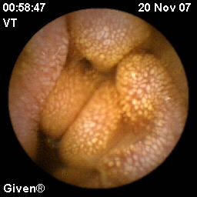 | 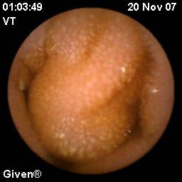
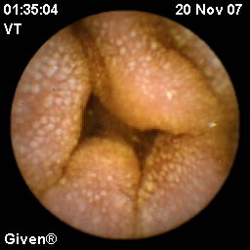 | 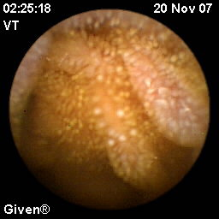

Fig. 2. The results of videocapsular endoscopy — the state of the small intestine of the patient L., 29 years old. Description in the text.

Final diagnosis and tactics of patient management
The results of capsular video endoscopy allowed to establish the cause of edematous syndrome and the following way to transform the final diagnosis:

Main diagnosis: Primary intestinal lymphangiectasia (Waldman's disease or exudative enteropathy) with pronounced edematous syndrome, hypoproteinemia and hypoalbuminemia, severe course.
Concomitant diagnosis: Secondary hypochromic anemia, mild-to-moderate flow.

The patient was prescribed albumin (intravenously), iron preparations (oral). In order to strengthen the intercellular contacts in the epithelium of the small intestine mucosa, we deemed it advisable to designate the octerotide and Essentiale forte N. The above therapy helped regress the edematous syndrome, significantly reduce weakness and body weight, increase the level of albumins and total protein, leveling the phenomena of hypochromic anemia.

Literature review
Brief historical information
In 1961, Waldman et al. described 18 cases of "idiopathic hypercatabolic hypoproteinemia": in the patients examined there were pronounced edemas that were associated with hypoproteinemia, hypoalbuminemia, and a decrease in γ-globulin concentration [2-6]. Researchers recorded a marked decrease in the total protein reserve determined with labeled 131I-albumin. In the course of a microscopic examination of the biopsy specimens of the small intestine, dilatation of the lymphatic vessels in the mucous, submucosal and serous layer of varying severity was revealed. To describe the discovered pathology, scientists suggested using the new term "intestinal lymphangiectasia" (IL) [2-6].

Epidemiology
The prevalence of clinically manifested IL is not known exactly [2-6]. It should be noted that IL can be asymptomatic, affect children, adolescents, adults. In the medical literature, single cases of the family form of Waldman's disease are described [2, 4].

Etiology
The causes of IL are currently not known exactly [2-6]. It has been established that exudative enteropathy can complicate the course of various diseases (Table 2).

Table 2
Causes of exudative enteropathy (М. Braamskamp et al., 2010 [3])
Mucosa lesion |  | Pathology of lymphatic vessels
Inflammatory and erosive-ulcerative lesions | Diseases without erosive-ulcerative lesions | Primary IL
Inflammatory bowel disease (Crohn's disease, ulcerative colitis) | Hypertrophic gastropathy (Menetries disease) | Secondary IL | Obstructive (Crohn's disease, sarcoidosis, lymphoma)
Infections (bacterial: Salmonella, Shigella, Campylobacter, Clostridium difficile, parasitic (Giardia liamblia), viral (Rotavirus) | Eosinophilic gastroenteritis |  | Due to high lymphatic pressure (congestive heart failure, constrictive pericarditis)
Gastrointestinal neoplasms (adenocarcinoma of the esophagus, stomach, large intestine, lymphoma, Kaposi's sarcoma) | Food-induced enteropathy |  | Syndromes (Turner, Nuan, Klippel-Trenone, Hennekama, von Recklinghausen)
 | Celiac disease
 | Tropical sprue
 | Syndrome of excessive bacterial growth
NSAID-enteropathy | Vasculitis (Shenlaine-Genocha purpura, systemic lupus erythematosus)
Necrotizing enterocolitis
Graft disease vs host

Pathophysiology
The pathogenesis of IL also remains precisely unknown. Relatively recently D. Levitt et al. (2017) [5] published a review in which they presented several possible pathophysiological mechanisms for the onset of IL (Fig. 3-6).

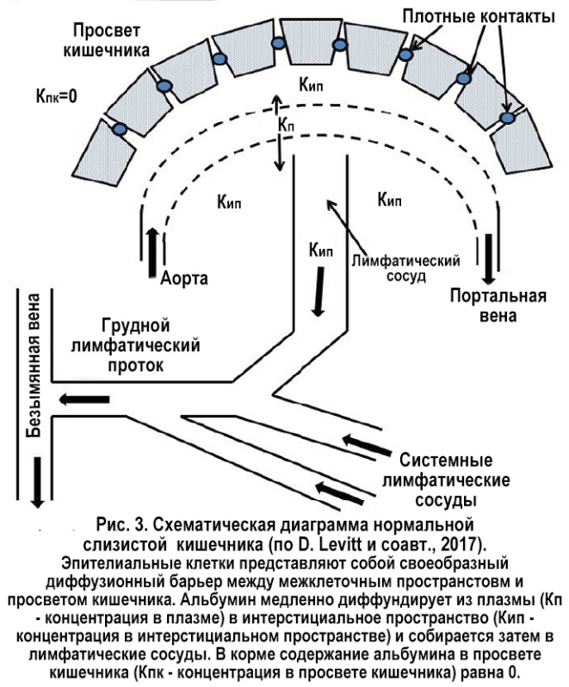

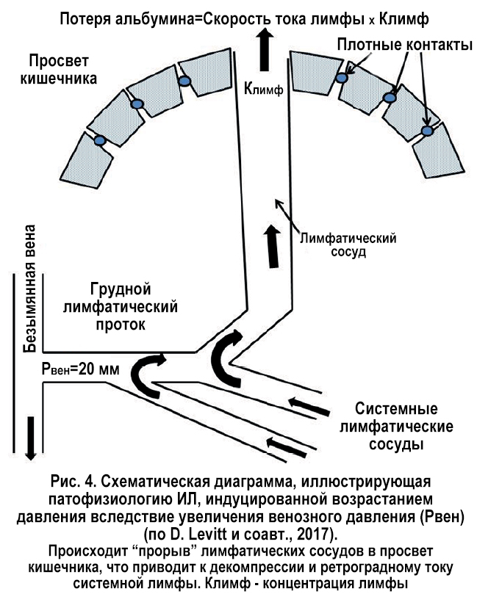

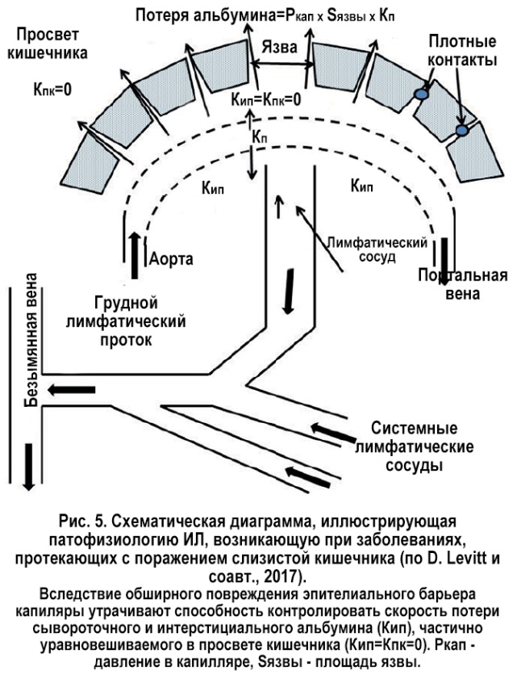

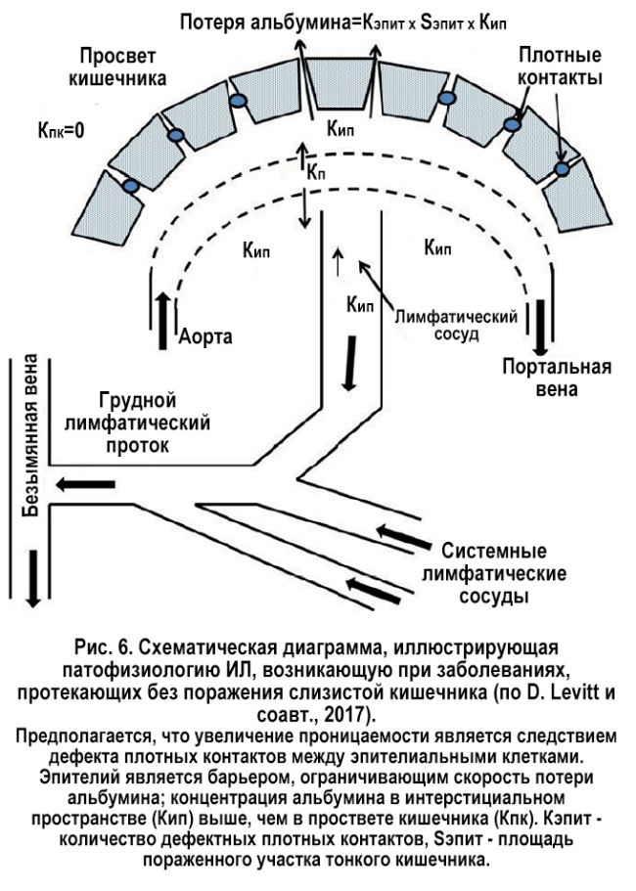

Clinical picture
The main clinical manifestation of IL is peripheral edema of varying severity (from moderate to severe). They are usually symmetrical, very often they affect the face and external genitalia (the main clinical sign, which is detected in 95% of patients) [2-6]. Characterization is also the formation of effusions of various localizations (hydrothorax, constrictive pericarditis, chylous ascites), however life-threatening anasarca develops extremely rarely. Edema in IL — soft, after pitting is a fossa (caused by a decrease in oncotic pressure on the background of hypoalbuminemia due to exudative enteropathy) [2-6].
Sometimes the course of the disease is accompanied by the appearance of diarrhea, malabsorption syndrome, mechanical obstruction of the small intestine (due to local edema leading to thickening and contraction of the intestinal wall). Patients with IL often suffer from celiac disease, have concomitant iron deficiency and anemia, rarely suffer from recurrent hemolytic uremic syndrome, osteomalacia [2-6]. In some cases, IL can manifest with recurrent gastrointestinal bleeding.
Five syndromes are associated with IL [2-6]: von Recklinghausen, Turner (X0), Nuan, Klippel-Trenone, Hennekam. As a rule, these syndromes can be easily diagnosed by the presence of anomalies on the face (Turner, Hennekam), delayed mental development (Hennekam), seizures (Hennekam), expressed lymphedema of the limbs and/or face (Hennekam), neurofibre and other tumors (von Recklinghausen), hemihypertrophy of extremities associated with vascular malformations (Klippel-Trenone).

Diagnostics
IL is confirmed by the detection of intestinal lymphangiectasia according to the histological examination of the biopsy specimen obtained during endoscopic examination of the small intestine [2-6]. Macroscopically, IL is characterized by a gently creamy, almost yellow staining of the villi in combination with a significant dilatation of the lymphatic vessels. The density of lymphangiectasia and its size varies from several mm to several cm. Histological examination of biopsy specimens of the duodenum and jejunum confirms the presence of lymph, dilated lymphatic vessels in the mucosa, submucosa, serosa and the presence of polyclonal plasma cells. With IL can be changed (dilatation) set or only a few intestinal lymphatic vessels. In the case of segmental or local lymphatic vascular lesions, upper endoscopy can give negative results, in such cases it is advisable to conduct video-video endoscopy, which has the maximum specificity in diagnosis of IL, regardless of its localization [2-6].
Indirect biochemical signs confirming IL include: hypoproteinemia, hypoalbuminemia, hypogammaglobulinemia with low IgG, IgA, IgM or lymphocytopenia [2-6]. In the diagnosis of IL can be used: the definition of alpha-1-antitrypsin in stool (assessment of the mucosa and protein loss in the intestine), lymphoscintigraphy, ultrasound, computed tomography, magnetic resonance tomography [2-6].

Complications
The course of the disease can be complicated by the development of neoplasia, the highest likelihood of lymphoma: the time interval from the diagnosis of IL to the development of lymphoma is 39-40 years. As a rule, lymphomas are localized in the gastrointestinal tract (stomach, small intestine). Lymphoma, in turn, can cause secondary IL [2-4, 6].

Treatment
Patients with IL are recommended to follow a diet with a low fat content [2-4, 6]. Previously, anti-plasmin inhibitors have been used in the treatment of IL (several studies have documented a positive effect of tranexamic acid at a dose of 1 g 3 times/day); scientists explained this fact by improving the permeability of lymphatic vessels against the background of increased fibrinolysis.
At present, octreotide is widely used for the treatment of IL (sandostatin 150-200 μg 2 times/day subcutaneously), which allows achieving clinical, biochemical and histological improvement [2-4, 6]. The mechanism of action of the somatostatin analogue on the gastrointestinal tract remains unclear. It is suggested that octerotide induces short-term vasoconstriction of internal organs, including lymphatic vessels, and also inhibits the absorption of triglycerides, which leads to a significant clinical effect.
In some cases, with secondary IL (in patients with inflammatory bowel diseases) corticosteroids are prescribed [2-4, 6]. Symptomatic therapy includes albumin infusions, this type of therapy is used in severe disease [2-4, 6]. Some authors consider it expedient to perform surgical intervention in case of segmental or local involvement of the small intestine.

Prognosis
The prognosis for IL depends on the underlying disease: in primary IL it is unfavorable, at secondary IL it depends on the underlying disease that caused its appearance.
Currently, the contact with the patient is lost (the patient has changed her residence), so how did her fate develop in the future, and whether the disease progressed is not known.
In conclusion, we give the basic data on intestinal lymphangiectasia, which are presented in this article (Table 3).

Table 3
Key provisions
Expressed peripheral edema combined with hypoproteinemia, hypoalbuminemia, hypogammaglobulinemia or lymphocytopenia are typical manifestations of IL.
To confirm the diagnosis, a histological examination of the small intestine biopsy obtained during upper endoscopy or video-endoscopy is necessary.
For successful treatment of IL it is necessary to observe a diet with a low fat content, symptomatic therapy (administration of albumins, correction of electrolyte disorders), administration of octreotide, if necessary, corticosteroids.
The prognosis for primary IL is unfavorable.

References:
- Либис Р. А. Дифференциальная диагностика отечного синдрома : учебное пособие / Р. А. Либис, Ю. В. Лискова. — Оренбург: Изд-во ОрГМА, 2011. — 116 с.
- Alshikho M. Intestinal lymphangiectasia: insights on management and literature review / M. Alshikho // Am. J. Case Rep. — 2016. — Vol. 17. — P. 512–522.
- Braamskamp M. Protein-losing enteropathy in children / M. Braamskamp // Eur J Pediatr. — 2010. — Vol. 169. — P. 1179–1185.
- Ingle S. Primary intestinal lymphangiectasia : minireview / S. Ingle // World J. Clin. Cases. — 2014. — Vol. 2, No 10. — P. 528–533.
- Levitt D. Protein losing enteropathy: comprehensive review of the mechanistic association with clinical and subclinical disease states / D. Levitt // Clinical and Experimental Gastroenterology. — 2017. — Vol. 10. — P. 147–168.
- Vignes S. Primary intestinal lymphangiectasia (Waldmann’s disease) / S. Vignes // Orphanet Journal of Rare Diseases. — 2008. — Vol. 3. — P. 5.

From edematous syndrome to the diagnosis of "intestinal lymphangiectasia" (clinical observation of a rare disease)
N. B. Gubergrits, K. Y. Linevskaya, K. A. Voronin
Donetsk National Medical University, Ukraine (Lyman),
National Medical University A. A .Bogomolets, Ukraine (Kyiv),
"Vivamedika" (Kyiv)

Key words: intestinal lymphangiectasia, clinical picture, diagnosis, treatment, prognosis
The article presents differential diagnostic approaches to the verification of intestinal lymphangiectasia in a patient with edematous syndrome; features of the clinical picture, diagnosis, treatment and prognosis of intestinal lymphangiectasia are shown.

