First use of ultrasound elastography in differential diagnostics of pancreatic cystic lesions
T. V. Dibina³, A. P. Koshel^{1,2}, Y. S. Drozdov^{2,4}, S. S. Klokov^{2,3}
¹City clinical hospital No 3 n.a. B.I. Alperovich, Tomsk, Russia
²Siberian State Medical University, Tomsk, Russia
³Medical Center n.a. G. K. Zherlov, Seversk, Russia
⁴Tomsk Regional Oncology Hospital, Tomsk, Russia

Key words: endosonography, elastography, diagnostics, differential diagnostics, pancreatic cysts
Introduction
The growing number of patients with cystic pancreas to direct a stringing recent years due, according to the literature, is associated with improved diagnosis and increase in the average age of the population techniques [12, 16]. The frequency of detection of pancreatic cysts is 2 — 3% in computed tomography (CT), 13 — 45% with magnetic resonance imaging (MRI) and 24% with autopsy. In most case a s disease is no bright signs and only a proportion of patients with severe symptom of netics, often in the form of pain and dyspeptic disorders. In this case, some types of cysts have the potential for malignancy, in some cases, there are malignant cystic lesions [7, 11, 20].
Unfortunately, to date, not been described as "universal" and methods Differential diagnosis of cystic formations cial pancreatic [9, 19]. Used for this purpose in etsya a complex instrumental methods, including invasive (EUS, ERCP) and invasive (ultrasound, MRI, CT, PET) techniques. This is due, in the first place, the possibility of choosing the wrong treatment tactics, performing unreasonable surgical interventions or, conversely, delaying radical treatment and, consequently, the neglect of the tumor process in case of an erroneous diagnosis of the nature of cystic education [1, 6, 10, 13]. For example, the ultrasound B-mode using dopplerography methods of three-dimensional reconstruction capabilities has not unequivocal signs of malignancy studied cysts of the pancreas [2]. When one uses mations s CT and MRI diagnostic accuracy of differential pancreatic cysts wish to set up amounted to 47 to 94% [17, 21, 22]. High precision has m etodika endosonography ultrasound, but this is the technique of invasiveoperatorzavisimoy and in most cases requires a total differential diagnosis pancreatic cysts (from 82% to 93%) [14, 15].
With the introduction into practice of the method of ultrasound o elastography and, allowing it to assess the degree of deformation and stiffness of tissues in the zone of interest in the process of conventional ultrasound and with the follow-up, new possibilities appeared in the differential diagnosis of the CSV. It should also be noted that elastography is characterized by a number of advantages, among which the smaller op e ratorzavisimost and good reproducibility [3, 5].
Despite the fact that e- lagography is used mainly to assess diffuse and focal lesions of the liver, lacteal, thyroid and prostate gland [1, 8, 18, 23], and in the stretch are few reports on the application of techniques in pancreatic study.
The aim of study was to evaluate the method and possibilities of ultrasound elastography in the differential diagnosis of cysts of the pancreas, these different about nology.
Materials and methods. Total in the study included 70 patients with cystic arr mations and pancreas of various etiologies, are examined and treated in OGAUZ "Medical Center. G.K. Zherlov "(Seversk, Tomsk region), including 31 (44.3%) men and 39 (55.7%) women, aged 26 to 75 years (48.9 ± 1.9 years). The average size of cyst formations at was 82.8 ± 8.7 mm (20 to 200 mm) (Tab. 1).

Table 1
Characteristics of patients, cystic formations and histological forms of cysts
 | n | Age  (years) | Cyst Size  (mm) | Locale andzation |  | Histological form
 |  |  |  | Head | Body/tail | Cystadenoma |  |  | Endocrine sictionally inactive cystic tumor | Solid pseudopapillaryswelling | Mixed serousneuroendocrineneoplasia | Pseudocyst
 |  |  |  |  |  | serous | mucinous | cystadenocarciumand noma
Men's | 31 | 48.9 ± 1.9  (26-75) | 82.8 ± 8.7 (20-200) | 13 | 18 | 0 | 1 | 0 | 0 | 1 | 0 | 29
Women | 39 | 48.9 ± 1.9  (26-75) | 82.8 ± 8.7 (20-200) | 17th | 22 | 2 | 1 | 2 | 1 | 0 | 1 | 32
Total | 70 | 48.9 ± 1.9  (26-75) | 82.8 ± 8.7 (20-200) | thirty | 40 | 2 | 2 | 2 | 1 | 1 | 1 | 61

All patients underwent a comprehensive examination (about u eklinicheskie blood tests, ultrasound, magnetic resonance or computed tomography, endoscopic ultrasonography). Since 2015, the compression checklist has included compression elastometry and shear wave elastography.
At present in the clinic is provided a method of differential diagnosis of cyst formations at the pancreas (received priority information to a request to issue a curtain n "method of differential diagnosis of pancreatic cysts", registration № 2017136332 of 10.13.2017).
The study was performed on an empty stomach after a standard ultrasound examination of the abdominal cavity organs in the gray-scale and dopplerographic regimens on the Aplio — 500 apparatus (Toshiba, Japan). Elastography in all patients performed using a C1-6 MHz convection sensor. In the position of the patient on the back for imaging pancreatic employs A transverse epigastric whether access.The sensor was positioned perpendicular to the body surface with minimal manual pressure. The polling zone was established successively in the area of the head, body, and tail. After selecting the region of interest in order to stabilize the image about mfr dilas fixation arm on position 4 — 6 s. Each zone was performed 5 — 10 times in the first measurement mode compression elastometry, then the patient drink offered 200.0 — 400.0 ml. d egazirovannoy liquid for sufficient acoustic access podzheludo h hydrochloric gland and measurement was performed in the mode of the shear wave elastography. Measuring wireof Dili on the background of quiet breathing, to optimize the visualization of the pancreas and pok ence filmed during breath holding at inspiration. Qualitative evaluation, resulting in Math and cal analysis, elasticity of tissues on the screen display certain color (the color of the howling mapping). Optimization was performed change in the degree of compression, painted cards and Bani, dynamic range and duration of persistence. Focal formations differentiated:
1) by the presence of color staining in the structure of education, its intensity;
2) by the nature of staining (homogeneous, heterogeneous);
3) by the characteristic of the sizes (the area of ​​coloring) in comparison with the sizes of the centers of the first lesion in the gray-scale image.
Quantitation of tissue stiffness (Young's modulus measurement) or the shift rate of howling waves carried in the zones of interest (within the formation, at the interface with the unmodified intact tissue and in the pancreas tissue) (p Is.1), the following evaluations were exponents e leu:
1) mean value (Ave) — m \ s or kPa;
2) standard deviation (SD);
3) the ratio of the ratio of the target and the refractive zones (Ratio).
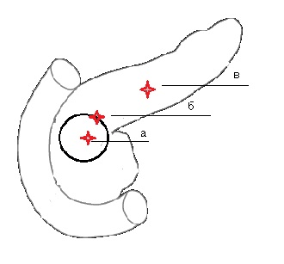
Fig. 1. Zone elastometricheskogo study: a — within the formation, b — bordering the tissue changes in the — in the unmodified pancreatic tissue.
Results and discussion. Based on the results of the survey, the following data were obtained. Values of Young's modulus in pseudocysts averaged 16 ± 2,27kPa, Coe f coefficient ratio 0.72 ± 2.4; In serous cystadenoma, the stiffness coefficient was higher — 30 ± 7.4 kPa, and the ratio of the opposite was smaller — 1.3 ± 0.86. For mucinous cysts and Dehn characteristic was to increase the stiffness and the coefficient (78,5 ± 11,6 kPa) Prevalence and n is the ratio of (3,2 ± 0,55). The maximum values ​​of the stiffness coefficient (100 ± 10.6 kPa) and the ratio (8 ± 1.9 kPa) were characteristic ofcystadenocarcinoma.
Thus, when coefficient ratio <5 units — is most likely the presence of PAC and cient benign process; in the case where the ratio exceeds the ratio of 5 — cl f blowing think of the process of malignant (pIS 2, 3, 4.).
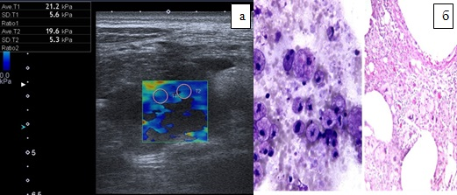
Fig. 2. Pseudocyst of the pancreas. a — ultrasound scanning, elastography. b — micropreparation (increase × 40)
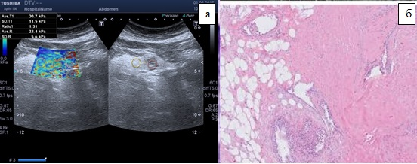
Fig. 3. Serous cystadenoma of the pancreas. a — ultrasound scan, elastography. b — micropreparation (increase × 40)
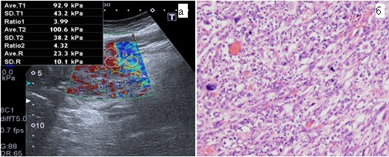
Fig. 4. Mucinous cystadenocarcinoma of the pancreas. a — CT and ultrasonic diffraction pattern, elastography. b — micropreparation (increase × 40)

Comparison of diagnostic accuracy transabdominal ultrasound studies (using a 3 D reconstruction) and elastography sensitivity indices are defined, specificity, positive predictive result, the negativepredictive result and a p th overall accuracy aforenamed methods for differential diagnosis of CSW. The results are shown in Table 2
Table 2
Comparing the differential diagnosis of cystic formations efficiency of the pancreas using ultrasound and ultrasound elastography and
 | Transabdominal ultrasound |  | Elastography
 | The results (n/n) | % (95% CI³) | The results (n/n) | % (95% CI³)
Sensitivity | 25/30 | 83%  (72 — 85%) | 29/30 | 95%  (86 — 97%)
Specificity | 16/40 | 40%  (32 — 42%) | 30/40 | 75%  (67 — 77%)
PPR¹ | 29/53 | 55%  (49 — 56%) | 29/39 | 74%  (66 — 77%)
NPR² | 16/17 | 94%  (76 — 99%) | 30/31 | 97%  (87 — 99%)
Overall accuracy | 45/70 | 64% *  (55 — 67%) | 59/70 | 84% *  (75 — 87%)
* P = 0.0001, PPR¹ — predictive positive result, ERP² — negative predictive result, CI³ — confidence interval

Hypothesis testing for compliance with the data developed by the diagnostic criteria and ki is accomplished by determining the sensitivity and specificity construction ROC-curve and calculating the area under the curve — AUC (p uc 5.).
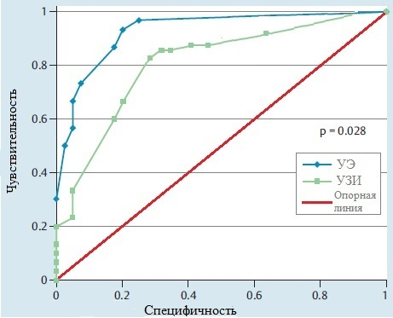
Fig. 5. ROC curve, the diagnostic value of elastography in the differential diagnosis of cystic pancreatic formations (UE — ultrasonic elastography, ultrasound — transabdominal ultrasound).
The AUC value for transabdominal ultrasound and elastography is 0.76 and 0.92, respectively (P = 0.028). These results show the superiority of elastography above Ultrasound examination in the differential diagnosis of cystic pancreatic formations. The quality of the test can be judged by the expert scale for AUC values ​​(Table 3).
Table 3
Expert scale for AUC values
The AUC interval | Quality of the model
0.9 — 1.0 | Excellent
0.8 — 0.9 | Very good
0.7 — 0.8 | Good
0.6 — 0.7 | Average
0.5 — 0.6 | Unsatisfactory

Conclusion. Summarizing first experience applying ultrasound elastography in the differential diagnosis of cystic formations pancreas, it should be noted that the method has high reliabilitydegrees Strongly determining etiology pancreatic cysts. The method is non-invasive and can be used in clinical practice, especially when other diagnostic methods do not provide a clear answer about the nature and origin of the cyst. The values obtained by the study have a high p tive information, the method is well reproducible. However, the authors understand that n e great experience of watching the first does not allow us to recommend this method in clinical practice. Further studies will help e NIJ defines the role and place of the method in practical pancreatology.

References:
- Кисты поджелудочной железы / А. Е. Борисов, К. Г. Кубачев, С. П. Яхонов, М. С. Качабеков // Вестник Северо-Западного государственного медицинского университета им. И.И. Мечникова. — 2011. — №3 (4). — С. 33–37.
- Майстренко Н. А. Кисты поджелудочной железы: трудности дифференциальной диагностики и выбора хирургической тактики / Н. А. Майстренко // Медицинский академический журнал. — 2010. — №10 (3). — P. 112–121.
- Морозова A. Г. Комплексная эластография печени и поджелудочной железы / A. Г. Морозова, A. В. Борсуков, A. В. Мамошин // Медицинская визуализация. — 2015. — №3. — С. 75–83.
- Acoustic Radiation Force Impulse elastography for fibrosis evaluation in patients with chronic hepatitis C : an international multicenter study / I. Sporea, S. Bota, M. Peck-Radosavljevic [et al.] // European journal of radiology. — 2012. — Vol. 81, No 12. — P. 4112–4118.
- Breast disease: clinical application of US elastography for diagnosis / A. Itoh, E. Ueno, E. Tohno [et al.] // Radiology. — 2006. — Vol. 239, No 2. — P. 341–350.
- The changing spectrum of surgically treated cystic neoplasms of the pancreas / J. K. Plichta, J. A. Brosius, S. G. Pappas [et al.] // HPB Surgery. — 2015. — Vol. 2015.
- Cystic pancreatic neoplasms: observe or operate / K. S. Spinelli, T. E. Fromwiller, R. A. Daniel [et al.] // Annals of surgery. — 2004. — Vol. 239, No 5. — P. 651–659.
- Diagnostic accuracy of real-time tissue elastography for the staging of liver fibrosis : a meta-analysis / K. Kobayashi, H. Nakao, T. Nishiyama [et al.] // European radiology. — 2015. — Vol. 25, No 1. — P. 230–238.
- Farrell J. J. Prevalence, diagnosis and management of pancreatic cystic neoplasms: current status and future directions / J. J. Farrell // Gut Liver. — 2015. — Vol. 9. — P. 571–589.
- Hutchins G. F. Cystic neoplasms of the pancreas: a diagnostic challenge / G. F. Hutchins, P. V. Draganov // World J. Gastroenterol. — 2009. — Vol. 15, No 1. — P. 48–54.
- Incidental pancreatic cysts on 3D turbo spin echo magnetic resonance cholangiopancreatography: prevalence and relation with clinical and imaging features / R. Girometti, S. Intini, G. Brondani [et al.] // Abdominal imaging. — 2011. — Vol. 36, No 2. — P. 196–205.
- Incidental pancreatic cysts: clinicopathologic characteristics and comparison with symptomatic patients / C. Fernandez-del Castillo, J. Targarona, S. P. Thayer [et al.] // Archives of Surgery. — 2003. — Vol. 138, No 4. — P. 427–434.
- Jenssen C. Management of incidental pancreatic cystic lesions / C. Jenssen, S. Kahl // Viszeralmedizin. — 2015. — Vol. 31, No 1. — P. 14–24.
- Kadiyala V. Endosonography in the diagnosis and management of pancreatic cysts / V. Kadiyala, L. S. Lee // World journal of gastrointestinal endoscopy. — 2015. — Vol. 7 (3). — P. 213–223.
- Non-invasive measurement of liver and pancreas fibrosis in patients with cystic fibrosis / M. Friedrich-Rust, N. Schlueter, C. Smaczny [et al.] // Journal of Cystic Fibrosis. — 2013. — Vol. 12 (5). — P. 431–439.
- Pancreatic incidentalomas: high rate of potentially malignant tumors / G. Lahat, M. Ben Haim, I. Nachmany [et al.] // Journal of the American College of Surgeons. — 2009. — Vol. 209, No 3. — P. 313–319.
- Pancreatic resections for cystic neoplasms: from the surgeon's presumption to the pathologist's reality / R. Salvia, G. Malleo, G. Marchegiani [et al.] // Surgery. — 2012. — Vol. 152 (3). — P. S135–S142.
- Performance of real-time elastography for the staging of hepatic fibrosis : a meta-analysis / H. Hong, J. Li, Y. Jin [et al.] // PloS one. — 2014. — Vol. 9, No 12. — P. e115702.
- Predictive factors for surgery among patients with pancreatic cysts in the absence of high-risk features for malignancy / S. Y. Quan, B. C. Visser, G. A. Poultsides [et al.] // Journal of Gastrointestinal Surgery. — 2015. — Vol. 19, No 6. — P. 1101–1105.
- Prevalence of unsuspected pancreatic cysts on MDCT / T. A. Laffan, K. M. Horton, A. P. Klein [et al.] // American Journal of Roentgenology. — 2008. — Vol. 191, No 3. — P. 802–807.
- Relative accuracy of CT and MRI in the differentiation of benign from malignant pancreatic cystic lesions / H. J. Lee, M. J. Kim, J. Y. Choi [et al.] // Clinical radiology. — 2011. — Vol. 66 (4). — P. 315–321.
- Small undifferentiated pancreatic adenocarcinoma which mimics IPMN at imaging / M. D’Onofrio, F. Vecchiato, A. Gallotti [et al.] // JOP. — 2009. — Vol. 10(4). — P. 406–408.
- Thyroid gland tumor diagnosis at US elastography / A. Lyshchik, T. Higashi, R. Asato [et al.] // Radiology. — 2005. — Vol. 237, No 1. — P. 202–211.

First use of ultrasound elastography in differential diagnostics of pancreatic cystic lesions
T. V. Dibina³, A. P. Koshel^{1,2}, Y. S. Drozdov^{2,4}, S. S. Klokov^{2,3}
¹City clinical hospital No 3 n.a. B.I. Alperovich, Tomsk, Russia
²Siberian State Medical University, Tomsk, Russia
³Medical Center n.a. G. K. Zherlov, Seversk, Russia
⁴Tomsk Regional Oncology Hospital, Tomsk, Russia

Key words: endosonography, elastography, diagnostics, differential diagnostics, pancreatic cysts
Aim is to evaluate the effectiveness of ultrasonic elastography in the differential diagnostics of pancreatic cystic lesions.
Materials and methods. Seventy patients with pancreatic cystic lesions were examined. Structure of clinical forms: serous cystadenoma — 2, mucinous cystadenoma — 2, mucinous cystadenocarcinoma — 2, highly differentiated endocrine functionally inactive cystic tumor — 1, solid pseudopapillary tumor — 1, mixed sero-neuroendocrine neoplasia — 1, pseudocyst — 61. Diagnosis of cystic pancreatic formations was stated with the help of transabdominal ultrasound examination (with 3D reconstruction) and ultrasonic elastography.
Results. The parameters of ultrasonic elastography for various types of cystic pancreatic formations were determined. Sensitivity, specificity, prognosticity of the positive result, predictability of the negative result, the overall accuracy of the technique were 97%, 75%, 74%, 97% and 84%, respectively. The AUC value (the area bounded by the ROC curve) for ultrasonic elastography was 0.93 (P=0.028).
Conclusions. Ultrasonic elastography is an effective, non-invasive technique of differential diagnostics of cystic pancreatic formations and can be widely used in clinical practice.

