Enzyme replacement therapy, life quality and expectancy of patients with chronic pancreatitis and exocrine pancreatic insufficiency
N. B. Gubergrits¹, N. V. Byelyayeva¹, А. Y. Klochkov¹, G. М. Lukashevich¹,
P. G. Fomenko¹, V. S. Rachmetova²
¹Donetsk National Medical University, Ukraine
²Medical University Astana, Kazakhstan

Key words: chronic pancreatitis, exocrine pancreatic insufficiency, life quality, life expectancy, enzyme replacement therapy
Malabsorption and malnutrition, developing with exocrine pancreatic insufficiency of the pancreas (EPI), are associated not only with complaints of loosening of the stool, flatulence, but also with much more serious consequences that lead to an increase in morbidity and a decrease in life expectancy (Figure 1) [1, 3, 23].

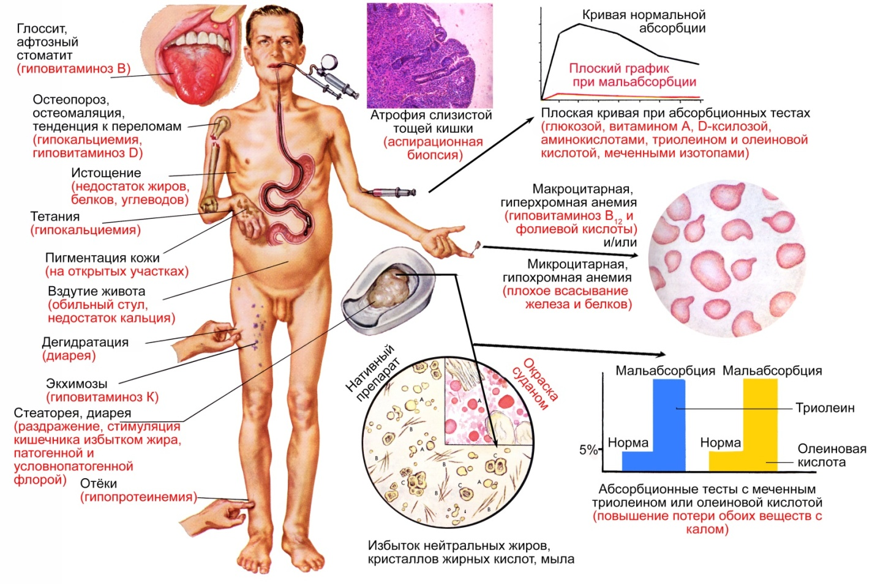
Fig. 1. The symptoms of malnutrition when EPI (F. H. Netter, 2001 [14]).

Thus, with EPI, the risk of cardiovascular diseases increases due to unfavorable changes in the lipid spectrum of the blood, asthenia develops, hypovitaminosis (especially A, D, E, K), skin, hair, nail, encephalopathy, anemia, bone mineral density decreases, immunity is impaired and so on [6, 10, 19]. In addition, EPI can be "under the mask" of other diseases, for example, irritable bowel syndrome [22].
In cystic fibrosis and chronic pancreatitis (CP), primary EPI develops, i.e., EPI associated with pathology, a decrease in the volume of the parenchyma and the functional capacity of the pancreas. The same variant of EPI occurs when the pancreatic duct is obstructed by the tumor, as well as after resection of the prostate orpancreatectomy. Secondary EPI is associated with the pathology of other organs. Thus, celiac disease leads to a decrease in stimulation of the prostate, and in Zollinger-Ellison syndrome, the enzymes of the prostate are inactivated. Violation of stimulation of pancreatic secretion is formed after resection of the stomach, small intestine,gastrectomy. Secondary EPI takes place with cholestasis, a violation of bile flow due to reduced emulsification of fats and creating conditions for the realization of pancreatic lipase activity [7].
EPI, of course, leads to a decrease in the quality of life, increased lethality (Figure 2) and a decrease in life expectancy [17, 20].

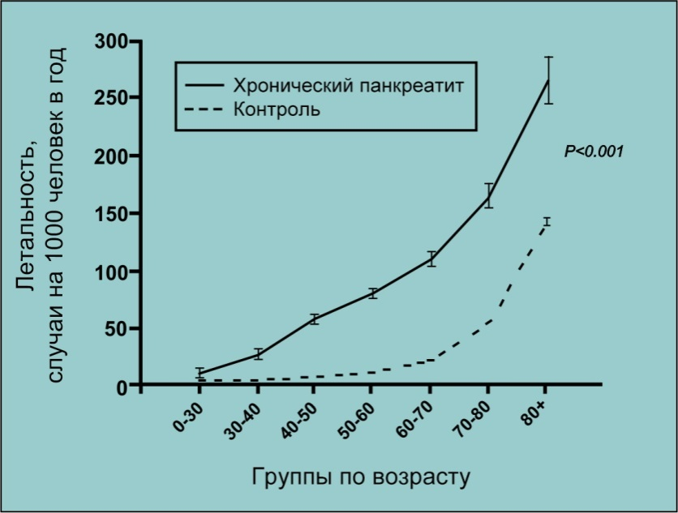
Fig. 2. Mortality in CP (U. C. Bang et al., 2014 [13]).

This review presents an analysis of evidence of the efficacy of HPAI for improving the quality of life and increasing its duration in patients with CP and EPI. We searched the PubMed electronic database data using the following keywords: CP, EPI, enzyme replacement therapy (ERT), pancreatin, pancrelipase, minimicrospheres,trophological indicators (nutritional) status, quality of life, life expectancy, survival. The analysis included data from meta-analyzes, systematic reviews, randomized trials.
We will begin with a summary of the results from the data of recent years, which confirmed the increase in the incidence of CP patients due to the presence of HPNP and a decrease in life expectancy in the absence of APT. At a meeting of the European Club of pancreatologists in Liverpool (United Kingdom) in 2016. Special attention was drawn to the report N. Vallejo — Senra (Spain) on cardiovascular risk in patients with HPA in patients with CP according to the results of a randomized study [2]. The speaker cited the results of a national retrospective cohort study in Denmark showing a significant increase in the mortality of patients with CP as compared to the general population (Figure 2).Contribution to mortality in CP also makes cardiovascular pathology.
Pathophysiology of cardiovascular events in CP:
- alcohol and smoking;
- diabetes;
- trophological insufficiency (EPI):
• deficiency of high density lipoproteins, apolipoprotein A-1, lipoprotein A;
• vitamin D deficiency;
• micronutrient deficiency;
• inflammatory syndrome associated with malnutrition.
According to the study of N. Vallejo-Senra, the life expectancy of patients with CP without EPI is significantly greater than with EPI (Figure 3).

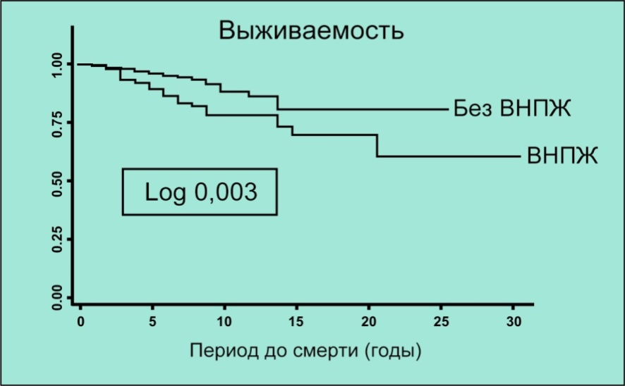
Fig. 3. Lifespan CP patients depending on the presence EPI (N. Vallejo — Senra et al., 2016 [2]).

Within the prospective cohort study, the researchers examined 430 patients. The diagnosis of CP was established on the basis of endosonography data, if necessary, performed magnetic resonance imaging, magnetic resonance cholangiopancreatography with secretin. The diagnosis of EPI was based on the results of a triglyceriderespiratory test. Nutritional status was assessed (hemoglobin, magnesium, albumin, prealbumin, retinol-binding protein, glycosylated hemoglobin). Cardiovascular events included myocardial infarction, stroke, and peripheral cardiovascular events — arterial thrombosis, intermittent claudication, etc. The results of the study are presented in Table 1.
Table 1
Cardiovascular risk in CP, depending on the presence of HIV
(according to N. Vallejo- Senra et al., 2016 [2])
 | EPI | Without EPI | R
All cardiovascular events | 29 (23.02%) | 16 (5.26%) | <0.001
Large cardiovascular events | 13 (10.31%) | 8 (2.63%) | 0,739
Peripheral cardiovascular events | 16 (12.69%) | 8 (2.63%) | 0.309

The risk of cardiovascular events with EPI was 2.46, without EPI — 0.67 (p <0.001). Based on the data obtained, the researchers concluded that during 8 years of follow-up, cardiovascular events occurred in 10% of patients with CP, their occurrence was associated with the presence of EPI, hypertension and alcohol and smoking abuse. N. Vallejo — Senra plans to continue research in this direction and to study the effect of OPT on the frequency of cardiovascular events in CP.
Illustrative results were obtained in a prospective cohort study with a long follow-up period performed by D. Iglesia-Garcia et al. (2017) [8]. The authors observed 430 patients with CP during 8.6 ± 4.6 years. Mortality in a cohort of patients with CP during this period was 17.2 ‰/year, while in the general population it was significantly lower -4.29 ‰/year (p <0.05). When analyzing mortality, depending on the level of activity of the exocrine secretion of the prostate, it was found that the presence of HPNP in CP is associated with an increase in all mortality rates (Table 2).
Table 2
Death rates of CP patients depending on the presence of HIV
(D. Iglesia — Garcia et al., 2017 [8])
 | CP with EPI | CP without EPI | R
Mortality | 17.4% | 6.1% | <0.05
Mortality rate | 34,3 ‰ per year | 12,3 ‰ per year | <0.05
Age of death | 57 | 63 | <0.05

The authors of the study showed a direct correlation between the deficit of nutrients and increased risk of cancer, infections and cardiovascular diseases. The causes of death of patients with CP were as follows: cancer of different localization — 40.4%, infection — 21.3%, cardiovascular disease — 14.9%, liver cirrhosis — 10%, other reasons — 17%.Multifactor analysis has proven the relationship between increased mortality and the presence of EPI (risk ratio (RR) 2.59, 95% confidence interval (CI) 1.42-4.71, p <0.003), cirrhosis (RR 3.87, 95% CI 1.95-7.69, p <0.001), the patient's age at the time of confirmation of diagnosis (RR 1.05, 95% CI 1.03-1.09, p <0.001), as well as toxic etiology of CP (RR 3.11, 95% CI, 1.11-8.70, p <0.05) and concomitant respiratory disease (RR 2.19, 95% CI, 1.12-4.31, p <0.03). Nutritional parameters of patients with EPI significantly inferior to those in patients without EPI (p <0.001); the values ​​of nutritional indices in surviving patients significantly exceeded the corresponding indices in deceased patients (p <0.001) [8]. Based on these studies, it can be assumed that compensating for HPV in patients with CP may reduce the risk of cardiovascular events and mortality from these events by almost 3 times.
A number of randomized placebo-controlled double-blind studies confirmed that ERT using preparations of pancreatin and pancrelipase in microspheres andminimicrospheres enteric coated increases fat absorption coefficient and the nitrogen absorption coefficient CP patients in the short term, [7, 18, 21, 23].
In a study in the United States, 27 patients received a placebo for 2 weeks, and then were randomized for TFP (40 000 USP/basic meal, 20 000 USP/intermediate food intake, minimocrosses; USP — US Pharmacopeia units) or in the placebo group for 2 weeks [7]. At the end of the randomized phase, fat absorption increased significantly in patients treated with PTA, compared with placebo (p = 0.0185). ERT contributed to a decrease in fat excretion and stool frequency, improving the consistency of the stool. These results are consistent with the data obtained in a cross-sectional study in which two doses of enzyme preparations were evaluated. Patients were randomized to receive low (10 000 USP/basic meal, 5000 USP/intermediate meal) or high (40 000 USP/basic meal, 20 000 USP/intermediate food intake, microspheres) doses of enzyme preparations [24]. During the 18-22-day PTA, the absorption of fats and proteins was significantly increased in comparison with the initial values ​​(p <0.001). In addition, the ERT contributed to a significant increase in body weight (+ 0.38 kg and + 0.50 kg for low-dose and high-dose DPT, respectively) and body mass index (+0.13 kg/m² and +0.16 kg/m², respectively) compared with placebo (in both cases, p≤0.020). CFT was associated with a statistically significant increase in the concentration of high-density lipoproteins (p<0.001) compared with placebo, while low-density lipoprotein cholesterol and levels of fat-soluble vitamins (A, E, and K) remained unchanged throughout the study.
The long-term effect of CFT on nutritional status, body weight of patients with CP was evaluated in several open trials with a follow-up duration of about 1 year [12, 25].They were usually preceded by short, randomized phases that examined the effects of TPA on the absorption of fat and protein. In one such study, conducted in 27 clinical centers in Europe and the United States, 7-day efficacy ERT initially evaluated (minimicrosphere preparation 72 000 USP/main meal, 36 000 USP/intermediate meal, average daily dose of 288 000 USP) randomization method [16], and then carried out the open phase of the study for 6 months with changes ERT doses (at the discretion of the investigator: Individual dose — 24 000 USP, capsules, average daily dose of 186 960 USP, minimosphere) [12] At the end of the randomized phase, the absorption of fats and proteins was higher in patients treated with PTA than in patients taking placebo (18). At the end of the 24th week of the open phase, a clinically and statistically significant increase in body weight (2.73 ± 3.35 kg, p <0.0001) was recorded (Figure 4A) [12].

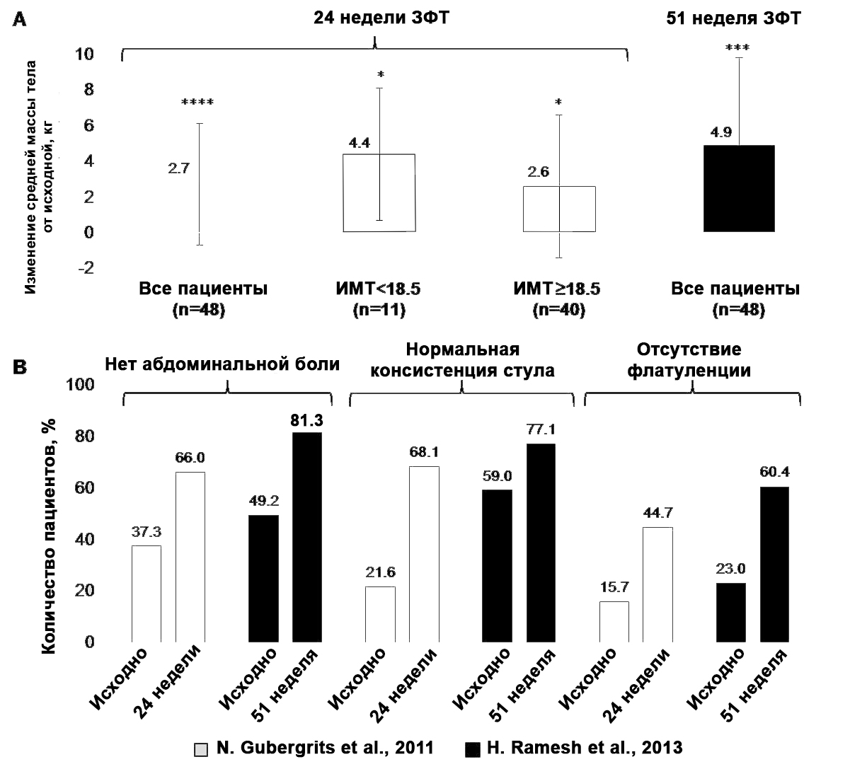
Fig. 4. Long-term research results ERT in CP (N. Gubergrits et al., 2011 [12]) and H. Ramesh et al., 2013 [25]). A — change in the mean values ​​of body weight in the dynamics of treatment; B — the frequency of clinical manifestations of BPH in patients with CP after treatment (statistical analysis of the dynamics of clinical symptoms was not performed).
Notes:
* — p <0.05 in comparison with the initial index;
*** — p <0.001 in comparison with the initial indicator;
**** — p <0.0001 in comparison with the initial index.

At the same time, a significant reduction in stool frequency (-1.0 ± 1.3, p <0.001) was achieved, as well as a decrease in the severity of clinical symptoms and an improvement in the global clinical impression [12]. However, a clinically significant change in the quality of life (a short version of the SF-36 questionnaire) was not observed at the end of the 24-week treatment period [12].
In India, a one-week, randomized, double-blind, placebo-controlled study [21] followed by a 51-week open phase [25]. ERT minimicrosphere preparation (80 000USP/basic meal, 40 000 USP/Intermediate Food) contributed to a significant improvement in the absorption of fat and protein, as well as a decrease in the average frequency of stool, stool weight, fat and stool nitrogen [21, 25]. In addition, after a year of treatment, a significant increase in body weight (4.9 ± 4.9 kg, p = 0.001) and body mass index (1.9 ± 1.9 kg/m ², p = 0.001) was achieved (Figure 4 A) [25]. An increase in body weight ≥7% occurred in 61.7% of patients. The mean values ​​of the body mass index increased from the initial 19.2 kg/m ² to 20.9 kg/m ² at the end of the open phase of the study.
In both studies with a long open phase described above ERT associated with a decrease in the symptoms associated with EPI such as abdominal pain, impaired stool consistency and flatulence (Fig. 4 B) [12, 25]. In a 24-week study, there was no clinically significant change in the quality of life (questionnaire SF- 36) at the end of treatment [12]. However, in a 51-week study, the AFT improved the quality of life; 7 out of 8 SF- 36 indicators and two total indicators (including a significant increase in overall health, vitality, role-playing emotional functioning, mental and physical health) increased [25].
Thus, clinical studies have shown that ERT reduces malabsorption due EPI and contributes significantly increase body weight in patients with CP [7, 12, 18, 21, 24, 25]. However, the effect of TFP on the life expectancy of patients was evaluated only in the study of D. de la Iglesia-Garcia et al. (2017) [8], as well as in the context of conducting operations on the prostate in cases of CP [9]. According to the data of the retrospective observational study, the absence of the appointment of the AFT after surgery was a strong and independent risk factor for increasing mortality in the long-term after discharge from hospital [9].
It has been proved that with the help of ZPT it is possible to eliminate the symptoms associated with EPI: abdominal pain, flatulence, steatori, and also improve the quality of life of patients with CP [15, 20, 25]. Thus, the studies carried out to date confirm the effectiveness of TFP in improving the quality of life, lengthening its duration, and also leveling the symptoms associated with EPI (malnutrition, weight loss and increased risk of mortality in patients with CP).
Unfortunately, in clinical practice, patients with EPI often do not receive treatment or receive insufficient doses of enzyme preparations [5, 16].
According to the unified European clinical guidelines for the diagnosis and treatment of CP, the minimum dose of lipase required for correcting HIV is 40 000-50 000USP for the main meal and half the dose for intermediate meals (level of evidence is 1A, the degree of agreement of experts is strong) [26]. The most recent and well methodologically constructed RCTs demonstrated the effectiveness of ZPT EPI with the use of minimocrosses with an enteric-coated membrane at a dose of 40 000 to 80 000 USP for each main meal and at half the dose for each intermediate meal for one snack.
These recommendations cite the results of clinical studies demonstrating that alleviating the symptoms of BPH is not always associated with the normalization of nutritional status [4]. A recent review confirms the concept of controlling the normalization of nutritional parameters (anthropometric and biochemical) as an optimal way of assessing the effectiveness of the LPT of the EPI [10].
These are important issues that have not yet been adequately reflected in practice.
Therefore, training physicians and patients for new approaches to the ZPT of EPI can potentially improve the quality of life and its duration in patients with CP.
Further long-term studies are worthwhile.

References:
- Bhutani M. S. Pancreas and biliary tract diseases / M. S. Bhutani, P. Vilmann, A. Saftoiu. — Oxford (UK) : Health Press, 2017. — 149 p.
- Cardiovascular risk (CVR) associated with pancreatic exocrine insufficiency (PEI) in patients with chronic pancreatitis (CP) / N. Vallejo-Senra, D. De la Inglesia-Garcia, A. Lopez-Lopez [et al.] / 48th European Pancreatic Club (EPC) meeting // Pancreatology. — 2016. — Vol. 16, No 3S1. — P. S80.
- Clinical pancreatology for practicing gastroenterologists and surgeons / Ed. : J. E. Dominguez-Munoz. — Oxford [et al.] : A Blackwell Publishing Company, 2005. — 535 р.
- 13C-mixed triglyceride breath test to assess oral enzyme substitution therapy in patients with chronic pancreatitis / J. E. Dominguez-Munoz, J. Iglesias-Garcia, M. Vilarino-Insua [et al.] // Clin. Gastroenterol. Hepatol. — 2007. — Vol. 5. — P. 484–488.
- The daily practice of pancreatic enzyme replacement therapy after pancreatic surgery : a northern European survey: enzyme replacement after surgery / E. C. Sikkens, D. L. Cahen, C. van Elick [et al.] // J. Gastrointest. Surg. ― 2012. ― Vol. 16, No 8. ― P. 1487–1492.
- Dominguez-Munoz J. E. Pancreatic exocrine insufficiency: diagnosis and treatment / J. E. Dominguez-Munoz // J. Gastroenterol. Hepatol. — 2011. — Vol. 26, Suppl. 2. — P. 12–16.
- The effects of oral pancreatic enzymes (Creon 10 capsule) on steatorrhea: a multicenter, placebo-controlled, parallel group trial in subjects with chronic pancreatitis / M. Safdi, P. K. Bekal, S. Martin [et al.] // Pancreas. ― 2006. ― Vol. 33, No 2. ― P. 156–162.
- Increased risk of mortality associated with pancreatic exocrine insufficiency in patients with chronic pancreatitis / D. de la Iglesia-Garcia, N. Vallejo-Senra, J. Iglesias-Garcia [et al.] // J. Clin. Gastroenterol. ― 2017. ― [Epub ahead of print].
- Insulin dependence and pancreatic enzyme replacement therapy are independent prognostic factors for long-term survival after operation for chronic pancreatitis / M. Winny, V. Paroglou, H. Bektas [et al.] // Surgery. ― 2014. ― Vol. 155, No 2. ― P. 271–279.
- Lindkvist B. Clinical, anthropometric and laboratory nutritional markers of pancreatic exocrine insufficiency: prevalence and diagnostic use / B. Lindkvist, M. E. Phillips, J. E. Dominguez-Munoz // Pancreatology. — 2015. — Vol. 15. — P. 589–397.
- Lohr J.-M. Exocrine pancreatic insufficiency / J.-M. Lohr. — Bremen : UNI-MED, 2010. — 91 p.
- A 6-month, open-label clinical trial of pancrelipase delayed-release capsules (Creon) in patients with exocrine pancreatic insufficiency due to chronic pancreatitis or pancreatic surgery / N. Gubergrits, E. Malecka-Panas, G. A. Lehman [et al.] // Aliment. Pharmacol. Ther. ― 2011. ― Vol. 33, No 10. ― P. 1152–1161.
- Mortality, cancer, and comorbidities associated with chronic pancreatitis : a Danish nationwide matched-cohort study / U. C. Bang, T. Benfield, L. Hyldstrup [et al.] // Gastroenterology. — 2014. — Vol. 146, No 4. — P. 989–994.
- Netter F. H. The Netter collection of medical illustrations / F. H. Netter. — New York : Colorpress, 2001. — Vol. 3. Digestive System, p. 3. — 200 p.
- Pancreatic enzyme replacement therapy in patients with exocrine pancreatic insufficiency due to chronic pancreatitis : a 1-year disease management study on symptom control and quality of life / J. G. D’Haese, G. O. Ceyhan, I. E. Demir [et al.] // Pancreas. ― 2014. ― Vol. 43, No 6. ― P. 834–841.
- Pancreatic enzyme replacement therapy in post-pancreatectomy patients / M. Braga, M. Cristallo, R. De Franchis [et al.] // Int. J. Pancreatol. ― 1989. ― Vol. 5, Suppl. ― P. 37–44.
- Pancreatitis: medical and surgical management / Eds. : D. B. Adams [et al.]. — Chichester : Wiley Blackwell, 2017. — 326 p.
- Pancrelipase delayed-release capsules (CREON) for exocrine pancreatic insufficiency due to chronic pancreatitis or pancreatic surgery : a double-blind randomized trial / D. C. Whitcomb, G. A. Lehman, G. Vasileva [et al.] // Am. J. Gastroenterol. ― 2010. ― Vol. 105, No 10. ― P. 2276–2286.
- Pancreatology : a clinical textbook / Eds. : T. B. Gardner, K. D. Smith. — Cham (Switzerland) : Springer International Publishing AG, 2017. — 193 p.
- Quality of life assessment after pancreatic enzyme replacement therapy in chronic pancreatitis / L. Czako, T. Takacs, P. Hegyi [et al.] // Can. J. Gastroenterol. ― 2003. ― Vol. 17, No 10. ― P. 597–603.
- Randomised clinical trial: the efficacy and safety of pancreatin enteric-coated minimicrospheres (Creon 40000 MMS) in patients with pancreatic exocrine insufficiency due to chronic pancreatitis — a double-blind, placebo-controlled study / V. Thorat, N. Reddy, S. Bhatia [et al.] // Aliment. Pharmacol. Ther. ― 2012. ― Vol. 36, No 5. ― P. 426–436.
- Some patients with irritable bowel syndrome may have exocrine pancreatic insufficiency / J. S. Leeds, A. D. Hopper, R. Sidhu [et al.] // Clin. Gastroenterol. Hepatol. ― 2010. ― Vol. 8, No 5. ― P. 433–438.
- Testoni P. A. Acute and chronic pancreatitis: new concepts and evidence-based approaches / P. A. Testoni, A. Mariani, P. G. Arcidiacono. — Turin : Edizioni Minerva Medica, 2013. — 193 p.
- Toskes P. P. Efficacy of a novel pancreatic enzyme product, EUR-1008 (Zenpep), in patients with exocrine pancreatic insufficiency due to chronic pancreatitis / P. P. Toskes, A. Secci, R. Thieroff-Ekerdt // Pancreas. ― 2011. ― Vol. 40, No 3. ― P. 376–382.
- A 51-week, open-label clinical trial in India to assess the efficacy and safety of pancreatin 40000 enteric-coated minimicrospheres in patients with pancreatic exocrine insufficiency due to chronic pancreatitis / H. Ramesh, N. Reddy, S. Bhatia [et al.] // Pancreatology. ― 2013. ― Vol. 13, No 2. ― P. 133–139.
- United European Gastroenterology evidence based guidelines for the diagnosis and therapy of chronic pancreatitis (HaPanEU) / J. M. Löhr, E. Domínguez-Muñoz, J. Rosendahl [et al.] // United European Gastroenterology Journal. — 2017. — Vol. 5, No 2. — P. 153–199.

Enzyme replacement therapy, life quality and expectancy of patients with chronic pancreatitis and exocrine pancreatic insufficiency
N. B. Gubergrits¹, N. V. Byelyayeva¹, А. Y. Klochkov¹, G. М. Lukashevich¹,
P. G. Fomenko¹, V. S. Rachmetova²
¹Donetsk National Medical University, Ukraine
²Medical University Astana, Kazakhstan

Key words: chronic pancreatitis, exocrine pancreatic insufficiency, life quality, life expectancy, enzyme replacement therapy
The article reviews the evidence-based studies devoted to the evaluation of the efficacy and safety of enzyme replacement therapy in patients with chronic pancreatitis with exocrine pancreatic insufficiency. Particular attention is paid to the effect of replacement therapy on the life quality and expectancy of patients. It has been proven that the correct prescription of enzyme preparations (minimicrosphere enteric-coated preparation, adequate dosage) improves the quality and prolongs the life of patients.

