Clinical observation of IgG4-associated disease
N. B. Gubergrits¹, Y. А. Dyadyk ², A. Ye. Klochkov¹, N. V. Byelyayeva¹,
M. D. Ivanova², Y. А. Ginkota³, Y. E. Chirkov⁴
¹Donetsk National Medical University (Lyman),
² National Medical Academy of Postgraduate Education n. a. P. L. Shupik (Kiev),
³Odessa National Medical University,
⁴Ukrainian Scientific & Practical Center of Endocrine Surgery, Transplantation of Endocrine Organs and Tissues (Kiev)

Key words: autoimmune pancreatitis of type I, IgG4, diagnostics, immunohistochemistry, treatment
We consider the analysis of difficult clinical cases to be very useful, because it is in such cases that the importance of right thinking at the patient's bed is demonstrated most clearly, and, at the same time, it encourages the doctor to actively self-independent thought.
A.S. Voronov,
distinguished therapist

IgG4-associated disease is an independent nosological unit with unknown etiology and multi-organ involvement in a specific inflammatory process characterized by pronounced infiltration of IgG with 4-positive cells and progressive fibrosis. The defeat of the following organs and structures is described: pancreas (pancreas); Biliary and w elchnogo bladder; liver; esophagus, stomach and intestines; retroperitoneal space; sl e znykh and salivary glands; thyroid gland; l e mild; kidney and ureter; prostate gland;mammary glands; the nasal cavity; central nervous system; myocardium, arteries and veins; lymph nodes; skin; bones [1, 2, 3, 5].
International standard criteria have been adopted for standardization of the verification of IgG 4-associated disease (Table 1), including the 3 main histological signs and additional (minor) signs. Immunohistochemical examination reveals 4 variable infiltration IgG-positive plasma cells, the number of which varies depending on the organ involvednnogo e (Fig. 1).
The most common organ that is affected by IgG 4-associated disease is the prostate.
Autoimmune pancreatitis (AIP) — pancreatitis, which is clinically characterized by frequent development of obstructive jaundice, histologically — lymphoplasmaticinfiltration and stoiroform fibrosis, a therapeutically — rapid and pronounced response to corticosteroids.
Allocate type 2 APS: limfoplazm about tsitarny sclerosing pancreatitis (IDL) — APS type I; idiopathic protocol-concentric pancreatitis with granulocyte epithelial lesions (IPCP) — type II AIP.
The following characteristics are characteristic for CSPP:
- patients older than 50 years;
- mainly men;
- plain frequency distribution around the world;
- accelerating levels of immunoglobulin G, G4 serum;
- autoantibodies are allocated;
- with the preservation of ductal epithelium;
- extrapancreatic manifestations: more often sclerosing cholangitis, sialoadenitis, retroperitoneal fibrosis;
- positive response to corticosteroids;
- frequent relapses;
- CBC is about 60% of cases of AIP.
The frequency of extrapancreatic manifestations, according to the Japanese Association of Pancreatologists, is as follows: sclerosing cholangitis — 60%, sclerosing sialoadenitis 13%, retroperitoneal fibrosis 9%, interstitial nephritis 9%, lymphadenopathy 9%, thyroiditis 7%, interstitial pneumonia 7%, pseudotumor — 2%.
Moreover, for certain IDL characteristic histological changes: pancreatic parenchymal infiltration by lymphocytes, IgG4-positive plasma cell t s, storioformny fibrosis,obliterative phlebitis.
The following characteristics are typical for IPPP:
- younger patients;
- sick woman;
- mainly found in Europe and the US;
- more frequently normal levels of immunoglobulins G and G4 in the serum;
- autoantibodies are not detected;
- granulocitary destruction of ductal epithelium;
- frequently ulcerative colitis;
- positive response to corticosteroid therapy;
- are typical periductal lymphoplasmatic infiltration and phlebitis, but it is less pronounced than in type I;
- typical infiltration of the duct wall by neutrophilic granulocytes;
- rare relapse;
- IPPP is about 40% of cases of AIP.
Differences and general characteristics of CBC and IPPP:
I. Principal differences — no.
II. Less pronounced for type I:
- diffuse tumor-like changes;
- stenosis of the common bile duct;
- narrowing of the pancreatic duct;
- involvement of the head of the prostate in comparison with the tail.
III. Common for both types:
- with the tenosis of the common bile duct.

Diagnostic criteria of AIP change as you gain new knowledge about this disease; offers a variety of treatment regimens, which are based invariably on corticosteroids.Conservative treatment in most cases leads to a significant improvement, even to recovery, but there may be relapses. The international consensus on the diagnosis of AIP was adopted at a meeting of the International Association of Pancreatologists in Japan in 2010 and published in 2011 [4].

Here is our clinical observation.
Patient K., 33 years old, specialist in veterinary medicine. At the present time it is not in contact with animals (about 3 years), engaged in trade supplies in tonnes. including feed, food additives, veterinary drugs.
Complaints of intermittent gravity, a discomfort mouth in the right half of the abdomen, not associated with eating. There are no dyspeptic phenomena. Moderate overall weakness, adequate physical exertion. The stool is regular, once a day, decorated, without blood, mucus, undigested food (against the background of Creon). The temperature is normal. The appetite is preserved.
Anamnesis of the disease. He considers himself sick from June I, 2016 when itchy skin integument drive indeed created to poor sleep. In early July, he said of the darker urine. I applied for medical help at the place of residence. The examination revealed improvement of bilirubin, transaminases, in the urine pigments (with the patient's words). Viral markers of hepatitis B and C are negative. With ultrasound OBP revealed s signs of biliary hypertension.
Abdominal USD 07.07. 2016: the common bile duct is not enlarged. E Vnutripech night moderately dilated bile ducts, gall bladder significantly increased 92 × 56 mm, pancreas -focal changes and formation not determined (head — 35 mm, the body — 19 mm, the tail — 30 mm).
FGD 11.07.2016: n overhnostny bulbit, moderate duodenogastric reflux.
CT OPP 14.07. G. 2016: Pancreas dimensions: head — 2.9 cm, body — 1.2 cm, tail — 1.0 cm (tail body and reduced), parenchyma thinned, virsungianov duct expanded to 0.6 cm diameter choledoch. — 0.9–1.0 cm. Inhomogeneous accumulation of contrast at the level of the head of the prostate in the form of a segment 1.1 × 1.2 cm density + 48 + 52 EH (the rest of the parenchyma +62 + 110 EN). Lymph nodes are not enlarged, there is no effusion in the abdominal cavity. Conclusion: biliary hypertension, chronic pancreatitis?formation of the head of the prostate?
Appointed Reosorbilakt, Glutargin. Treatment without significant effect.
At the end of July 2016 there were pains in the right podre bier.
Biochemical analysis of blood 07.20.2016 g.: bilirubin total s — 45.9 μmol/l, straight line — 15.1 μmol/l, glucose — 6.1 mmol/l, ALT — 4.33 mmol/(λ×η) (the norm is 0.10-0.68 mmol/(h × l)), AST — 1.33 mmol/(h × l) (the norm is 0.10-0.45 mmol/(h × L)).
Assigned ANA (antinuclear antibodies), AMA (antimitochondrial antibodies), copper blood and urine, α-fetoprotein, CEA, CA 19-9 (within the limits of the norm).
Received Heptral intravenously, Lyoliv intravenously. Against the background of treatment, he began to note improvement in the condition: pain in the right hypochondrium, itching of the skin, decreased.
Due to the fact that in August 2016 he lost 20 kg, it was recommended MRI OP.
Abdominal MRI 24.08. 2016 without contrast: focal liver changes, the prostate is not detected (Figures 2, 3, 4, 5).
However, following a subsequent analysis in June 2017 of the results of MRI on 24.08.2016 it was proved that the lesion in the head of the pancreas was determined (increased intensity in T1VI and hypointense in T2VI, but not described in the protocol). In general, the description of 2016 is extremely meager, moreover and does not correspond to the images (the pancreas head and rail e lchny bubble increased, the focus is visible, but the slice thickness is too large (6 — 8 mm !!!), a set of scan sequences part (defective in diagnostic terms, namely missed DWI, study without contrasting, etc. etc.)). Consequently, the MR research in 2016 was conducted with a violation of the technology (with an incomplete package of MP sequences and without intravenous amplification, thick sections).
Received Livonorm, other hepatoprotectors. Several times he took biochemical blood tests, in August — September, the indicators returned to normal. At the end of 2016,intense epigastric pains appeared around the neck, left hypochondrium, which did not allow sleeping, not associated with food intake. Accepted Omez, Proxium, Almagelwithout effect. In early 2017 the pain decreased, but jaundice, darkening of urine, clarified the feces. In mid-January 2017, I turned to the surgeon. Pre -examination was carried out.
OBP with MRI cholangiography (01.19.2017) (Figure 6, 7) of the Shareable g e lchny flow tortuosity, extended to 1.7 cm. Choledoch dilated, diameter 1.2 cm, in theintrapancreatic part conically narrowed, the lumen free. Pancreas: head — 3.0 × 2.5 cm, body — 1.4 cm, tail — 0.8 cm diffusely inhomogeneous structure, circuit melkovolnisty, virsungianov duct to wholly e m unevenly over extended to 0.3 cm Narrowing. proximal part of the duct. After the introduction of contrast, the site of the decrease in the MR signal in the head of the prostate is μεασυρεδ at a size of 2.1 × 2.2 cm on the background of a diffusely contrasting parenchyma. The abdominal and abdominal malfunctions arenot enlarged. Free fluid in the abdominal cavity is not determined. Conclusion: MR — picture Ob e lot of education pancreatic head, partially obstructed virsungianova duct.Biliary hypertension. It is impossible to exclude sclerosing cholangitis.
Expert who analyzed the MRI results from 19. 01.2017, at a given full conclusion in June 2017: as described was conducted DWI and contrasting, slice thickness 5 mm longer (although according to the need to no more than 3 mm standard), but themselves There are no tomograms on the presented disk. There are only coronal and axial T2VI.Evaluate the compliance of the MRI description from 19. 01.2017 The truth is not possible (there are no tomograms). Although there is a small clue: in the description after contrasting, the focus in the head is described as hypo-intensive (and hence hypovascular) compared to the surrounding parenchyma of the gland. And with a neoplastic process, the focus must accumulate a contrast (effect e neovascularization). Consequently, there is an erroneous interpretation of post-contrast tomograms (there is a focus, but it is not neoplastic in nature). Although this is only an analysis of the text, without visualization.
In connection with the presence of biliary hypertension on January 19, 2017, a transcutaneous cholangiostomy, cholangiography, and then in a few days (January 24) Apancreatoduodenal resection was performed on Whipple.
Intraoperative g istologiya — mucinous carcinoma.
After 2 weeks I was discharged with improvement: The fucker disappeared, the pain diminished.
Postoperative genology February 1, 2017 — mucinous carcinoma of ductal epithelium Pancreas. In the lymph nodes tumor growth was not detected.
Consultation of the historical material on February 17, 2017 in the Kiev city oncological dispensary — chronic inducible pancreatitis with foci of sclerosing cholangitis and hypertrophy of mucinous cells.
I lost weight immediately after the operation for 10–12 kg (up to 60 kg). I was worried about the abdominal bloating, rumbling. The chair is unformed, fat, foamy, up to 5 times a day, with the remnants of undigested food. After the operation, Creon is prescribed 10 000 3 times a day + pancreatin, limiting fatty foods for 2 weeks. Treatment without effect.
In March 2017 he addressed to the clinic Into-Sana (Odessa). By appointment prof. Gubergrits NB was taken Creon 50,000 with a basic food for e IOM (3 r aza per day) and 20 000 s at intermediate e IOM food (2 p aza per day). Against the background of treatment, the chair was normalized, gained 4 kg per month. Every day adds about 100 -150 g.
Anamnesis of life. Often b olel catarrhal diseases. As a child, he suffered pneumonia th. In 1993 he was operated on for paraproctitis a.
About 10 years ago, there were changes in the right eye (strabismus). Chlamydia, genital candidiasis in 2012 For the treatment of which, including, independently appliedAlfarekin. Periodically, with the onset of acute respiratory viral disease, self hosted immunomodulators (occasional one-off John Z projection CEC loferona, Laferobiona).Hereditary and allergic anamnesis is not burdened.
Objectively. Height — 187, weight — 68 kg. BMI is 19.45 kg/m². Asthenic.
The general condition is relatively satisfactory. Low power. Peripheral lymph nodes are not enlarged. Skin and visible mucous membranes are clean, of normal color. Pronounced strabismus (mows the right eye).
Percutally above the lungs clear clear pulmonary sound, auscultatory breath vesicular. The boundaries of relative dullness of the heart within the norm s, heart rhythmic activity, heart rate — 76 per minute, blood pressure — 130/85 mm gt; Art. The tongue is moist, coated with a white coating. On the anterior abdominal wall there is a postoperative scar. The abdomen is soft, moderately inflated. The sensitivity in the projection of the body and tail of the prostate is determined. Segments of the colon of ordinary properties. The liver is 2 cm below the edge of the costal arch, compacted, painless, the edge is sharp, uneven, the surface is uneven. The spleen is not clearly palpable. Peripheral edema is absent. Pasternatsky's symptom is negative on both sides.
Data of additional survey methods.
General tests of blood, urine (March 13, 2017) — within the limits of the norm s.
Blood chemistry 13.03.2017 of: b or rubinum total — 10.3 μmol/l, straight line — 3.3 μmol/l, ALT — 48 Е/l (the norm is <40 Е/l), AST — 97 Е/л (the norm — <45 Е/л), GGT — 20 Е/л (the norm — <56 E/l), alkaline phosphatase — 194 E/L (the norm is <115 Е/л), glucose is 6.6 mmol/l, cholesterol is 2.2 mmol/l, the total protein is the norm,γ — globulins are 34.8%, amylase is the norm.
15 — 03/30/2017 city: to Alzen total and ionized magnesium, glycosylated hemoglobin n th within the norm. Pancreatic elastase — 0.98 μg/g (again — 4 μg/g).
Coprogram.04.2017 February 1 g (in an adequate dose Creon): neutral oil + corn starch + + myofibers.
Lipase — 11,2 Е/л (norm — above 13 Е/л) (2 1.04.2017).
Pancreatic amylase — 6 E/l (norm — above 13 E/l) (21.04.2017).
Biochemical blood test from May 25, 2017: b or Rubin total — 9.9 μmol/l, direct — 4.4 μmol/l, ALT — 30 Е/l (norm — <40 Е/l), AST — 21 Е/l (the norm is <45 Е/л), GGT P — 14 Е/л (norm — <56 Е/л), alkaline phosphatase — 129 Е/л (the norm — <115 Е/л), glucose — 8,43 mmol/l, Cholesterol — 2.2 mmol/l, total protein, albumin, amylase, urea, creatinine, cholesterol, triglycerides within norms s.
The general analysis of blood (7.08.2017) — erythrocytes, hemoglobin, leukocytes, ESR — norm, neutrophils — 46.3% (norm — 47.0-72.0%), monocytes — 12.6% (norm — 3, 0-10.0%), eosinophils — 5.8% (the norm is 0.5-5.0%).
The general or common analysis of urine (7.08.2017) — norm or rate.
Biochemical blood test from 7.08.2017: bilirubin total — 13.7 micromol/l, straight — 5, 4 μmol/l, ALT — 16 Е/l (the norm — <40 Е/л), AST — 15 (Norm — <45 U/l), GGTP — 12 U/l (norm — <5 6 U/l), alkaline phosphatase — 133 U/l (the norm is <115 U/l), high-density lipoproteins — 1,18 mmol/l (the norm is ˃1,45 mmol/l), total protein, albumin, amylase, urea, creatinine, cholesterol, triglycerides, calcium common — in the normal range.
Proteinogram (August 26, 2017): total protein — 69.7 g/l, albumin — 70.7% (the norm is 55.0-69.0%), albumin — 49.28 g/l, α ₁ — Globulins — 1,9% (1,32 g/l), α ₂ -globulins — 7,4% (5,16 g/l), β- globulins — 8,7% (6,06 g/l), γ-globulins — 11,3%, γ-globulins — 7,88 g/l (norm — 8,0-13,0 g/l), A/G — 2,41 (the norm is 1,0-2, 0).
The level of fat-soluble vitamins in the blood (8.7.2017 g) in itamin E — 4.7 mg/l (norm — 18,0 5,0 mg/l), vitamin A — 0.42 mg/l (norm — 0,3-0,8 mg/l), vitamin D total (D ₂ + D ₃) — 20.76 ng/ml (the norm is 30.0-50.0 ng/ml).
CA 19-9 (August 7, 2017) — 5.54 U/ml (norm — <34.0 E/ml).
Auto and ntitela (8.7.2017 g): AMA — 1: 100 (norm — <1: 100), ANA — 1: 100 (norm — <1: 100), LKM (antibodies to kidney and liver microsomes) — 1: 100 (the norm is <1: 100), the IgG antibody to myeloperoxidase (antibody index) is <0.2 (the norm is <1.0), the IgG antibody to proteinase 3 (PR 3) (antibody index) is <0, 2 (the norm is <1.0), IgGantibodies to the basement membrane of the glomerular apparatus (GBM) (antibody index) — <0.2 (norm — <1.0).
IgG 4 (of 03.13.2017) — 3, 3 g/l (norm — 0.1 — 1.2 g/l).
IgG 4 (May 12, 2017) — 1340 mg/l (the norm — 52 — 1250 mg/l).
MRI cholangiography with SSB (04.03.2017 g): S TATUS after surgery. MR characteristics Ob e mnyh structures is not revealed. The lymph nodes of the abdomen and BOAD w innogo space is not increased. Free fluid in the abdominal cavity is not determined.
N osleoperatsionn first material to onsulti Rowan head. Department of Pathological and Topographic Anatomy of NMAPE them. P. L. Shupika prof. E. A. Dyadyk in May 2017 (Figure 8, 9, 10, 11, 12, 13).
Pathomorphological conclusion. In the PZ picture of chronic pancreatitis with a marked sclerosing, lymphoplasmocytic infiltration, hyperplasia and hypertrophy of duct glands, in some glands signs of epithelial dysplasia, focal mucus production decrease. Chronic sclerosing cholangitis.
Immunohistochemical conclusion. IgG 4. In areas of sclerosis between the glands, cytoplasmic expression to ++, in the part of cells up to +++, positive expression in part of the cells in the glands. Vimentin. Positive expressed expression in areas of sclerosis, between cells in lobules. SK 7, SK18, SK 19. Positive cytoplasmic expression in the glands.
Conclusions: in reading the data of pathomorphological, histochemical, immunohistochemical studies, clinical and laboratory data, changes in the prostate are evidence of IgG 4-associated disease with PI.
In connection with the presence of strabismus, an MRI of the brain was performed (April 22, 2017) — pathology was not revealed. Consultations of an oculist, a neurologist (May 2017) — in a special treatment and a survey does not need.
Densitometry (May 30, 2017) — the mineral density of the bone tissue of the lumbar spine, the proximal femur is not reduced and corresponds to normal and sex and age.
Examination of the endocrine function of the prostate (7/08/2017): blood glucose — 8.21 mmol/l, glycosylated hemoglobin — 6.53% (normal — up to 5.9%), C-peptide — 0.81 ng/ml (norm — 0.9-7.1 ng/ml), insulin — 6.1 μE/ml (normal — 2.6 — 24.9 μE/ml), antibodies IgG to glutamic acid decarboxylase (GADA) — < 5 Е/л (the norm — <10 Е/л).
Consultation of rheumatologist Dr. honey. n. TV Anikeeva (27, 07, 2017).
There are currently no exact data for systemic connective tissue disease.
When the level of IgG4 in the blood increases by more than 30%, further examination of the systemic disease is indicated. As a rule, in the systemic pathology, there are antinuclear factors, and antibodies to neutrophil cytoplasm antigens. However, with pancreatitis during the period of exacerbation, these indices are not specific. The main clinical manifestations of systemic IgG4 vasculitis are nephritis, coronaryitis, Mikulich syndrome (edema and lacrimal and salivary gland tightening). Until the manifestation of these manifestations, it is not possible to say with certainty about the systemic process, since only the biopsy is a confirmation criterion.
There is an undifferentiated syndrome of connective tissue dysplasia, probably associated with genetically determined enzymopathy. However, examination to establish a specific syndrome of connective tissue dysplasia is not practical.
Consultation of the endocrinologist. n. N.D. Halangot. The patient has pancreatogenic diabetes mellitus. It is recommended to start oral treatment with metformin with 250 mg/day. With good tolerability (no diarrhea), the dose should be increased to 500 mg/day.
Clinical diagnosis.
Basic. IgG4-associated disease: chronic autoimmune pancreatitis of type I in the stage of incomplete remission (minimal increase in serum IgG4 level from 12.05.2017). Pancreatic duodenal resection by Whipple in January 2017. Severe exocrine insufficiency of the prostate (and dekvatnaya substitution therapy Creon). Pancreatogenic diabetes mellitus.
Companion. IgG4-sclerosing cholangitis, subclinical course.
Treatment.
- Creon 50 000 with basic food (3 rations a day) and 20 000 with intermediate food (2 rations a day) for a long time. Taking into account the laboratory signs of hypovitaminosis D and E, the dose of Creon will be increased to 75,000-100,000 with the main meal (3 times a day) and 25,000-50000 with an intermediate meal (2 times a day) under the control of biochemical parameters and, if possible, the results of 13 C-triglyceride respiratory test.
- Ursofalk for 1 capsule 3 rasa a day for a long time.
- Metformin 250 mg/day. under the control of glycemia (if necessary, increase the dose to 500 mg/day.).
Lessons, which, in our opinion, need to be extracted from our clinical observation:
- IgG 4-associated disease — this is a reality, which you need to know and remember about anyone who deals with patients with pathology of the pancreas, liver;
- in every business a professional is needed, and in medicine especially; Medical mistakes can lead to serious consequences and turn a young working man into a disabled person ("measure seven times, cut once");
- "Before Mr. Roentgen (additional methods) you need to take off your hat, but not your head" (Academician M. M. Gubergrits) — see the mistakes in the performance and description of the MRI;
- conservative treatment can indeed be "sharper than a surgeon's scalpel" (Academician B. E. Votchal), for example, treatment with corticosteroids for AIP;
- immunomodulators should be prescribed according to strict indications;
- in practice, it is necessary to be guided by the principles of evidence-based medicine and not to use drugs (in particular, immunomodulators) that do not have a strong evidence base;
- you need to be "on the cutting edge", at least in the field of medicine that you are engaged in.
In conclusion, we quote the words of the outstanding therapist, Academician E. M. Tareyev: "The study of rare diseases, both ancient and especially new, is of great significance and interest." In fact, perhaps, IgG4-associated disease is not so rare. We need to study more closely its pathogenesis and take a closer look at patients with "inductive" pancreatitis. Who knows, it is possible that we are on the verge of a new stage not only in pancreatology, but also in rheumatology and internal medicine in general.

References:
- Буеверов А. О. IgG4-ассоциированная болезнь/А. О. Буеверов, Ю. А. Кучерявый. — М.: Форте Принт, 2014. — 128 с.
- Consensus statement on the pathology of the IgG4-related disease/V. Deshpande, Y. Zen, J. K. Chan [et al.] // Mod. Pathol. — 2012. — Vol. 25, No 9. — P. 1181–1192.
- Current concept and diagnosis of IgG4-related disease in the hepato-bili-pancreatic system/K. Okazaki, K. Ushida, T. Ikeura, M. Takaoka // J. Gastroenterol. — 2013. — Vol. 48, No 3. — P. 303–314.
- International consensus diagnostic criteria for autoimmune pancreatitis: guidelines of the International Association of Pancreatology/T. Shimosegawa, S. T. Chari, L. Frulloni [et al.] // Pancreas. — 2011. —Vol. 40, No 3. — P. 352–358.
- Proposal for a new clinical entity, IgG4-positive multi-organ lymphoproliferative syndrome: analysis of 64 cases of IgG4-related disorders/E. Masaki, L. Dong, N. Kurose [et al.] // Ann. Rheum. Dis. — 2009. — Vol. 68. — P. 1310–1315.

Clinical observation of IgG4-associated disease
N. B. Gubergrits¹, Y. А. Dyadyk ², A. Ye. Klochkov¹, N. V. Byelyayeva¹,
M. D. Ivanova², Y. А. Ginkota³, Y. E. Chirkov⁴
¹Donetsk National Medical University (Lyman),
² National Medical Academy of Postgraduate Education n. a. P. L. Shupik (Kiev),
³Odessa National Medical University,
⁴Ukrainian Scientific & Practical Center of Endocrine Surgery, Transplantation of Endocrine Organs and Tissues (Kiev)

Key words: autoimmune pancreatitis of type I, IgG4, diagnostics, immunohistochemistry, treatment
The article presents general ideas on IgG4-associated disease, two types of autoimmune pancreatitis, major and additional histopathological criteria, a diagnostic scheme for IgG4-associated disease using histological criteria. The authors described a clinical case of disease involving the pancreas and biliary tract. Lessons of clinical observation are drawn.

Table 1
The main and additional histopathological criteria of IgG4-associated disease, the minimum diagnostic criteria for the defeat of other organs with IgG4-associated disease. Data of international consensus of pathologists (according to V. Deshpande et al., 2012 [2], А. O. Буеверову et al., 2014 [1])

No. | Three major histological criteria for IgG4-associated disease
1. | Pronounced ("dense") lymphoplasmocytic infiltration
2. | Fibrosis with structure stoiiform, at measure in the central zone
3. | Obliterating phlebitis
No. | Additional histological features of IgG4-associated disease
1. | Phlebitis without obliteration of the lumen of the vessel
2. | Increased number of eosinophils in inflammatory infiltrate
No. | Minimum diagnostic criteria for the multiplicity of lesions (involvement of other organs) within IgG4-associated disease
1. | Characteristic histopathological signs in combination with an increase in the number of IgG4-positive plasmocytes in the blood and the ratio of levels of IgG4/IgG-general> 40%

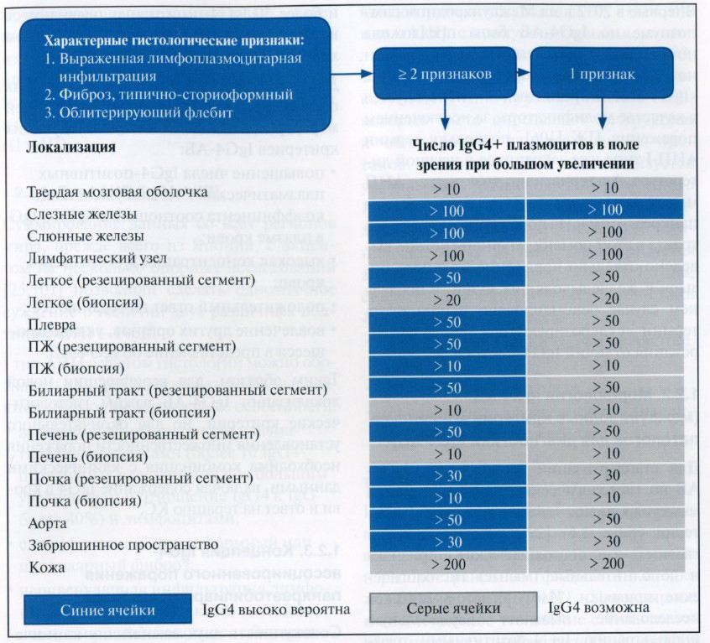
Fig. 1. Scheme of diagnosis of IgG4-associated disease using histological criteria (according to V. Deshpande et al., 2012 [2] with the changes by A.O. Buyverov et al., 2014 [1]).

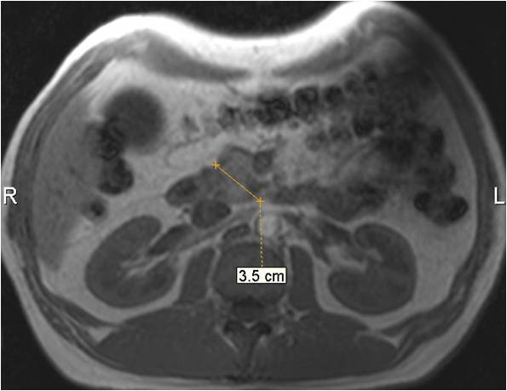
Fig. 2. MRI of the patient K. Aug. 24, 2016. Increase in the head of the prostate. MR-sequence T1VI, axial plane of scanning.
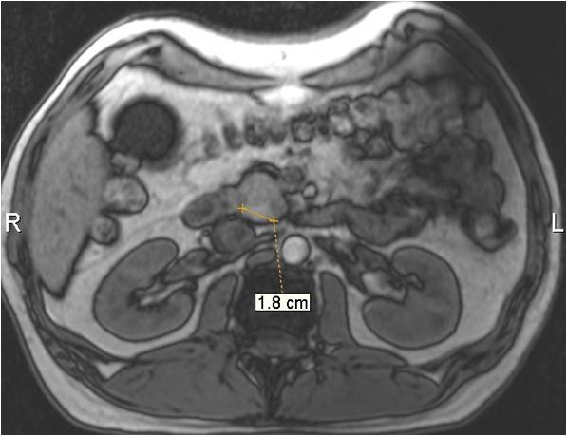
Fig. 3. MRI of the patient K. August 24, 2016 MR-sequence T1VI, axial plane of scanning. Pseudocontrol in the head of the prostate of high intensity.

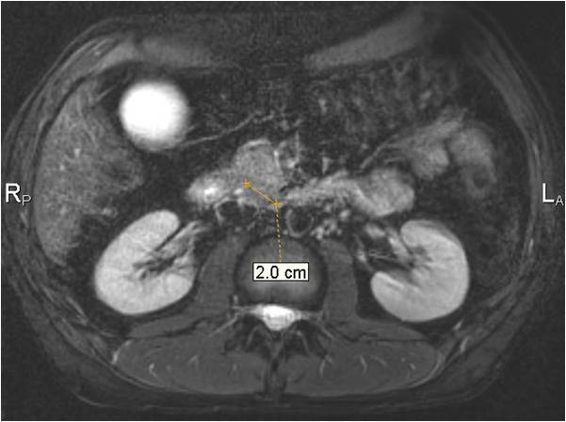
Fig. 4. MRI of the patient K. August 24, 2016 MR-sequence T2VI, axial plane of scanning, FatSat (fat suppression). Hypoensitive pseudo-focal zone in the head of the prostate.

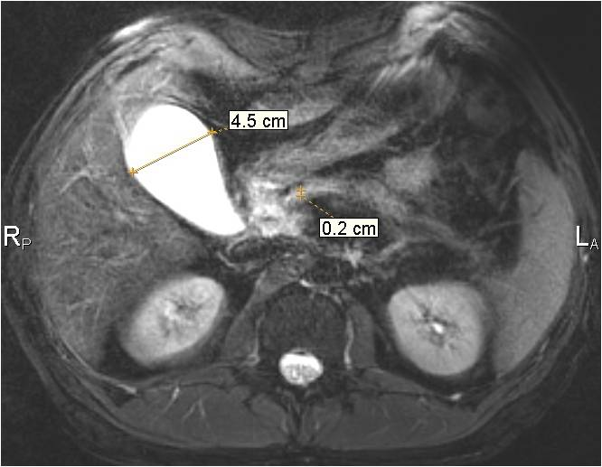
Fig. 5. MRI of the patient K. August 24, 2016 MR-sequence T2VI, axial plane of scanning, FatSat (fat suppression). Gall bladder of Ivirsungian duct (up to 2 mm).

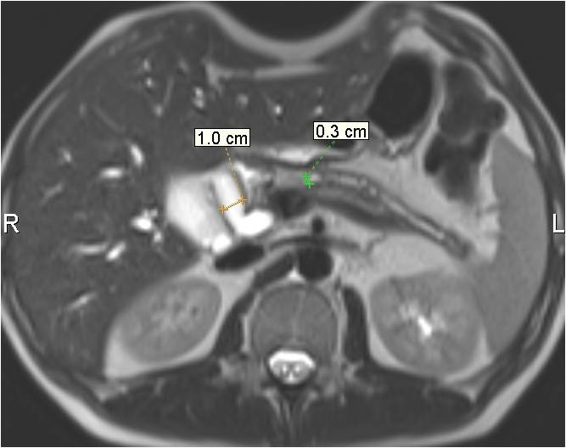
Fig. 6. MRI of patient K. 19.01.2017 MR sequence T2VI, axial plane of scanning, FatSat (fat suppression). Expanded yegepatico choledocha and Virsungian duct.

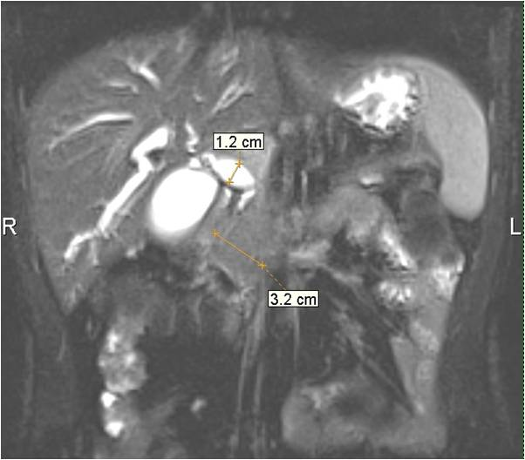
Fig. 7. MRI of patient K. 19.01.2017 MR sequence T2VI, — coronal plane of scanning, FatSat (fat suppression). Expansion of hepatoclean choledoch, enlargement of the head of the prostate.

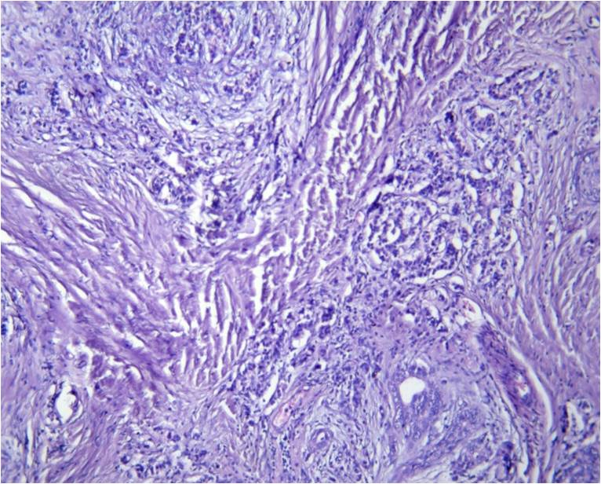
Fig. 8. Patient K. PZH with violation of architectonics due to a significant proliferation of connective tissue, sclerosing with the replacement of parenchyma, single glands deformed, compressed duct glands. Staining with hematoxylin and eosin, uv. × 100.
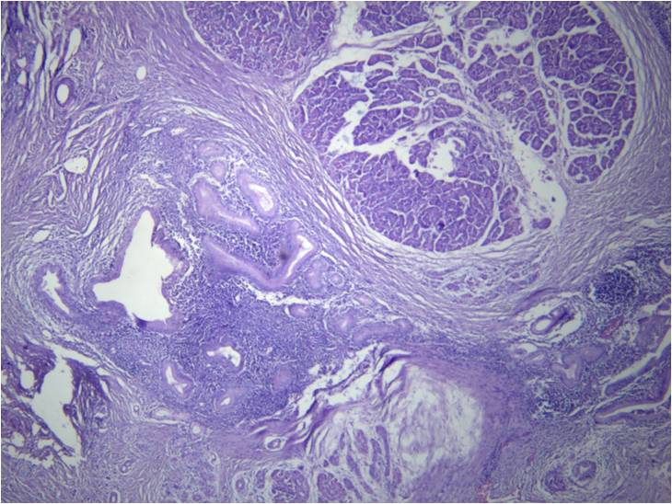
Fig. 9. Patient K. PZH with restructuring of the structure due to pronounced sclerosis, enlargement of individual ducts, hyperplasia and hypertrophy of them, in part with signs of epithelial dysplasia, focal lympho-histiocompatum infiltration. Staining with hematoxylin and eosin, uv. × 100.

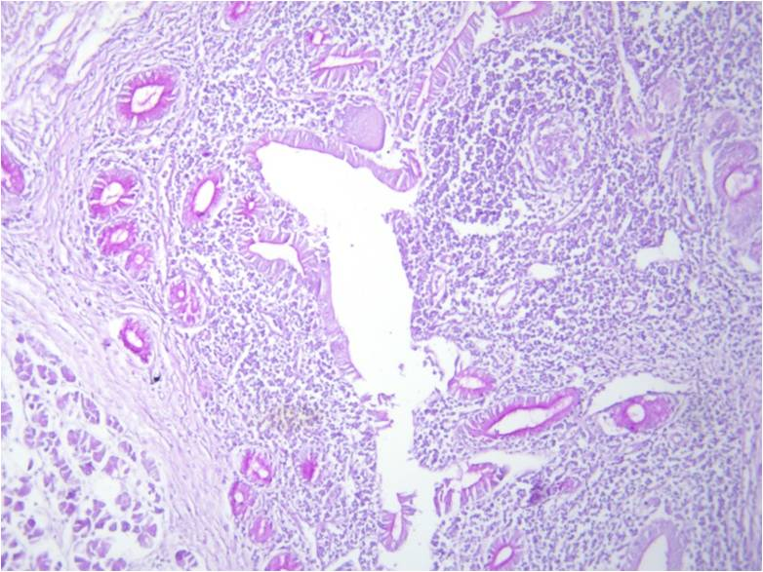
Fig. 10. Patient K. In the pancreas, a part of the duct glands with signs of dysplasia and hypertrophy, in them is sharply reduced and/or there is no secretion of mucus. PAS-reaction, uv. × 100.
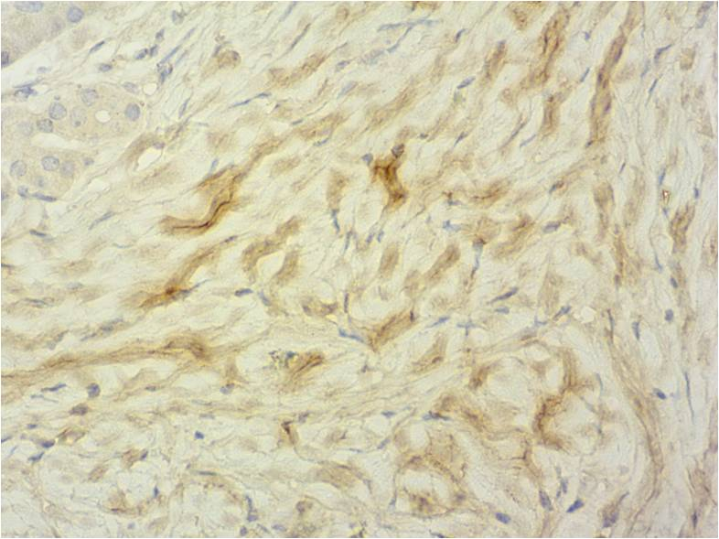
Fig. 11. Patient K. In the sites of sclerosis between the glands, positive cytoplasmic expression (deposits) of IgG4 from ++ to +++, an immunohistochemical study with monoclonal antibodies to IgG4, UV. × 400.

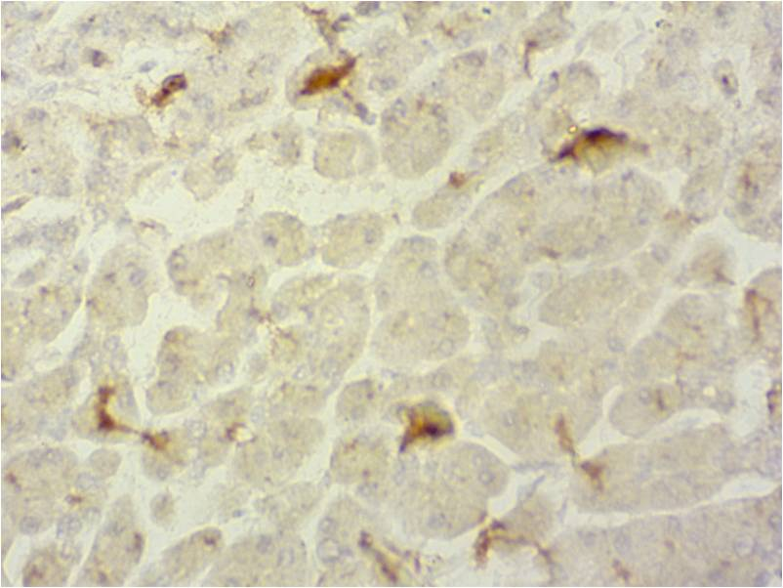
Fig. 12. Patient K. In the middle of the PI lobule, distinct positive expression (deposits) in individual parenchyma cells, between cells from ++ to +++. Immunohistochemical study with monoclonal antibodies to IgG4, uv. × 400.
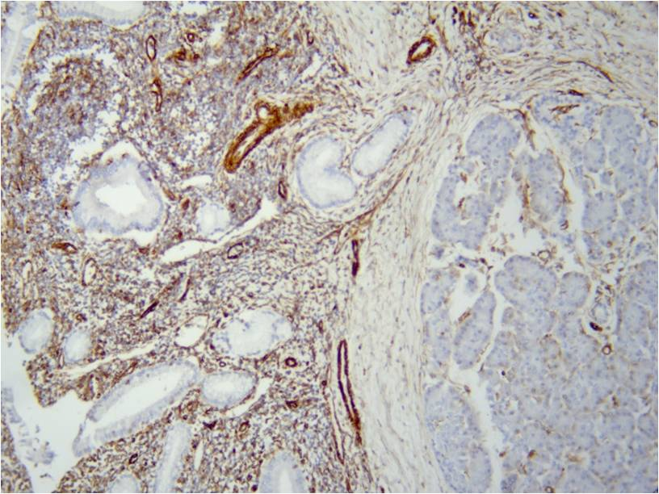
Fig. 13. Patient K. Positive expression in areas of sclerosis, cellular infiltrates, in the duct wall and foci between parenchyma cells in lobules. Immunohistochemical study with monoclonal antibodies to Vimentin, uv. × 100.

